# User Guide

Table of Contents

User Guide 1

Purpose 2

Datasets 2

Background………………………………………………………………………………………………………………………………………….3

Home 4

Map Tool 5

Filters Tab 5

Results Tab 9

Output Tab 11

Task Manager 13

## Purpose:

This tool queries a Data Cube to produce custom cloud-free mosaics for any defined spatial region and time period (multi-year, multi-month). Output can be displayed in several RGB false color composites and saved in JPEG and GEOTIFF format for additional offline analysis. Statistics are also available for image area, total pixels, percent of pixels without valid land data (clouds, cloud shadows, missing data), and the underlying Landsat scene count and scene IDs.

## Datasets:

The current version of this tool only uses Landsat 7 and Landsat 8. Data from these missions has been processed into surface reflectance products (via USGS ordering) and ingested into a Data Cube format where pixel information is stored in a 1-deg x 1-deg tiles using a UTM (WGS84) grid projection. The boundaries of these tiles are shown in the user interface as “red lines”. Analyses using this tool are conducted on a tile basis where each tile contains the full time series of the data over this spatial region.

**Kenya**

Landsat 7

Date range: 2000-01-04 07:35:12 to 2015-01-20 07:48:18

Spatial Range: Entire Country (Kenya)

Landsat 8

Date range: 2013-04-12 07:49:33 to 2014-12-18 07:55:40

Spatial Range: Entire Country (Kenya)

**Colombia**

Landsat 5

Date range: 1998-01-05 14:48:49 to 2011-11-02 14:55:33

Spatial Range: 4 Path-Row regions (7/59,7/60,8/59,8/60) for Colombia

Landsat 7

Date range: 1999-07-11 15:06:20 to 2015-08-24 15:13:47

Spatial Range: 4 Path-Row regions (7/59,7/60,8/59,8/60) for Colombia

Landsat 8

Date range: 2013-04-13 15:09:10 to 2015-08-25 15:07:32

Spatial Range: 4 Path-Row regions (7/59,7/60,8/59,8/60) for Colombia

## Background

The Data Cube is a common analytical framework composed of a series of data structures and tools which facilitate the organization and analysis of large gridded data collections. It has initially been developed for the analysis of temporally-rich Earth observation data, however the flexibility of the platform allows other gridded data collections to also be included and analyzed. Such data may include elevation models, geophysical grids, interpolated surfaces and model outputs. A key characteristic of the Data Cube is that every unique observation is kept, which is in contrast to many other methods used to handle large gridded data collections. The Data Cube provides a common analytical framework to allow multiple data sources to produce information for multiple uses. By transforming raw data into a standardized data infrastructure, the requirement for difficult and time-consuming pre-processing of the data is eliminated from individual applications. This allows an increased capacity for development of information products by the Earth observation community, and increased value for the public from Earth observation information.

How does the Data Cube work?

The Data Cube works by organizing the data into stacks of consistent, time-stamped geographic ‘tiles’ so that they can be rapidly manipulated in an HPC environment. A relational database is used to track all of the tiles in the data cube. Although the Data Cube contains a very large number of individual observations, the database can be used to track every observation back to the point of collection.

Data Cube Fundamentals:

* The Data Cube presents a common analytical environment, it is not just a data warehouse
* The Data Cube vision is to be able to perform data fusion analyses between heterogeneous gridded data collections with minimal overhead, e.g. products of different resolution and sensor
* To achieve interoperability we need a few common elements for a proposed data collection to ensure compatibility:
  + Data has a geometric base which is compatible with the existing data cube contents: i.e. Landsat uses the USGS GLS as a base with the SRTM 1 second DEM for ortho-correction.
  + Spectral data products should represent an inter-comparable metric: i.e. reflectance, which can be directly compared between different acquisitions and sensors
  + Inclusion of Pixel Quality information is essential
  + Reflectance products should have common settings in terms of the nadir view / solar elevation etc.

## Home

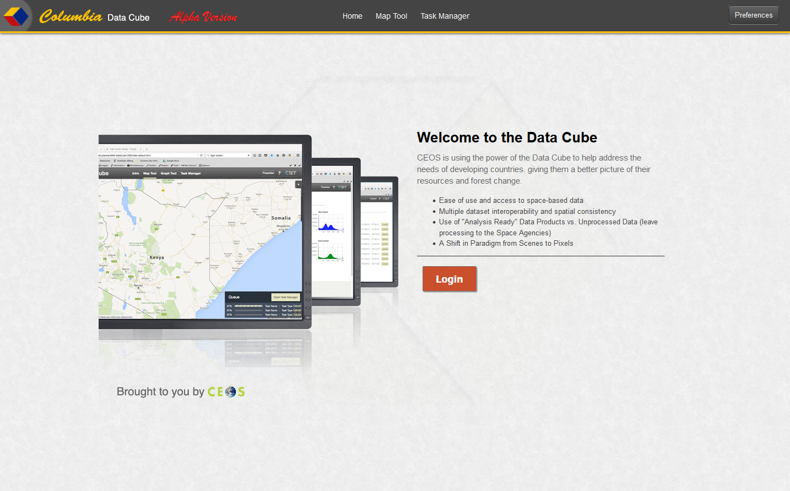

The Home page is the very first page a user will see after sign in has been completed. It provides basic information on what the Data Cube is for and navigation links to other pages of the application. The user can navigate around the application by using the header links described below or clicking on the Login button. Currently, clicking the Login button will take the user to the map tool.



A common header will appear above each page in the system that provides the following information:

* Logo for the current Cube
* Navigation links that will take the user to:
  + Home— returns the user to the login page.
  + Map Tool—where mosaic requests are run, results of those requests can be view, and save and download features can be executed.
  + Task Manager—currently a work in progress. The intent is to give the user a place to go where they can manage requests that have already completed or are currently running. It will allow a user to delete results that they no longer need.
  + User Guide—launches the User Guide (this document) in a new tab window
  + Preferences—currently a work in progress. When implemented this will be where the user can go to update configuration settings or personal information.

## Map Tool

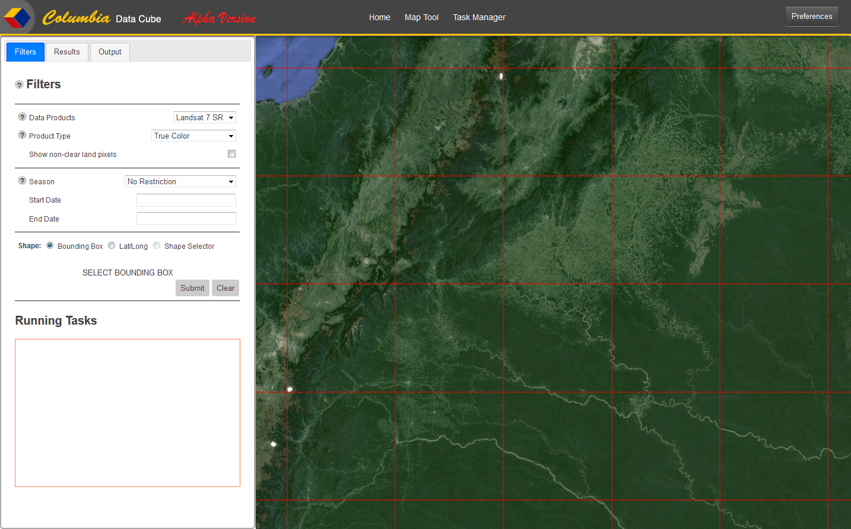

The Map Tool is where the majority of a user’s work will be done. A static map is shown on the right with a grid outline overlay to help the user to place bounding boxes and see the mosaic results of their queries. The left displays a tab panel. The three tabs are for:

1. Filters—where data selections are made to submit a request for mosaics and supporting information. There is also list at the bottom to show the submit requests that are currently in progress.
2. Results—this is the panel to find results of requests that have been completed. A list of completed tasks with start, stop, and execution times. There are also areas to show the scene list and statistics for the result that has been selected in the results list.
3. Output—the user can load or save a completed request, download a completed request as a particular file type, or select a yearly mosaic to show on the map.

### Filters Tab

The Filters tab contains the following:

* Data Products—this drop down box is where the user can select the specific type of satellite they would like the mosaic data to come from. The drop down contains the following options:
  + Landsat 7 SR
  + Landsat 8 SR
  + Spot 6 (currently disabled)
  + MODIS 250m (currently disabled)
* Product Type—this drop down box is where the user can select what color pattern will be used to further define what mosaic data is to be used. The following options are available:
  + True Color
  + NIR, SWIR1, SWIR2
  + NIR, SWIR1, RED
  + SWIR1, NIR, RED
  + SWIR2, NIR, GREEN
* Show non-clear land pixels—a checkbox where the user can indicate if they would like to have the pixels that are hidden by clouds, cloud shadows, water, etc. on the selected mosaic to be highlighted. When this indicator is checked all the mosaics on the map will show red where these missing pixels are.
* Season—a drop down box that has several options so the user has different ways of identifying a date range to be used in defining the mosaic data. These options are:
  + No Restriction
  + Custom Continuous
  + Custom Annual Multi-Month

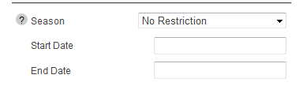

“No Restriction”—when selected the user is required to select a normal start and end date range. When the user puts focus on either of the fields a date selector tool will pop up showing a calendar of the current month plus the next 2 months. From there the user can pick the year, month, and day of their desired date.

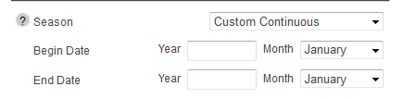

“Custom Continuous”—when selected the user will use these dates to define the beginning and ending month and year of the of the date range. The system will default to the first day of the beginning month and the last day of the ending month. The user will manually enter the year in the Year field and then select the month they want from the Month drop down list.

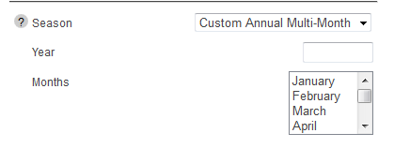

“Custom Annual Multi-Month”—this selection should be used when the user wants a mosaic from one year but multiple months. The user will enter the year they are requesting into the year field. The Months drop down box has all 12 months listed and allows the user to select more than one month. By holding down the Ctrl key the user can select individual months or they can hold down the Shift key and select a range of months.

* Shape—is a group of radio buttons that will be used to indicate how the user will select the latitude and longitude of the geographic area they want the mosaic produced for. There are three shape options, listed below, but only two of which are currently available for use.
  1. Bounding Box—this is default selection. The user will need to move their mouse over the map and click the upper left corner of the area they want to see and, without releasing the mouse, drag the mouse down and to the right. As they drag the mouse, the map will display a bounding box that will correspond to the area that will be used to produce the mosaic. By releasing the mouse they will define the bottom right corning of the box.
  2. Lat/Long—when the user selects this radio button, fields appear so they can manually enter the latitude and longitude values they wish to use for the mosaic request. They will need to enter minimum and maximum values for each.
  3. Shape Selector—currently disabled.
* Submit button—when the above criteria has been entered and the user clicks this button, a mosaic request will be started. For each submit, the details of the running request can be found in the in the Running Tasks list described below.
* Clear button—provides a way for the user to reset the filter fields described above to their default state, remove all mosaics shown on the map, and clear out the information found in the scene and statistics lists found in the results tab.
* Running Tasks—displays a list of any request that is currently executing. For each task that is executing, the list will show the following information:
  + Task status, which could be either finding pixels or creating mosaic
  + A cancel option that will stop the current request only
  + Start time of that particular task so the user can determine how long it has been running

### Results Tab

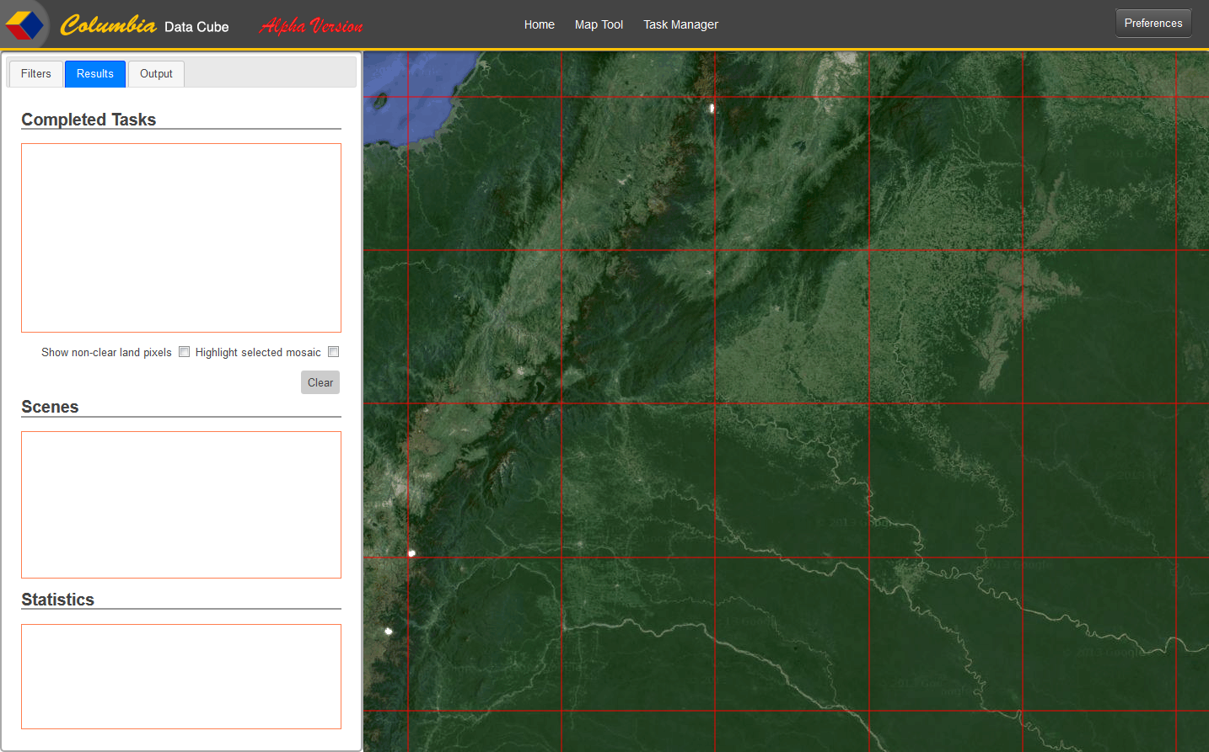

The Results tab contains the following:

* Completed Tasks list—displays a list of all requests that have completed successfully. The currently selected task will be highlighted. The following information will be displayed for each task:
  + Start date/time
  + End date/time
  + Total execution time
* Show non-clear land pixels—a checkbox where the user can indicate if they would like to have the pixels that are hidden by clouds, cloud shadows, water, etc. on the selected mosaic to be highlighted. When this indicator is checked all the mosaics on the map will show red where these missing pixels are.
* Highlight selected mosaic—this checkbox indicates that the user would like to have the currently selected mosaic be highlighted with a border. The selected mosaic corresponds to the selected task in the Completed Tasks list. As the user changes selections in the Completed Tasks list the highlighted border will re-draw around the tasks mosaics.
* Clear button—provides a way for the user to reset the filter fields described above to their default state, remove all mosaics shown on the map, and clear out the information found in the scene and statistics lists found in the results tab.
* Scenes List—the list of scene id’s that were used to generate the current mosaic.
* Statistics—lists detail information pertaining to the selected task from the Completed Tasks list described above.

### Output Tab

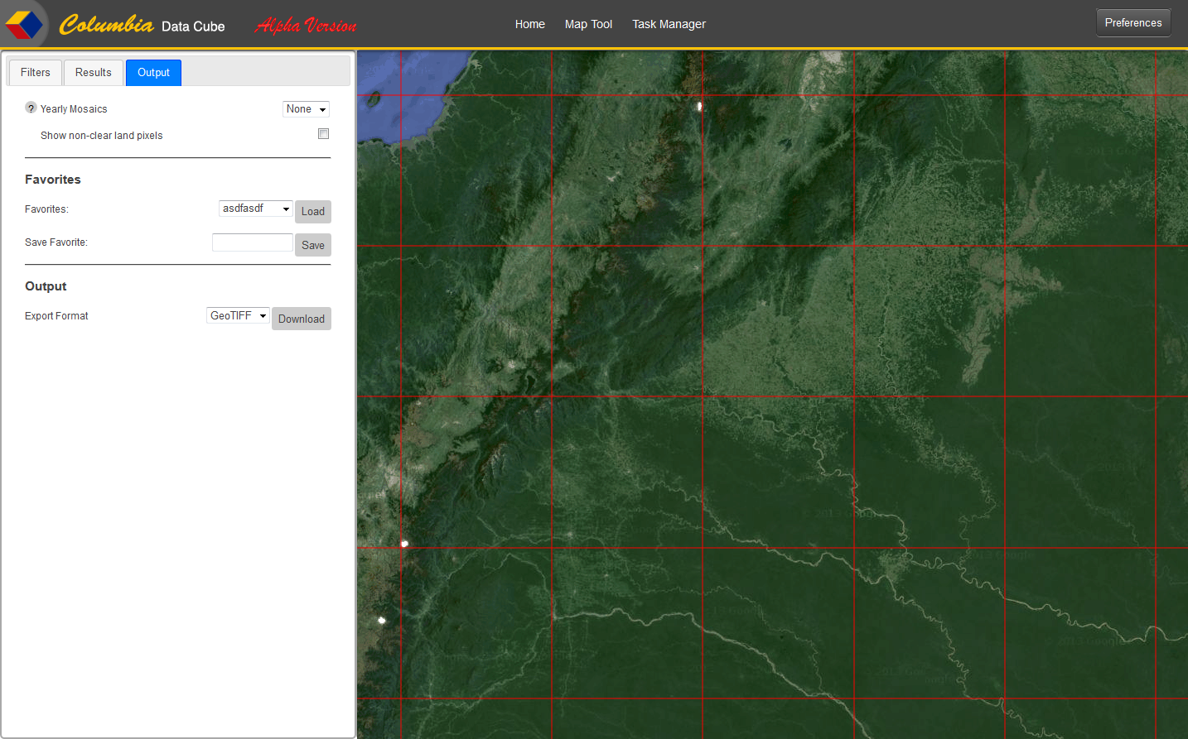

The Output tab contains the follow:

* Yearly Mosaics—is a list of years that the system has predefined images for. These images show, for the particular year, a snapshot of the satellite paths that have been used to generate the Data Cube data. When a year is selected the image will be placed on the map. If the “Show non-clear land pixels” checkbox is on, the image will change to reflect the red color, indicating missing pixels. To remove the image all together, the user simply selects “None” in the drop down list.
* Show non-clear land pixels—a checkbox where the user can indicate if they would like to have the pixels that are hidden by clouds, cloud shadows, water, etc. on the selected mosaic to be highlighted. When this indicator is checked all the mosaics on the map will show red where these missing pixels are.
* Favorites—is a list of all the saved mosaics generated by the Save Favorites process described next. To view the saved favorite, the user needs to select the desired entry and click on the Load button. This will then add the favorite to the Completed Tasks List. Once the user selects an item in the Completed Tasks list the mosaic, scenes, and statistics for that favorite will be shown in the application.
* Save Favorites—the process the user can perform to save data of the task that is currently selected. The user will enter a descriptive name of the Favorite they wish to save, then select the Save button. The favorite will be added to their list of favorites found in the Favorites combo box. This will allow them to view that task (mosaic, scenes, etc.) at a future time.
* Export Format—this will generate an image from the selected mosaic and save it on their system in the file format selected in the drop down list. Currently the available formats are:
  + GeoTIFF
  + JPEG

## Task Manager

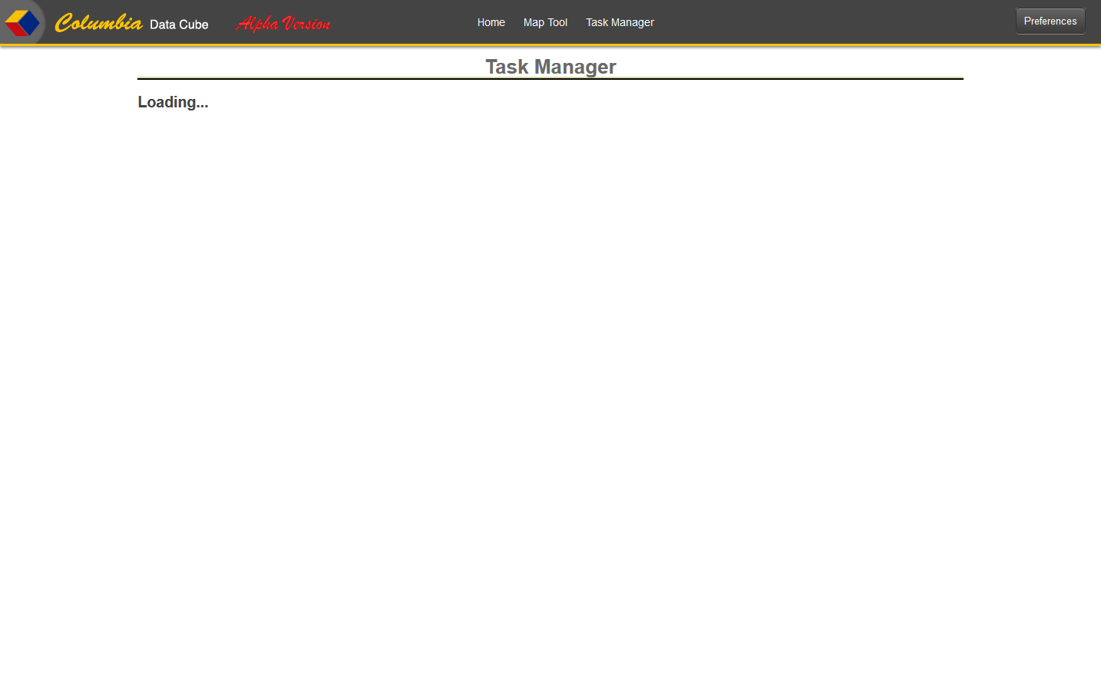

Currently the Task Manager is a work in progress. The intent is to give the user a place to go where they can manage requests that have already completed or are currently running. It will allow a user to delete results that they no longer need.