前言
随着大数据思想实施的落地，推荐系统也开始倍受关注。不光是电商，各种互联网应用都开始应用推荐系统，像搜索，社交网络，音乐，餐饮，地图服务等等。
在以前，我们没有使用推荐算法的时候，我们是通过设置各种约束条件，匹配数据的自然属性呈现给用户，这种就是基于规则的系统。比如，用户购买了一个商品，我们会推荐同类别的其他商品，通过类别属性作为推荐的规则。后来问题就出现了，当用户一次性买了多种类别的不同商品的时候，前一条规则就失败了，我们要进一步设计规则，IT类别优先推荐，价格高的产品优先推荐…..几个回合下来，我们要不停的增加规则，以至于规则有可能的会前后冲突，增加一条新的规则会让推荐结果越来越不好，而且还无法解释是为什么。
推荐算法从另一角度入手，解决了基于规则设置的问题。下面将用Mahout来构建一个职位推荐算法引擎。
目录
- Mahout推荐框架概述
- 需求分析：职位推荐引擎指标设计
- 算法模型：推荐算法
- 架构设计：职位推荐引擎系统架构
- 程序开发：基于Mahout的推荐算法实现

1. Mahout推荐系统框架概述
Mahout框架包含了一套完整的推荐系统引擎，标准化的数据结构，多样的算法实现，简单的开发流程。Mahout推荐的推荐系统引擎是模块化的，分为5个主要部分组成：数据模型，相似度算法，近邻算法，推荐算法，算法评分器。
更详细的介绍，请参考文章：从源代码剖析Mahout推荐引擎

2. 需求分析：职位推荐引擎指标设计
下面我们将从一个公司案例出发来全面的解释，如何进行职位推荐引擎指标设计。
案例介绍：
互联网某职业社交网站，主要产品包括 个人简历展示页，人脉圈，微博及分享链接，职位发布，职位申请，教育培训等。
用户在完成注册后，需要完善自己的个人信息，包括教育背景，工作经历，项目经历，技能专长等等信息。然后，你要告诉网站，你是否想找工作！！当你选择“是”（求职中），网站会从数据库中为你推荐你可能感兴趣的职位。
通过简短的描述，我们可以粗略地看出，这家职业社交网站的定位和主营业务。核心点有2个：
- 用户：尽可能多的保存有效完整的用户资料
- 服务：帮助用户找到工作，帮助猎头和企业找到员工
因此，职位推荐引擎 将成为这个网站的核心功能。
KPI指标设计
- 通过推荐带来的职位浏览量: 职位网页的PV
- 通过推荐带来的职位申请量: 职位网页的有效转化

3. 算法模型：推荐算法
2个测试数据集：
- pv.csv: 职位被浏览的信息,包括用户ID，职位ID
- job.csv: 职位基本信息,包括职位ID，发布时间，工资标准
1). pv.csv
- 2列数据：用户ID，职位ID(userid,jobid)

- 浏览记录:2500条

- 用户数:1000个，用户ID:1-1000

- 职位数:200个，职位ID：1-200

部分数据：
1,11
2,136
2,187
3,165
3,1
3,24
4,8
4,199
5,32
5,100
6,14
7,59
7,147
8,92
9,165
9,80
9,171
10,45
10,31
10,1
10,152
2). job.csv
- 3列数据：职位ID，发布时间，工资标准(jobid,create_date,salary)
- 职位数:200个，职位ID：1-200
部分数据：
1,2013-01-24,5600
2,2011-03-02,5400
3,2011-03-14,8100
4,2012-10-05,2200
5,2011-09-03,14100
6,2011-03-05,6500
7,2012-06-06,37000
8,2013-02-18,5500
9,2010-07-05,7500
10,2010-01-23,6700
11,2011-09-19,5200
12,2010-01-19,29700
13,2013-09-28,6000
14,2013-10-23,3300
15,2010-10-09,2700
16,2010-07-14,5100
17,2010-05-13,29000
18,2010-01-16,21800
19,2013-05-23,5700
20,2011-04-24,5900
为了完成KPI的指标，我们把问题用“技术”语言转化一下：我们需要让职位的推荐结果更准确，从而增加用户的点击。
- 1. 组合使用推荐算法，选出“评估推荐器”验证得分较高的算法
- 2. 人工验证推荐结果
- 3. 职位有时效性，推荐的结果应该是发布半年内的职位
- 4. 工资的标准，应不低于用户浏览职位工资的平均值的80%
我们选择UserCF,ItemCF,SlopeOne的 3种推荐算法，进行7种组合的测试。
- userCF1: LogLikelihoodSimilarity + NearestNUserNeighborhood + GenericBooleanPrefUserBasedRecommender
- userCF2: CityBlockSimilarity+ NearestNUserNeighborhood + GenericBooleanPrefUserBasedRecommender
- userCF3: UserTanimoto + NearestNUserNeighborhood + GenericBooleanPrefUserBasedRecommender
- itemCF1: LogLikelihoodSimilarity + GenericBooleanPrefItemBasedRecommender
- itemCF2: CityBlockSimilarity+ GenericBooleanPrefItemBasedRecommender
- itemCF3: ItemTanimoto + GenericBooleanPrefItemBasedRecommender
- slopeOne：SlopeOneRecommender
关于的推荐算法的详细介绍，请参考文章：Mahout推荐算法API详解
关于算法的组合的详细介绍，请参考文章：从源代码剖析Mahout推荐引擎

4. 架构设计：职位推荐引擎系统架构
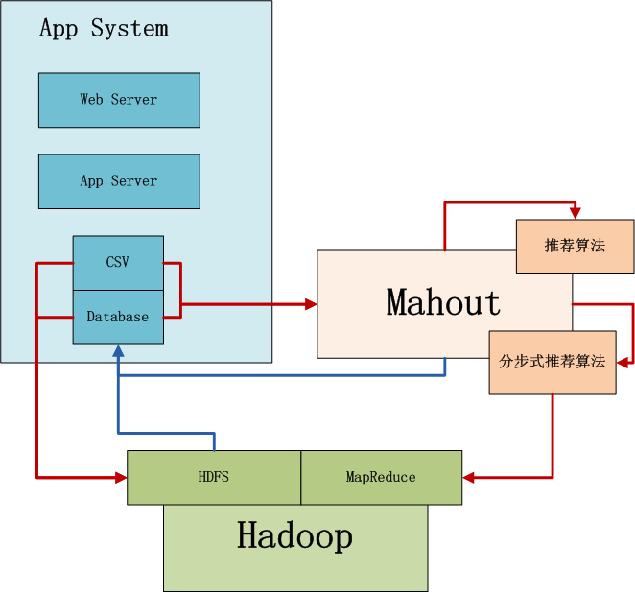
上图中，左边是Application业务系统，右边是Mahout，下边是Hadoop集群。
- 1. 当数据量不太大时，并且算法复杂，直接选择用Mahout读取CSV或者Database数据，在单机内存中进行计算。Mahout是多线程的应用，会并行使用单机所有系统资源。
- 2. 当数据量很大时，选择并行化算法(ItemCF)，先业务系统的数据导入到Hadoop的HDFS中，然后用Mahout访问HDFS实现算法，这时算法的性能与整个Hadoop集群有关。
- 3. 计算后的结果，保存到数据库中，方便查询

5. 程序开发：基于Mahout的推荐算法实现
开发环境mahout版本为0.8。 ，请参考文章：用Maven构建Mahout项目
新建Java类：
- RecommenderEvaluator.java, 选出“评估推荐器”验证得分较高的算法
- RecommenderResult.java, 对指定数量的结果人工比较
- RecommenderFilterOutdateResult.java，排除过期职位
- RecommenderFilterSalaryResult.java，排除工资过低的职位
1). RecommenderEvaluator.java, 选出“评估推荐器”验证得分较高的算
源代码：

public class RecommenderEvaluator {

final static int NEIGHBORHOOD_NUM = 2;
final static int RECOMMENDER_NUM = 3;

public static void main(String[] args) throws TasteException, IOException {
String file = "datafile/job/pv.csv";
DataModel dataModel = RecommendFactory.buildDataModelNoPref(file);
userLoglikelihood(dataModel);
userCityBlock(dataModel);
userTanimoto(dataModel);
itemLoglikelihood(dataModel);
itemCityBlock(dataModel);
itemTanimoto(dataModel);
slopeOne(dataModel);
}

public static RecommenderBuilder userLoglikelihood(DataModel dataModel) throws TasteException, IOException {
System.out.println("userLoglikelihood");
UserSimilarity userSimilarity = RecommendFactory.userSimilarity(RecommendFactory.SIMILARITY.LOGLIKELIHOOD, dataModel);
UserNeighborhood userNeighborhood = RecommendFactory.userNeighborhood(RecommendFactory.NEIGHBORHOOD.NEAREST, userSimilarity, dataModel, NEIGHBORHOOD_NUM);
RecommenderBuilder recommenderBuilder = RecommendFactory.userRecommender(userSimilarity, userNeighborhood, false);

RecommendFactory.evaluate(RecommendFactory.EVALUATOR.AVERAGE_ABSOLUTE_DIFFERENCE, recommenderBuilder, null, dataModel, 0.7);
RecommendFactory.statsEvaluator(recommenderBuilder, null, dataModel, 2);
return recommenderBuilder;
}

public static RecommenderBuilder userCityBlock(DataModel dataModel) throws TasteException, IOException {
System.out.println("userCityBlock");
UserSimilarity userSimilarity = RecommendFactory.userSimilarity(RecommendFactory.SIMILARITY.CITYBLOCK, dataModel);
UserNeighborhood userNeighborhood = RecommendFactory.userNeighborhood(RecommendFactory.NEIGHBORHOOD.NEAREST, userSimilarity, dataModel, NEIGHBORHOOD_NUM);
RecommenderBuilder recommenderBuilder = RecommendFactory.userRecommender(userSimilarity, userNeighborhood, false);

RecommendFactory.evaluate(RecommendFactory.EVALUATOR.AVERAGE_ABSOLUTE_DIFFERENCE, recommenderBuilder, null, dataModel, 0.7);
RecommendFactory.statsEvaluator(recommenderBuilder, null, dataModel, 2);
return recommenderBuilder;
}

public static RecommenderBuilder userTanimoto(DataModel dataModel) throws TasteException, IOException {
System.out.println("userTanimoto");
UserSimilarity userSimilarity = RecommendFactory.userSimilarity(RecommendFactory.SIMILARITY.TANIMOTO, dataModel);
UserNeighborhood userNeighborhood = RecommendFactory.userNeighborhood(RecommendFactory.NEIGHBORHOOD.NEAREST, userSimilarity, dataModel, NEIGHBORHOOD_NUM);
RecommenderBuilder recommenderBuilder = RecommendFactory.userRecommender(userSimilarity, userNeighborhood, false);

RecommendFactory.evaluate(RecommendFactory.EVALUATOR.AVERAGE_ABSOLUTE_DIFFERENCE, recommenderBuilder, null, dataModel, 0.7);
RecommendFactory.statsEvaluator(recommenderBuilder, null, dataModel, 2);
return recommenderBuilder;
}

public static RecommenderBuilder itemLoglikelihood(DataModel dataModel) throws TasteException, IOException {
System.out.println("itemLoglikelihood");
ItemSimilarity itemSimilarity = RecommendFactory.itemSimilarity(RecommendFactory.SIMILARITY.LOGLIKELIHOOD, dataModel);
RecommenderBuilder recommenderBuilder = RecommendFactory.itemRecommender(itemSimilarity, false);

RecommendFactory.evaluate(RecommendFactory.EVALUATOR.AVERAGE_ABSOLUTE_DIFFERENCE, recommenderBuilder, null, dataModel, 0.7);
RecommendFactory.statsEvaluator(recommenderBuilder, null, dataModel, 2);
return recommenderBuilder;
}

public static RecommenderBuilder itemCityBlock(DataModel dataModel) throws TasteException, IOException {
System.out.println("itemCityBlock");
ItemSimilarity itemSimilarity = RecommendFactory.itemSimilarity(RecommendFactory.SIMILARITY.CITYBLOCK, dataModel);
RecommenderBuilder recommenderBuilder = RecommendFactory.itemRecommender(itemSimilarity, false);

RecommendFactory.evaluate(RecommendFactory.EVALUATOR.AVERAGE_ABSOLUTE_DIFFERENCE, recommenderBuilder, null, dataModel, 0.7);
RecommendFactory.statsEvaluator(recommenderBuilder, null, dataModel, 2);
return recommenderBuilder;
}

public static RecommenderBuilder itemTanimoto(DataModel dataModel) throws TasteException, IOException {
System.out.println("itemTanimoto");
ItemSimilarity itemSimilarity = RecommendFactory.itemSimilarity(RecommendFactory.SIMILARITY.TANIMOTO, dataModel);
RecommenderBuilder recommenderBuilder = RecommendFactory.itemRecommender(itemSimilarity, false);

RecommendFactory.evaluate(RecommendFactory.EVALUATOR.AVERAGE_ABSOLUTE_DIFFERENCE, recommenderBuilder, null, dataModel, 0.7);
RecommendFactory.statsEvaluator(recommenderBuilder, null, dataModel, 2);
return recommenderBuilder;
}

public static RecommenderBuilder slopeOne(DataModel dataModel) throws TasteException, IOException {
System.out.println("slopeOne");
RecommenderBuilder recommenderBuilder = RecommendFactory.slopeOneRecommender();

RecommendFactory.evaluate(RecommendFactory.EVALUATOR.AVERAGE_ABSOLUTE_DIFFERENCE, recommenderBuilder, null, dataModel, 0.7);
RecommendFactory.statsEvaluator(recommenderBuilder, null, dataModel, 2);
return recommenderBuilder;
}

public static RecommenderBuilder knnLoglikelihood(DataModel dataModel) throws TasteException, IOException {
System.out.println("knnLoglikelihood");
ItemSimilarity itemSimilarity = RecommendFactory.itemSimilarity(RecommendFactory.SIMILARITY.LOGLIKELIHOOD, dataModel);
RecommenderBuilder recommenderBuilder = RecommendFactory.itemKNNRecommender(itemSimilarity, new NonNegativeQuadraticOptimizer(), 10);

RecommendFactory.evaluate(RecommendFactory.EVALUATOR.AVERAGE_ABSOLUTE_DIFFERENCE, recommenderBuilder, null, dataModel, 0.7);
RecommendFactory.statsEvaluator(recommenderBuilder, null, dataModel, 2);

return recommenderBuilder;
}

public static RecommenderBuilder knnTanimoto(DataModel dataModel) throws TasteException, IOException {
System.out.println("knnTanimoto");
ItemSimilarity itemSimilarity = RecommendFactory.itemSimilarity(RecommendFactory.SIMILARITY.TANIMOTO, dataModel);
RecommenderBuilder recommenderBuilder = RecommendFactory.itemKNNRecommender(itemSimilarity, new NonNegativeQuadraticOptimizer(), 10);

RecommendFactory.evaluate(RecommendFactory.EVALUATOR.AVERAGE_ABSOLUTE_DIFFERENCE, recommenderBuilder, null, dataModel, 0.7);
RecommendFactory.statsEvaluator(recommenderBuilder, null, dataModel, 2);

return recommenderBuilder;
}

public static RecommenderBuilder knnCityBlock(DataModel dataModel) throws TasteException, IOException {
System.out.println("knnCityBlock");
ItemSimilarity itemSimilarity = RecommendFactory.itemSimilarity(RecommendFactory.SIMILARITY.CITYBLOCK, dataModel);
RecommenderBuilder recommenderBuilder = RecommendFactory.itemKNNRecommender(itemSimilarity, new NonNegativeQuadraticOptimizer(), 10);

RecommendFactory.evaluate(RecommendFactory.EVALUATOR.AVERAGE_ABSOLUTE_DIFFERENCE, recommenderBuilder, null, dataModel, 0.7);
RecommendFactory.statsEvaluator(recommenderBuilder, null, dataModel, 2);

return recommenderBuilder;
}

public static RecommenderBuilder svd(DataModel dataModel) throws TasteException {
System.out.println("svd");
RecommenderBuilder recommenderBuilder = RecommendFactory.svdRecommender(new ALSWRFactorizer(dataModel, 5, 0.05, 10));

RecommendFactory.evaluate(RecommendFactory.EVALUATOR.AVERAGE_ABSOLUTE_DIFFERENCE, recommenderBuilder, null, dataModel, 0.7);
RecommendFactory.statsEvaluator(recommenderBuilder, null, dataModel, 2);

return recommenderBuilder;
}

public static RecommenderBuilder treeClusterLoglikelihood(DataModel dataModel) throws TasteException {
System.out.println("treeClusterLoglikelihood");
UserSimilarity userSimilarity = RecommendFactory.userSimilarity(RecommendFactory.SIMILARITY.LOGLIKELIHOOD, dataModel);
ClusterSimilarity clusterSimilarity = RecommendFactory.clusterSimilarity(RecommendFactory.SIMILARITY.FARTHEST_NEIGHBOR_CLUSTER, userSimilarity);
RecommenderBuilder recommenderBuilder = RecommendFactory.treeClusterRecommender(clusterSimilarity, 3);

RecommendFactory.evaluate(RecommendFactory.EVALUATOR.AVERAGE_ABSOLUTE_DIFFERENCE, recommenderBuilder, null, dataModel, 0.7);
RecommendFactory.statsEvaluator(recommenderBuilder, null, dataModel, 2);

return recommenderBuilder;
}
}
运行结果，控制台输出：

userLoglikelihood
AVERAGE_ABSOLUTE_DIFFERENCE Evaluater Score:0.2741487771272658
Recommender IR Evaluator: [Precision:0.6424242424242422,Recall:0.4098360655737705]
userCityBlock
AVERAGE_ABSOLUTE_DIFFERENCE Evaluater Score:0.575306732961736
Recommender IR Evaluator: [Precision:0.919580419580419,Recall:0.4371584699453552]
userTanimoto
AVERAGE_ABSOLUTE_DIFFERENCE Evaluater Score:0.5546485136181523
Recommender IR Evaluator: [Precision:0.6625766871165644,Recall:0.41803278688524603]
itemLoglikelihood
AVERAGE_ABSOLUTE_DIFFERENCE Evaluater Score:0.5398332608612343
Recommender IR Evaluator: [Precision:0.26229508196721296,Recall:0.26229508196721296]
itemCityBlock
AVERAGE_ABSOLUTE_DIFFERENCE Evaluater Score:0.9251437840891661
Recommender IR Evaluator: [Precision:0.02185792349726776,Recall:0.02185792349726776]
itemTanimoto
AVERAGE_ABSOLUTE_DIFFERENCE Evaluater Score:0.9176432856689655
Recommender IR Evaluator: [Precision:0.26229508196721296,Recall:0.26229508196721296]
slopeOne
AVERAGE_ABSOLUTE_DIFFERENCE Evaluater Score:0.0
Recommender IR Evaluator: [Precision:0.01912568306010929,Recall:0.01912568306010929]
可视化“评估推荐器”输出：
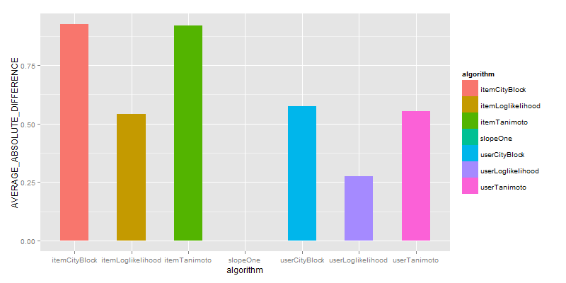
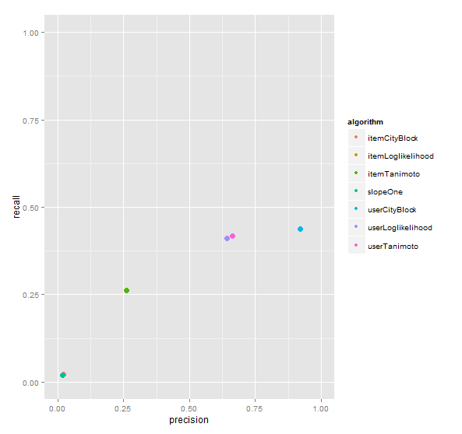
UserCityBlock算法评估的结果是最好的，基于UserCF的算法比ItemCF都要好，SlopeOne算法几乎没有得分。
2). RecommenderResult.java, 对指定数量的结果人工比较
为得到差异化结果，我们分别取UserCityBlock,itemLoglikelihood，对推荐结果人工比较。
源代码：

public class RecommenderResult {

final static int NEIGHBORHOOD_NUM = 2;
final static int RECOMMENDER_NUM = 3;

public static void main(String[] args) throws TasteException, IOException {
String file = "datafile/job/pv.csv";
DataModel dataModel = RecommendFactory.buildDataModelNoPref(file);
RecommenderBuilder rb1 = RecommenderEvaluator.userCityBlock(dataModel);
RecommenderBuilder rb2 = RecommenderEvaluator.itemLoglikelihood(dataModel);

LongPrimitiveIterator iter = dataModel.getUserIDs();
while (iter.hasNext()) {
long uid = iter.nextLong();
System.out.print("userCityBlock =>");
result(uid, rb1, dataModel);
System.out.print("itemLoglikelihood=>");
result(uid, rb2, dataModel);
}
}

public static void result(long uid, RecommenderBuilder recommenderBuilder, DataModel dataModel) throws TasteException {
List list = recommenderBuilder.buildRecommender(dataModel).recommend(uid, RECOMMENDER_NUM);
RecommendFactory.showItems(uid, list, false);
}

}
控制台输出：只截取部分结果

...
userCityBlock =>uid:968,(61,0.333333)
itemLoglikelihood=>uid:968,(121,1.429362)(153,1.239939)(198,1.207726)
userCityBlock =>uid:969,
itemLoglikelihood=>uid:969,(75,1.326499)(30,0.873100)(85,0.763344)
userCityBlock =>uid:970,
itemLoglikelihood=>uid:970,(13,0.748417)(156,0.748417)(122,0.748417)
userCityBlock =>uid:971,
itemLoglikelihood=>uid:971,(38,2.060951)(104,1.951208)(83,1.941735)
userCityBlock =>uid:972,
itemLoglikelihood=>uid:972,(131,1.378395)(4,1.349386)(87,0.881816)
userCityBlock =>uid:973,
itemLoglikelihood=>uid:973,(196,1.432040)(140,1.398066)(130,1.380335)
userCityBlock =>uid:974,(19,0.200000)
itemLoglikelihood=>uid:974,(145,1.994049)(121,1.794289)(98,1.738027)
...
我们查看uid=974的用户推荐信息：
搜索pv.csv：

> pv[which(pv$userid==974),]
userid jobid
2426 974 106
2427 974 173
2428 974 82
2429 974 188
2430 974 78
搜索job.csv:

> job[job$jobid %in% c(145,121,98,19),]
jobid create_date salary
19 19 2013-05-23 5700
98 98 2010-01-15 2900
121 121 2010-06-19 5300
145 145 2013-08-02 6800
上面两种算法，推荐的结果都是2010年的职位，这些结果并不是太好，接下来我们要排除过期职位，只保留2013年的职位。
3).RecommenderFilterOutdateResult.java，排除过期职位
源代码：

public class RecommenderFilterOutdateResult {

final static int NEIGHBORHOOD_NUM = 2;
final static int RECOMMENDER_NUM = 3;

public static void main(String[] args) throws TasteException, IOException {
String file = "datafile/job/pv.csv";
DataModel dataModel = RecommendFactory.buildDataModelNoPref(file);
RecommenderBuilder rb1 = RecommenderEvaluator.userCityBlock(dataModel);
RecommenderBuilder rb2 = RecommenderEvaluator.itemLoglikelihood(dataModel);

LongPrimitiveIterator iter = dataModel.getUserIDs();
while (iter.hasNext()) {
long uid = iter.nextLong();
System.out.print("userCityBlock =>");
filterOutdate(uid, rb1, dataModel);
System.out.print("itemLoglikelihood=>");
filterOutdate(uid, rb2, dataModel);
}
}

public static void filterOutdate(long uid, RecommenderBuilder recommenderBuilder, DataModel dataModel) throws TasteException, IOException {
Set jobids = getOutdateJobID("datafile/job/job.csv");
IDRescorer rescorer = new JobRescorer(jobids);
List list = recommenderBuilder.buildRecommender(dataModel).recommend(uid, RECOMMENDER_NUM, rescorer);
RecommendFactory.showItems(uid, list, true);
}

public static Set getOutdateJobID(String file) throws IOException {
BufferedReader br = new BufferedReader(new FileReader(new File(file)));
Set jobids = new HashSet();
String s = null;
while ((s = br.readLine()) != null) {
String[] cols = s.split(",");
SimpleDateFormat df = new SimpleDateFormat("yyyy-MM-dd");
Date date = null;
try {
date = df.parse(cols[1]);
if (date.getTime() < df.parse("2013-01-01").getTime()) {
jobids.add(Long.parseLong(cols[0]));
}
} catch (ParseException e) {
e.printStackTrace();
}

}
br.close();
return jobids;
}

}

class JobRescorer implements IDRescorer {
final private Set jobids;

public JobRescorer(Set jobs) {
this.jobids = jobs;
}

@Override
public double rescore(long id, double originalScore) {
return isFiltered(id) ? Double.NaN : originalScore;
}

@Override
public boolean isFiltered(long id) {
return jobids.contains(id);
}
}
控制台输出：只截取部分结果

...
itemLoglikelihood=>uid:965,(200,0.829600)(122,0.748417)(170,0.736340)
userCityBlock =>uid:966,(114,0.250000)
itemLoglikelihood=>uid:966,(114,1.516898)(101,0.864536)(99,0.856057)
userCityBlock =>uid:967,
itemLoglikelihood=>uid:967,(105,0.873100)(114,0.725016)(168,0.707119)
userCityBlock =>uid:968,
itemLoglikelihood=>uid:968,(174,0.735004)(39,0.696716)(185,0.696171)
userCityBlock =>uid:969,
itemLoglikelihood=>uid:969,(197,0.723203)(81,0.710230)(167,0.668358)
userCityBlock =>uid:970,
itemLoglikelihood=>uid:970,(13,0.748417)(122,0.748417)(28,0.736340)
userCityBlock =>uid:971,
itemLoglikelihood=>uid:971,(28,1.540753)(174,1.511881)(39,1.435575)
userCityBlock =>uid:972,
itemLoglikelihood=>uid:972,(14,0.800605)(60,0.794088)(163,0.710230)
userCityBlock =>uid:973,
itemLoglikelihood=>uid:973,(56,0.795529)(13,0.712680)(120,0.701026)
userCityBlock =>uid:974,(19,0.200000)
itemLoglikelihood=>uid:974,(145,1.994049)(89,1.578694)(19,1.435193)
...
我们查看uid=994的用户推荐信息：
搜索pv.csv：

> pv[which(pv$userid==974),]
userid jobid
2426 974 106
2427 974 173
2428 974 82
2429 974 188
2430 974 78
搜索job.csv:

> job[job$jobid %in% c(19,145,89),]
jobid create_date salary
19 19 2013-05-23 5700
89 89 2013-06-15 8400
145 145 2013-08-02 6800
排除过期的职位比较，我们发现userCityBlock结果都是19，itemLoglikelihood的第2，3的结果被替换为了得分更低的89和19。
4).RecommenderFilterSalaryResult.java，排除工资过低的职位
我们查看uid=994的用户，浏览过的职位。

> job[job$jobid %in% c(106,173,82,188,78),]
jobid create_date salary
78 78 2012-01-29 6800
82 82 2010-07-05 7500
106 106 2011-04-25 5200
173 173 2013-09-13 5200
188 188 2010-07-14 6000
平均工资为=6140，我们觉得用户的浏览职位的行为，一般不会看比自己现在工资低的职位，因此设计算法，排除工资低于平均工资80%的职位，即排除工资小于4912的推荐职位(6140*0.8=4912)
大家可以参考上文中RecommenderFilterOutdateResult.java,自行实现。
这样，我们就完成用Mahout构建职位推荐引擎的算法。如果没有Mahout，我们自己写这个算法引擎估计还要花个小半年的时间，善加利用开源技术会帮助我们飞一样的成长！！
原代码下载：
https://github.com/bsspirit/maven_mahout_template/tree/mahout-0.8/src/main/java/org/conan/mymahout/recommendation/job
######################################################
看文字不过瘾，作者视频讲解，请访问网站：http://onbook.me/video
######################################################
转载请注明出处：
http://blog.fens.me/hadoop-mahout-recommend-job/

