# **E-Medical Store**

The purpose of this application is to remove the manual work of general medical stores like paper work or register entry of the stock. This application provides its users with stock control, accounting and client management. . E-medicine Store is very needy for medical store. It will help them to maintain day to day transaction in computer. All the information of medicine including its name and company name will be stored in database. Stock Information will be stored in Database and we can get any kind of information from stored data.

Manual addition of medicine record, salaries record and order record of the customer in the registers or files, become very hectic. In this system, the administrator can add the staff information and salary. The staff then keep the record of the stock and can change in the stock database according to the need.

## **Business Rules:**

* Staff information should be proper.
* Staff can only login and logout no other authority will be provide.
* Only administrator can create a new staff.
* Medicine name should be proper.
* Only administrator can add, delete and modify the salaries of the staff.
* Staff can add, delete or modify the details of medicine.
* Staff can add, delete or modify the details of stock.
* Staff can add, delete or modify the details of inventory.
* Staff can add, delete or modify the details of sold product
* Interface should be user friendly.
* Easy to modify the information for the administrator and staff according to their need.
* Staff salary should be handled cautiously
* System can check the stock information, its addition, deletion and any type of modification.
* Organizational need base report generation of the whole system.

## **Conceptual Design (ER Diagram):**

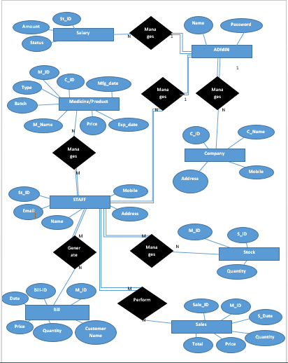

## **Logical Database Design:**

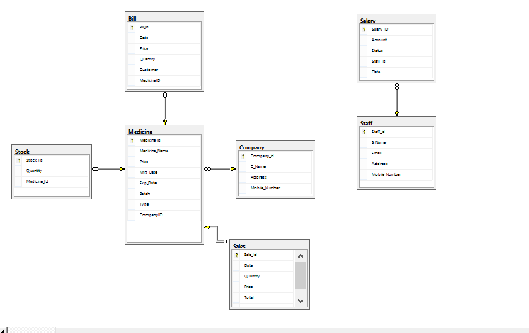

**List of Reports:**

In thisproject we will generate the following reports:

1. Staff Information report.
2. Staff salaries report.
3. Medicine name and ID information report.
4. Medicine name and company name report from which medicine belong.
5. Medicine name and price, type report.
6. Company name and ID report.
7. Stock information report.
8. Details of the inventory report.
9. Details of Sold product report.
10. Daily, weekly or monthly report of sales.

## **Technology to be used:**

* Core i3 with 4GB RAM
* Windows 7 or latest
* Chrome Browser
* Internet
* Visual Studio ASP.NET 2017
* .NET Framework 5.0/6.0
* Language C#
* Microsoft SQL Server Management Studio 2017