1. eNodes algorithms description
   1. Component Name [e.g. DieselClassObject]
      1. xMS overview
         1. Diagram

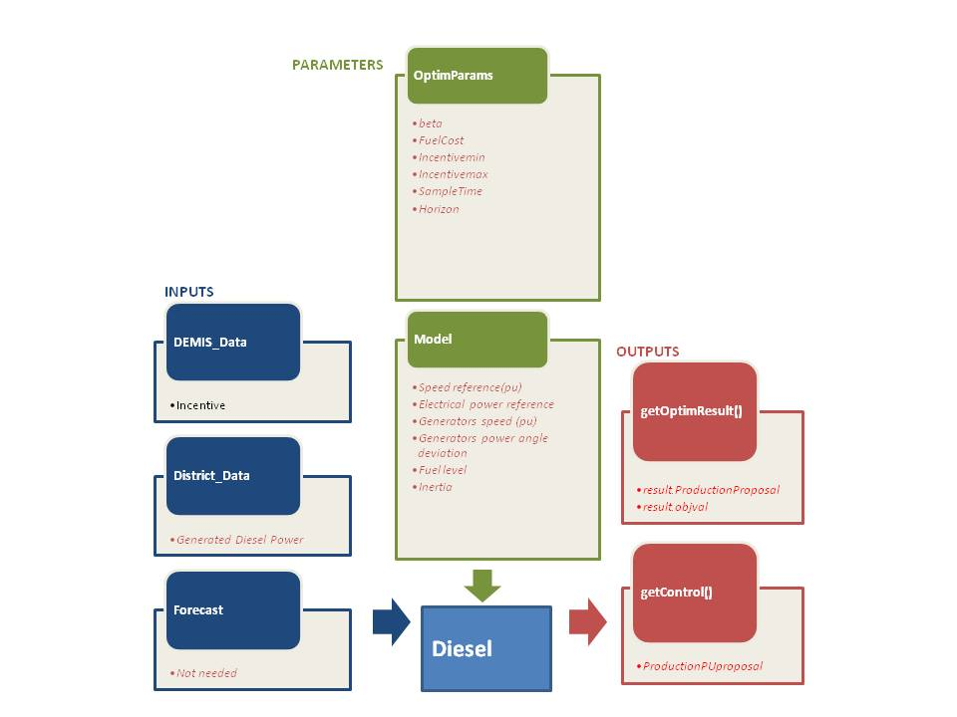

* + - 1. Details on inputs/outputs/parameters

|  |  |  |  |
| --- | --- | --- | --- |
|  | Name | Description | Unit |

|  |  |  |  |
| --- | --- | --- | --- |
| Inputs | |  |  |
| DEMIS_Data | * Incentive | For us it is a 96 values vector | -- |
| District_Data | * *Generated Power* | *Effective generated power (96 values vector)* | *W* |
|  |  |  |  |
|  |  |  |  |
|  |  |  |  |
| Forecast | * *Not Needed* |  |  |
|  |  |  |  |

|  |  |  |  |
| --- | --- | --- | --- |
| Outputs | |  |  |
| getOptimResult() | * result. ProductionProposal | Power profile over next horizon (96 15 min time slot power production proposal) | W |
|  |  |  |  |
|  |  |  |  |
|  |  |  |  |
| getControl() | * *ProductionPUproposal* | *Power setpoint sent to power stage in pu* | *pu* |
|  |  |  |  |

|  |  |  |  |  |  |
| --- | --- | --- | --- | --- | --- |
| Parameters | |  | | | |
| optimParameters | * IncentiveFactor.beta | Incentive Factor function’s sharpe parameter. | | | |
|  |  |  | | | |
|  | * IncentiveFactor.Incentivemin * IncentiveFactor.Incentivemax | Incentive Factor functions’ shape factors | | | |
|  | * *SampleTime* * *Lambda* * *deltaT* * *horizon* | Sample time for power production vector.  Ponderation factor for power production or consummation.  Battery Dynamical model simulation time step.  Optimization time horizon. | | | |
| Model |  |  | | | |
|  | * *Speed reference* * *Electrical power reference* * *Generators speed* * *Generators power angle deviation* * *Fuel level* * *Capacity Fuel-tank* * *Inertia (H)* * *Param.Eff.Ploss* * Angular speed (∆w) variation with respect to speed of operation * Mechanical speed of the rotor (wt) * Speed of the operation (wo) in p.u. * Mechanical torque (Tm) * Electrical torque (Te) * Damping factor (Kd) representing the effect of damper windings * Internal voltage (E) * Terminal voltage (Vnet) * Load angle (sigma) | | *rpm*  *Watts*  *rpm*  *Degrees*  *Litres*  *Litres*  *Watts* | | |
|  |  |  | |
|  |  |  | | |

* + 1. Optimization problem generation
       1. Incentive factor concept and the cost function analysis

The Incentive factor that depends on DEMIS_Data’s Incentive function. The incentive factor can be defined in the next equations:

$$fi =\frac{1}{1+e^{-\frac{Incentive}{beta}}}$$

$$q={Incentive}_{min}+\left({Incentive}_{max}-{Incentive}_{min}\right)fi$$

$$IncentiveFactor=\left\{\begin{matrix}q:if q≥0 \\ 0:else\end{matrix}\right.$$

The incentive function lets to DEMIS to modulate how much energy wants to capture depending on the PowerProposal.

* + - 1. Embedded component model

/*---------------------------------------------the info from ekaitz----------------------------------------*/

We have 2 set points the speed and the power. For the speed we will use next formula:

$$\dot{∆ω}= \frac{T_{m}-T_{e}-K_{d}*∆ω}{2*H}$$

The u talks about everything in accept the governator

$$T_{m}\left(t\right)+ T_{2}\frac{d\left(T_{m}\right)}{dt}=u \left(t-T\right)$$

$$u= K_{p}\left(ω^{*}-ω\right)+ \frac{k_{p}}{T_{i}}\int{\left(ω^{*}-ω\right) d(t)}$$

And final our second set point the power. We will set if with variable Te (electrical torque)

🡺 (in p.u.) Pe =Te * **w**

/*---------------------------------------------end of his info-----------------------------------------------*/

$DieselPower=\left\{\begin{aligned}f_{gen}\left(V\right): if\frac{1}{10} V_{CapacityFueltank}≤V_{FuelLevel} \\ 0:Else\end{aligned}\right.$ (eq.1)

${DieselPower}_{pu}=(\frac{DieselPower}{P_{nom}}- Inertia)*{Switch}_{on/off}$ (eq.2)

$p0=\frac{P_{loss}}{P_{nom}}*{Switch}_{on/off}$ (eq.3)

${DieselPowerProposal}_{theo}= \frac{DieselPower}{P_{nom}}-P_{loss}$

(eq.4)

${PowerProposal}_{theo}=min\left({DieselPowerProposal}_{theo}{,ProductionProposal}_{pu}{.P}_{nom}\right)$ (eq.5)

$PowerProposal=-min⁡({PowerProposal}_{theo},P_{max})$ (eq.6)

The Diesel Generator has been described following these steps:

1. The Electrical Power is calculated with DieselPower (equation 1).
2. Power losses are calculated in equation 2, even if we have a very little power loss on the Diesel Generator.
3. The estimated electrical performance is calculated in equation 3 as ${DieselPowerProposal}_{theo}$.
4. The Electrical Power Proposal is calculated from the minimum value between this Available Electrical Power and the Production Proposal in p.u. given by the incentive factor.

DieselPowerProposalpu is a fixed value of the power (p.u.) given by the generator. We can change this value later.

Switchon/off is a value used to control if the Generator is producing or not. If it is not, this value should be 0 and if it is, the value should be 1.

* + - 1. Limits

Assumptions:

We have proposed an incentive factor that lets to DEMIS to modulate how much energy needs from the Diesel Generator. This Incentive factor has several parameters that must be set before the optimization process. These parameters’ values can be optimized with Adaptive BackTracking Search Algorithm. We have supposed that the input incentive is between two limits.

* + 1. Optimization problem resolution

*The optimization algorithm calculates the electrical power that can be captured in each time slot. If needed, the Generator can be switched on/off depending of the production demand given by the optimization problem.*

*And after this step DEMIS incentive inputs can modulate this power production to adapt the power generation as it wants.*