1. eNodes algorithms description
   1. Component Name [e.g. PV Zigor]
      1. xMS overview
         1. Diagram

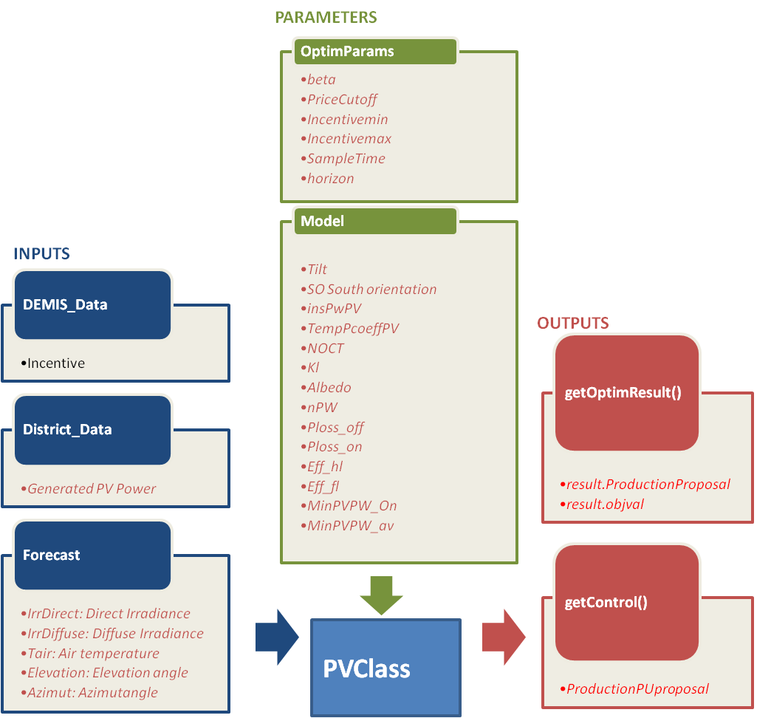

* + - 1. Details on inputs/outputs/parameters

|  |  |  |  |
| --- | --- | --- | --- |
|  | Name | Description | Unit |

|  |  |  |  |
| --- | --- | --- | --- |
| Inputs | |  |  |
| DEMIS\_Data | * Incentive | For us it is a 96 values vector | -- |
| District\_Data | * *Generated PV Power* | *Effective photovoltaic power (96 values vector)* | *W* |
|  |  |  |  |
|  |  |  |  |
|  |  |  |  |
| Forecast | * *IrrDirect* | *Direct irradiance for all time slots. (96 values vector)* | *W/m2* |
|  | * *IrrDiffuse* | *Diffuse irradiance for all time slots (96 values vector)* | *W/m2* |
|  | * *Tair* | *External air temperature* | *ºC* |
|  | * *Elevation angle* | *Elevation angle of the sun* | *º* |
|  | * *Azimut angle* | *Azimut angle of the sum* | *º* |

|  |  |  |  |
| --- | --- | --- | --- |
| Outputs | |  |  |
| getOptimResult() | * result. ProductionProposal | Power profile over next horizon (96 15 min time slot power production proposal) | W |
|  |  |  |  |
|  |  |  |  |
|  |  |  |  |
| getControl() | * *ProductionPUproposal* | *Power setpoint sent to the Photo Voltaic inverter in pu* | *pu* |
|  |  |  |  |

|  |  |  |  |  |  |  |
| --- | --- | --- | --- | --- | --- | --- |
| Parameters | |  | | | |  |
| optimParameters | * IncentiveFactor.beta | Incentive Factor function’s sharpe parameter | | | | -- |
|  | * IncentiveFactor.PriceCutoff | Incentive Factor function’s Price Cut off values at power production falls. | | | | -- |
|  | * IncentiveFactor.Incentivemin * IncentiveFactor.Incentivemax | Incentive Factor functions’ shape factors | | | | -- |
|  | * *SampleTime* * *Horizon* |  | | | | -- |
| Model |  |  | |  | | |
|  | * *DATA.tilt Angle of inclinaison of solar panels [°]* * *DATA.SO South orientation of solar panel [°]* * *DATA.insPwPV Installed PV power (at 1000 W/m2 and 25 °C) [W]* * *DATA.TempPcoeffPV Solar cells Power temperature coefficient [%/°C]* * *DATA.NOCT NOCT (Nominal operating Cell Temperature) @ Tair = 28°C, G = 800 W/m2 [°C]* * *DATA.Kl Factor for losses in the panel, shades and/or dust* * *DATA.AlbedoAlbedo (green grass surface example)* * *DATA.nPW Nominal Power of the inverter [W]* * *DATA.Ploss\_off Power losses when PV inverter stopped [W]* * *DATA.Ploss\_on Power losses when PV inverter generating Ppv=0 [W]* * *DATA.Eff\_hl Efficiency at 50% load [%]* * *DATA.Eff\_fl Efficiency at 100% load [%]* * *DATA.MinPVPW\_On Minimum PV power for production [W]* * *DATA.MinPVPW\_av Minimum PV power to have the inverter available for communication purposes with BMS [W]* | |  | |  | |

* + 1. Optimization problem generation
       1. Expression of cost function

Our cost function can be defined as follows:

We calculate the maximum power production that can be achieved in each time slot that PV cans capture. This maximum power proposal for each time slot is calculated changing the proposal power in pu from zero to one. In that way we obtain the maximum power that can be captured in each time slot.

$${MaxProductionProposal}_{pu}={Argmax}_{Subjec to:V_{wind}}\left(PowerProposal\right)$$

After we calculate the Incentive Factor that depends on DEMIS\_Data’s Incentive function. The incentive Factor can be defined in the next equation:

$$f=\frac{1}{1+e^{-\frac{Incentive-PriceCutoff}{beta}}}$$

$$q={Incentive}_{min}+\left({Incentive}_{max}-{Incentive}_{min}\right)f$$

$$IncentiveFactor=\left\{\begin{matrix}q:if q≥0 \\ 0:else\end{matrix}\right.$$

The incentive function lets to DEMIS to modulate how much energy wants to capture from this maximum power.

* + - 1. Embedded component model

The PV model is defined as follows:

The PV panel power is described as a function

* + - 1. Limits

Assumputions:

We haved supposed that each time slot is independent one from other, because the irradiace, and temperature change from one time slot to another time slot. We have proposed an incentive factor that lets to DEMIS to modulate how much energy needs from maximum power. This Incentive factor has several parameters that must to be set before the optimization process. This parameters’ values can be optimizated with Adaptive BackTracking Search Algorithm. We have supposed that the input incentive is between two limits.

* + 1. Optimization problem resolution

*The optimization algorithm first calculates the maximum power that can be captured in each time slot.*

*And after this step DEMIS incentive inputs can modulate this power production to adapt the power generation as it wants.*

* + 1. Algorithm results illustration

*It is the same algorithm as in Wind Turbine Optimization. Not implemented yet.*

*Incentive factor function plot with Price Cutoff=0.5, beta=0.1, Incentivemin=-0.1, Incentivemax=1;*

*IncentiveFactor.emf*

*Fig1*

*Incentive factor function plot with Price Cutoff=0.85, beta=0.1, Incentivemin=-0.1, Incentivemax=1;*

*IncentiveFactor0_85.emf*

*Fig2*

1. Conclusion

*To be completed [CEA]*