1. eNodes algorithms description
   1. Component Name [e.g. Wind Turbine]
      1. xMS overview
         1. Diagram

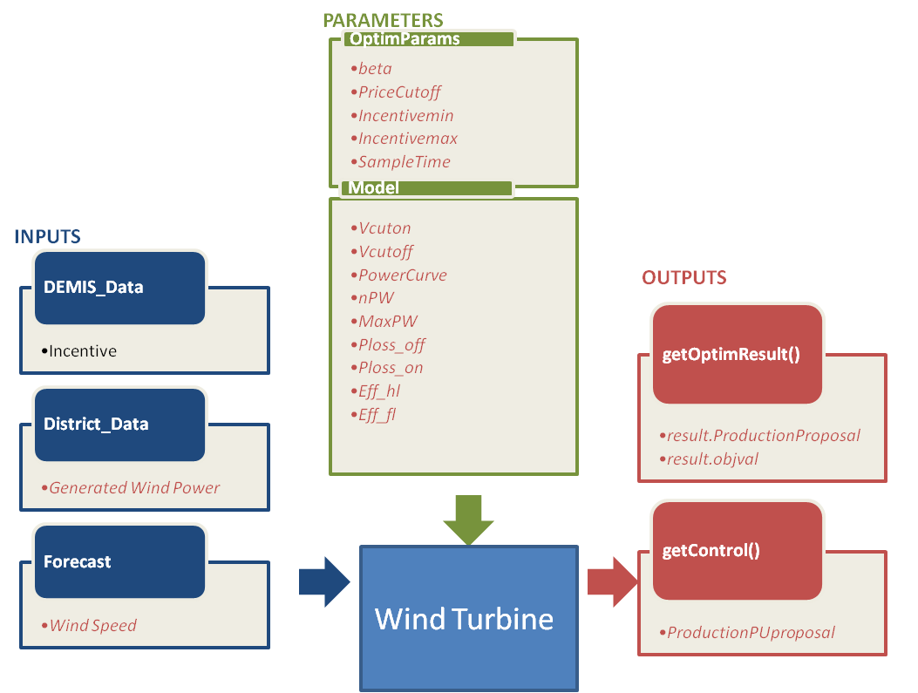

* + - 1. Details on inputs/outputs/parameters

|  |  |  |  |
| --- | --- | --- | --- |
|  | Name | Description | Unit |

|  |  |  |  |
| --- | --- | --- | --- |
| Inputs | |  |  |
| DEMIS\_Data | * Incentive | For us it is a 96 values vector | -- |
| District\_Data | * *Generated Wind Power* | *Effective wind turbine power (96 values vector)* | *W* |
|  |  |  |  |
|  |  |  |  |
|  |  |  |  |
| Forecast | * *Wind Speed* | *Wind Speed forecast for all time slots. (96 values vector)* | *m/seg* |
|  |  |  |  |

|  |  |  |  |
| --- | --- | --- | --- |
| Outputs | |  |  |
| getOptimResult() | * result. ProductionProposal | Power profile over next horizon (96 15 min time slot power production proposal) | W |
|  |  |  |  |
|  |  |  |  |
|  |  |  |  |
| getControl() | * *ProductionPUproposal* | *Power setpoint sent to the Wind Turbine in pu* | *pu* |
|  |  |  |  |

|  |  |  |  |  |  |
| --- | --- | --- | --- | --- | --- |
| Parameters | |  | | |  |
| optimParameters | * IncentiveFactor.beta | Incentive Factor function’s sharpe parameter | | | -- |
|  | * IncentiveFactor.PriceCutoff | Incentive Factor function’s Price Cut off values at Wind Turbine production falls. | | | -- |
|  | * IncentiveFactor.Incentivemin * IncentiveFactor.Incentivemax | Incentive Factor functions’ shape factors | | | -- |
|  |  |  | | | -- |
| Model | * *Param\_s.Vcuton Cut on Wind Turbine Speed* * *Param\_s.Vcutoff Cut off Wind Turbine Speed* | *m/seg* | *m/seg* | | |
|  | * *Param\_m.PowerCurve Wind Turbine vs speed in m/s* * *Param.nPW Wind Turbine’s Rated Power Watts* * *Param.MaxPW Wind Turbine’s Maximum Power Watts* * *Param.Eff.Ploss\_off Wind Turbine’s Power losses in off mode Watts* * *Param.Eff.Ploss\_on Wind Turbine’s Power losses in on mode Watts* * *Param.Eff.Eff\_hl Wind Turbine’s efficiency in half charge* * *Param.Eff.Eff\_fl Wind Turbine’s efficiency in full charge* | *Watts* | |  | |

* + 1. Optimization problem generation
       1. Expression of cost function

Our cost function can be defined as follows:

We calculate the maximum power production that can be achieved in each time slot that Wind Turbine cans capture with each Wind Speed. This maximum power proposal for each time slot is calculated changing the proposal power in pu from zero to one. In that way we obtain the maximum power that can be captured in each time slot.

$${MaxProductionProposal}_{pu}={Argmax}_{Subjec to:V_{wind}}\left(PowerProposal\right)$$

After we calculate the Incentive Factor that depends on DEMIS\_Data’s Incentive function. The incentive Factor can be defined in the next equation:

$$f=\frac{1}{1+e^{-\frac{Incentive-PriceCutoff}{beta}}}$$

$$q={Incentive}_{min}+\left({Incentive}_{max}-{Incentive}_{min}\right)f$$

$$IncentiveFactor=\left\{\begin{matrix}q:if q≥0 \\ 0:else\end{matrix}\right.$$

The incentive function lets to DEMIS to modulate how much energy wants to capture from this maximum power.

* + - 1. Embedded component model

$WindPower=\left\{\begin{aligned}f_{turbine}\left(V\right): if V_{cuton}≤V_{wind}≤V_{cutoff} \\ 0:Else\end{aligned}\right.$ (eq.1)

${WindPower}_{pu}=\frac{WindPower}{P_{nom}}$ (eq.2)

$p0=\frac{P_{loss,on}}{P_{nom}}$ (eq.3)

$a=\frac{200.{Eff}_{fl}-3.p0.{Eff}_{hl}.{Eff}_{fl}-100.{Eff}_{hl}-{Eff}_{hl}.{Eff}_{fl}}{{Eff}_{hl}.{Eff}_{fl}}$ (eq.4)

$b=\frac{200.\left({Eff}_{hl}-{Eff}_{fl}\right)+2.p0.{Eff}_{hl}.{Eff}_{fl}}{{Eff}_{hl}.{Eff}_{fl}}$ (eq.5)

$μ_{inverter}=\frac{{WindPower}_{pu}}{{{WindPower}_{pu}.\left(1+a\right)+p0+b.{\left({WindPower}_{pu}\right)}^{2}}_{}}$ (eq.6)

${WindPowerProposal}_{theo}=WindPower.\left(1-a\right)-\frac{WindPowerx^{2}}{b.P_{nom}}-P_{loss,on}$ (eq.7)

${PowerProposal}_{theo}=min\left({WindPowerProposal}_{theo}{,ProductionProposal}_{pu}{.P}_{nom}\right)$ (eq.8)

$PowerProposal=-min⁡({PowerProposal}_{theo},P_{max})$ (eq.9)

The Wind Turbine has been described following these steps:

1.-The Avaiable Wind Power is calculated before with equation 1.

2.-The Avaiable Electrical Power is calculated with Wind Power, and the estimated performance

(equations 2-7).

3.-The Electrical Power Proposal is calculated from the minimum value between this Avaiable Electrical Power and the Production Proposal in pu given by the incentive factor.

* + - 1. Limits

Assumputions:

We haved supposed that each time slot is independent one from other, because the wind speed changes from one time slot to another time slot. We have proposed an incentive factor that lets to DEMIS to modulate how much energy needs from maximum wind power. This Incentive factor has several parameters that must to be set before the optimization process. This parameters’ values can be optimizated with Adaptive BackTracking Search Algorithm. We have supposed that the input incentive is between two limits.

* + 1. Optimization problem resolution

*The optimization algorithm first calculates the maximum wind power that can be captured in each time slot.*

*And after this step DEMIS incentive inputs can modulate this power production to adapt the power generation as it wants.*

* + 1. Algorithm results illustration

*We show two optimization for two different incentive factor functions’ optimization results:*

*with Price Cutoff=0.5, beta=0.1, Incentivemin=-0.1, Incentivemax=1;*

*GraficasOptimizacion.emf*

*Fig1*

*Incentive factor function plot with Price Cutoff=0.5, beta=0.1, Incentivemin=-0.1, Incentivemax=1;*

*IncentiveFactor.emf*

*Fig2*

*We show the last optimization results with Price Cutoff=0.85, beta=0.1, Incentivemin=-0.1, Incentivemax=1;*

*GraficasOptimizacion0_85.emf*

*Fig3*

*IncentiveFactor0_85.emf*

*Fig4*

*As the incentive factor function’s price cutoff is higher, the diference between the PowerProposals and the ${WindPowerProposal}_{theo}$ is bigger (See Fig1 and Fig3, difference in red and in blue).The difference between the prince cutoff in incentive factor functions can be shown clearly in Fig4 an fig2.*

1. Conclusion