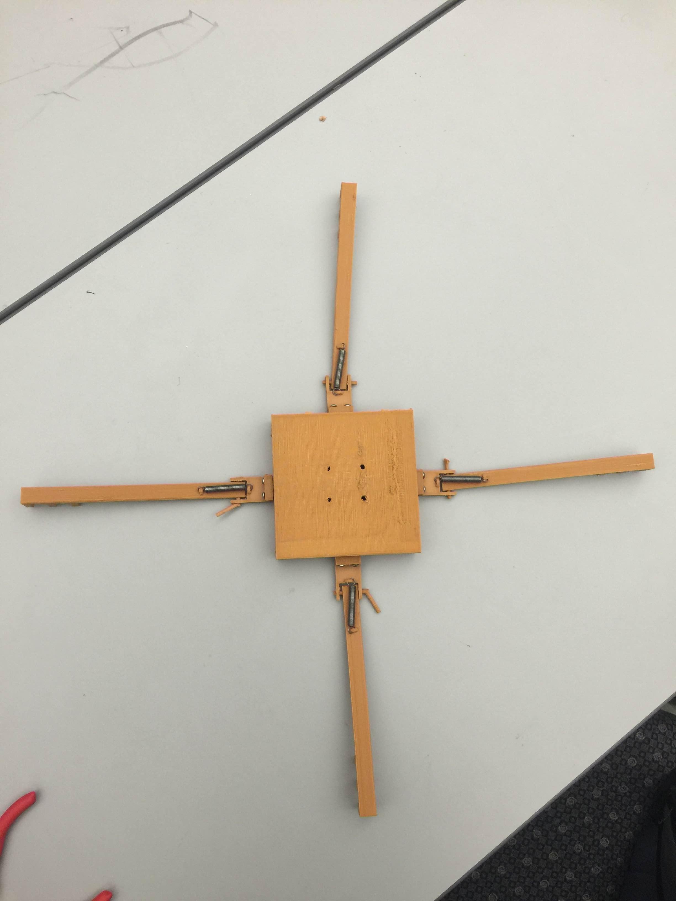

Hollow Box

Shaft

Hanger

Claw

Channel

This mechanism is designed to be controlled by an actuator (it will work with the actuator we already have assuming it has enough power to bend the springs).

How it works

1. Mount the actuator in the hollow box
2. Connect 4 strings each from a channel and through both sides of the hanger, to the tip of the actuator (i.e. the tip of the small rod in the actuator that shoots out when the actuator is turned on, and is retracted when the actuator is turned off).
3. When the actuator is turned on, it bends the claws by pulling on the strings; When turned off, it relaxes the strings and the claws return to their original positions. The return of the claws to their original position is facilitated by the springs.

Note: There is need to design better shafts to connect the claws and the hangers. The ones we have now were gotten off random printed parts. The idea is to glue the shafts to the side of the hanger so they don’t come off during flight, but the claw should still be able to rotate about the shaft. Printing the shaft should not take more than 20 minutes for all four shafts.