Can You Say that Again?
A Real-World API and Data Exercise

At this point, you are familiar with both the Java API and the Karel API. The Java API is the set of classes that are included with the Java Development Environment. The Karel API included all the classes needed to work in the Karel environment.

So, what’s an API anyway?
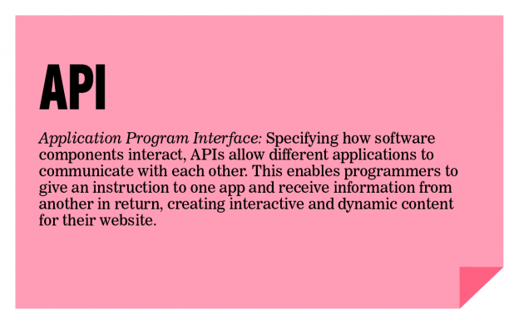
Read more about APIs and why they are so useful at: http://readwrite.com/2013/09/19/api-defined.

We are going to use an API which allows us to interact with Twitter. With just a few lines of code, we can access our personal tweets as well as the public tweets of others. And we can do much more!

Part I

You will access the last 200 tweets of a person’s twitter handle (this can be your own, someone you know, or a public figure) and determine the most common word they use. To do this, you will need to interact with a Twitter API, grab the 200 tweets, store individual words in a data structure of your choice, and then write an algorithm to determine the most common term. Note: since it would not be interesting to count “the”, “a”, or “and”, you need to remove those too-common words. Fortunately, we put those too-common words in the file commonWords.txt . Remove those too-common words from the tweeter's list of words before determining the tweeter's most commonly used word.

We decided to use the Twitter4j API which can be found at http://twitter4j.org. Click on JavaDoc.

Let’s get started. Copy the Twitter-students folder from the R: drive.

In the folder, you will notice a lib folder containing a twitter4j-core-4.0.2.jar file. You will need to set the classpath in JGrasp to lib\twitter4j-core-4.0.2.jar

Also, you should notice a twitter4jproperties file. That file holds the credentials in order for you to access Twitter data. At this point, you have been granted read-only access to Twitter. In the 2nd part of the assignment, you will may change the values if you want to interact with your own Twitter feed.

Let’s study the first part of the Twitter_shell.java program.

2 import twitter4j.*; //set the classpath to: lib\twitter4j-core-4.0.2.jar
3 import java.util.List;
4 import java.io.*;
5 import java.util.ArrayList;
6 import java.util.Scanner;
7
8 public class Twitter_shell
9 {
10 public static void main (String []args) throws TwitterException, IOException
11 {
12 // Remembers the standard output location (the screen)
13 PrintStream stnd_out = System.out;
14
15 // Make an instance of Twitter - this is re-useable and thread safe.
16 Twitter twitter = TwitterFactory.getSingleton(); //connects to Twitter
17
18 //Ask for Twitter handle
19 Scanner scan = new Scanner(System.in);
20 System.out.print("Please enter a Twitter handle (without the @ symbol, type done to quit) --> ");
21 String handle = scan.next();
22 while (!handle.equals("done"))
23 {
24 System.setOut(new PrintStream(new FileOutputStream("garbageOutput.txt")));
25
26 Paging page = new Paging(1,200); // Accesses last 200 tweets
27 int p = 1;
28 List<Status> tweets = new ArrayList<Status>();
29 while (p < 10) // Can only access 20 per page I think
30 {
31 p++;
32 page.setPage(p);
33 tweets.addAll(twitter.getUserTimeline(handle,page)); //get tweets
34 }
35
On line 2, notice the import statement. To avoid an error, make sure you set the classpath.

Line 16 makes an instance of Twitter, authenticates the credentials, and opens the connection between your program and Twitter’s database.

The Twitter feed sends lots of connection data back and forth. We don't want that data to be a part of the tweet data. So Line 24 sends that data to a file. Later, on Line 65, we want to print to the screen, so we set the output to the screen with the line System.setOut(stnd_out);

Line 26 sets the number of tweets you want to receive. The maximum was 200 the last time we checked.

Line 33 gets the tweets from a user’s timeline.

And that’s it! Just a few lines of code and you were able to open the connection to Twitter to receive data into your program.
Now it’s your turn. Once you have all the tweets in a list, you need to determine the most common word. For consistency sake, we created a list of too-common words you should remove from your collection of individual words. We also recommend removing any words starting with the @ symbol since that’s not always interesting. You might find yourself wanting to do things like remove punctuation and sort words. You’ve done that before in other programs. Don’t recreate that code, go grab it and reuse!

Sample run

Please enter a Twitter handle (without the @ symbol, type done to quit) --> RyanLMcElveen
Count = 140 in 200 tweets.
The most common word from @RyanLMcElveen is: #FCPS

Enter Twitter handle, (without the @ symbol, type done to quit) --> TaylorSwift13
Count = 116 in 200 tweets.
The most common word from @TaylorSwift13 is: tonight
Enter Twitter handle, (without the @ symbol, type done to quit) --> KingJames
Count = 127 in 200 tweets.
The most common word from @KingJames is: #StriveForGreatness
Enter Twitter handle, (without the @ symbol, type done to quit) --> done
Part II

Team up with a partner and brainstorm something interesting you can do with Twitter. You have the JavaDocs as a resource (http://twitter4j.org/oldjavadocs/4.0.2/index.html) and you can find some sample code at http://twitter4j.org/en/code-examples.html.

The JavaDocs can be overwhelming. You should think about what you might wish to do first. Here are some ideas:

- Filter your home timeline (these are all the tweets from people you follow) to avoid a particular term. For instance, if you are an Android fan, you could filter out all tweets with Apple in them.
- Count the number of tweets originating from your zip code that contain the word "flu".
- Send tweets every 10 minutes to your friend on his/her birthday. Use a timer, of course.

If you don’t have your own Twitter account, you can continue to work with public feeds.

If you have your own Twitter account (or you make one for this assignment), you will need to authenticate your account by changing the data in the properties file. This must be done if you wish to send tweets from your account.

- Visit http://apps.twitter.com and sign in with your Twitter account.
- Select Create New App.
- Fill in the first three fields of Application Details.
  - Name: APCS Twitter Project
  - Description: Learning to Work with APIs
  - Website: http://www.tjhsst.edu
- Agree to the Developer Agreement.
- Under My Applications → Modify app permissions → Select Read and write
- After your application is created, go to the Settings tab and ensure the access is set to your application.

- Retrieve the four keys you will need for the properties file
- Go to My Applications
- Click on the application you made
- API key → manage API keys
- Click on generate my access token
- Get the four keys you need. Note: the Consumer Key is the API key and the ConsumerSecret is the APISecret. Update the properties file in your folder with your specific data.
oauth.consumerKey=
oauth.consumerSecret=
oauth.accessToken=
oauth.accessTokenSecret=
- Now try this code from your program to see if it works with your new Twitter account!
twitter.updateStatus("I just tweeted from my Java program! #APCSRocks @TJColonials");

