Rushi Shah

Gabor P 3

4/19/16

Path distance: 1567897.0824796238

Method: Shuffled, generated children, took best and repeated for each generation

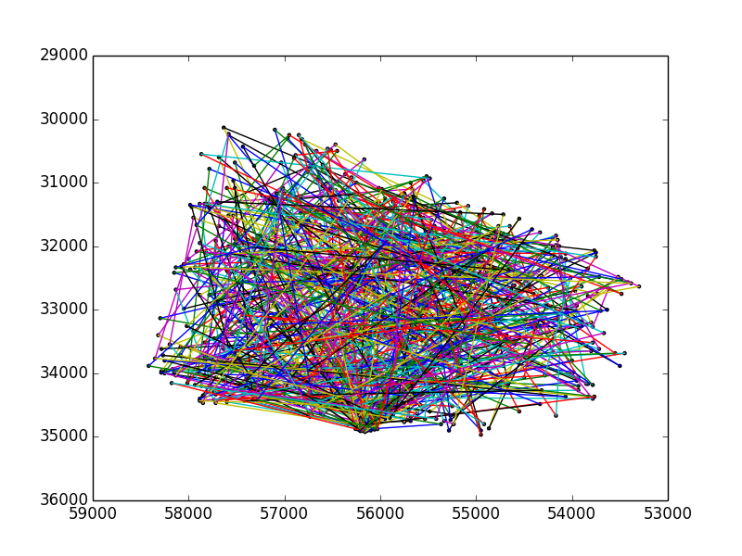

Path taken:

[511, 555, 80, 321, 351, 52, 689, 658, 376, 211, 620, 270, 277, 522, 348, 545, 297, 319, 732, 437, 557, 472, 450, 41, 576, 48, 12, 50, 542, 224, 415, 629, 317, 388, 283, 441, 646, 307, 285, 491, 359, 460, 550, 426, 201, 611, 543, 286, 378, 124, 206, 316, 342, 235, 148, 106, 133, 386, 183, 381, 265, 252, 497, 94, 250, 284, 185, 664, 214, 720, 121, 560, 679, 411, 604, 504, 436, 57, 505, 502, 215, 22, 549, 2, 309, 310, 324, 56, 47, 513, 708, 272, 66, 19, 245, 382, 117, 418, 350, 352, 404, 105, 326, 699, 729, 503, 234, 333, 468, 181, 552, 346, 676, 420, 481, 236, 519, 680, 219, 5, 78, 406, 385, 225, 74, 446, 77, 10, 327, 123, 173, 119, 476, 715, 462, 630, 62, 189, 514, 258, 445, 135, 72, 184, 261, 180, 114, 253, 255, 492, 734, 712, 158, 65, 580, 51, 171, 602, 494, 532, 160, 726, 25, 169, 463, 266, 530, 535, 217, 58, 137, 722, 28, 395, 510, 73, 358, 625, 714, 527, 464, 612, 353, 392, 453, 208, 459, 661, 672, 684, 188, 313, 622, 663, 356, 39, 244, 375, 44, 717, 677, 361, 31, 161, 128, 733, 698, 303, 323, 146, 638, 37, 695, 633, 394, 402, 685, 109, 454, 610, 177, 694, 367, 627, 719, 665, 40, 49, 678, 438, 1, 659, 697, 11, 15, 368, 597, 125, 566, 435, 609, 115, 539, 168, 18, 655, 537, 343, 538, 79, 75, 660, 344, 176, 565, 573, 434, 263, 192, 641, 493, 212, 713, 642, 287, 584, 721, 331, 271, 90, 218, 20, 644, 448, 156, 681, 35, 332, 157, 150, 16, 209, 99, 291, 82, 423, 36, 53, 487, 588, 608, 248, 409, 393, 337, 70, 564, 669, 231, 628, 23, 134, 561, 431, 615, 298, 670, 172, 247, 632, 495, 300, 645, 377, 401, 474, 243, 595, 397, 606, 390, 428, 657, 506, 280, 515, 596, 728, 371, 605, 607, 154, 196, 329, 34, 98, 262, 489, 449, 556, 198, 582, 275, 164, 282, 264, 194, 97, 147, 151, 33, 508, 696, 521, 452, 178, 254, 652, 398, 345, 289, 67, 24, 111, 554, 193, 594, 693, 688, 179, 440, 578, 302, 558, 701, 593, 624, 132, 276, 603, 95, 149, 229, 636, 86, 305, 155, 384, 465, 651, 138, 488, 129, 116, 6, 195, 222, 656, 417, 421, 623, 292, 533, 702, 89, 92, 587, 69, 251, 233, 667, 724, 108, 634, 618, 432, 673, 365, 71, 102, 469, 330, 101, 103, 238, 380, 27, 711, 704, 32, 408, 574, 456, 349, 334, 104, 355, 563, 113, 544, 473, 575, 145, 87, 55, 617, 260, 683, 363, 391, 531, 569, 512, 190, 517, 314, 213, 174, 614, 429, 716, 412, 42, 451, 83, 598, 242, 274, 373, 322, 118, 45, 648, 175, 405, 200, 85, 166, 278, 227, 112, 26, 122, 136, 210, 499, 131, 59, 226, 654, 433, 592, 336, 256, 501, 30, 186, 13, 304, 583, 579, 204, 318, 540, 687, 635, 548, 165, 301, 308, 691, 110, 241, 407, 523, 203, 690, 223, 294, 637, 126, 170, 341, 306, 709, 379, 700, 4, 577, 458, 416, 718, 470, 674, 96, 419, 230, 3, 141, 590, 268, 163, 91, 572, 325, 647, 509, 457, 339, 311, 372, 626, 127, 601, 682, 335, 727, 484, 38, 354, 518, 167, 315, 485, 467, 81, 7, 486, 88, 152, 442, 144, 259, 410, 68, 546, 547, 366, 396, 374, 414, 525, 703, 475, 725, 9, 281, 320, 586, 567, 29, 443, 8, 187, 498, 63, 553, 524, 707, 425, 290, 387, 269, 422, 705, 447, 221, 76, 466, 507, 293, 312, 477, 369, 675, 723, 364, 570, 220, 296, 427, 471, 340, 500, 650, 228, 581, 130, 299, 362, 60, 120, 591, 360, 93, 246, 479, 159, 444, 107, 562, 64, 61, 731, 14, 153, 139, 216, 692, 455, 534, 571, 706, 197, 143, 613, 551, 568, 478, 490, 526, 686, 559, 541, 84, 399, 383, 461, 516, 520, 710, 357, 202, 640, 400, 370, 140, 257, 529, 639, 207, 240, 621, 424, 249, 338, 616, 237, 439, 328, 239, 232, 619, 43, 413, 54, 536, 599, 100, 668, 267, 273, 191, 182, 162, 17, 142, 643, 653, 600, 347, 589, 528, 671, 496, 482, 21, 205, 662, 295, 631, 46, 585, 649, 483, 666, 389, 288, 480, 730, 403, 430, 199, 279]