­­Method: Randomly shuffled 349 times, untangled each, and took best path from results

Distance: 85876.047

Map:

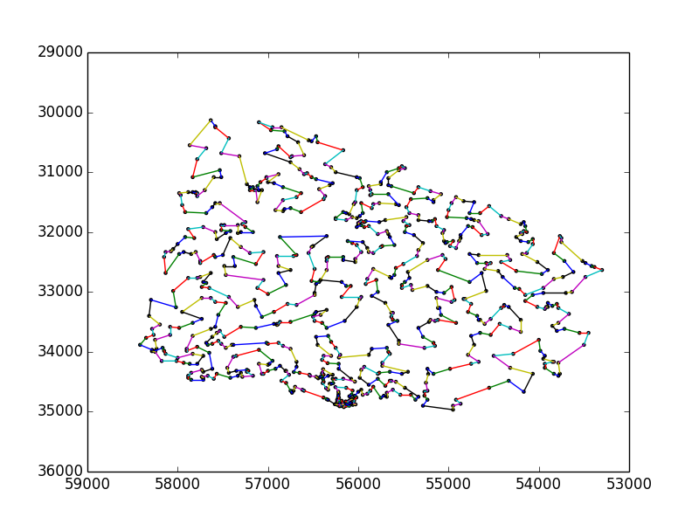

Path:

[1, 3, 6, 11, 22, 25, 58, 68, 67, 76, 75, 74, 105, 72, 73, 63, 54, 50, 44, 41, 53, 56, 66, 83, 95, 100, 123, 124, 121, 120, 126, 98, 92, 69, 60, 55, 51, 43, 39, 40, 34, 28, 21, 19, 17, 26, 24, 23, 15, 10, 8, 7, 2, 5, 4, 12, 13, 9, 14, 20, 29, 31, 38, 42, 49, 65, 71, 104, 113, 134, 132, 125, 143, 147, 151, 140, 142, 137, 131, 108, 119, 112, 107, 111, 114, 88, 89, 90, 70, 62, 57, 52, 37, 33, 30, 32, 35, 48, 59, 61, 82, 64, 78, 87, 99, 103, 96, 97, 117, 130, 135, 149, 154, 153, 146, 174, 183, 194, 219, 225, 223, 218, 232, 238, 217, 211, 202, 173, 177, 201, 198, 152, 148, 145, 141, 138, 122, 106, 94, 101, 102, 129, 128, 116, 136, 144, 164, 158, 172, 188, 185, 193, 197, 206, 216, 222, 214, 228, 250, 254, 282, 303, 315, 307, 283, 275, 258, 259, 255, 288, 287, 286, 290, 299, 308, 320, 350, 354, 367, 349, 327, 319, 309, 279, 249, 204, 210, 221, 278, 285, 293, 297, 302, 318, 358, 361, 362, 366, 382, 398, 407, 397, 396, 385, 393, 388, 403, 415, 440, 452, 464, 461, 468, 467, 495, 549, 593, 608, 594, 565, 553, 546, 545, 540, 531, 516, 482, 524, 532, 566, 595, 667, 634, 652, 692, 712, 723, 734, 724, 693, 679, 668, 661, 641, 603, 569, 596, 568, 554, 547, 528, 496, 474, 469, 471, 444, 456, 466, 427, 399, 391, 394, 404, 425, 445, 428, 429, 420, 409, 389, 377, 376, 356, 311, 333, 304, 273, 260, 276, 310, 323, 334, 342, 351, 341, 355, 344, 359, 363, 347, 380, 383, 373, 406, 405, 417, 441, 430, 433, 431, 437, 457, 477, 487, 502, 505, 491, 484, 450, 434, 432, 423, 413, 414, 386, 369, 360, 329, 339, 328, 300, 321, 324, 316, 298, 291, 264, 241, 226, 203, 189, 175, 166, 155, 139, 150, 159, 156, 160, 157, 161, 163, 168, 179, 167, 178, 176, 200, 186, 199, 207, 230, 233, 235, 251, 243, 239, 224, 220, 227, 231, 244, 274, 284, 277, 267, 268, 272, 280, 305, 330, 335, 346, 345, 371, 370, 378, 400, 435, 458, 442, 436, 422, 418, 408, 410, 416, 438, 439, 448, 451, 446, 447, 459, 453, 479, 465, 470, 480, 490, 500, 494, 485, 493, 508, 499, 498, 489, 492, 488, 503, 511, 548, 564, 586, 588, 604, 610, 616, 624, 619, 615, 606, 599, 592, 573, 605, 609, 631, 640, 643, 655, 658, 646, 645, 644, 629, 628, 627, 638, 625, 570, 555, 552, 541, 534, 533, 497, 478, 475, 486, 507, 530, 538, 529, 510, 506, 521, 525, 550, 561, 582, 597, 583, 587, 598, 563, 574, 620, 647, 626, 648, 636, 635, 639, 653, 683, 694, 675, 676, 656, 670, 684, 680, 689, 649, 662, 673, 677, 657, 669, 681, 686, 699, 711, 716, 722, 706, 707, 702, 703, 700, 698, 690, 682, 674, 660, 654, 651, 666, 672, 678, 685, 688, 695, 696, 705, 709, 708, 704, 701, 710, 713, 718, 717, 714, 725, 726, 727, 732, 733, 729, 728, 730, 731, 719, 720, 721, 715, 697, 691, 687, 663, 659, 650, 664, 671, 665, 642, 637, 607, 577, 581, 562, 571, 578, 600, 601, 557, 560, 556, 542, 514, 535, 537, 567, 590, 580, 575, 579, 584, 611, 617, 589, 612, 621, 602, 630, 613, 618, 622, 632, 633, 623, 614, 591, 576, 585, 572, 523, 504, 517, 512, 476, 462, 454, 419, 387, 384, 374, 375, 412, 426, 443, 460, 455, 472, 483, 513, 519, 509, 518, 527, 539, 526, 536, 558, 559, 551, 543, 544, 522, 520, 515, 501, 481, 473, 463, 449, 421, 379, 402, 357, 326, 325, 322, 313, 337, 338, 348, 353, 372, 401, 381, 395, 424, 411, 390, 392, 368, 364, 340, 336, 332, 301, 252, 236, 234, 205, 208, 261, 265, 266, 294, 306, 312, 343, 365, 352, 331, 317, 296, 295, 269, 292, 245, 253, 237, 212, 262, 270, 263, 289, 281, 246, 256, 247, 257, 314, 271, 248, 242, 240, 229, 209, 213, 182, 181, 192, 215, 196, 187, 184, 171, 170, 169, 195, 191, 190, 180, 165, 162, 109, 110, 118, 133, 127, 115, 91, 86, 81, 80, 79, 85, 84, 93, 77, 46, 45, 36, 47, 27, 18, 16]