**Uruguay Submission**

Distance Traveled: 87001.197

Time: 0m19.902s

Map:

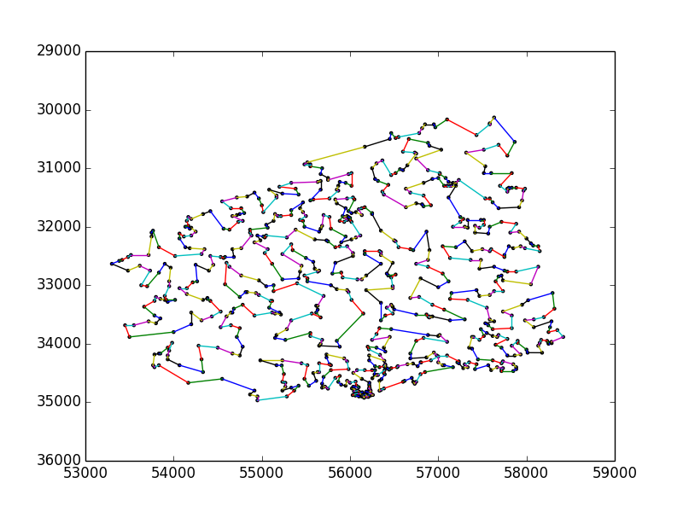

(Path taken on next page)

Path taken:

[1, 16, 27, 18, 22, 25, 36, 45, 46, 47, 77, 93, 84, 85, 79, 80, 81, 86, 91, 115, 127, 133, 118, 110, 109, 58, 68, 67, 63, 54, 50, 44, 41, 28, 21, 19, 17, 15, 23, 24, 26, 34, 40, 39, 43, 51, 29, 31, 38, 55, 60, 69, 92, 98, 126, 120, 121, 124, 123, 100, 95, 83, 66, 56, 53, 72, 73, 74, 75, 76, 105, 162, 165, 180, 190, 191, 195, 169, 170, 171, 184, 196, 187, 212, 215, 192, 181, 182, 213, 209, 229, 240, 242, 248, 271, 257, 247, 256, 246, 281, 289, 263, 270, 262, 269, 237, 253, 245, 292, 295, 296, 317, 313, 322, 325, 326, 314, 357, 348, 337, 338, 353, 375, 374, 384, 387, 372, 381, 395, 401, 419, 454, 462, 465, 470, 480, 476, 443, 426, 412, 402, 379, 421, 449, 455, 460, 472, 463, 473, 483, 481, 501, 515, 520, 522, 519, 513, 509, 518, 527, 544, 543, 539, 517, 512, 526, 551, 559, 558, 536, 523, 504, 490, 500, 494, 485, 479, 493, 508, 499, 498, 535, 537, 567, 572, 585, 576, 591, 614, 623, 633, 632, 622, 618, 613, 630, 602, 621, 590, 580, 589, 612, 617, 584, 579, 575, 557, 556, 542, 562, 564, 548, 511, 503, 514, 489, 492, 488, 478, 475, 486, 507, 497, 534, 541, 533, 530, 538, 552, 573, 555, 570, 605, 609, 606, 592, 599, 615, 619, 624, 616, 610, 604, 588, 586, 607, 577, 581, 571, 560, 578, 600, 601, 611, 637, 642, 665, 671, 664, 650, 659, 663, 687, 691, 697, 658, 655, 643, 640, 631, 646, 645, 651, 644, 629, 628, 627, 625, 638, 654, 666, 672, 678, 685, 688, 696, 695, 701, 704, 705, 708, 709, 715, 721, 720, 719, 731, 730, 728, 718, 710, 713, 717, 729, 733, 732, 727, 726, 725, 722, 716, 711, 706, 707, 714, 702, 703, 700, 698, 699, 690, 686, 681, 682, 674, 660, 669, 657, 677, 673, 662, 647, 649, 689, 680, 684, 670, 648, 626, 620, 574, 563, 550, 561, 587, 598, 583, 636, 635, 639, 656, 676, 653, 597, 582, 569, 568, 596, 603, 641, 661, 668, 679, 693, 683, 675, 694, 724, 734, 723, 712, 692, 652, 667, 594, 608, 593, 549, 545, 546, 531, 516, 540, 553, 565, 595, 634, 566, 524, 532, 547, 554, 528, 496, 474, 469, 471, 445, 428, 429, 420, 409, 441, 430, 433, 437, 431, 417, 406, 405, 383, 380, 377, 376, 389, 356, 299, 311, 333, 347, 363, 359, 373, 355, 386, 414, 413, 423, 432, 450, 434, 457, 477, 487, 502, 505, 484, 491, 506, 521, 525, 529, 510, 435, 400, 378, 370, 369, 360, 351, 342, 334, 324, 321, 316, 298, 291, 264, 241, 276, 310, 323, 341, 344, 304, 273, 260, 238, 232, 218, 223, 225, 219, 226, 203, 230, 233, 235, 251, 243, 244, 274, 284, 300, 329, 328, 339, 345, 346, 335, 305, 277, 267, 268, 272, 280, 301, 330, 336, 332, 340, 364, 368, 371, 408, 458, 442, 436, 418, 410, 416, 422, 438, 439, 448, 451, 446, 447, 459, 453, 424, 411, 390, 392, 343, 365, 352, 331, 312, 306, 294, 266, 208, 265, 261, 252, 236, 234, 205, 147, 143, 125, 132, 134, 151, 140, 142, 137, 113, 104, 108, 112, 119, 131, 156, 176, 178, 167, 160, 157, 161, 163, 168, 179, 220, 227, 231, 239, 224, 200, 159, 150, 186, 199, 207, 189, 175, 166, 155, 139, 130, 117, 135, 149, 154, 153, 146, 174, 183, 194, 202, 211, 217, 255, 259, 288, 287, 290, 286, 283, 308, 320, 307, 350, 354, 367, 366, 382, 399, 391, 394, 404, 425, 444, 456, 427, 466, 482, 495, 467, 468, 461, 464, 452, 440, 415, 403, 388, 393, 396, 407, 398, 397, 385, 362, 349, 315, 303, 327, 361, 358, 319, 309, 318, 302, 297, 293, 285, 278, 279, 221, 210, 204, 249, 282, 275, 258, 254, 250, 228, 214, 222, 216, 206, 193, 197, 188, 185, 172, 158, 164, 144, 136, 198, 201, 177, 173, 152, 148, 145, 141, 129, 128, 116, 102, 101, 94, 106, 122, 138, 103, 99, 87, 96, 97, 82, 78, 64, 61, 59, 88, 114, 111, 107, 90, 89, 70, 62, 65, 71, 42, 49, 57, 52, 48, 37, 35, 33, 32, 30, 20, 14, 9, 13, 12, 10, 8, 4, 5, 7, 2, 11, 6, 3]