Circular, Doubly Linked Lists
The DLL class

Of all the species of linked lists, the circular, doubly linked list with a dummy head node is the most powerful. In this lab we make such a class and implement selected methods in Java's List interface and its LinkedList class. We will use Object, not <E>.
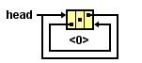
You are given the code for the DLNode class. It has one private field for an object, a prev pointer, and a next pointer. In the default constructor, the prev and the next both point to this.

The DLL class has a private field for a DLNode. This DLNode is a dummy head node, meaning that it is always present, does not store data, and whose only purpose is to simplify the insertion and deletion operations; specifically, one item of data is no longer a special case. Notice the dummy head in the DLL object named myList below.

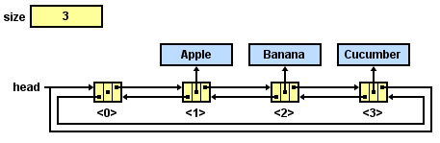
myList

Given this data structure, implement the methods as specified below. Also write a toString method, so that the list can print itself. For example, System.out.println(myList) produces [Apple, Banana, Cucumber]

As you write each method, test it in a driver class to see that it actually works. If you are using JGrasp, setting a breakpoint and stepping through the action can be quite instructive.

interface java.util.List<E>
- int size()
- boolean add(E obj) // appends obj to end of list; returns true
- void add(int index, E obj) // inserts obj at position index (0 <= index <= size)
// moving elements at position index and higher
// to the right (adds 1 to their indices); adjusts size
- E get(int index)
- E set(int index, E obj) // replaces the element at index with obj
// returns the element formerly at index
- E remove(int index) // removes element from position index, moving
// elements at position index + 1 and higher to the
// left (subtracts 1 from their indices) and adjusts
// size; returns the element formerly at index
boolean contains(E obj)
String toString()

class java.util.LinkedList<E> implements java.util.List<E>
Methods in addition to the List methods:
- void addFirst(E obj)
- void addLast(E obj)
- E getFirst()
- E getLast()
- E removeFirst()
- E removeLast()

//classwork: write some code before going to the computers
public class DLL //DoubleLinkedList
{
private int size;
private DLNode head = new DLNode(); //dummy node--very useful
public int size()
{
}
/* inserts obj at position index. increments size. */
public void add(int index, Object obj)
{

}
/* appends obj to end of list; increases size;
@return true */
public boolean add(Object obj)
{

}
/* return obj at position index. */
public Object get(int index)
{

}
/* inserts obj at front of list; increases size; */
public void addFirst(Object obj)
{
}
public Object removeLast()
{

}
public String toString()
{

}
//lots more methods in the List Interface

