REQUIRED FOR EVERYONE:

1. Uncover the basic facts: Name, location, architect, and date of construction
   1. Name: Jawahar Kala Kendra
   2. Location: Jaipur, Rajasthan, India
   3. Architect: Charles Correa
   4. Date of construction: 1986 – 1992
   5. <http://www.charlescorrea.net/>
2. Identify the purpose, program, and users of the building
   1. The Jawahar Kala Kendra was built as an “international art and culture center” for Rajasthani heritage [1]. It caters to indigenous folk singers, dancers, art- connoisseurs / scholars, artists / artisans, and tourists.
   2. <http://jawaharkalakendra.rajasthan.gov.in/SitePages/introduction.aspx>
3. Find at least two (2) plans, sections, or other architectural drawings of the building.
   1. <http://www.archinomy.com/sites/default/files/case-studies/2011/jawahar-kala-kenda-plan.jpg>
      1. <http://www.archinomy.com/case-studies/1867/jawahar-kala-kendra-jaipur-india>
   2. <http://jawaharkalakendra.rajasthan.gov.in/images/map_s.jpg>
      1. <http://jawaharkalakendra.rajasthan.gov.in/SitePages/introduction_next.aspx>
   3. <http://archinomy.com/sites/default/files/case-studies/2011/jawahar-kala-kenda-sketch-entrance.jpg>
      1. <http://archinomy.com/case-studies/1867/jawahar-kala-kendra-jaipur-india>
4. Find at least two (2) photographs of the exterior of the building. Include titles and captions on something noteworthy. Label the building materials on one of the photographs
   1. <http://jawaharkalakendra.rajasthan.gov.in/images/jkk-about.jpg>
      1. Dome of JKK: entrance someone sees as they approach the building. As they enter they will see the interior of dome painted with Rajasthani artwork
   2. <https://www.flickr.com/photos/panovscott/6543093939/in/photolist-aYc4St-aYc7fa-aYc7kx-aYc68p-aYc6JM-aYc5pn>
      1. Exterior Façade of JKK: imposing classic red granite wall gives sense of solidity mixed with the greenery growing over it

TODO 5 and 6

PLEASE COMPLETE AT LEAST SEVEN (7) OF THE FOLLOWING TASKS:

1. Find at least one (1) photograph of the interior of the building. Include a title and caption on something noteworthy
   1. <http://images.adsttc.com/media/images/5193/c3a2/b3fc/4bc9/6a00/00f2/large_jpg/Jawahar_Kala_Kendra_2.jpg?1368638357>
      1. <http://www.archdaily.com/373265/charles-correa-india-s-greatest-architect/5193c3a2b3fc4bc96a0000f2-charles-correa-india-s-greatest-architect-photo>
   2. Central Courtyard of JKK: note the red stone coloring/texture which is reminiscent of historical Jaipur building materials
2. Find a Flickr photo cache of the building and comment on meaningful details that catch your eye.
   1. <https://www.flickr.com/search/?sort=date-taken-desc&safe_search=1&tags=jawaharkalakendra&user_id=63751593%40N03&view_all=1>
      1. The red granite facades are reminiscent of traditional Indian architecture. The stone helps keep the atmosphere cool. The hard lines and geometric forms are indicative of the grid layout of the entire building.
3. Find a written or recorded interview about this building with the architect, an owner, or a user.
   1. <http://www.ft.com/cms/s/2/552fb8f8-bd87-11e2-890a-00144feab7de.html>
   2. Interview with Charles Correa, the architect
      1. “Rulers used architecture as a message, to reinforce their power. In a way it is good we have moved on but what are we representing now?”
4. Find building on Google Earth and comment on its surroundings−for starters, is it in a city or in an open ‑eld? Include a screenshot
   1. The JKK stands on the border between the sprawl of Jaipur and a park that extends out into the surrounding country-side. These surroundings mean it can be part of the bustling city while still being removed enough to let visitors escape into the arts they experience there.
   2. 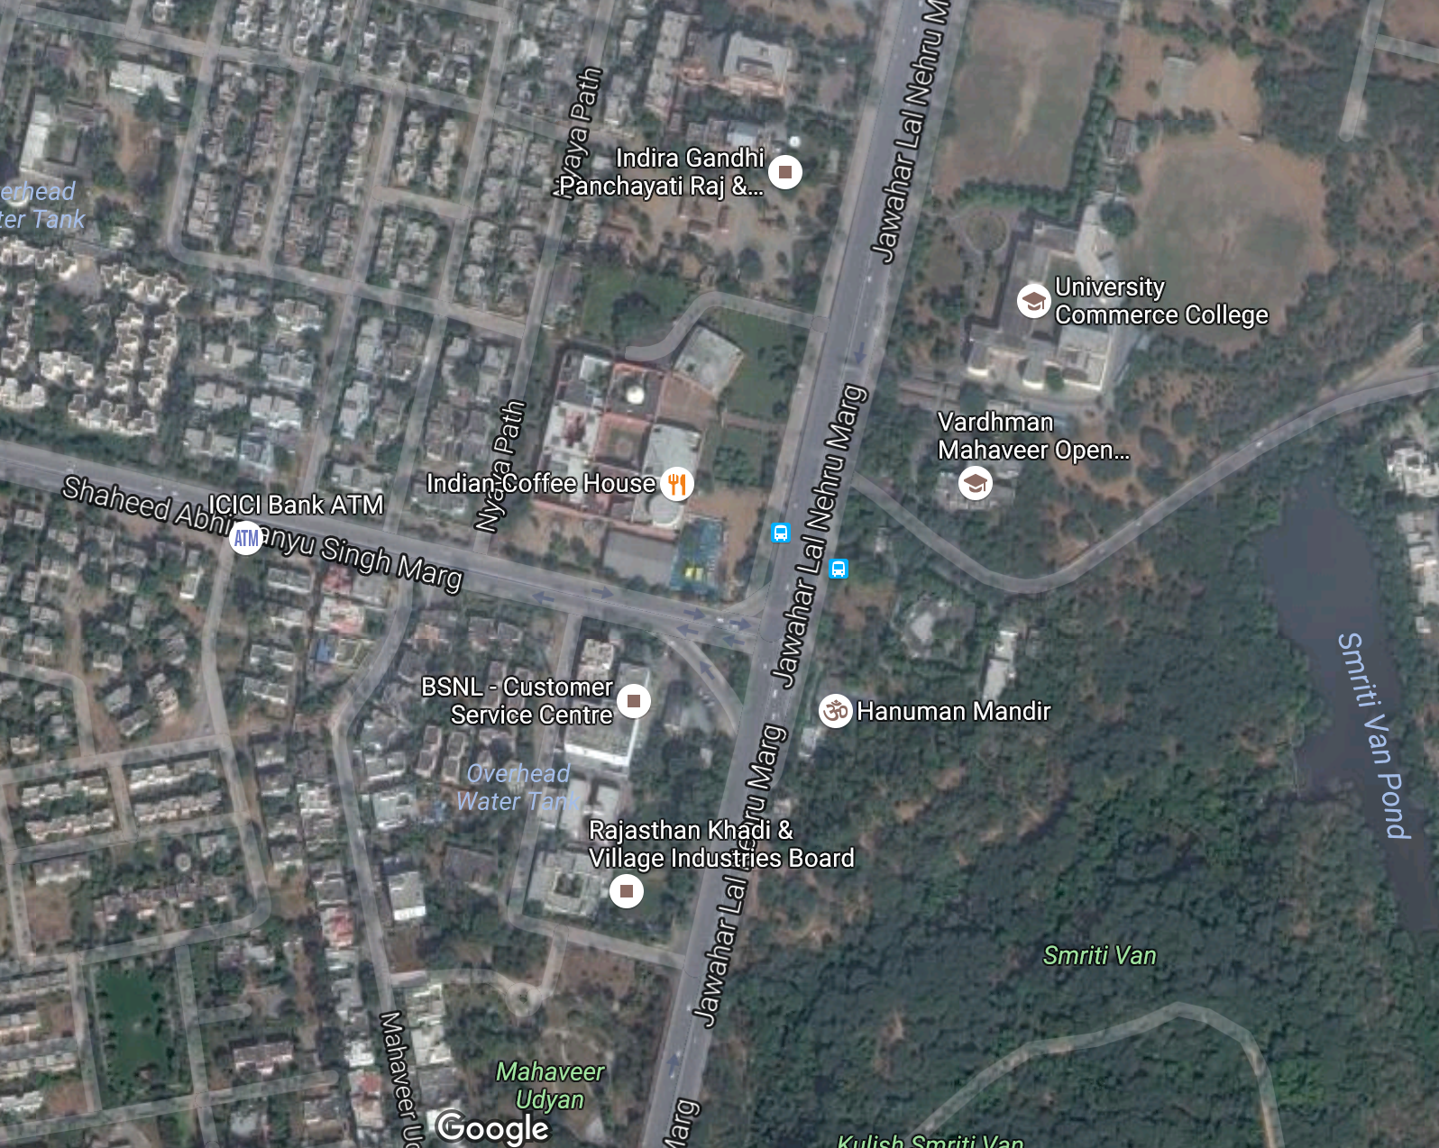
5. Find a blog or website that features your building and write one important thing you learn from it. Do you agree with the author?
   1. <https://thearchiblog.wordpress.com/2011/07/16/jawahar-kala-kendra-charles-correa/>
   2. According to the author of this blog, “Indian+ Modernism was the key”. I’m not sure I agree, I think the JKK was more of a throwback to classic traditional Indian architecture (Vastu Shastra) rather than an exposition of modernism in India
6. Find a book, magazine, website, or blog that features the architect and record three pertinent facts.
   1. Charles Correa actually wrote a series of essays himself, and I am going to use those as his “blog” that features himself: http://charlescorrea.net/pdfs/
      1. Correa was very interested in the relationship between student and teacher. He explained an Indian folktale about a guru, his disciples, and a follower of his. Then, he drew parallels between that story and the current state of architectural education. He was skilled at applying art to the real world. <http://charlescorrea.net/pdfs/essay02.pdf>
      2. Correa, once again interested in architectural education, examines the differences between artists and engineers and the varying amount of glamour in each profession. He concludes by suggesting that his alma mater (MIT) integrate more interdisciplinary courses in their architectural studio classes with civil and environmental engineers. <http://charlescorrea.net/pdfs/essay03.pdf>
      3. When I read essay #2 it ended on a rather dark note for the fact that the essay as a whole had been very inspiring. I considered that as rather jarring but when I read essay #5 the next day I was met with the same type of abrupt and disconcerting ending. What starts as an inspiring essay ends on a down note contrary to the excitement of the piece. I am not sure what fact I can draw from this other than the fact that Correa was not just a skilled architect, but a surprisingly adept writer as well. <http://charlescorrea.net/pdfs/essay05.pdf>
7. Find a video or film that features the building and write down something you observed about the building.
   1. <https://www.youtube.com/watch?v=KsccXxj-u18>
   2. Everything feels outside. Thanks to the open-air layout for most of the blocks, everything just feels like a well-integrated set of courtyards except the black-box theater and the library. But even with the library, there are floor to ceiling windows that give the same sense (and obviously you want to avoid this in the black-box theater).