Final Report: Microbial Analysis in Lean and Obese Neutered Cats

Isabella Finney

December 14, 2017

# Introduction

Add about 2-3 pages here. Across the whole manuscript, you should cite at least 20 peer reviewed articles.

# Methods

## Study design

Twenty-four domestic shorthair cats, with ages ranging from 1-12 years, were obtained from the University of California. Using a body condition score system (Laflamme, 1997), Fischer et al. determined which cats were considered lean or obese. They chose eight obese (4 male and 4 female); eight lean intact (4 male and 4 female); and eight lean neutered (6 male and 2 female) cats. Neutered cats were either castrated or spayed about 1-6 years before the start of the study. To control the specimens’ environmental factors, all cats were housed together in a temperature and enriched controlled facility. Each cat was also brushed and socialized once a day. The scientists ensured that each cat was given the same dry-type diet for two before the experiment as well as throughout the duration of the study. They ensured that diet provided met all of the standard nutritional recommendations for cats of all ages (Freeman *et al.*, 2013). Cats were fed a diet that consisted of proportional rates of protein, fat, N-free extract, dietary fibre, and ash. Although food intake for each specimen was not exactly measured, weekly recordings showed that each cat kept a consistent weight. Particular steps were taken to preform energy restriction on obese neutered cats. For 10 days, these cats were briefly individually housed during their feeding times and were weighed to ensure food intake stability. For the next 6 weeks, the cats were fed 60-70% of their previous energy intake to obtain a 0.5-1% in weight loss every week. Each cat had their body weight measured every week and a body composition scored was recorded every other week.

## Sample origin and sequencing

### Determining Body Composition

To determine body fat mass and fat free mass, Fischer et al. used a deuterium oxide (D2O) isotopic dilution method purchased from Fisher Scientific. This technique essentially applies a deuterium dilution to some bodily fluid in order to measure the total body water present in the body (Lukaski and Johnson, 1985). For this experiment, a blood sample was taken 12 hours after food fasting and 2 hours after water was withheld. To collect blood and faecal samples, each cat (obese, lean, intact, and neutered) was temporarily housed in a separate location. The dilution was applied to each subcutaneously, or “under the skin” and then after allowing the dilution to equilibrate from a few hours, another blood sample was collected. An IR spectrometer with a class 2A laser was used to analyze the sample.

### Faecal Collection and Bacterial Sequencing

Fresh faecal samples were collected from litter boxes once a day over the period of three days. These samples were placed in sterile tubes and stored at -80 Celsius. To determine that each sample collected was considered “fresh”, Fischer and other staff at the facility observed the cats every 15 minutes and only the faeces produced during this time period was collected.A DNA extraction kit, sold as the Mo Bio PowerSoil Kit, used a bead-beading on each sample to remove the DNA.

## Computational

These are the methods you used to do your bioinformatic analyses analyses. Should probably be between 0.5 and 1 pages. At a very minimum should include citations for DADA2 and phyloseq if you are doing an amplicon study, or other citations as appropriate.

# Results

## Subsections are ok in the results section too

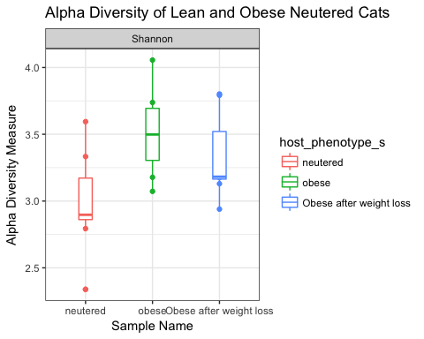

**Figure 1**: Alpha diversity measures of the three sample types, neutered obese and lean cats. Overall, there is a substantial amount of microbial diversty present among each sample type.

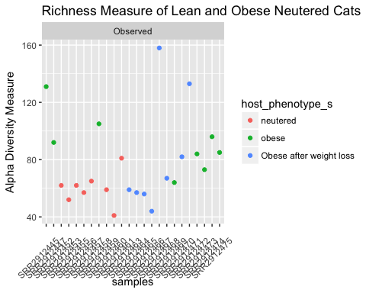

**Figure 2**: Alpha richness of each particular sample type.

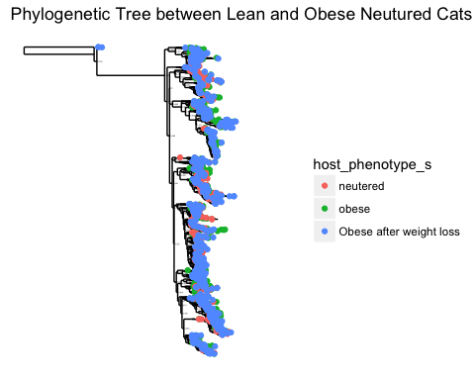

**Figure 3**: This is an inferred phylogenetic tree of sequences present within the three sample types. The tips of the tree represents samples where each particular taxa occurred. The tree itself represents the maximum likelihood of phylogengy.

## Square root transformation  
## Wisconsin double standardization  
## Run 0 stress 0   
## Run 1 stress 0   
## ... Procrustes: rmse 0.1963583 max resid 0.4541358   
## Run 2 stress 0   
## ... Procrustes: rmse 0.1929723 max resid 0.5279553   
## Run 3 stress 0   
## ... Procrustes: rmse 0.1989447 max resid 0.4889735   
## Run 4 stress 0   
## ... Procrustes: rmse 0.203718 max resid 0.4864508   
## Run 5 stress 0   
## ... Procrustes: rmse 0.1975233 max resid 0.4990052   
## Run 6 stress 0   
## ... Procrustes: rmse 0.1997684 max resid 0.4993428   
## Run 7 stress 0   
## ... Procrustes: rmse 0.1934571 max resid 0.4604881   
## Run 8 stress 0   
## ... Procrustes: rmse 0.2007549 max resid 0.5231527   
## Run 9 stress 0   
## ... Procrustes: rmse 0.2022978 max resid 0.4915197   
## Run 10 stress 0   
## ... Procrustes: rmse 0.2036993 max resid 0.4938114   
## Run 11 stress 0   
## ... Procrustes: rmse 0.1939089 max resid 0.4503963   
## Run 12 stress 0   
## ... Procrustes: rmse 0.1954599 max resid 0.4533975   
## Run 13 stress 0   
## ... Procrustes: rmse 0.195701 max resid 0.4632485   
## Run 14 stress 0   
## ... Procrustes: rmse 0.1946367 max resid 0.4377684   
## Run 15 stress 0   
## ... Procrustes: rmse 0.1963823 max resid 0.4955502   
## Run 16 stress 0   
## ... Procrustes: rmse 0.2013031 max resid 0.4672279   
## Run 17 stress 0   
## ... Procrustes: rmse 0.2003226 max resid 0.4711004   
## Run 18 stress 0   
## ... Procrustes: rmse 0.1971071 max resid 0.4661305   
## Run 19 stress 0   
## ... Procrustes: rmse 0.1883595 max resid 0.4291078   
## Run 20 stress 0   
## ... Procrustes: rmse 0.1901807 max resid 0.4188514   
## *** No convergence -- monoMDS stopping criteria:  
## 20: stress < smin

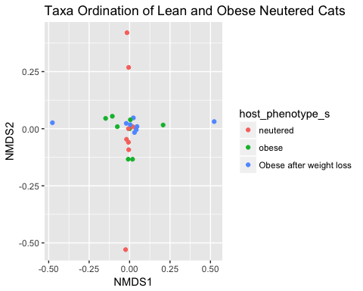

**Figure 4**: Plot ordination of the taxa present from each type of neutered cat.

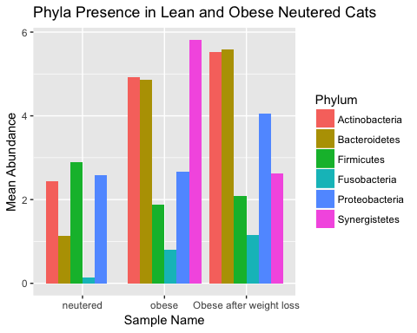

**Figure 5**: Bar plot representing the mean abundance of each phyla present in each sample type (lean netured, obese neutered, and obese and neutered with energy restriction).

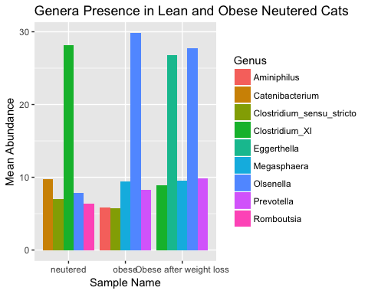

**Figure 6**: Bar plot representing the mean abundance of the top 5 genera present in each sample type (lean netured, obese neutered, and obese and neutered with energy restriction).

|  |  |  |  |
| --- | --- | --- | --- |
| Genus | neutered | obese | Obese after weight loss |
| Alloprevotella | NA | 4.318750 | NA |
| Aminiphilus | NA | 5.812500 | NA |
| Anaerobiospirillum | 5.296875 | 4.152344 | 6.097656 |
| Blautia | 3.545530 | NA | NA |
| Catenibacterium | 9.723684 | NA | NA |
| Clostridium_sensu_stricto | 6.973404 | 5.710106 | NA |
| Clostridium_XI | 28.154167 | 5.277083 | 8.902083 |
| Clostridium_XlVa | NA | NA | 7.190790 |
| Collinsella | NA | 3.396342 | NA |
| Eggerthella | NA | NA | 26.750000 |
| Enterococcus | 4.531250 | NA | NA |
| Faecalicoccus | NA | NA | 5.750000 |
| Hydrogenoanaerobacterium | NA | NA | 6.138393 |
| Megasphaera | 3.740385 | 9.437500 | 9.478365 |
| Olsenella | 7.812500 | 29.837500 | 27.687500 |
| Prevotella | NA | 8.286152 | 9.829044 |
| Romboutsia | 6.323077 | NA | NA |
| Slackia | NA | NA | 5.034091 |
| Streptococcus | NA | 3.694444 | NA |
| Turicibacter | 5.453125 | NA | NA |

**Table 1**: Summary table showing the mean abundance values for the top 15 genera present among all three sample types.

In addition to a minimum of 5-10 figures/tables (and associated captions), you should include sufficient text in this section to describe what your findings were. Remember that in the results section you just describe what you found, but you don't interpret it - that happens in the discussion. 2-3 pages.

# Discussion

Add around 3-4 pages interpreting your results and considering future directions one might take in analyzing these data.

# Sources Cited

Freeman,L.M. *et al.* (2013) Current knowledge about the risks and benefits of raw meat–based diets for dogs and cats. *Journal of the American Veterinary Medical Association*, **243**, 1549–1558.

Laflamme,D. (1997) Development and validation of a body condition score system for cats: A clinical tool. *Feline practice (Santa Barbara, Calif.: 1990)(USA)*.

Lukaski,H.C. and Johnson,P.E. (1985) A simple, inexpensive method of determining total body water using a tracer dose of d2o and infrared absorption of biological fluids. *The American journal of clinical nutrition*, **41**, 363–370.