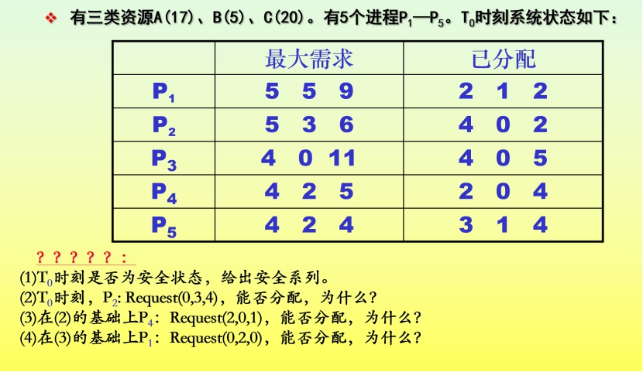

|  |  |  |  |  |
| --- | --- | --- | --- | --- |
|  | Max | Allocation | Need | Available |
|  | A B C | A B C | A B C | A B C |
| P1 | 5 5 9 | 2 1 2 | 3 4 7 | 2 3 3 |
| P2 | 5 3 6 | 4 0 2 | 1 3 4 |  |
| P3 | 4 0 11 | 4 0 5 | 0 0 6 |
| P4 | 4 2 5 | 2 0 4 | 2 2 1 |
| P5 | 4 2 4 | 3 1 4 | 1 1 0 |

（1）是安全状态，安全序列为P4，P2，P3，P5，P1

|  |  |  |  |  |  |  |
| --- | --- | --- | --- | --- | --- | --- |
|  | Work | Need | Allocation | Max | Work+ Allocation | Finish |
| 进程 | A B C | A B C | A B C | A B C | A B C |  |
| P4 | 2 3 3 | 2 2 1 | 2 0 4 | 4 2 5 | 4 3 7 | TRUE |
| P2 | 4 3 7 | 1 3 4 | 4 0 2 | 5 3 6 | 8 3 9 | TRUE |
| P3 | 8 3 9 | 0 0 6 | 4 0 5 | 4 0 11 | 12 3 14 | TRUE |
| P5 | 12 3 14 | 1 1 0 | 3 1 4 | 4 2 4 | 15 4 18 | TRUE |
| P1 | 15 4 18 | 3 4 7 | 2 1 2 | 5 5 9 | 17 5 20 | TRUE |

（2）Request2(0,3,4)≤Need2(1,3,4)成立

Request2(0,3,4)≤Available(2,3,3)不成立，故不能分配进程

（3）P4：Request4(2,0,1)≤Need4(2,2,1)成立

Request4(2,0,1)≤Available(2,3,3)成立

|  |  |  |  |  |
| --- | --- | --- | --- | --- |
|  | Max | Allocation | Need | Available |
|  | A B C | A B C | A B C | A B C |
| P1 | 5 5 9 | 2 1 2 | 3 4 7 | 0 3 2 |
| P2 | 5 3 6 | 4 0 2 | 1 3 4 |  |
| P3 | 4 0 11 | 4 0 5 | 0 0 6 |
| P4 | 4 2 5 | 4 0 5 | 0 2 0 |
| P5 | 4 2 4 | 3 1 4 | 1 1 0 |

再利用银行家算法判断此时系统是否安全

|  |  |  |  |  |  |
| --- | --- | --- | --- | --- | --- |
|  | Work | Need | Allocation | Work+Allocation | Finish |
| A B C | A B C | A B C | A B C |
| P4 | 0 3 2 | 0 2 0 | 4 0 5 | 4 3 7 | True |
| P2 | 4 3 7 | 1 3 4 | 4 0 2 | 8 3 9 | True |
| P3 | 8 3 9 | 0 0 6 | 4 0 5 | 12 3 14 | True |
| P5 | 12 3 14 | 1 1 0 | 3 1 4 | 15 4 18 | True |
| P1 | 15 4 18 | 3 4 7 | 2 1 2 | 17 5 20 | True |

存在安全序列<P4,P2,P3,P5,P1>，故可以分配

（4）P1:Request(0,2,0)<Need(3,4,7)成立

Request(0,2,0)<Available(0,3,2)成立

|  |  |  |  |  |
| --- | --- | --- | --- | --- |
|  | Max | Allocation | Need | Available |
| A B C | A B C | A B C | A B C |
| P1 | 5 5 9 | 2 3 2 | 3 2 7 | 0 1 2 |
| P2 | 5 3 6 | 4 0 2 | 1 3 4 |  |
| P3 | 4 0 11 | 4 0 5 | 0 0 6 |
| P4 | 4 2 5 | 4 0 5 | 0 2 0 |
| P5 | 4 2 4 | 3 1 4 | 1 1 0 |

由于Available（0,1,2）无法满足任何进程资源的需求，所以不能分配