High level budget

LongHorn Banks has an overall IT budget of around $120,000 for consolidation project. This project will migrate all internal web applications of the bank to a web content management (WCM) platform to organize content and structure of applications.

In order to migrate the application, we require various hardware, software and resources. The budget for the whole project can be divided into various categories.

*The table below gives the description of the individual category and the budget assigned to that event. The category can be further broken down to events but to maintain the simplicity, it has been avoided*

|  |  |  |
| --- | --- | --- |
| Category | Event | Budget |
| Software | **Procurement of Atlassian PM software licenses.** | **3000** |
| Software | Procurement of SQL server 2016 licenses. | 11000 |
| Software | Procurement of Visual Studio Professional 2015 licenses. | 12000 |
| Hardware | Procurement of AWS EC2 cloud server instances. | 4000 |
| Hardware | Configuration of Servers. | 2000 |
| Hardware | Setting up the Network. | 3000 |
| Hardware | Procurement and configuration of Workstations. | 8000 |
| Implementation | Migration of legacy solutions to the responsive platform | 6700 |
| Implementation | Development of new modules and central dashboard application | 16500 |
| Implementation | Testing of the implemented module for integration testing and unit testing. | 15500 |
| Implementation | Deployment of solutions on servers | 3500 |
| Implementation | WhiteHat Application Security Testing | 3000 |
| Human Resources | Personnel to carry out implementation | 18000 |
| Human Resources | Human Resources to carry out training and Project Management | 7500 |
| Engineering | Physical security including measures such as Bio-metrics, ID etc. | 1500 |
| Support | Support required in case of hardware failure, cloud server failure, power failure. | 4500 |

*Figure: Category-wise Project Budget*

The figure above gives the budget assignment with respect to the categories i.e. Engineering, Hardware, Implementation, Software and support.

The overall budget distribution from January to July is given in the below table.

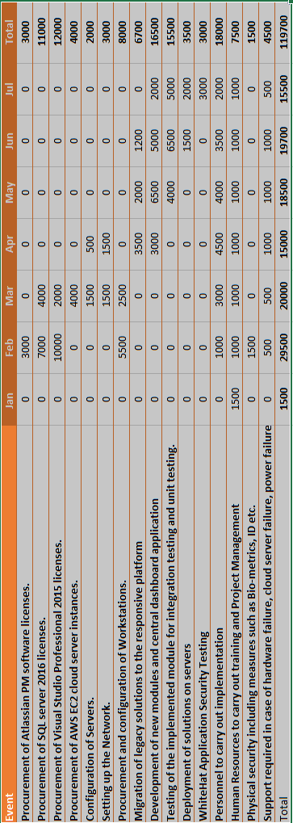

Budget for March 2017

|  |  |  |  |  |  |
| --- | --- | --- | --- | --- | --- |
| **Month of March** | **Week 1** | **Week 2** | **Week 3** | **Week 4** | **Total** |
| Procurement of SQL server licenses | $2000 for SQL server license for development server |  | $2000 for SQL server license for production server |  | **$4,000** |
| Procurement of Visual Studio Professional 2015 licenses | $2000 for VS 2015 pro license for developers |  |  |  | **$2,000** |
| Procurement of AWS EC2 cloud server instances | $1000 for development server on AWS cloud | $1000 for QA server on AWS cloud | $1000 for UAT server on AWS cloud | $1000 for development production server on AWS cloud | **$4,000** |
| Configuration of AWS servers | $375 to configure development server on AWS | $375 to configure QA server on AWS | $375 to configure UAT server on AWS | $375 to configure production server on AWS | **$1,500** |
| Setting up network | $900 for configuring network settings for development workstations | $600 for configuring network settings for QA team workstations |  |  | **$1,500** |
| Procurement and configuration of workstations | $1500 for procuring new workstations for development team | $1000 for procuring new workstations for development team |  |  | **$2,500** |
| Personnel to carry out implementation | $1500 required for developing responsive web pages | $1000 required for developing backend solutions | $500 required for testing developed modules |  | **$3,000** |
| Human resources to carry out training and project management | $500 for training developers about new tools |  | $500 for training QA team |  | **$1,000** |
| Support required in case of hardware failure, cloud server failure or power failure | $125 for IT support in case of failure | $125 for IT support in case of failure | $125 for IT support in case of failure | $125 for IT support in case of failure | **$500** |
| **Weekly Total** | **$9900** | **$4100** | **$4500** | **$1500** | **$20,000** |