**研究富有新意，得出的结论具有实际操作价值。Data Analysis方面做的很细致。**

**语法、拼写可以进一步改进。**

**Methods部分建议：**

**Methods部分不需要呈现全部问卷内容，可先介绍问卷的目的和设计的原则、Participant的情况以及问卷有效性的情况等。Methods部分还应该简单介绍后文中使用的数据分析方法。**

**Results部分建议：**

1. **只要涉及到问卷的结果，就应该放在Result部分，而不是Method部分，现在results部分比较散，都是针对不同的问题的数据来分别做comment, 缺乏一个主线。应考虑整合。**
2. **对呈现出来的结果，在文中要有充分的讨论，不能只展示一个图表，然后文中说This result is much better。图表中重要的数据在文中也要呈现，并结合文字对结果进行说明，告诉读者通过这些数据可以得到什么样的结果。现在Results部分中，数据和结果由于没有经过充分的讨论，属于分离的状态。**
3. **每一个图表都要按照在文中出现的顺序来进行编号，并且文中也要提到呈现相关数据的图表，如：As Figure 3.4.3 shows, ...**

Classification of Take-out Orderers by Expectation Maximization

Algorithm.



Topic: Research on UCAS students' online take-out ordering



 Group members: 王华强、刘蕴哲、杨钊、高云聪



Introduction

(The revision for the Introduction part have not started yet.)

With the fast development of the mobile Internet, incresing people are using online take-out platforms. According to the report of Institute of Frontier Industry Research in 2016, the whole market of online take-out selling will reach at 118 billion yuan per year at the end of 2017. Meanwhile, the fast-growing Big Data technology and the Mobile Internet technology have exerted an increasingly powerful impact on traditional food markets (iiMedia Research, 2016). The growth trend of the O2O food market is inversable and it is easy to predict that the market will grow even faster in the following few years (iiMedia Research, 2017). Above all, take-out is becoming a part of urban citizens' life.

Among people who order take-out online, students are the very first group of people who use online platform for take-out as soon as they are launched, and also an unignoreable group of people who buy food online (TrustData, 2017). TrustData found a strong relationship between the number of take-out orders and the number of universities, which also suggests that students consumed a large number of online take-out(citation information needed). However, among all the exist studies, no math model of university students' take-out ordering pattern has been developed. Despite many reports focusing on the whole market of take-out, none of them is detailed enough to show the buying pattern on campus. There have also been reports made by other universities’ students which are based on rather casual questionnaires and guesses (reference needed), which is not enough to reveal the whole pattern of campus online take-out buying.

Our research is focused on the data obtained from UCAS’s Yuquan campus. With the help of data analysis algorithm offered by Weka, it is easier to find out the pattern of online take-out buying and the relationships between all these factors. After the analysis of the results of 107 questionnaires, the result clearly showed two different activity patterns of take-out orderers, which will help both the take-out providers and the canteen to serve the students better.

Objective

The aim of this paper is to provide a pattern for take-out orderers in UCAS Yuquan campus, and provide a method to conjecture one's take-out ordering behavior according to his daily routine. Thence, we can get a clear view of the take-out ordering behavior in Yuquan campus and offer some useful suggestions for the university's logistics department.

Methods

1. Questionnaire design

We adopt the method of online questionnaire. The object of the survey is all the undergraduates in the Yuquanlu campus of the University of Chinese Academy of Sciences (hereinafter referred to as UCAS).

We posted our online questionnaire on all the major social platforms. It is convenient to collect the data through the backstage especially when the sample scale is large.

The contents of the questionnaire are listed as follows:

1. **Consumption situation on online ordering**
   1. Online ordering frequency: the options were set as follows: ”never”, ”no more than three times a month”, ”several times a week”, ”almost once a day”, ”two or three times a day”.
   2. Online ordering time: the options were set as follows: ”mostly on weekends”, ”mostly on weekdays”, ”whenever I want”.
   3. Online ordering platform: the options included three most commonly used takeout platforms.
   4. Online ordering price range: the options were set as follows: ”<15 rmb/share”, ”15-25 rmb/share”, ”25-50rmb/share”, ”>50 rmb/share”.

Take the eleme app as an example. The lowest discount price of most stores is set in the range of 20-30 yuan. A part of the students

1/8

possibly order what they want only. However, most of the students, in order to use the red envelopes, have to purchase food valued over 35 yuan. The final cost will consequently exceed 25 yuan. As a result, we set the price range as above.

1. **Influence factors on online ordering**
   1. The main factors considered in online ordering: we considered subjective needs of consumers and quality of store's service as two major factors. In addition, we provided several other options, “Other-Specify” included.
   2. The main reasons for choosing online ordering: we provided following options: ”felt bad about food in canteen“, “felt crowded in canteen”, “got coupons “, ”be recommended by others”, “joined others to obtain a discount”, “missed the meal time”, ”expected for a big meal”, “refused to go out”, “had too much money”, an “Other-Specify” is also included.
2. **Other views on takeout**

In this part, we investigated the degree of concern about takeout hygiene, the degree of parents' support for children ordering online and students’ general evaluations of takeout. We also added a fill - in question to investigate conditions in which the students will give up ordering online, hoping to collect more information for later analysis.

In our survey, we received in total 105 sets of questionnaire answers, of which 103 are valid. 2 responses were eliminated because though the participants confirmed that they ordered take-out, they called for deliveries at a frequency of null. According to the data, over half of the students had take-out several times a week. A Similar percentage of students mostly had take-out on weekends. The major factor which students considered when ordering online is the price along with the taste. It is partly confirmed by following data. Around sixty percent of students spent 15 to 25 yuan per order. Half of them allocated less than 15 percent of their living expenses to take-out. In addition, both parents and children worried little about take-out hygiene. The reasons why students chose to have take-out are highly diversified. Poor impression on canteen contributed to the popularity of take-out because over half of the students expressed disappointment for dishes offered in canteen.

从这里开始，应该就是Result Section了

We first finished the preliminary analysis of the data. Having collected enough information, we exported spreadsheet data. Then we made pie charts and bar charts on the basis of the data. Before setting out to find internal relationships among data, we ruled out some invalid information. Some of the questions were not set properly. Consequently, their results have no reference value.

*Do you order online?*

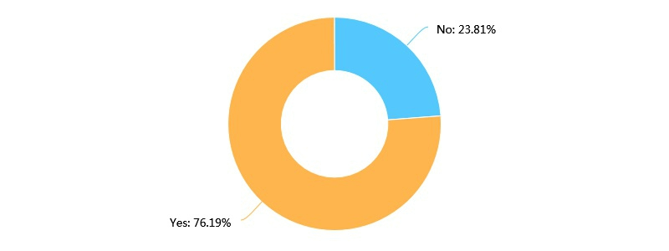

It is a seemingly meaningful result that three fourths of the students order online. However, we conducted the survey with an online questionnaire, which means we have no access to obtain the recovery rate of the questionnaire. In addition, the title of our questionnaire is Take-out in UCAS. As a result, undergraduates who never conducted online ordering probably overlooked the questionnaire. In conclusion, it is not a proper sampling of undergraduates in UCAS. Consequently, we are not able to conclude the ratio of take-out users according to the answers of our second question.

*What factors will you consider when choosing take-out?*

2/8

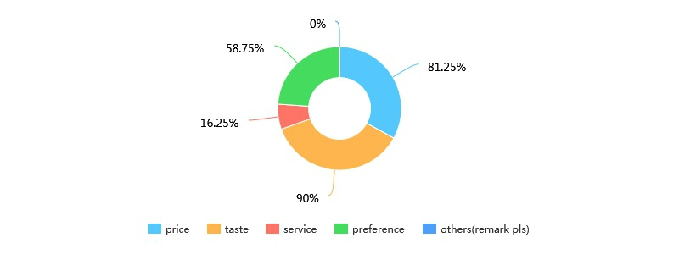

The options of the question were not properly set because the meaning of the word preference was not explicit enough for participants. As a result, the fourth option has various interpretations. In conclusion, the result of the question is invalid strictly.

In order to cover all possible factors which affect students’ take-out ordering behavior, we set a large number of questions. In addition, some of the questions were poorly related to each other. As a result, we soon found that some data are redundant. Additionally, it is still difficult to conclude rules manually according to the simply-processed data.

3. Preliminary analysis

As it is impossible for us to give out rules from the simply-processed data, we chose to use machine learning algorithm to analyze these data. Before we formally start mining the data, we did some preliminary studies to find a correct direction. Because there are so many algorithms to choose, it is hard to decide which one to use. Therefore, we chose to test every valid algorithm in Weka (Waikato Environment for Knowledge Analysis) using the initial parameter, and compare each one for the better result.

The result revealed that all the classify algorithm returned result with kappa less than 0.2, some of the even had negative kappa value, which means the results were even worse that the result of random classify. The same result also happened in the associate algorithms. Surprisingly, the EM algorithm, although did not offer a clear pattern, did provide some meaningful findings with the disordered data. As a result, we chose to use the EM algorithm to do the further mining job.

4. Applying the Expectation Maximization Algorithm

In order to rule out redundant information, we are going to analyze the influence factors with the EM algorithm. We expect to explore possible relationships among various factors. Expectation–Maximization (EM) algorithm is an iterative method to find maximum likelihood or maximum a posteriori (MAP) estimates of parameters in statistical models, where the model depends on unobserved latent variables.



岳佳. (2007). 基于EM算法的模型聚类的研究及应用. (Doctoral dissertation, 江南大学).

The EM Algorithm ,as the name suggests, is an algorithm used for getting the classification of a known data set which have the max expectation(Do, C. B., & Batzoglou, S. (2008)). In this experiment, we used the EM algorithm included in Weka (Waikato Environment for Knowledge Analysis) by the University of Waikato.

(Do, C. B., & Batzoglou, S. (2008). What is the expectation maximization algorithm?. Nature biotechnology, 26(8), 897.)

At the very begining, we apply the EM algorithm directly to the pre-processed data, the first test used the following parameters:



weka.clusterers.EM -I 100 -N -1 -X 10 -max -1 -ll-cv 1.0E-6 -ll-iter 1.0E-6 -M 1.0E-6 -K 10 -num-slots 1 -S 100

The head of the results are listed as follow.



EM

Number of clusters selected by cross validation: 2

Number of iterations performed: 14

3/8

|  |  |  |
| --- | --- | --- |
|  | Cluster |  |
| Attribute | 0 | 1 |
|  | (0.56) | (0.44) |

===============================================

WHERE-ELM

|  |  |  |
| --- | --- | --- |
| yes | 29.1075 | 35.8925 |
| no | 17.871 | 1.129 |
| [total] | 46.9785 | 37.0215 |
| WHERE-BD |  |  |
| yes | 9.6428 | 16.3572 |
| no | 37.3356 | 20.6644 |
| [total] | 46.9785 | 37.0215 |
| ...... |  |  |
| (23 attributes unlisted) |  |  |

The result includes a large sum of data, which is quite hard to find some significant results in it. However, the EM algorithm did succeed in

part the raw data into two different sets with similar size. For most of the attributes int the result list, the difference is not obvious. However, for some of the binary attributes, the classification matrix showed that the 2 sets generated by this algorithm have huge difference in those properties. We picked out these attributes as following:

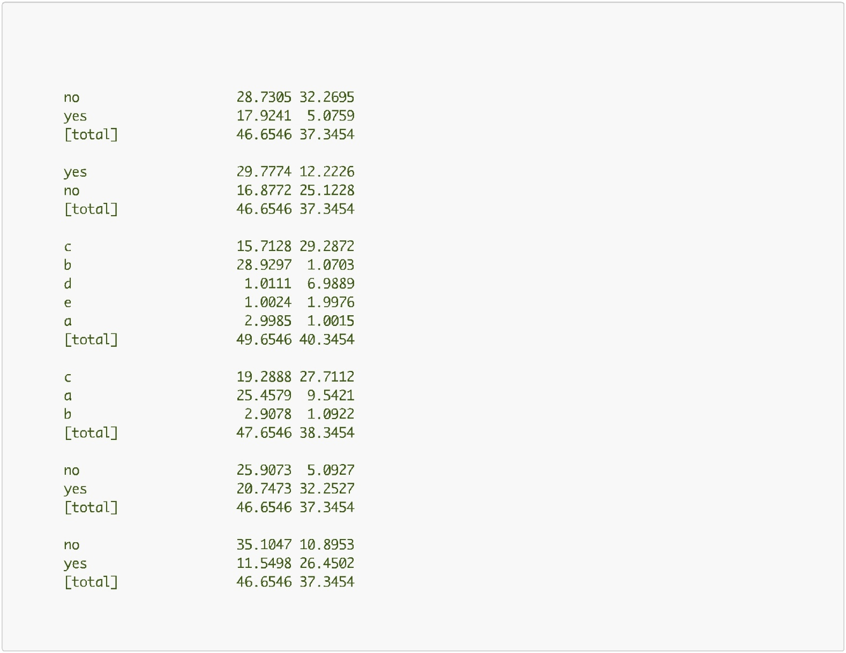

Attributes picked out in the result of EM

|  |  |  |
| --- | --- | --- |
| WHY-TOGETHER |  |  |
| no | 28.7305 | 32.2695 |
| yes | 17.9241 | 5.0759 |
| [total] | 46.6546 | 37.3454 |
| WHY-OUTOFLUNCHTIME |  |  |
| yes | 29.7774 | 12.2226 |
| no | 16.8772 | 25.1228 |
| [total] | 46.6546 | 37.3454 |
| FREQUENCY |  |  |
| c | 15.7128 | 29.2872 |
| b | 28.9297 | 1.0703 |
| d | 1.0111 | 6.9889 |
| e | 1.0024 | 1.9976 |
| a | 2.9985 | 1.0015 |
| [total] | 49.6546 | 40.3454 |
| AT_TIME |  |  |
| c | 19.2888 | 27.7112 |
| a | 25.4579 | 9.5421 |
| b | 2.9078 | 1.0922 |
| [total] | 47.6546 | 38.3454 |
| WHY-AWFULCANTEEN |  |  |
| no | 25.9073 | 5.0927 |
| yes | 20.7473 | 32.2527 |
| [total] | 46.6546 | 37.3454 |
| WHY-CROWDEDCANTEEN |  |  |
| no | 35.1047 | 10.8953 |
| yes | 11.5498 | 26.4502 |
| [total] | 46.6546 | 37.3454 |

......

All the attributes listed above had obvious difference in the two groups, and this was only the basic result generated by the EM algorithm

with the initial parameters.

5. Improve the Algorithm: further data process

Although we could already see the difference in the two groups, there were still vast improvement space for it.

In the first classification, we take 25 factors into consideration. However, according to the result, only some of them shows great differences

4/8

in the two sets, which showed they had no significant contribution for the classification. Therefore, doing further process of these attributes should be able to improve the outcome greatly.

For some of the other attributes, the choices gathered together in single choices.

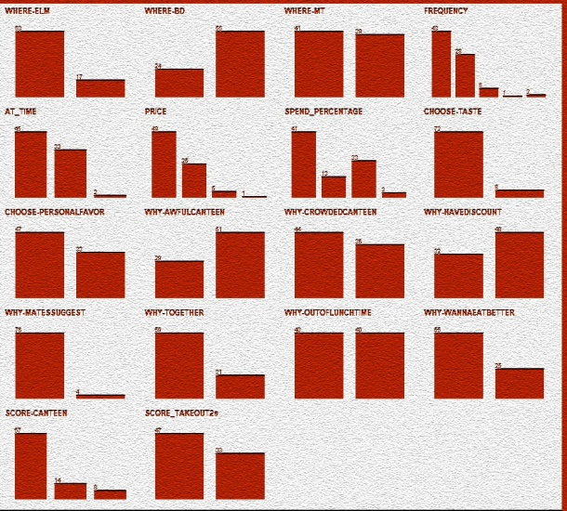

**(Pre-processed data, 1-1)**

For instance, in attributes like WHY-MATESUGGEST (which asked if the responder choose to order take-out because of ohter peoples' suggest), is greatly imbalanced. As the graph suggests, few participants order take-out because others' suggest. In this situation, this attribute can be deleted in the next EM test, for it can hardly provide any useful informations for classification, so according to the principle of EM. , deleting them will not harm the general result. Also, if left untouched, these imbalance attrtbute will introduce more Randomness into the result of EM. Attributes with similar conditions are:



WHY-IAMRICH

CHOOSE-ELSE

WHERE-ELSE

WHY-MATESSUGGEST

WHY-TASTE

CHOOSE-SERVICE

WHY-NOOUTDOOR

These attributes were removed before the next turn of EM began.

Not only the common pattern will make blur of the results, but also one question with many different options can also add up to the difficulty of data analysis. In order to avoid this, we chose to merge the options of such questions.

Take the score for canteen attribute for instance. In the questionnaire, the question asking participants to make a score foe the canteen was designed as a Likek scale (Likert summated rating scale) in order to make out te difference between the slight difference in attitudes towards the canteen. Unfortunately, the design also made the result too complexed so that the algorithm could not use this key to do classify works correctly, for the algorithm does not know the relationship between "dislike" and "hate". The algorithm considered these 2 options as totally different emotions while in fact they are only representation of different level of negative emotions. Therefore, merge such options together as negative attitude can greatly improve the outcome of the algorithm.



林东方. (2012). 基于EM算法的不完全测量数据的处理方法研究. (Doctoral dissertation, 中南大学).

Attributes with merged options are listed below.

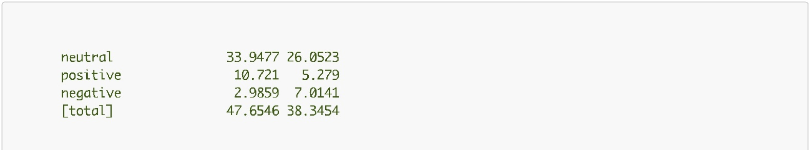

|  |  |  |
| --- | --- | --- |
| SCORE-CANTEEN |  |  |
| neutral | 33.9477 | 26.0523 |
| positive | 10.721 | 5.279 |
| negative | 2.9859 | 7.0141 |
| [total] | 47.6546 | 38.3454 |
| SCORE_TAKEOUT2s |  |  |