

实验名称 测量金属的杨氏模量 地点 学生姓名 学号 专业

实验日期 年 月 日 成绩评定 教师签字

1. 拉伸法

1. 钼丝长度 L= mm，卷尺仪器误差 e= mm
2. 钼丝直径

|  |  |  |  |  |  |  |  |
| --- | --- | --- | --- | --- | --- | --- | --- |
| 测量次数 | 1 | 2 | 3 | 4 | 5 | 6 | 平均值 ̅ |
| d/mm |  |  |  |  |  |  |  |

1. 监视器示数初始示数 = mm，千分尺仪器误差 e= mm

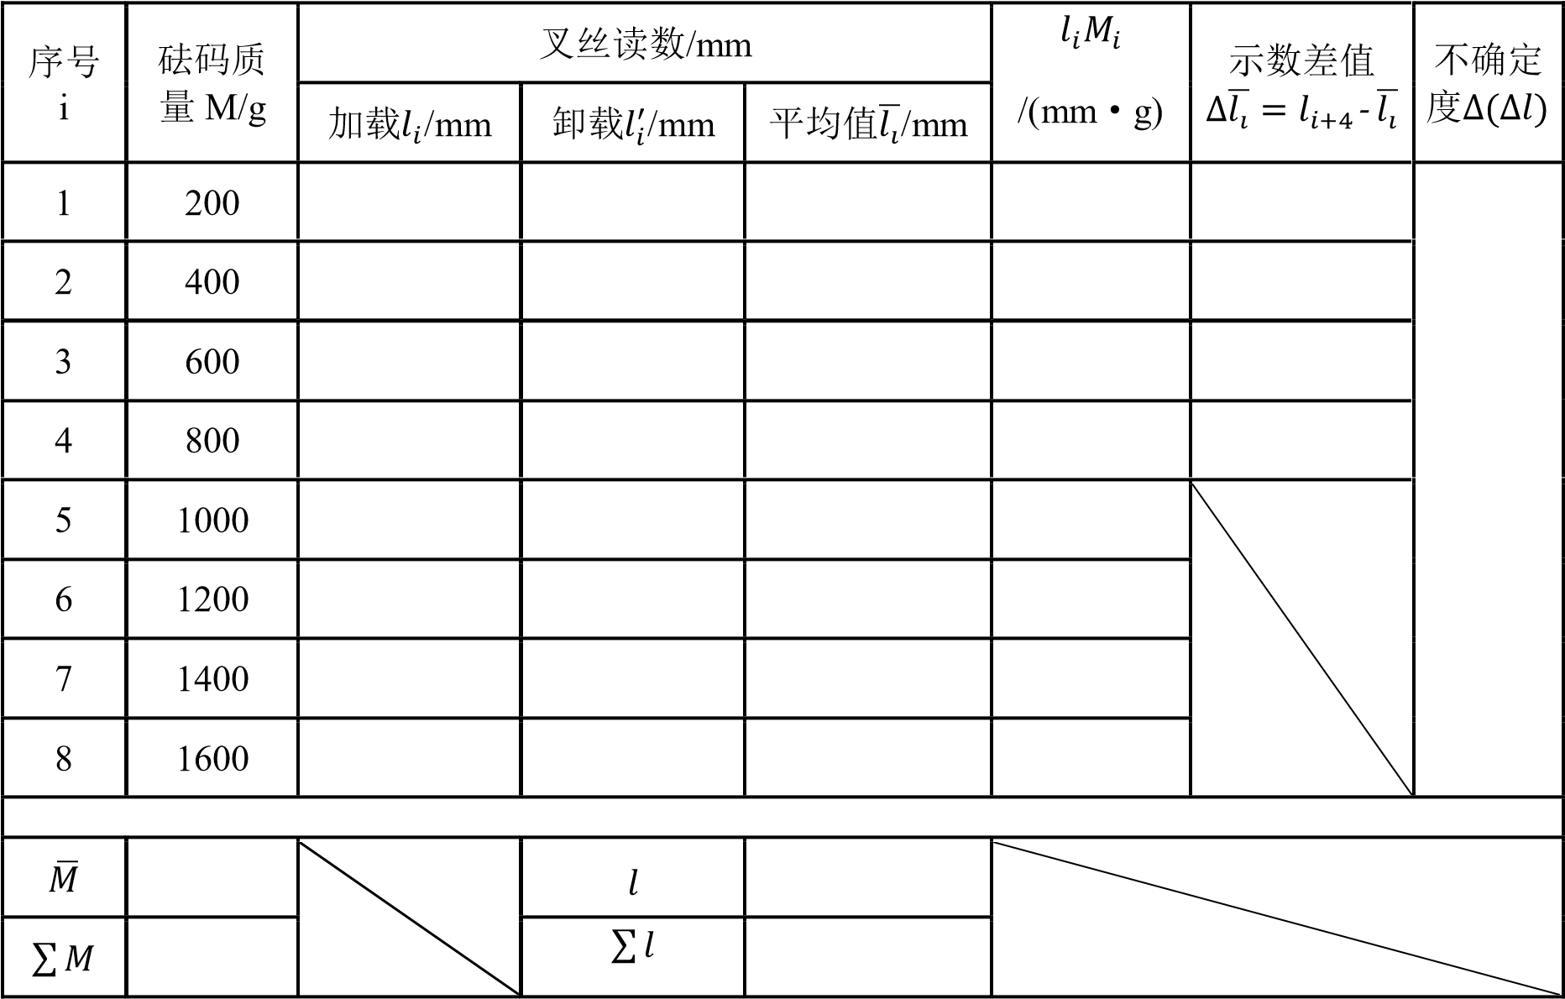̅

̅̅

̅

2. 霍尔法

1. 黄铜横梁的几何尺寸

|  |  |  |  |  |  |  |  |  |  |
| --- | --- | --- | --- | --- | --- | --- | --- | --- | --- |
| 长度 d/mm |  | | | | | | | | 平均值 |
| 宽度 b/mm |  | |  | |  | |  | |  |
| 厚度 a/mm |  |  |  |  |  |  |  |  |  |

1



1. 读数显微镜示数

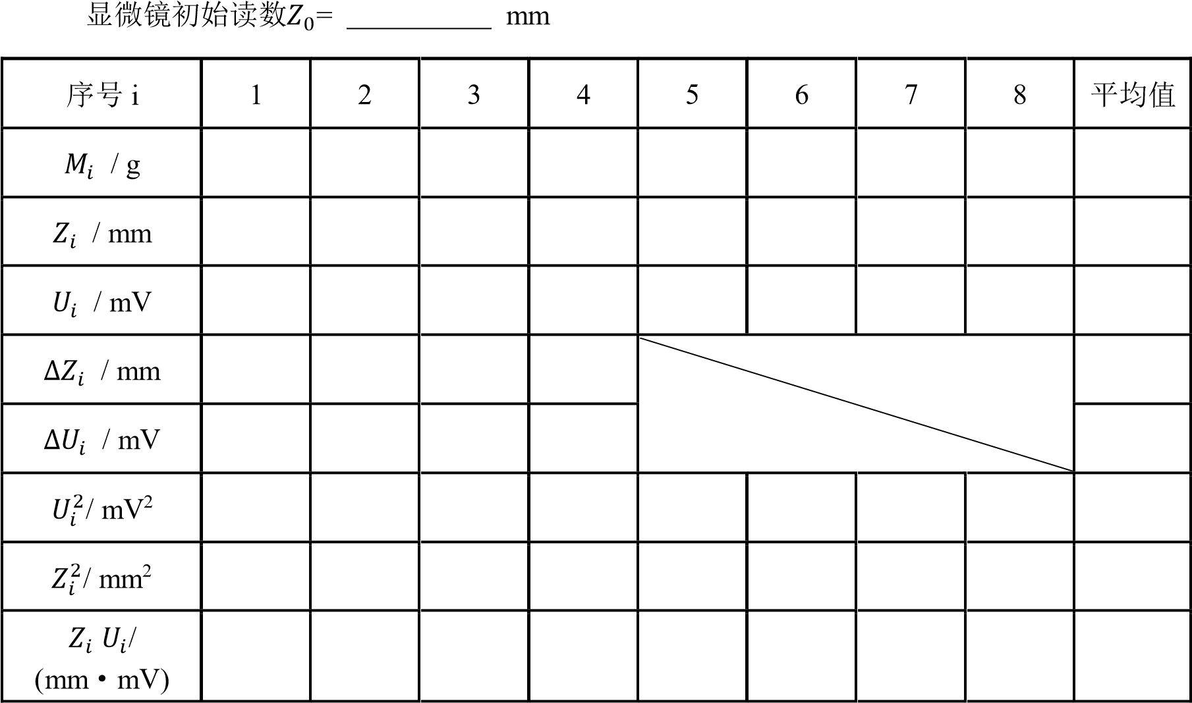

2

# 实验名称 气轨上弹簧振子的简谐振动 地点

学生姓名 学号 专业 实验日期 年 月 日 成绩评定 教师签字

1. 试验仪器的调试

|  |  |  |
| --- | --- | --- |
| V1 | V2 | 误差% |
|  |  |  |
|  |  |  |
|  |  |  |

1. 测量弹簧振子的振动周期并考察振动周期和振幅的关系

滑块的振幅 A 分别取 10.0, 20.0, 30.0, 40.0cm 时，测量其相应振动周期

|  |  |  |  |  |
| --- | --- | --- | --- | --- |
|  | 10cm | 20cm | 30cm | 40cm |
| T1（ms） |  |  |  |  |
| T2（ms） |  |  |  |  |
| T3（ms） |  |  |  |  |
| T4（ms） |  |  |  |  |
| T5（ms） |  |  |  |  |
| T |  |  |  |  |

3．研究振动周期和振子质量之间的关系

滑块的振幅 A 取 40.0cm

|  |  |  |  |  |  |
| --- | --- | --- | --- | --- | --- |
| m（g） | 1 | 2 | 3 | 4 | 5 |
| T1（ms） |  |  |  |  |  |
| T2（ms） |  |  |  |  |  |
| T3（ms） |  |  |  |  |  |
| T4（ms） |  |  |  |  |  |
| T5（ms） |  |  |  |  |  |
| T6（ms） |  |  |  |  |  |
| T7（ms） |  |  |  |  |  |
| T8（ms） |  |  |  |  |  |

1

|  |  |  |  |  |  |
| --- | --- | --- | --- | --- | --- |
| T9（ms） |  |  |  |  |  |
| T10（ms） |  |  |  |  |  |
| **T**（**ms**） |  |  |  |  |  |

1. 研究速度和位移的关系

滑块的振幅 A 取 40.0cm

|  |  |  |  |  |  |
| --- | --- | --- | --- | --- | --- |
|  | 10cm | 15cm | 20cm | 25cm | 30cm |
| V1 |  |  |  |  |  |
| V2 |  |  |  |  |  |
| V3 |  |  |  |  |  |
| V |  |  |  |  |  |

1. 研究振动系统的机械能是否守恒滑块的振幅 A 取 40.0cm

|  |  |  |  |  |  |
| --- | --- | --- | --- | --- | --- |
|  | 10cm | 15cm | 20cm | 25cm | 30cm |
| V（cm/s） |  |  |  |  |  |
| Ek（J） |  |  |  |  |  |
| Ep（J） |  |  |  |  |  |
| E（J） |  |  |  |  |  |

1. 改变弹簧振子的振幅A，测相应的ܸܽ݉ݔ，由ܸܽ݉ܣ−2ݔ2关系求k，与实验内容3的结果进行比较

|  |  |  |  |  |  |
| --- | --- | --- | --- | --- | --- |
|  | 10cm | 15cm | 20cm | 25cm | 30cm |
| V max1 |  |  |  |  |  |
| V max2 |  |  |  |  |  |
| V max3 |  |  |  |  |  |
| V max |  |  |  |  |  |

2

# 实验名称 弦上驻波及介质中声速测量 地点

学生姓名 学号 专业 实验日期 年 月 日 成绩评定 教师签字

1.线密度测试

|  |  |  |  |  |
| --- | --- | --- | --- | --- |
| 弦号 | 质量（g） | 长度（mm） | 直径（mm） | 线密度（Kg/m） |
|  |  |  |  |  |

2.波速的测量将拉力放在 2mg 的地方，测驻波频率 f1 和波长，求波速。（两种方法中 **T** 和 **L** 要统一）

|  |  |  |  |  |
| --- | --- | --- | --- | --- |
| 原理 | 原始数据 | 计算值 | 测量值 | 波速 |
| v λ ∙f | L= mm | λ= mm | f1= Hz |  |
| v ⁄ | m= g | T= N | μ Kg/m |  |

3．倍频谐波

在上述实验中观察到驻波后，将驱动线圈频率粗设为 2f1,3f1,4f1，然后微调，直至出现

多个波腹和波节。（用手机拍多个波腹和波节的实验现象，作为实验报告的实验记录。）

|  |  |  |  |  |
| --- | --- | --- | --- | --- |
|  | f1 | 2f1 | 3f1 | 4f1 |
| f |  |  |  |  |
| λ |  |  |  |  |
| v |  |  |  |  |

4.频率和有效长度的关系固定张力 T=3mg，将有效长度设为 L，3L/4，L/2，L/4 等，测试频率 f1 的变化。

|  |  |  |  |  |
| --- | --- | --- | --- | --- |
| L | 640 mm | 480 mm | 320 mm | 160 mm |
| f1 |  |  |  |  |

5.频率和张力的关系

固定有效长度 L=400 mm，将琴码放在 200mm 和 600mm 的地方，然后将拉力改为

1mg，2mg，3mg，4mg，5mg 时测频率 f1。（绘制 **logf-logT** 的曲线，并进行线性拟合。）

|  |  |  |  |  |  |
| --- | --- | --- | --- | --- | --- |
| T | 1mg | 2mg | 3mg | 4mg | 5mg |
| f1 |  |  |  |  |  |

1

6.频率和线密度的关系

同一个屋每个同学的弦号都不同，和其他同学共享上一步中 T= mg，L=400mm 时的数据。（绘制 **logf-log** 的曲线，并进行线性拟合。）

|  |  |  |  |  |  |  |
| --- | --- | --- | --- | --- | --- | --- |
| 弦号 |  |  |  |  |  |  |
| （Kg/m） |  |  |  |  |  |  |
| f1 |  |  |  |  |  |  |
| 数据来源 |  |  |  |  |  |  |

7.测超声波在空气和水中的波速（存储相位法测试时的屏幕图片，优选U盘，拍照也行。）空气中超声波波速的测试

|  |  |  |  |
| --- | --- | --- | --- |
| 方法 ，f= Hz，室温 t= ℃， | | | = m/s  理论值 |
| i | 刻度值 Li（mm） |  | 2| | |
| 1 |  |  |  |
| 2 |  |  |  |
| 3 |  |  |  |
| 4 |  |  |  |
| 5 |  |  |  |
| 6 |  |  |  |
| 测量结果：v（实验值）= m/s | | |  |

水中超声波波速的测试

|  |  |  |  |
| --- | --- | --- | --- |
| 方法 ，f= Hz，室温 t= ℃， | | | = m/s  理论值 |
| i | 刻度值 Li（mm） |  | 2| | |
| 1 |  |  |  |
| 2 |  |  |  |
| 3 |  |  |  |
| 4 |  |  |  |
| 5 |  |  |  |
| 6 |  |  |  |
| 测量结果：v（实验值）= m/s | | |  |

2



基 础 物 理 实 验 原 始 数 据 记 录

# 实验名称 动态法测定良导体的热导率 地点

学生姓名 学号 专业 实验日期 年 月 日 成绩评定 教师签字

1.热波波速的测量 （存储数据，在实验报告上精确计算）

相邻热电偶间距 *l*0 为 2cm，则波速 *V*= *l*0/(*t*n+1-*t*n)，，n 为测量点的位置坐标。

动态法测铜的热导率

|  |  |  |  |  |  |  |
| --- | --- | --- | --- | --- | --- | --- |
| 测量点 n |  |  |  |  |  |  |
| 对应峰值时间 t (s) |  |  |  |  |  |  |
| 波速（m/s） |  |  |  |  |  |  |
| 波速平均值： |  | | 热导率： | | | |

动态法测铝的热导率

|  |  |  |  |  |  |  |
| --- | --- | --- | --- | --- | --- | --- |
| 测量点 n |  |  |  |  |  |  |
| 对应峰值时间 t (s) |  |  |  |  |  |  |
| 波速（m/s） |  |  |  |  |  |  |
| 波速平均值： |  | | 热导率： | | | |

2.电位差计测热电偶温差电动势 （绘制 Ex~t 温度曲线，求出热电偶的温差电系数α）

室温：t = ℃ 电动势：Ex = mv 冷端温度：t0 = 0℃

|  |  |  |  |  |  |
| --- | --- | --- | --- | --- | --- |
| 温度 t（℃） |  |  |  |  |  |
| 电动势 Ex (mv) |  |  |  |  |  |

3．平衡电桥测铜电阻温度特性曲线（绘制 Rx~t 温度特性曲线，线性拟合求出铜电阻温度系数α。）

室温：t = ℃ 电阻： Rx = Ω

|  |  |  |  |  |  |
| --- | --- | --- | --- | --- | --- |
| 温度 t（℃） |  |  |  |  |  |
| 电阻 Rx (Ω) |  |  |  |  |  |

1

4.平衡电桥测热敏电阻温度特性曲线绘制 RT~t 曲线，观察热敏电阻的温度特性；绘制 lnRT ~1/T 曲线，线性拟合求出热敏电阻的特性常数 A 和 B（注意：T 为热力学温度）。

|  |  |  |  |  |  |
| --- | --- | --- | --- | --- | --- |
| 温度 t（℃） |  |  |  |  |  |
| 电阻 RT (Ω) |  |  |  |  |  |

室温：t = ℃ 电阻： RT= Ω

5.非平衡电桥热敏电阻温度计的设计

|  |  |  |  |  |  |
| --- | --- | --- | --- | --- | --- |
| 设定温度 t（℃） |  |  |  |  |  |
| 测试电压 Uo (mv) |  |  |  |  |  |
| 测试温度（℃） |  |  |  |  |  |

温度区间： 30 ℃— 50 ℃； 热敏电阻特性常数：A = ， B = ；表头参数选择：λ= -0.4V ，m= -0.01V/℃ ；工作电源电压：E = V ， R2 = Ω， R1/ R3 = ；实际值：R2 = Ω，R1 = Ω，R3 = 1000 Ω。

(

热敏电阻温度计：*U*0   *m t* *t*1，式中*t*1  40 *C* (所测温度区间的中心值) 参数计算：

*E*  42*BT*12 2 *m*，注意*T*1=273+40=313*K*

4*T*1 *B* 

*R*2 *B T*2 1 *RxT*1 *B T*2 1

*R*1 2*BE*



*RxT*1为在温度*T*1时热敏电阻的电阻

1

*R*3 *B T E B*2 1 2 

）

2

用霍尔效应测量磁场实验数据记录表表 1.1 直流电源霍尔电流与霍尔电压数据记录

|  |  |  |  |  |  |
| --- | --- | --- | --- | --- | --- |
| 霍尔电流：IH  (mA) |  | 霍尔电压：𝑈𝐻 (mV) | | | |
| 𝑈1 | 𝑈2 | 𝑈3 | 𝑈4 | 𝑈𝐻 |
| 2 | -4.9 | 4.8 | -4.5 | 4.35 | 4.6375 |
| 4 | -9.8 | 9.6 | -8.9 | 8.8 | 9.275 |
| 6 | -14.75 | 14.5 | -13.4 | 13.2 | 13.9625 |
| 8 | -19.7 | 19.4 | -17.9 | 17.65 | 18.6625 |
| 10 | -24.6 | 24.2 | -22.3 | 22.0 | 23.725 |
| 霍尔电流输入接 1,2 端  励磁电流：IM = 0.6 (𝐴) | |  | |  |  |

学生：

助教：

表 1.2 直流电源霍尔电流与霍尔电压数据记录

|  |  |  |  |  |
| --- | --- | --- | --- | --- |
| 霍尔电流：IH  (mA) |  | 霍尔电压：𝑈𝐻 (mV) | |  |
| 𝑈1 | 𝑈2 | 𝑈3 | 𝑈4 |
| 2 |  |  |  |  |
| 4 |  |  |  |  |
| 6 |  |  |  |  |
| 8 |  |  |  |  |
| 10 |  |  |  |  |
| 霍尔电流输入接 3,4 端  励磁电流：IM = 0.6 (𝐴) | |  | |  |

学生：

助教：

2 霍尔系数测量数据记录

|  |  |  |  |  |  |
| --- | --- | --- | --- | --- | --- |
| 磁场强度：  B (mT) | 励磁电流：IH  (A) |  | 霍尔电压：𝑈𝐻 (mV) | |  |
| 𝑈1 | 𝑈2 | 𝑈3 | 𝑈4 |
| -0.3 | 0.0 | -1.2 | 0.85 | 0.85 | -1.025 |
| 14.9 | 0.1 | -5.1 | 4.75 | -2.85 | -3.800 |
| 29.9 | 0.2 | -8.9 | 8.55 | -6.7 | -7.625 |
| 44.7 | 0.3 | -12.8 | 12.4 | -10.6 | -11.5 |
| 59.9 | 0.4 | -16.65 | 16.3 | -14.4 | -15.3625 |
| 75.1 | 0.5 | -20.6 | 20.2 | -18.3 | -19.275 |
| 89.7 | 0.6 | -24.55 | 24.15 | -22.2 | -23.2 |
| 104.8 | 0.7 | -28.25 | 27.95 | -26.1 | -27.0875 |
| 120.1 | 0.8 | -32.3 | 31.9 | -29.9 | -30.925 |
| 134.3 | 0.9 | -36.2 | 35.8 | -33.85 | -34.85 |
| 150.0 | 1.0 | -40.0 | 39.6 | -37.8 | -38.725 |
| 霍尔电流：IH = 10 (𝑚𝐴) | |  |  | |  |

学生：

助教：

表 3 交流电源霍尔电压数据记录

|  |  |  |  |  |  |
| --- | --- | --- | --- | --- | --- |
| 励磁电流：  IM (A) | 0.2 | 0.4 | 0.6 | 0.8 | 1.0 |
| 霍尔电压：  𝑈𝐻 (mV) | 8.5 | 16.1 | 23.5 | 31.5 | 39.3 |
| 交流电源接 1,2 端  交流电源频率：f = 500 (𝐻𝑧) 霍尔电流：IH = 10 (𝑚𝐴) | |  |  |  |  |

学生：

助教：

4 圆电流线圈轴线上磁场分布测量数据记录

|  |  |  |  |  |  |  |  |  |  |  |  |  |  |  |  |
| --- | --- | --- | --- | --- | --- | --- | --- | --- | --- | --- | --- | --- | --- | --- | --- |
| 轴向距离X (mm) | -35 | -30 | -25 | -20 | -15 | -10 | -5 | 0 | 5 | 10 | 15 | 20 | 25 | 30 | 35 |
| 𝑈𝑚𝑎𝑥 (𝑚𝑉) | 5.17 | 5.38 | 5.57 | 5.74 | 5.87 | 5.98 | 6.04 | 6.06 | 6.04 | 5.98 | 5.89 | 5.74 | 5.60 | 5.42 | 5.20 |
| 测量值： |  |  |  |  |  |  |  |  |  |  |  |  |  |  |  |
| 计算值： |  |  |  |  |  |  |  |  |  |  |  |  |  |  |  |
|  |  |  |  |  |  |  |  |  |  |  |

学生：

助教：

表 5 亥姆霍兹线圈轴线上磁场分布测量数据记录

|  |  |  |  |  |  |  |  |  |  |  |  |  |  |  |  |
| --- | --- | --- | --- | --- | --- | --- | --- | --- | --- | --- | --- | --- | --- | --- | --- |
| 轴向距离X (mm) | -35 | -30 | -25 | -20 | -15 | -10 | -5 | 0 | 5 | 10 | 15 | 20 | 25 | 30 | 35 |
| 𝑈𝑚𝑎𝑥 (𝑚𝑉) | 8.55 | 8.58 | 8.60 | 8.60 | 8.60 | 8.60 | 8.59 | 8.59 | 8.59 | 8.59 | 8.59 | 8.58 | 8.57 | 8.54 | 8.50 |
| 测量值： |  |  |  |  |  |  |  |  |  |  |  |  |  |  |  |
| f = 120 Hz |  |  |  |  |  |  |  | |  |  |  |  |  |  |  |

学生：

助教：

表 6 亥姆霍兹线圈磁场径向分布测量数据记录

|  |  |  |  |  |  |  |  |  |  |  |  |  |  |  |  |
| --- | --- | --- | --- | --- | --- | --- | --- | --- | --- | --- | --- | --- | --- | --- | --- |
| 轴向距离X (mm) | -35 | -30 | -25 | -20 | -15 | -10 |  | 0 | 5 | 10 | 15 | 20 | 25 | 30 | 35 |
| 𝑈𝑚𝑎𝑥 (𝑚𝑉) |  |  |  |  |  |  |  |  |  |  |  |  |  |  |  |
| 测量值： |  |  |  |  |  |  |  |  |  |  |  |  |  |  |  |
| f = 120 Hz |  |  |  |  |  |  |  | |  |  |  |  |  |  |  |

学生：

助教：

7 探测线圈转角与感应电压数据记录

|  |  |  |  |  |  |  |  |  |  |  |
| --- | --- | --- | --- | --- | --- | --- | --- | --- | --- | --- |
| 探测线圈转角θ | 0 | 10 | 20 | 30 | 40 | 50 | 60 | 70 | 80 | 90 |
| 𝑈 (𝑚𝑉) | 8.59 | 8.45 | 7.99 | 7.37 | 6.55 | 5.46 | 4.17 | 2.77 | 1.37 | 0.00 |
| 计算值：U = 𝑈𝑚𝑎𝑥 ∙ 𝑐𝑜𝑠𝜃 |  |  |  |  |  |  |  |  |  |  |
| 探测线圈转角θ | 100 | 110 | 120 | 130 | 140 | 150 | 160 | 170 | 180 | 190 |
| 𝑈 (𝑚𝑉) | 1.45 | 2.90 | 4.10 | 5.32 | 6.40 | 7.33 | 7.92 | 8.35 | 8.51 | 8.42 |
| 计算值：U = 𝑈𝑚𝑎𝑥 ∙ 𝑐𝑜𝑠𝜃 |  |  |  |  |  |  |  |  |  |  |
| 探测线圈转角θ | 200 | 210 | 220 | 230 | 240 | 250 | 260 | 270 | 280 | 290 |
| 𝑈 (𝑚𝑉) | 8.07 | 7.52 | 6.68 | 5.55 | 4.42 | 2.92 | 1.58 | 0.00 | 1.41 | 2.96 |
| 计算值：U = 𝑈𝑚𝑎𝑥 ∙ 𝑐𝑜𝑠𝜃 |  |  |  |  |  |  |  |  |  |  |
| 探测线圈转角θ | 300 | 310 | 320 | 330 | 340 | 350 | 360 |  |  |  |
| 𝑈 (𝑚𝑉) | 4.42 | 5.59 | 6.70 | 7.52 | 8.15 | 8.49 | 8.59 |  |  |  |
| 计算值：U = 𝑈𝑚𝑎𝑥 ∙ 𝑐𝑜𝑠𝜃 |  |  |  |  |  |  |  |  |  |  |
|  |  |  |  |  | |  |  |  |  |  |

学生：

助教：

表 8 励磁电流频率对磁场强度的影响

|  |  |  |  |  |  |  |  |  |  |  |  |  |  |  |
| --- | --- | --- | --- | --- | --- | --- | --- | --- | --- | --- | --- | --- | --- | --- |
| 励磁电流频率f (Hz) | 20 | 30 | 40 | 50 | 60 | 70 | 80 | 90 | 100 | 110 | 120 | 130 | 140 | 150 |
| 𝑈𝑚 (𝑚𝑉) | 1.39 | 2.12 | 28.4 | 3.56 | 4.29 | 4.99 | 5.72 | 6.42 | 7.15 | 7.87 | 8.59 | 9.32 | 9.44 | 9.52 |
| 测量值： |  |  |  |  |  |  |  |  |  |  |  |  |  |  |
| I = 60 mA |  |  |  |  |  |  |  | |  |  |  |  |  |  |

学生：

助教：

微波布拉格衍射实验原始数据记录

指导教师 实验日期 学生姓名 学 号 实验台

1. 实验条件确认

微波频率： 微波波长:

1. 微波单缝衍射实验
2. 微波实验仪对准确认

功率：

|  |  |  |  |
| --- | --- | --- | --- |
| 角度（°） | 0 | 20 | -20 |
| 电压（mV） |  |  |  |

1. 单缝实验数据

功率：

|  |  |  |  |  |  |  |  |  |  |
| --- | --- | --- | --- | --- | --- | --- | --- | --- | --- |
| θ（°） | 0 | 2 | 4 | 6 | 8 | 10 | 12 | 14 | 16 |
| U+(mV) |  |  |  |  |  |  |  |  |  |
| U-(mV) |  |  |  |  |  |  |  |  |  |
| θ（°） | 18 | 20 | 22 | 24 | 26 | 28 | 30 | 32 | 34 |
| U+(mV) |  |  |  |  |  |  |  |  |  |
| U-(mV) |  |  |  |  |  |  |  |  |  |
| θ（°） | 36 | 38 | 40 |  |  |  |  |  |  |
| U+(mV) |  |  |  |  |  |  |  |  |  |
| U-(mV) |  |  |  |  |  |  |  |  |  |

调节功率： （增大功率，根据实验数据在极小值附近细扫，1°角间隔）

|  |  |  |  |  |  |  |  |  |  |
| --- | --- | --- | --- | --- | --- | --- | --- | --- | --- |
| θ（°） |  |  |  |  |  |  |  |  |  |
| U+(mV) |  |  |  |  |  |  |  |  |  |
| U-(mV) |  |  |  |  |  |  |  |  |  |

3、微波双缝干涉实验

1. 微波实验仪对准确认

功率：

|  |  |  |  |
| --- | --- | --- | --- |
| 角度（°） | 0 | 20 | -20 |
| 电压（mV） |  |  |  |

1. 双缝实验数据

功率：

|  |  |  |  |  |  |  |  |  |  |
| --- | --- | --- | --- | --- | --- | --- | --- | --- | --- |
| θ（°） | 0 | 2 | 4 | 6 | 8 | 10 | 12 | 14 | 16 |
| U+(mV) |  |  |  |  |  |  |  |  |  |
| U-(mV) |  |  |  |  |  |  |  |  |  |
| θ（°） | 18 | 20 | 22 | 24 | 26 | 28 | 30 | 32 | 34 |
| U+(mV) |  |  |  |  |  |  |  |  |  |
| U-(mV) |  |  |  |  |  |  |  |  |  |
| θ（°） | 36 | 38 | 40 | 42 | 44 | 46 | 48 | 50 |  |
| U+(mV) |  |  |  |  |  |  |  |  |  |
| U-(mV) |  |  |  |  |  |  |  |  |  |

功率： （根据实验数据确定扫描角度，1°角间隔）

|  |  |  |  |  |  |  |  |  |  |
| --- | --- | --- | --- | --- | --- | --- | --- | --- | --- |
| 一级极大 | θ（°） |  |  |  |  |  |  |  |  |
| U+(mV) |  |  |  |  |  |  |  |  |
| U-(mV) |  |  |  |  |  |  |  |  |

功率： （根据实验数据确定扫描角度，1°角间隔）

|  |  |  |  |  |  |  |  |  |  |
| --- | --- | --- | --- | --- | --- | --- | --- | --- | --- |
| 零级极小 | θ（°） |  |  |  |  |  |  |  |  |
| U+(mV) |  |  |  |  |  |  |  |  |
| U-(mV) |  |  |  |  |  |  |  |  |

功率： （根据实验数据确定扫描角度，1°角间隔）

|  |  |  |  |  |  |  |  |  |  |
| --- | --- | --- | --- | --- | --- | --- | --- | --- | --- |
| 一级极小 | θ（°） |  |  |  |  |  |  |  |  |
| U+(mV) |  |  |  |  |  |  |  |  |
| U-(mV) |  |  |  |  |  |  |  |  |

4、微波迈克尔逊干涉实验

1. 微波实验仪对准确认

功率：

|  |  |  |  |  |  |  |  |
| --- | --- | --- | --- | --- | --- | --- | --- |
| 角度（°） | | 0 |  | 20 |  | -20 |  |
| 电压（mV） | |  |  |  |  |  |  |
| （2）迈克尔逊实验数据 | | |  |  |  |  |  |
| 最小点读数 |  | |  |  |  |  |  |
| 5、微波布拉格衍射实验  （1）微波实验仪对准确认功率： | | |  |  |  |  |  |
| 角度（°） | | 0 |  | 20 |  | -20 |  |
| 电压（mV） | |  |  |  |  |  |  |

1. 布拉格衍射实验数据

功率： 晶面 ϕI 为入射角度 ϕR为反射角度

|  |  |  |  |  |  |  |  |  |  |
| --- | --- | --- | --- | --- | --- | --- | --- | --- | --- |
| ϕ（I °） | 30 | 32 | 34 | 36 | 38 | 40 | 42 | 44 | 46 |
| ϕ（R °） |  |  |  |  |  |  |  |  |  |
| U(mV) |  |  |  |  |  |  |  |  |  |
| ϕ（I °） | 48 | 50 | 52 | 54 | 56 | 58 | 60 | 62 | 64 |
| ϕ（R °） |  |  |  |  |  |  |  |  |  |
| U(mV) |  |  |  |  |  |  |  |  |  |
| ϕ（I °） | 66 | 68 | 70 | 72 | 74 | 76 | 78 | 80 |  |
| ϕ（R °） |  |  |  |  |  |  |  |  |  |
| U(mV) |  |  |  |  |  |  |  |  |  |

功率： （根据实验数据确定扫描角度，1°角间隔）

|  |  |  |  |  |  |  |  |  |  |
| --- | --- | --- | --- | --- | --- | --- | --- | --- | --- |
| ϕ（I °） |  |  |  |  |  |  |  |  |  |
| ϕ（R °） |  |  |  |  |  |  |  |  |  |
| U(mV) |  |  |  |  |  |  |  |  |  |

附加实验：微波布拉格衍射（110）晶面

1. 微波实验仪对准确认

功率：

|  |  |  |  |
| --- | --- | --- | --- |
| 角度（°） | 0 | 20 | -20 |
| 电压（mV） |  |  |  |

1. 布拉格衍射实验数据

功率： 晶面 ϕI 为入射角度 ϕR为反射角度

|  |  |  |  |  |  |  |  |  |  |
| --- | --- | --- | --- | --- | --- | --- | --- | --- | --- |
| ϕ（I °） | 30 | 32 | 34 | 36 | 38 | 40 | 42 | 44 | 46 |
| ϕ（R °） |  |  |  |  |  |  |  |  |  |
| U(mV) |  |  |  |  |  |  |  |  |  |
| ϕ（I °） | 48 | 50 | 52 | 54 | 56 | 58 | 60 | 62 | 64 |
| ϕ（R °） |  |  |  |  |  |  |  |  |  |
| U(mV) |  |  |  |  |  |  |  |  |  |
| ϕ（I °） | 66 | 68 | 70 | 72 | 74 | 76 | 78 | 80 |  |
| ϕ（R °） |  |  |  |  |  |  |  |  |  |
| U(mV) |  |  |  |  |  |  |  |  |  |

功率： （根据实验数据确定扫描角度，1°角间隔）

|  |  |  |  |  |  |  |  |  |  |
| --- | --- | --- | --- | --- | --- | --- | --- | --- | --- |
| ϕ（I °） |  |  |  |  |  |  |  |  |  |
| ϕ（R °） |  |  |  |  |  |  |  |  |  |
| U(mV) |  |  |  |  |  |  |  |  |  |