Temporal Graph Convolutional Network for Urban Traffic Flow Prediction Method

**Model**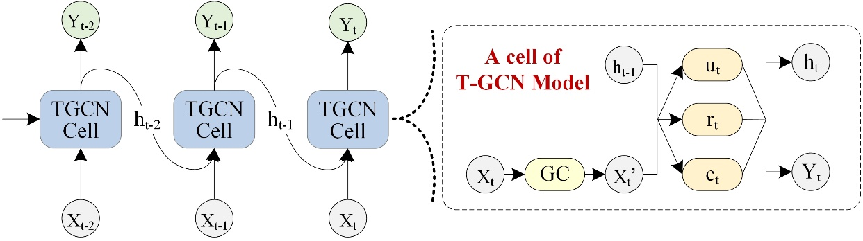

This is a TensorFlow implementation of Temporal Graph Convolutional Network for the task of traffic flow prediction.

**Requirements**

* tensorflow
* scipy
* numpy
* matplotlib
* pandas
* math

**Run the demo**

Python main.py

**Data Description**

In order to use the model, we need

* an N by N adjacency matrix, which describes the spatial relationship between roads,
* an N by D feature matrix, which describes the speed change over time on the roads.