

**ACYCLE**

a time-series analysis software for paleoclimate projects

version 0.2.1

**User’s Guide**

**Mingsong Li**

[www.mingsongli.com/acycle](http://www.mingsongli.com/acycle)

[www.github.com/mingsongli/acycle](http://www.github.com/mingsongli/acycle)

Penn State University, State College, USA

September 14, 2018

Contents

1. Copyrights - 1 -

2. References - 1 -

3. Software Specifications - 1 -

**3.1 System Requirements** - 1 -

**3.2 Downloading the ACycle software** - 2 -

**3.3 Installation** - 2 -

**3.4 Startup** - 2 -

**3.5 Data requirement** - 2 -

4. Acycle GUI - 3 -

**4.1 Functions and GUI** - 3 -

**4.2 File** - 4 -

**4.3 Edit** - 4 -

**4.4 Plot** - 5 -

**4.5 Basic Series** - 6 -

**Insolation:** - 6 -

**Astronomical Solution:** - 6 -

**LR04 Stack:** - 7 -

**Sine Wave:** - 7 -

**White Noise:** - 7 -

**Red Noise:** - 7 -

**4.6 Math** - 8 -

**Sorting & Unique:** - 8 -

**Select Parts:** - 8 -

**Merge Series:** - 8 -

**Add Gaps:** - 8 -

**Remove Parts:** - 8 -

**Remove Peaks:** - 8 -

**Interpolation:** - 9 -

**Smoothing:** - 9 -

**Standardize:** - 9 -

**Principal Component:** - 9 -

**Log-transform:** - 9 -

**First Difference:** - 9 -

**Simple Function** - 9 -

**4.7 Time series** - 10 -

**Prewhitening:** - 10 -

**Spectral Analysis:** - 10 -

**Evolutionary Spectral Analysis:** - 11 -

**Filtering:** - 12 -

**Build Age Model:** - 13 -

**Age Scale:** - 14 -

**Sedimentary Rate to Age Model:** - 14 -

**Power Decomposition Analysis:** - 14 -

**DYNOT:** - 15 -

**ρ1 method:** - 15 -

**Correlation Coefficient (COCO):** - 15 -

**Evolutionary Correlation Coefficient (eCOCO):** - 17 -

**Track Sedimentation Rates:** - 18 -

**4.8 Help** - 18 -

**Readme** - 18 -

**Manuals** - 18 -

**Find Updates** - 18 -

**Copyright** - 18 -

**Contact** - 18 -

5. DYNOT model Description - 19 -

**5.1 Startup** - 19 -

**5.2 Import Data** - 20 -

**5.3 Settings** - 21 -

**5.4. Running the DYNOT model** - 23 -

**5.5. Output Files** - 24 -

References: - 25 -

# **1. Copyrights**

Copyright (C) Mingsong Li.

This program is free software; you can redistribute it. This program is distributed in the hope that it will be useful, but WITHOUT ANY WARRANTY; without even the implied warranty of MERCHANTABILITY or FITNESS FOR A PARTICULAR PURPOSE.

The original author reserves the right to license this program or modified versions of this program under other licenses at our discretion.

Any questions regarding the license or the operation of this software may be directed to:

*Mingsong Li*

*Department of Geosciences, Penn State University*

*mul450@psu.edu or limingsonglms@gmail.com*

*410 Deike Bldg, University Park, PA 16802, USA*

[*www.mingsongli.com/acycle*](http://www.mingsongli.com/acycle)

[*github.com/mingsongli/acycle/*](https://github.com/mingsongli/acycle/)

# **2. References**

If you publish results generated by this program, please cite the following references:

* Li, Mingsong, Hinnov, Linda, Kump, Lee. Acycle: a time-series analysis software for education and paleoclimate projects, in submission, for *Computers and Geosciences*
* Li, M., Kump, L.R., Hinnov, L.A., Mann, M.E., 2018. Tracking variable sedimentation rates and astronomical forcing in Phanerozoic paleoclimate proxy series with evolutionary correlation coefficients and hypothesis testing. *Earth and Planetary Science Letters* 501, 165-179. **[COCO or eCOCO]**
* Kodama, K.P., Hinnov, L., 2015. *Rock Magnetic Cyclostratigraphy*. Wiley-Blackwell. **[evolutionary FFT]**
* Li, Mingsong, Hinnov, Linda, Huang, Chunju, Ogg, James, 2018. Sedimentary noise and sea levels linked to land–ocean water exchange and obliquity forcing. *Nature communications* 9, 1004. Doi: 10.1038/s41467-018-03454-y **[DYNOT or *ρ*1 methods]**
* Li, Mingsong, Huang, Chunju, Hinnov, Linda, Ogg, James, Chen, Zhong-Qiang, Zhang, Yang, 2016. Obliquity-forced climate during the Early Triassic hothouse in China. *Geology* 44, 623-626. doi: 10.1130/G37970.1 **[*pda.m*, Power decomposition analysis]**

# **3. Software Specifications**

## **3.1 System Requirements**

This software is developed in MatLab version 2015b. It was tested in Mac OS El Capitan system.

[1. MatLab version for both Mac and Windows]: Recommended. MatLab is essential for the Acycle package. The package works with both Mac and Windows OS.

[2. Windows version]: This software is a stand-alone program. It was tested in Windows 10 OS. If the computer runs with no MatLab, MatLab runtime is essential for the ACycle stand-alone software. MatLab runtime can be downloaded at: [www.matlab.com](http://www.matlab.com).

[3. Mac version]: This software is a stand-alone program. It was tested in Mac OS El Capitan system. If the Mac runs with no MatLab, MatLab runtime is essential for the ACycle stand-alone software. MatLab runtime can be downloaded at: [www.matlab.com](http://www.matlab.com).

## **3.2 Downloading the ACycle software**

The ACycle software is available for download from

**GitHub** ([*https://github.com/mingsongli/acycle/*)](https://github.com/mingsongli/acycle/)), **Dropbox** (<https://www.dropbox.com/sh/t53vjs539gmixnm/AAC0BqTR0U5xghKwuVc1Iwbma?dl=0>), or **Baidu Cloud** (<https://pan.baidu.com/s/14-xRzV_-BBrE6XfyR_71Nw>).

## **3.3 Installation**

[1. MatLab version]: Unzip the Acycle software to your root directory. No installation is needed.

【Warning: if the acycle folder is not in your root directory, users need to make sure the directory contains no SPACE or no language other than ENGLISH.】

[2. Windows version]: *coming …*

[3. Mac version]: *coming …*

## **3.4 Startup**

[1. MatLab version]:

(1) Startup MatLab

(2) Change the MatLab working directory to the acycle directory

(3) Type

**cd**

in MatLab’s command window, then press the Enter key.

## **3.5 Data requirement**

The input file of data series can be in a variety of formats, including table- or space-delimited text (*\*.txt*), and comma-separated values files (*\*.csv*) from an Excel-type spreadsheet.

The most data file must contain two columns of series. The first column must be in depth or time, and the second column should be value in the corresponding depth or time.

The data can be saved in any directory and is recommended to save in *Acycle* “data” folder. All data files, plots, and folders are displayed in the GUI list box (Fig. 1).

# **4. Acycle GUI**

## **4.1 Functions and GUI**

Acycle contains the following functions.

**File**

(New Folder; New Text File; Save *.AC.fig; Open *.fig File; Open Working Directory; Extract Data)

**Edit**

(Rename; Cut; Copy; Paste; Delete)

**Plot**

(Plot; Plot PLUS; Plot Standardized; Plot Swap Axis; Sampling Rate; Data Distribution; ECOCO Plot)

**Basic Series**

(Insolation; Astronomical Solution; LR04 Stack; Sine Wave; White Noise; Red Noise)

**Math**

(Sorting & Unique; Select Parts; Merge Series; Add Gaps; Remove Parts; Remove Peaks; Interpolation; Smoothing; Sampling Rate Sensitivity; Standardize; Principal Component; Log-transform; First Difference; Simple Function)

**Time series**

(Pre-whitening; Spectral Analysis; Evolutionary Spectral Analysis; Filtering; Amplitude Modulation; Build Age Model; Age Scale; Sedimentary Rate to Age Model; Power Decomposition Analysis; DYNOT; *ρ*1 method; Correlation Coefficient; Evolutionary Correlation Coefficient; Track Sedimentation Rates)

**Help**

(Readme; Manuals; Find Updates; Copyright; Contact)

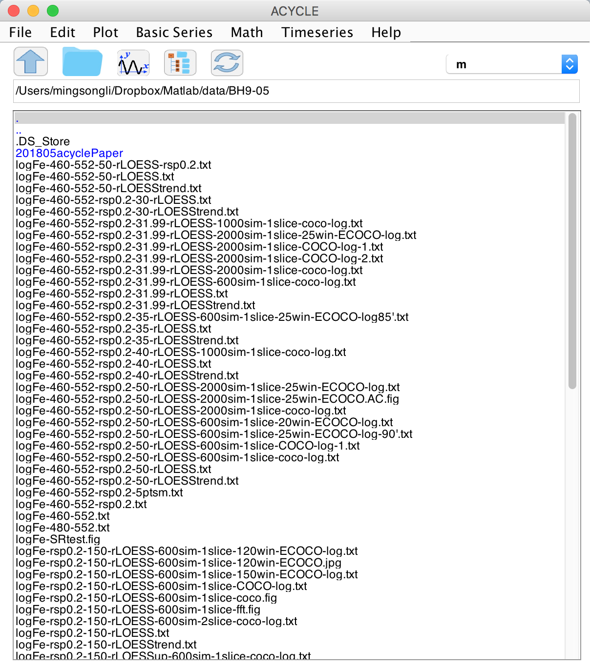

The GUI of the *Acycle* program

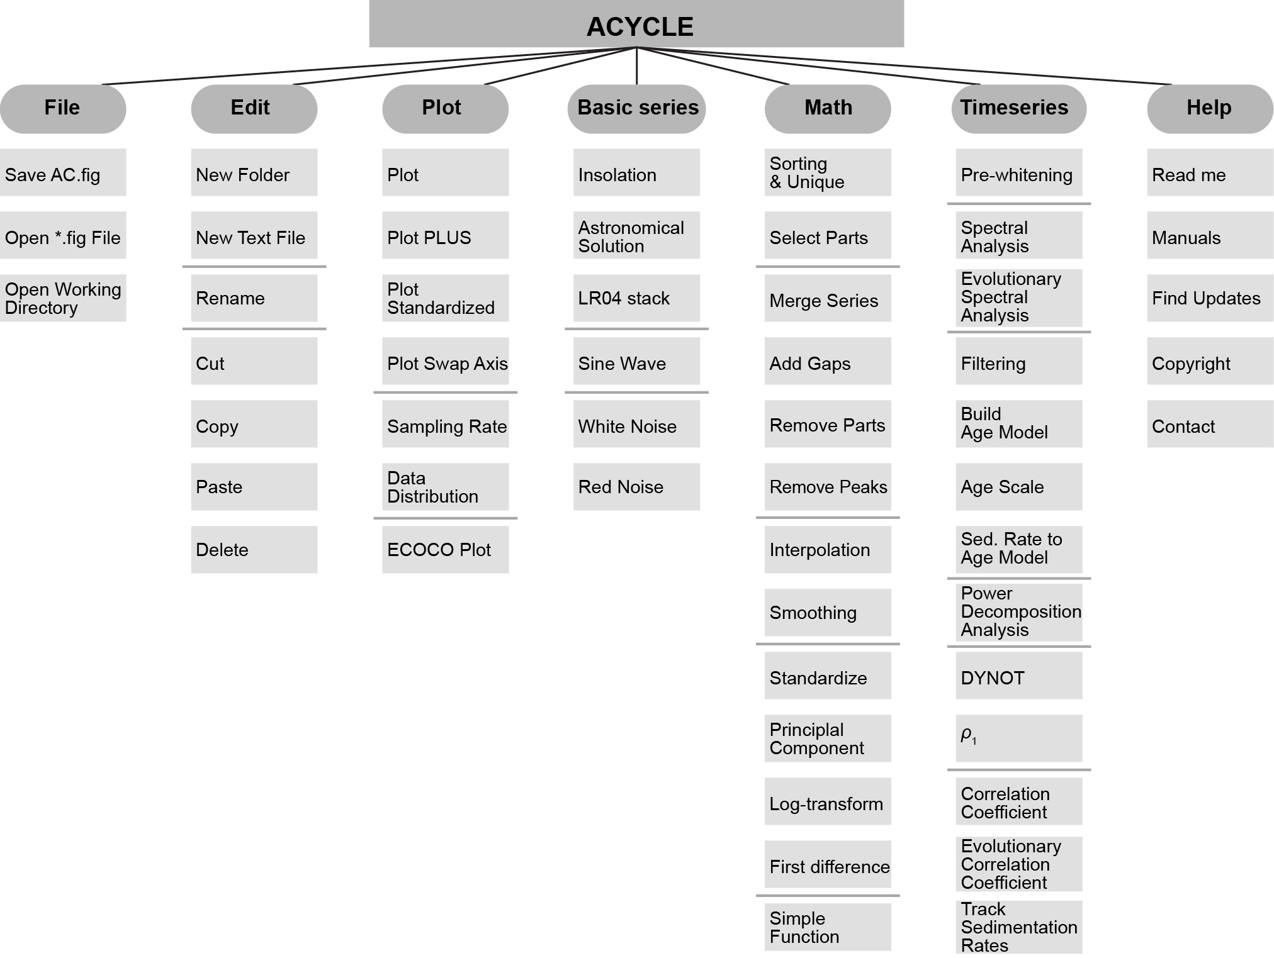

The structure of the *Acycle* program

## **4.2 File**

**New Folder:**

make a new empty folder with a user-defined folder name.

**New Text File:**

make a new empty *.txt file with a user-defined file name.

**Save *.AC.fig file:**

Save the current figure as an *.ac.fig file. This file enable users continue a suspended project.

For example, after running the eCOCO (evolutionary correlation coefficient), users may want to plot the eCOCO results anytime. One can save the current figure as an *.AC.fig file, then double click this *.AC.fig file and show “ECOCO plot” anytime.

## **4.3 Edit**

**Rename:**

Select one file, the “rename” function enable changing the name of the selected file.

**Cut/Copy/Paste/Delete:**

Just do it.

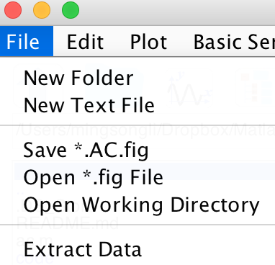 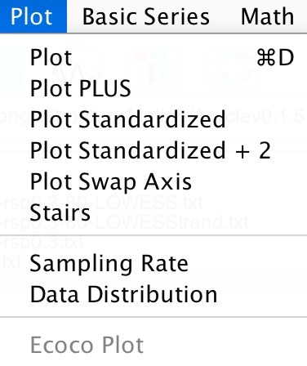

## **4.4 Plot**

**Plot:**

A quick plot of the selected data file. Shortcut [Mac]: ⌘ + D; [Windows]: Ctrl + D

**Plot PLUS:**

An advanced plot of the selected data file (GUI below). One can change plot type, line, and marker styles, and control the axis.

**Plot Standardized:**

A quick plot of the standardized data file. Useful if one wants to compare 2 or more series.

**Plot Standardized +2:**

A quick plot of the standardized data file. Useful if one wants to compare 2 or more series.

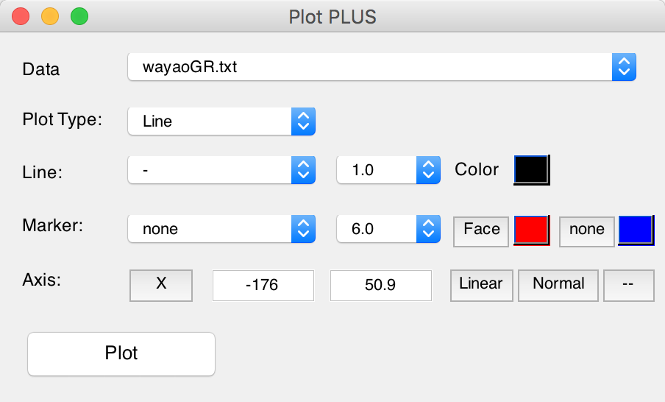**Plot Swap Axis:**

A quick plot, swap axis.

**Stairs:**

Stairs plot.

**Sampling Rate:**

A quick plot showing the distribution of the 1st column (time/depth) of the selected data file.

**Data Distribution:**

A quick plot showing the distribution of the 2nd column (data) of the selected data file.

**ECOCO Plot:**

Plot eCOCO results from a *.AC.fig, or after running the eCOCO (Timeseries-eCOCO).

## **4.5 Basic Series**

### **Insolation:**

A powerful GUI calculates the insolation using various astronomical solutions. Based on the MatLab code **inso.m** by Jonathan Levine (2001), UC Berkeley. This code was modified by Peter Huybers (Harvard) and edited by Mingsong Li (Penn State, 2018) for the *Acycle* software.

Only insolation series younger than 249,000 k.a. are available.

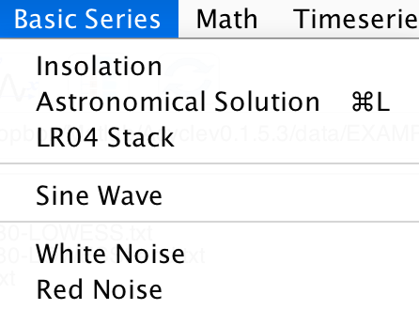 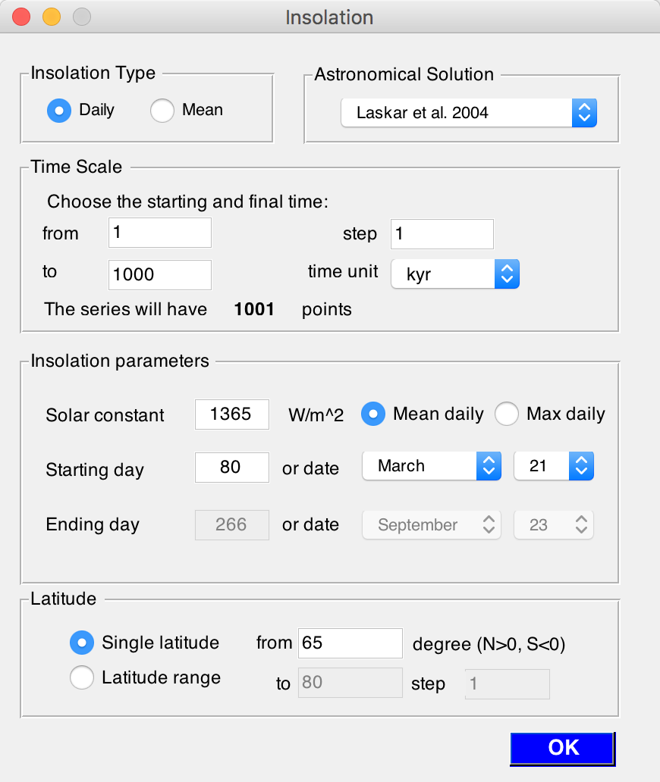

*This GUI generates mean daily insolation series on March 21 for the past 1000 kyr (1-1000) at 65°N using the Laskar et al. (2004) solutions. The calculate uses a solar constant of 1365 w/m2.*

[NOTE: one has to click the Refresh button  in the main window to see the generated insolation series]

### **Astronomical Solution:**

A GUI generates astronomical solutions of Laskar et al. (2004); Laskar et al. (2011), and Zeebe (2017).

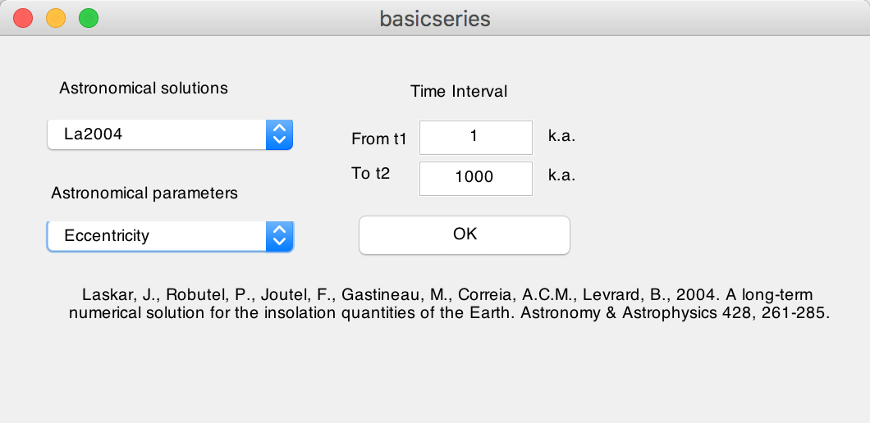

*This GUI generates eccentricity series for the past 1 million years from 1 k.a. throughout 1000 k.a. using the La2004 solution* (Laskar et al., 2004)*.*

[NOTE: one has to click the Refresh button  in the main window to see the generated insolation series]

### **LR04 Stack:**

This function generates the classical LR04 stack of the Plio-Pleistocene benthic d18O record (Lisiecki and Raymo, 2005). The input time (below) should be within the interval of 0 and 5320 (k.a.).

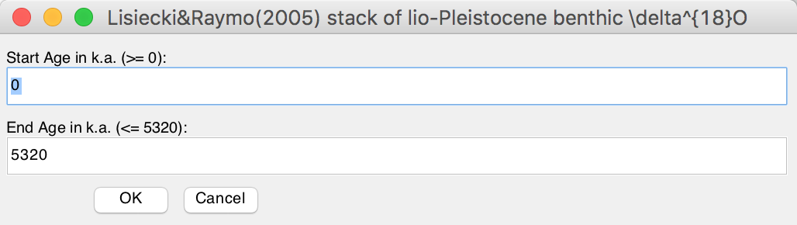

*This GUI generates LR04 stack from 0 to 5320 k.a.*

### **Sine Wave:**

Generate a sine wave using user-defined parameters and the following equation:

Y = A * sin(2π / T * X + Ph) + bias

Where A is amplitude, T is period, X is a time series ranges from *t1* to *t2* and a sampling rate of dt, Ph is the phase, and bias is signal bias.

### **White Noise:**

This function generates the white noise.

### **Red Noise:**

This function generates the red noise using user-defined standard deviation, and autocorrelation coefficient (RHO-1, from 0 to 1).

*This GUI generates a sine wave from 1 to 1000 unit with a sampling rate of 1 unit. Its amplitude is 1, with a period of 100 unit and zero phase shift and 0 signal bias.*

## **4.6 Math**

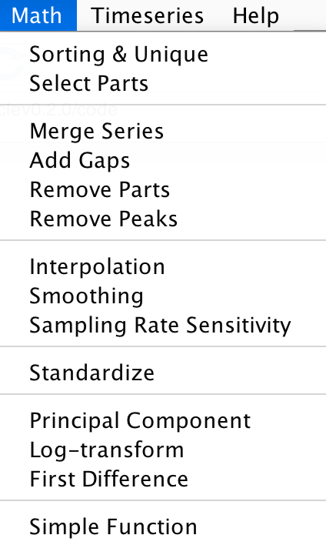

### **Sorting & Unique:**

This function will sort the selected data file like MS Excel’s SORT function. If a dataset contains 2 or more data points with the same time/depth, then these data points will be replaced by their mean value.

New file name: *-su.txt or *-s.txt or *-u.txt

### **Select Parts:**

This function generates a new series from the selected data using user-defined ‘start’ and ‘end’ of the interval.

New file name: *-a-b.txt, where a is the “start” and b is the “end”.

### **Merge Series:**

Two selected series may be merged if their first column are exactly the same.

New file name: mergedseries.txt.

### **Add Gaps:**

This function generates a new series based on the selected data file via adding a gap or gaps using user-defined location and duration of the gap(s). Format, comma delimited:

10.5, 3.2

*Add a 3.2-unit gap at the depth/time of 10.5 unit, or*

10.5, 3.2, 13.3, 1.5

*Add a 3.2-unit gap at the depth/time of 10.5 unit and add the second 1.5-unit gap at the depth/time of 13.3 unit.*

### **Remove Parts:**

This function generates a new series based on the selected data file via removing an user-defined interval(s). Format, comma delimited

15, 3, 20.2, 4

*Remove a 3-unit data at the 15 unit (remove 15-18-unit data), and remove the second interval of 20.2-24.2-unit.*

### **Remove Peaks:**

This function generates a new series based on the selected data file via converting any (2nd column) data higher than the user-defined Maximum value to that value and any data smaller than Minimum value to that value.

### **Interpolation:**

Linear interpolation using MatLab’s *interp1* function.

New file name: *-rsp0.3.txt, where 0.3 is user-defined interpolation sampling rate.

### **Smoothing:**

This function generates a new series based on selected data file using *n*-points smoothing, where *n* is a user-defined parameter.

New file name: *-3ptsm.txt, means 3 points smoothing output.

### **Standardize:**

Using MatLab’s *zscore* function.

Z = (X-u)/σ, where X is the second column data, u is the mean of X, and σ is the standard deviation of X.

New file name: *-stand.txt

### **Principal Component:**

This function has different requirements of the data inputs. All column (including the first column) of data should be value, not depth or time.

### **Log-transform:**

This function generates a new data file based on selected data file using log10 transformation of the second column of the selected data.

*Xi* = log10(*Xi*)

New file name: *-log10.txt

### **First Difference:**

Differences and approximate derivatives, using MatLab’s diff function.

*Y* = diff(*X*), calculates differences between adjacent elements of *X*.

New file name: *-1stdiff.txt

### **Simple Function**

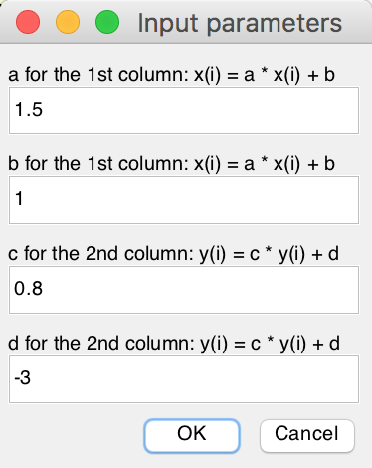This function is very useful. It generates a new data file based on the selected data file. Both columns (1st or X column and 2nd or Y column) can be modified. See below case study.

*X(i) = a * X(i) + b*

*Y(i) = c * Y(i) + d*

*The selected data: all value in the first column data will be transformed using the equation X(i) = 1.5 * X(i) + 1; and all value in the second column data will be transformed using the equation Y(i) = 0.8 * Y(i) + (-3).*

New file name: *-new.txt

## **4.7 Time series**

### **Prewhitening:**

This function generates 2 new data files based on the selected data file and user-defined parameters: window length and detrending method. Steps:

(1) Select a data file in the Main Window

(2) Select **Timeseries** 🡪 **Prewhitening** menu

(3) Type a window length or a percentage, or move the slider. Default value is 35% of the total length, that is, if a data length is 100 m, then a window is 35 m.

(4) Tick one or more prewhitening method

(5) Click OK button, wait for several seconds (up to a minute, depending on the speed of your CPU). A new window will popup showing the data and its 35% trend(s)

(6) In the “Select & Save Prewhitening Model” panel, select the preferred trend. The trend and detrended file will be displayed in the Main Window after user clicks the refresh button  in the Main Window.

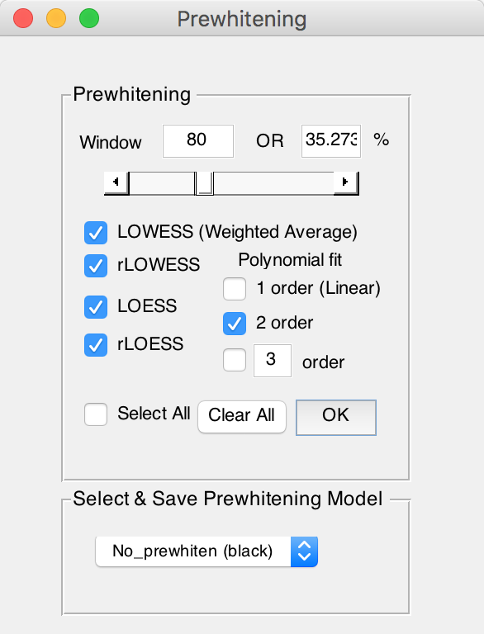 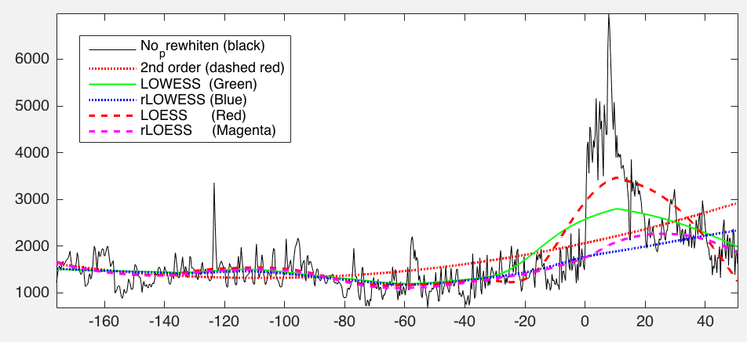

New file names: *-80-LOWESS.txt AND *-80-LOWESStrend.txt

### **Spectral Analysis:**

This function conducts spectral analysis with user-defined parameters. Steps:

(1) Select a data file in the Main Window

(2) Select **Timeseries** 🡪 **Spectral Analysis** menu

(3) Select one method for spectral analysis. Options are Multi-taper method (MTM) (Thomson, 1982), Lomb-Scargle spectrum (Lomb, 1976; Scargle, 1982), and MatLab’s periodogram.

(4) If Multi-taper method (MTM) is selected, then the Method panel may be changed. The default value is using 2π MTM, with a 5X zeropadding.

(5) Plot panel: set the max frequency in the coming figure.

(6) Red Noise panel: AR(1) noise model using RedNoise.m by Husson (2014) and modified by Linda Hinnov.

(7) Run or Run & Save button, generates power spectrum (and save power spectrum data and AR(1) series)

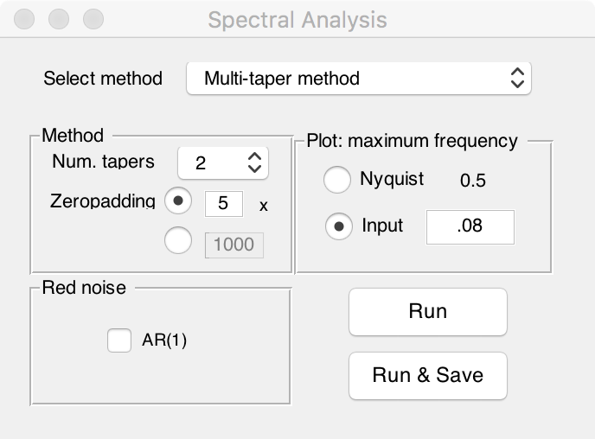 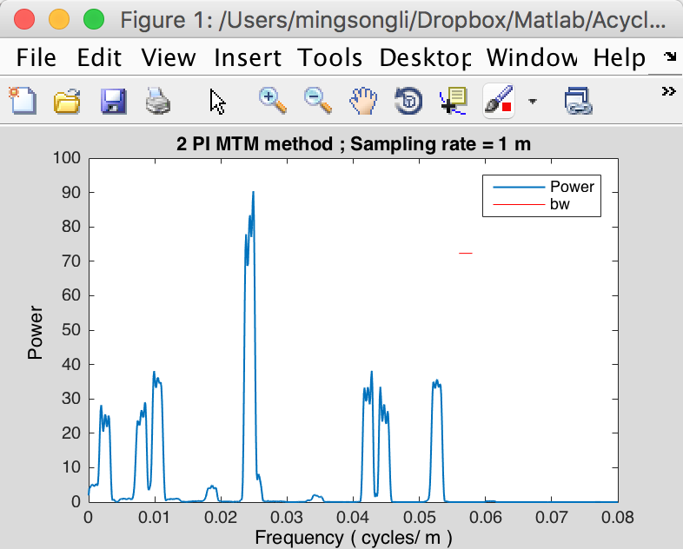

*2π MTM power spctrum of the La2004 astronomical solution (0-2 Ma)*

New file name: *-2piMTM-CL.txt, means 2π MTM and confidence level series.

### **Evolutionary Spectral Analysis:**

This function conducts evolutionary spectral analysis with user-defined parameters. Steps:

(1) Select a data file in the Main Window.

*Warning: The data file must be an evenly spaced depth/time series.*

(2) Select **Timeseries** 🡪 **Evolutionary** **Spectral Analysis** menu

(3) Select Method. The default method is Fast Fourier transform (LAH) by Linda A. Hinnov (Kodama and Hinnov, 2015). Other options are MatLab’s Fast Fourier transform and periodogram, multi-taper method (MTM) (Thomson, 1982), and Lomb-Scargle spectrum (Lomb, 1976; Scargle, 1982).

(4) Input for evolutionary spectral analysis panel includes settings for plot frequencies. Default values from 0 to Nyquist (*f*nyq = 1 / (*N* * *Δt*)), where N is the total number of data, and *Δt* is the sampling rate.

(5) Step of sliding windows. The default value should be sufficient for most paleoclimate projects. The unit may be *m*, *kyr*, etc.

(6) Sliding Window: **very important!** The length of the sliding window. The default value is 35% of the total length of the selected data. Tips: assuming the data series is dominated by 35 m cycles, the window may be 2-4 times of 35 m, that is, 70 to 140 m. A large window can smooth out the higher frequencies signals while a small window cannot detect low-frequency signals.

(7) Plot-dimension: 2D or 3D with rotation option.

(8) Flip Y-axis: give me a try.

(9) OK button: generates a new figure showing the evolutionary spectral analysis results. No new files generated automatically.

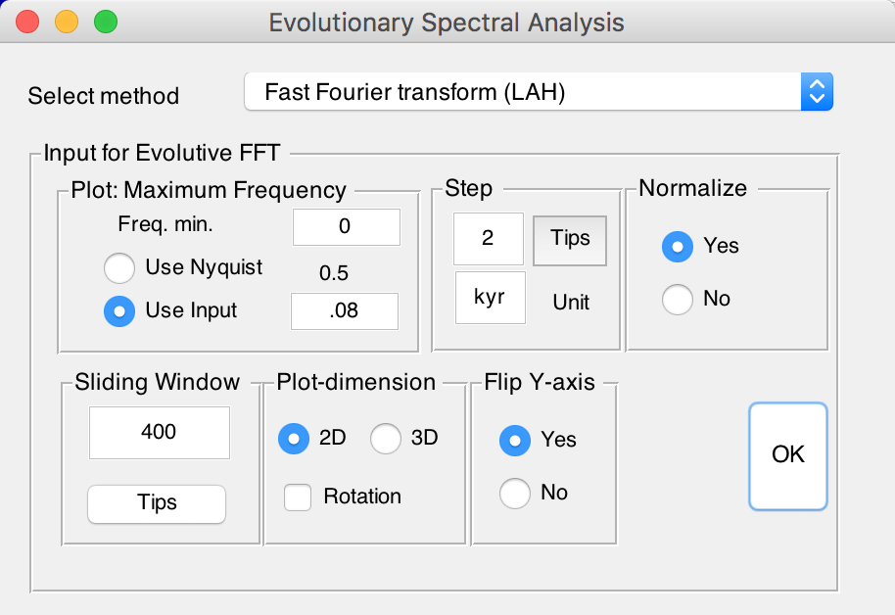 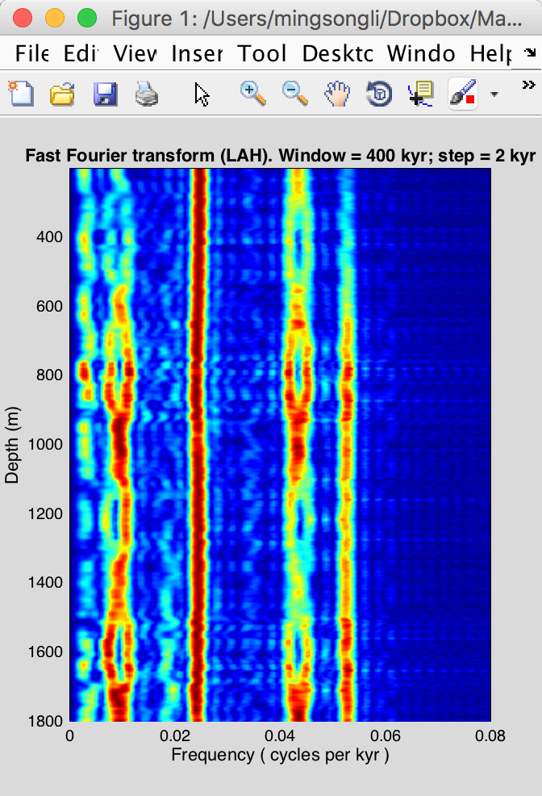

*Evolutionary FFT of the La2004 astronomical solutions using a 400 kyr sliding window and 2 kyr step*

### **Filtering:**

This function generates a filter output series based on the selected data file with user-defined parameters. Steps:

(1) Select a data file in the Main Window.

*Warning: The data file must be an evenly spaced depth/time series.*

(2) Select **Timeseries** 🡪 **Filtering** menu

(3) **Bandpass filter** panel: very important! Type min and center frequencies of the passband, the max frequency will be set automatically. The bandpass filters are MatLab’s Butter, Cheby1, and Ellip filters and Gaussian, and Taner-Hilbert filters. The recommended filters are Gaussian filter and Taner-Hilbert filters code by Linda Hinnov (Kodama and Hinnov, 2015).

*Tips: The Taner-Hilbert filter generates both filtered output series and the amplitude modulation of the filtered output series.*

Click Save Data button, the filter outputs will be displayed after clicking the refresh button  in the Main Window.

(4) **Highpass and lowpass** panel: Two options are MatLab’s Butter and Ellip filter. Type cutoff frequency in the text box and select a filter.

Click Save Data button, the filter outputs will be displayed after clicking the refresh button  in the Main Window.

(5) Power spectrum plot: give options for display the power spectrum in the right of the GUI.

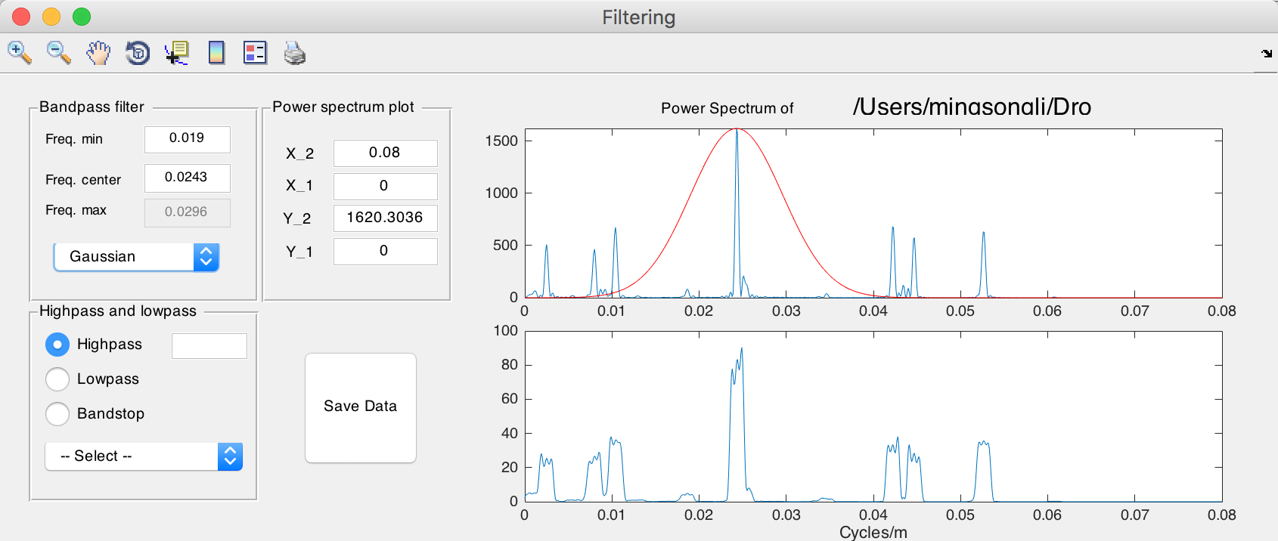

New file name: *-gaus-0.0243+-0.0053.csv, means filtered output series using gauss filter and a 0.0243 ± 0.0053 cycles/unit bandpass.

*-Tan-0.03+-0007.csv and *-Tan-0.03+-0007-AM.csv, mean filtered output series using Taner-Hilbert filter and a 0.03 ± 0.007 cycles/unit bandpass, with its amplitude modulation file saved.

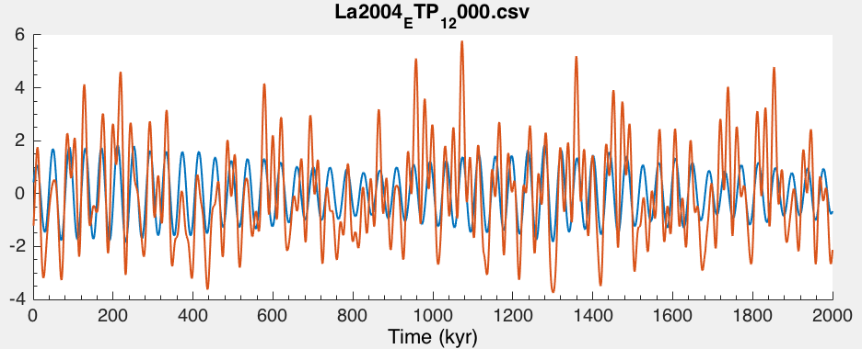

*Plot original La2004 solutions and filtered 41 kyr cycles*

### **Build Age Model:**

This function generates an age model file from a filter output data file. Steps:

(1) Assuming the filtering wavelength generates a filtered 35 m cycle series. The 35 m cycles are assumed to be 405 kyr long eccentricity cycles. This filtered data file should be selected.

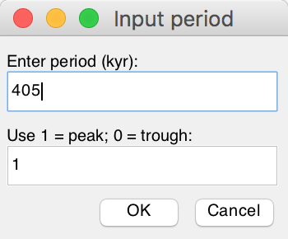(2) Select **Timeseries** 🡪 **Build Age Model** menu

(3) In the pop-up window, enter 405 and 1, and click OK button. This generates a new age model series via assigning every peak of 35 m cycles as peaks of the 405 kyr cycles.

New file name: *-agemodel-405-max.csv,

means an age model file using filtered wavelength peaks as 405 kyr anchors.

### **Age Scale:**

This function conducts depth-to-time transformation in a new standalone GUI. Steps:

(1) Select 1 (ONE) age model file, click the top ==> button to record this file as an age model file.

(2) Select 1 or more data files, click the bottom ==> button to record this file (these files) as series needs to be transformed.

(3) Click the OK button. The transformed series can be displayed after clicking the Refresh button  in the Main Window.

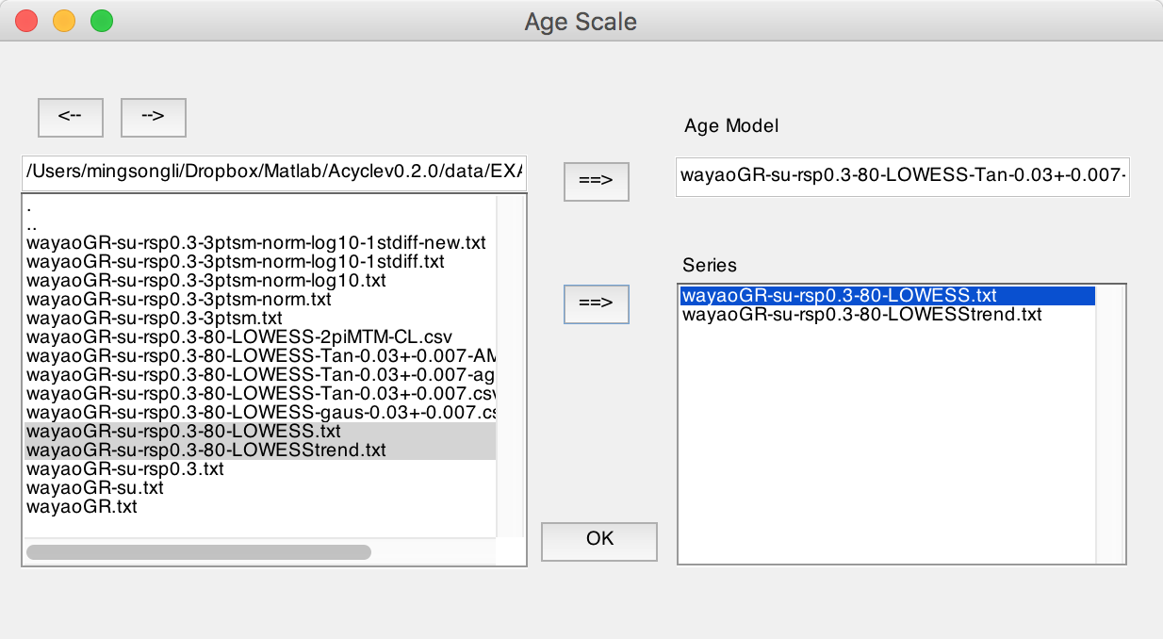

New file name(s): *-TD-name-of-agemodel-file.csv

*(Tips) Change directory using <-- or --> button*

### **Sedimentary Rate to Age Model:**

Assuming you want to generate an age model file from a sedimentary rates file (2 columns: depth and sedimentation rate), this function generates the age model working well with acycle software.

### **Power Decomposition Analysis:**

This function subtracts power/variance within a user-defined frequency band. The code written by Mingsong Li and Linda Hinnov has been published in Li et al. (2016). Time-dependent amplitude modulations in the obliquity component were obtained from 2π multi-taper variance (power) spectra calculated along a sliding time window (Meyers et al., 2012) using the Matlab script *pda.m* (also available at <https://doi.pangaea.de/10.1594/PANGAEA.859147)>. Steps:

(1) Select the original data file.

Warning: The data must be evenly spaced data in the first column. And the unit must be in kyr.

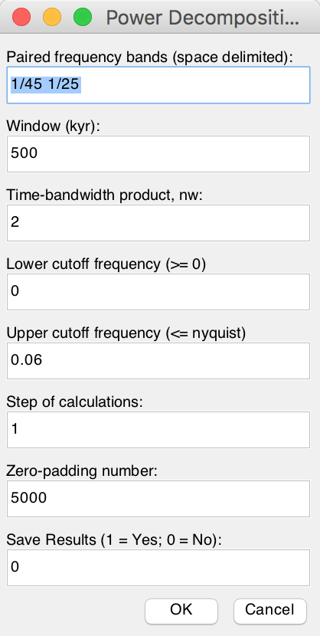(1) Type paired frequency bands; space delimited. If a dominated frequency is 1/33, then a 1/45 1/25 frequency band is used

(2) Sliding window in kyr, a 500 kyr is used in Li et al. (2016)

(3) Time-bandwidth product, ‘2’ means 2π MTM method will be used.

(4) cutoff frequencies, min = 0, max should cover all Milankovitch frequencies.

### **DYNOT:**

Dynamic noise after orbital tuning. Detect non-orbital variances from a tuned series. See **Chapter 5.** **DYNOT model Description**. See Li et al. (2018a) for details about this method.

### **ρ1 method:**

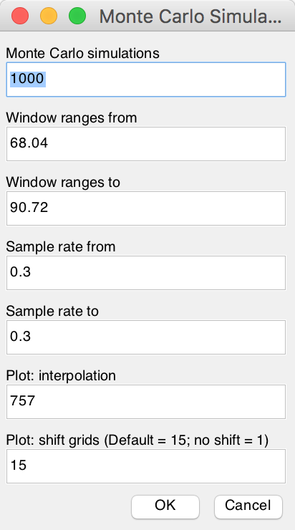This function conducts either single run or Monte Carlo simulations of lag-1 autocorrelation coefficient (***ρ*1**) using a sliding window. It works with both depth series and time series.

The “Single run” requires the input of “window” and “interpolation sampling rate”.

The “Monte Carlo” requires several parameters: Number of Monte Carlo simulations (default is 1000), sliding window ranges from *win1* to *win2*, and a sampling rates from *sr1* to *sr2*, and plot settings (interpolation and shift grid).

See Li et al. (2018a) for details about the parameters and significance of this method.

### **Correlation Coefficient (COCO):**

This function addresses two fundamental issues in cyclostratigraphy and paleoclimatology: identification of astronomical forcing in sequences of stratigraphic cycles, and accurate evaluation of sedimentation rates. The technique considers these issues part of an inverse problem and estimates the product-moment correlation coefficient between the power spectra of astronomical solutions and paleoclimate proxy series across a range of test sedimentation rates. The number of contributing astronomical parameters in the estimate is also considered. Our estimation procedure tests the hypothesis that astronomical forcing had a significant impact on proxy records. The null hypothesis of no astronomical forcing is evaluated using a Monte Carlo simulation approach. Details are included in (Li et al., 2018b).

**Step 1: settings for generating target power spectrum**

Select a depth series (interpolated, detrended), select **Timeseries --> Correlation Coefficient** menu

Note: the data series must have a unit in meter.

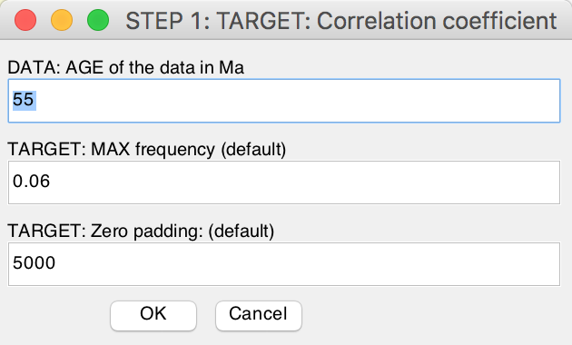Type the approximate age for the depth series, the unit is million years ago (Ma).

Target frequency ranges from 0 cycle/kyr to the given “MAX frequency”. Default values are recommended for the depth series with age less than 250 Ma. For the depth series older than 250 Ma, the MAX frequency may be set to 0.08. This is because the precession cycle can be very short than 16 kyr.

**Step 2: astronomical solution [optional]**

If the age of the data in Ma is larger than 249 Ma, users need to select which astronomical solution should be used.

1 = Berger89 solution (Berger et al., 1989),

2 = Laskar 2004 solution (Laskar et al., 2004),

3 = user-defined solution and the second box should be filled by 7 astronomical periods.

Online resource for user-defined astronomical parameters may be found at <http://nm2.rhul.ac.uk/wp-content/uploads/2015/01/Milankovitch.html> (Waltham, 2015).

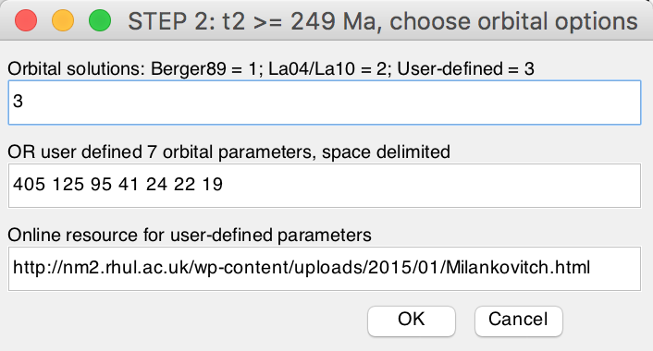

**Step 3: settings for generating data power spectrum**

MIN sedimentation rate (cm/kyr):

MAX sedimentation rate (cm/kyr):

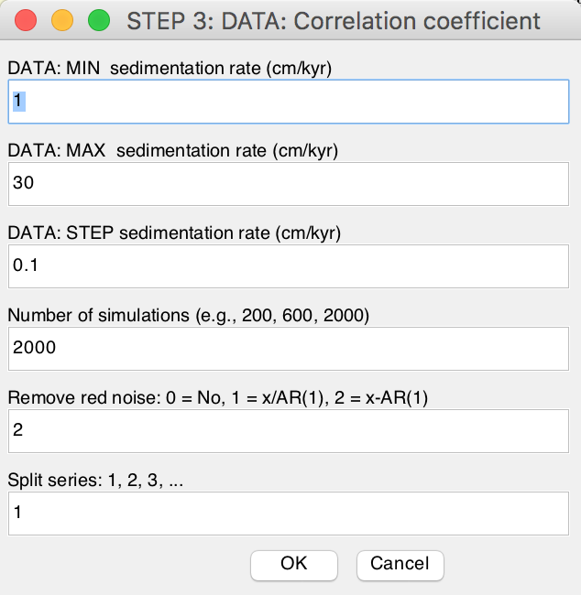STEP sedimentation rate (cm/kyr): tested sedimentation rates range from *MIN* to *MAX*, with a step of *STEP* cm/kyr. In the following example, the tested sed. rates are 1, 1.5, 2, 2.5, 3, …, 29.5, and 30 cm/kyr.

Number of simulations: 200-600 simulations are suggested for an initial run. And 2000 simulations generate publication quality results.

Remove red noise: 0 = no removing; else removing red noise:

1 = power spectrum / AR(1) series and those less than AR(1) series are set to 0;

2 = power spectrum - AR(1) series and those less than 0 are set to 0.

Split series: 1, 2, 3. The series is split into 2 or more slices.

Click the OK button, Monte Carlo simulation steps can be displayed in the Command Window of MatLab. A log file will be generated recording all parameters used in the correlation coefficient analysis. The user needs to decide which figure output should be saved or not.

### **Evolutionary Correlation Coefficient (eCOCO):**

The method is applied using a sliding stratigraphic window to track variable sedimentation rates along the proxy series, in a procedure termed “eCOCO” (evolutionary correlation coefficient) analysis. (Li et al., 2018b)

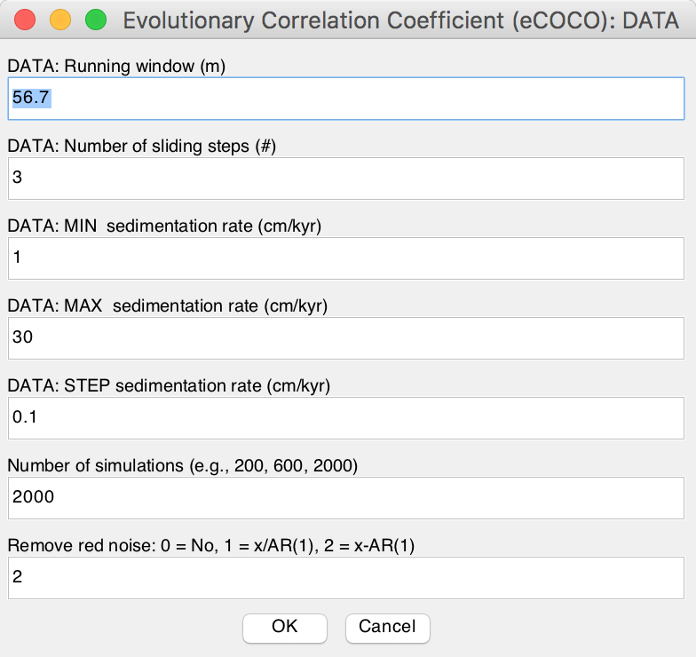Waning: the data series must have a unit in meter.

Step 1: same as that in COCO.

Step 2: same as that in COCO.

Step 3: most parameters are the same as those in COCO (see above). Two new parameters:

DATA: running window (m): default window is 35% of the total length of the data series.

DATA: Number of steps (#): sliding steps. The default value will give about ~300 sliding windows for publication quality results.

Click the OK button, Monte Carlo simulation steps can be displayed in the Command Window of MatLab. A log file and the related *.AC.fig file will be generated recording all parameters used in the evolutionary correlation coefficient analysis. The user needs to decide which figure output should be saved or not.

Tips: Users may save the main window using “File” 🡪 “save ac.fig” menu anytime. This will save the data stored in the main window figure, and the user doesn’t have to re-run the eCOCO using the same parameters.

Tips: User can plot eCOCO results anytime at “Plot” 🡪 “ECOCO plot” menu.

Q: Which window should I use?

A: Well, if your series is dominated by 35 m cycles (405 kyr), then a 70 m window (= 35 *2) may be good to keep the balance: A large window eCOCO losses resolution of variable sedimentation rates, and a small window may not give correct results.

### **Track Sedimentation Rates:**

*Not finish yet…*

## **4.8 Help**

### **Readme**

Update log

### **Manuals**

Open the folder of user’s guide

### **Find Updates**

Visit our website to find updates of acycle software.

[www.mingsongli.com/acycle](http://www.mingsongli.com/acycle)

<https://github.com/mingsongli/acycle>

### **Copyright**

### **Contact**

# **5. DYNOT model Description**

*Li et al. (2018a)* *developed a dynamic noise after orbital tuning, or DYNOT model for the*

*recognition of sea-level variations based on the dynamic non-orbital signal in climate proxy records after subtracting orbital, i.e., astronomically forced climate signal. The DYNOT model is*

*supplemented by a second, independent lag-1 autocorrelation coefficient, or ρ1 model, which forms the basis of a well-established statistical method for red noise estimation of time series. DYNOT and ρ1 modeling of a GR series of ODP Site 1119 over the past 1.4 myr correlates with the classic low-passed δ18O sea-level curve, demonstrating the efficacy of the sedimentary noise model.*

## **5.1 Startup**

*\* Timeseries - DYNOT*

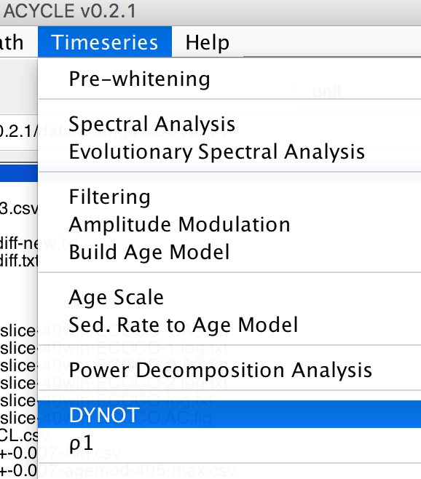

Fig. 1. MatLab workspace for the DYNOT model.

The DYNOT sea-level model GUI is as follows (Fig. 2):

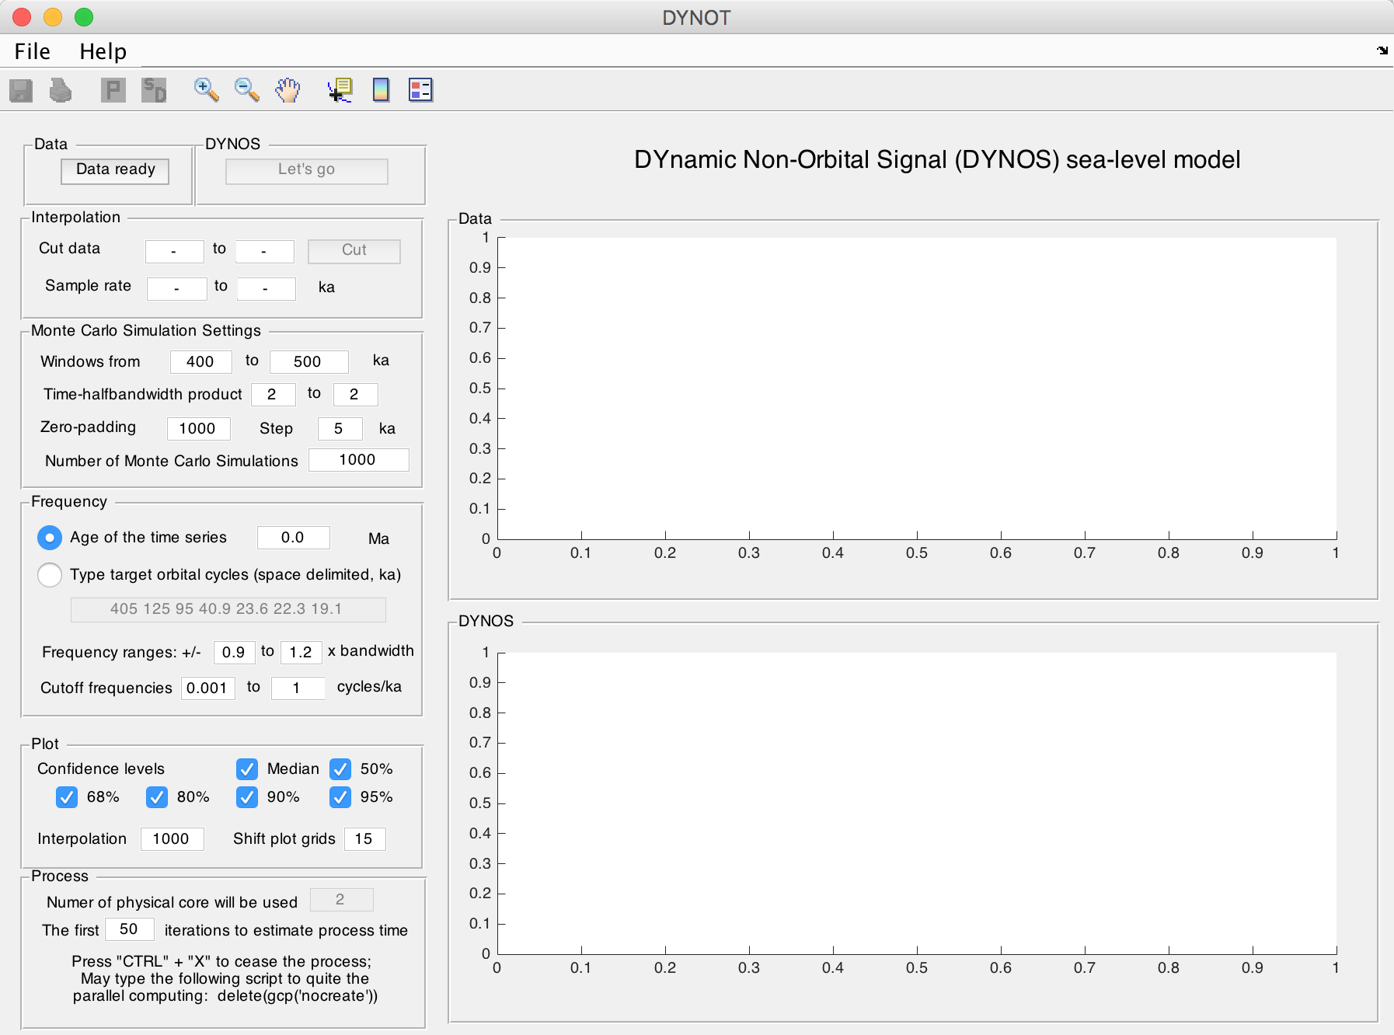

Fig. 2. The DYNOT model

## **5.2 Import Data**

*data for the DYNOT model (support data in *.csv and *.txt format)*

Name: data

Length: m × 2 % must be a 2-column dataset

Column 1: time % unit must be in ka;

Column 2: value

**Notes**:

**#1:** Proxy data is assumed to be sensitive to water-depth related noise at your section/core.

**#2:** There is no requirement for interpolation, normalization, or removing long-term trend (i.e., pre-whitening) of the dataset.

**#3:** Extreme values should be removed.

**#4:** Both increasing-upward and decreasing-upward time series are valid.

***from *.txt or *.csv file***

In the DYNOT menu: Select “File” 🡪 “Import Data (*.txt, *.csv) ” 🡪 Select data (chose “1119_gr_1400de_finetuned.txt” or “1119_gr_1400de_finetuned.csv”) 🡪 Click “Open ”

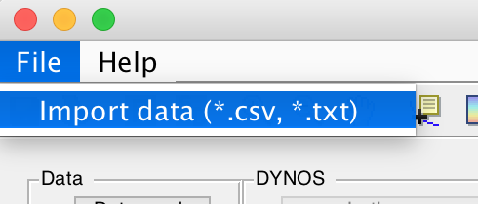

Fig. 3. Load data to DYNOT model.

## **5.3 Settings**

*Yellow: load data and run the model.*

*Red: Key settings. Check before running the model.*

*Green: Optional settings. Default values are okay for most running.*

5.3.0. Click on Data ready (button) to load data into the DYNOT model.

5.3.1. Cut data (*optional*): These settings automatically show the beginning and the end of the time series, i.e., time span of dataset. Unit is ka. If you want to choose a different interval, just type two new ages and click Cut button.

5.3.2. Sampling rates (*optional*): These show a range of sample rates covering 90% of sample rates (Green Box 20 in Fig. 4). Unit is ka. A Monte Carlo method of hypothesis testing and the multi-taper method (MTM) of power spectral analysis are to be undertaken, and so resampling must be applied. Sampling rates of proxy datasets in time are always greater than zero and so are non-normally distributed. Therefore, the Weibull distribution is used to represent sampling rate distributions for uncertainty analysis in the DYNOT model. To avoid an ultra-low or ultra-high, unrealistic sampling rate created by the Weibull distribution algorithm, we set the 5th and 95th percentiles of sampling rates of of the data as default, lower and upper limits of the generated, Weibull-distributed sampling rates.

5.3.3. **Windows**: These values set sliding window range. Moving window length in units of time (<< total data length). Unit is ka.

Different windows in the DYNOT model can affect results in two ways.

(1) The DYNOT model with a large window will shorten DYNOT results, and the model with a small window will generate longer DYNOT results, *Nr* = *Ndata* – *window* + 1, where *Nr* is total number of DYNOT values of each simulation, *Ndata* is total number of interpolated data points, and *window* is the running window employed.

(2) The DYNOT model with a small running window generates higher resolution results, however, the variance of low-frequency cycles and total variance diminish simultaneously, which leads to increased uncertainty in non-orbital signal ratio estimation.

The DYNOT model with a small running window also increases the MTM power spectrum bandwidth (i.e., reduces frequency resolution). The expected sea-level variations of interest in the Early Triassic are 104 to 106 year-scale, i.e., the fifth to third-order sequences, therefore a comparable or shorter time window (e.g., 300-500 kyr, 400 kyr or shorter) should be adopted for DYNOT modeling.

5.3.4. Time-bandwidth product (*optional*): Time-bandwidth product of discrete prolate spheroidal sequences used for window. Typical choices are 2, 5/2, 3, 7/2, 4.

5.3.5. Zero-padding (*optional*). zero-padding number, e.g., 1000.

5.3.6. Step (*optional*). step of calculations; default is 5 ka.

5.3.7. **Number of Monte Carlo Simulations:** default is 1000. Maybe use 100 or 300 for a trial running. Recommended value for publication is >5000.

5.3.8. **Age of the time series**: The age in Ma will be used to estimated target orbital cycles in 5.3.9. You can use either 5.3.8 or 5.3.9 to tell the DYNOT model the target cycles.

5.3.9. **Target orbital cycles** (space delimited, in ka): 6 orbital cycles of long-eccentricity (405), short-eccentricity (125 and 95), obliquity (40.9 or shorter), precession (23.6, 22.3, and 19.1 or shorter). This is age dependent (see 7.8). The 405, 125, and 95 kyr cycles are assumed to be invariant through time. While the obliquity = 41-0.0332*age; precession 1 = 23.75-0.0121*age; precession 2 = 22.43-0.0121*age; precession 3=19.18-0.0079*age. These calculations are from Yao et al. (2015), and are based on the La2004 astronomical model (Laskar et al., 2004).

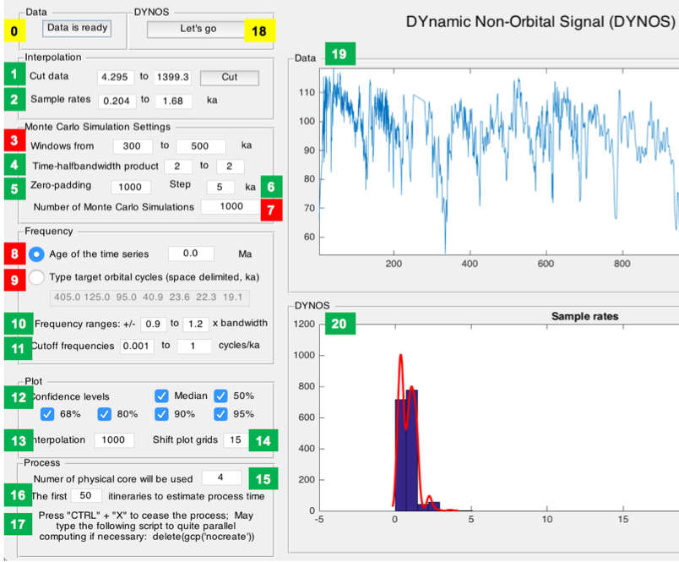

Fig. 4. Settings of the DYNOT model.

*Yellow: load data and run the model.*

*Red: Key settings. Check before running the model.*

*Green: Optional settings. Default values are okay for most running.*

5.3.10. Frequency ranges (*optional*): For the definition of the non-orbital signal ratio by Li et al. (2018a), cutoff frequencies and their bandwidths are crucial for estimation of variances of eccentricity, obliquity and precession signals. We vary each cutoff frequency assuming a uniform distribution with cutoff frequency ranges at ± 90% to ± 120% bandwidth. Here the bandwidth (*bw*) equals *nw*/*window*, where *nw* is time-bandwidth product of discrete prolate spheroidal sequences, and *window* is the running window.

5.3.11. Cutoff frequencies (*optional*): lower cutoff frequency (> 0) for estimation of total variance and upper cutoff frequency (< Nyquist frequency) for estimation of total variance.

5.3.12. Confidence levels (*optional*): default values show median and confidence levels (e.g., 50%, 68%, 80%, 90%, and 95%) of the DYNOT results.

5.3.13. Interpolation (*optional*): In 5.3.3, a smaller *Nr* compared to *Ndata* leads to a “no data” effect at the very beginning and/or very end of the DYNOT results. To avoid this problem and to provide a better constraint for noise estimation, technically, the DYNOT model is interpolated and randomly shifts and plots simulation results of a single iteration at the same time scale of the dataset, although the plots also generate relatively smoothed DYNOT spectra when a gap is shorter than 2 × *window*. Here 1000 is adequate for the DYNOT model.

5.3.14 Shift plot grids (*optional*): See 5.3.13 for interpretation. Default is 15. One can also use 15-30 for the better shape of the beginning and the end of the DYNOT spectra.

5.3.15. Number of physical cores (*optional*): This detects the physical cores of the CPU of the computer.

5.3.16. Number of itineraries to estimate the process time (*optional*): To estimate process time of the time-consuming DYNOT model, the model will run some itineraries. Default is 50.

5.3.17. Emergency note: Press “Ctrl” + “C” to cease the DYNOT process before the parallel computing. Press “Ctrl” + “X” to cease the DYNOT process during the parallel computing. You may need to type the following script in the command window to quite parallel computing.

>> delete(gcp(‘nocreate’))

5.3.18. Click the button to run the model.

5.3.19. A window shows the dataset.

5.3.20. A window shows sample rates of the dataset OR the DYNOT spectrum of the dataset.

## **5.4. Running the DYNOT model**

Click the Let’s go button to run the DYNOT code. In the command window, the estimated running time will appear:

16:21:20 Begin the process ...

16:22:54 First 50 iterations suggest: remain >= 0h:7m:27sec

% The model runs the first 50 iterations to estimate that the total running time will last ca. 7 minutes 27 seconds. The real run-time may be 10s seconds to several minutes longer than this estimate.

Starting parallel pool (parpool) using the 'local' profile ... connected to 4 workers.

16:23:07 Current iteration takes 1.11 seconds

16:23:08 Current iteration takes 1.21 seconds

16:23:15 Current iteration takes 1.19 seconds

16:26:26 Current iteration takes 1.38 seconds

% Start parallel computing and show time of each iteration.

Parallel pool using the 'local' profile is shutting down.

>> Done. % Stop parallel computing and display the DYNOT result (Fig. 5).

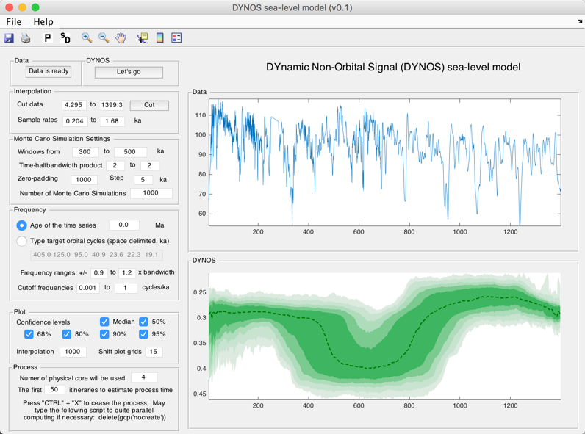

Fig. 5. DYNOT sea-level model of the gamma-ray series at ODP site 1119 from 0 to 1.4 Ma.

## **5.5. Output Files**

After running the DYNOT model, the GUI menu (Fig. 6) can be used to:

#1: save a MatLab-fig in the working directory entitled “plots_.fig”.

#2: save a PDF file of the plots in the working directory entitled “plots_.pdf”

#3: pop-up display the DYNOT spectrum in a new window.

#4: save DYNOT output data in the working directory entitled “result_handles.mat”.

**Caution: Change names of output files, or they will be overwritten by new files.**

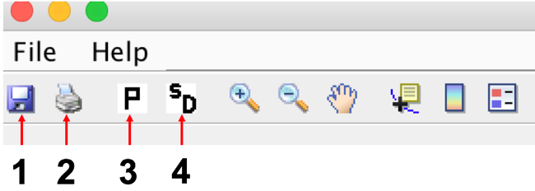

Fig. 6. Output files

# **References:**

Berger, A., Loutre, M., Dehant, V., 1989. Influence of the changing lunar orbit on the astronomical frequencies of pre‐Quaternary insolation patterns. Paleoceanography 4, 555-564.

Husson, D., 2014. MathWorks File Exchange: RedNoise_ConfidenceLevels, <http://www.mathworks.com/matlabcentral/fileexchange/45539-rednoise-confidencelevels/content/RedNoise_ConfidenceLevels/RedConf.m>.

Kodama, K.P., Hinnov, L., 2015. Rock Magnetic Cyclostratigraphy. Wiley-Blackwell.

Laskar, J., Fienga, A., Gastineau, M., Manche, H., 2011. La2010: a new orbital solution for the long-term motion of the Earth. Astronomy & Astrophysics 532. doi: 10.1051/0004-6361/201116836.

Laskar, J., Robutel, P., Joutel, F., Gastineau, M., Correia, A.C.M., Levrard, B., 2004. A long-term numerical solution for the insolation quantities of the Earth. Astronomy & Astrophysics 428, 261-285.

Li, M., Hinnov, L.A., Huang, C., Ogg, J.G., 2018a. Sedimentary noise and sea levels linked to land–ocean water exchange and obliquity forcing. Nature communications 9, 1004. doi: 10.1038/s41467-018-03454-y.

Li, M., Huang, C., Hinnov, L., Ogg, J., Chen, Z.-Q., Zhang, Y., 2016. Obliquity-forced climate during the Early Triassic hothouse in China. Geology 44, 623-626.

Li, M., Kump, L.R., Hinnov, L.A., Mann, M.E., 2018b. Tracking variable sedimentation rates and astronomical forcing in Phanerozoic paleoclimate proxy series with evolutionary correlation coefficients and hypothesis testing. Earth and Planetary Science Letters 501, 165-179.

Lisiecki, L.E., Raymo, M.E., 2005. A Pliocene‐Pleistocene stack of 57 globally distributed benthic δ18O records. Paleoceanography 20. doi:10.1029/2004PA001071.

Lomb, N.R., 1976. Least-squares frequency analysis of unequally spaced data. Astrophysics and Space Science 39, 447-462.

Meyers, S.R., Sageman, B.B., Arthur, M.A., 2012. Obliquity forcing of organic matter accumulation during Oceanic Anoxic Event 2. Paleoceanography 27. doi: 10.1029/2012pa002286.

Scargle, J.D., 1982. Studies in astronomical time series analysis. II-Statistical aspects of spectral analysis of unevenly spaced data. The Astrophysical Journal 263, 835-853.

Thomson, D.J., 1982. Spectrum estimation and harmonic analysis. Proceedings of the IEEE 70, 1055-1096.

Waltham, D., 2015. Milankovitch Period Uncertainties and Their Impact On Cyclostratigraphy. Journal of Sedimentary Research 85, 990-998.

Yao, X., Zhou, Y., Hinnov, L.A., 2015. Astronomical forcing of a Middle Permian chert sequence in Chaohu, South China. Earth and Planetary Science Letters 422, 206-221.

Zeebe, R.E., 2017. Numerical Solutions for the orbital motion of the Solar System over the Past 100 Myr: Limits and new results. The Astronomical Journal 154, 193.