**DYnamic Non-Orbital Signal (DYNOS)   
sea-level model**

version 0.1

**User’s Guide**

**Mingsong Li, Linda Hinnov, Chunju Huang**

China University of Geosciences, Wuhan

George Mason University, Fairfax

May 1, 2017

**Content**

1. **Copyright**
2. **References**
3. **Software Specifications**
4. **DYNOS model Description**
5. **Input Data**
6. **Load data**
7. **Settings**
8. **Running the model**
9. **Output Files**
10. **References**

**1. Copyright**

Copyright (C) Mingsong Li.

This program is free software; you can redistribute it and/or modify it under the terms of the GNU General Public License as published by the Free Software Foundation; version 3 of the License.

This program is distributed in the hope that it will be useful, but WITHOUT ANY WARRANTY; without even the implied warranty of MERCHANTABILITY or FITNESS FOR A PARTICULAR PURPOSE. See the GNU General Public License for more details.

The original author reserves the right to license this program or modified versions of this program under other licenses at our discretion.

Any questions regarding this license or the operation of this software may be directed to:

*Mingsong Li*

*Department of Geosciences, Penn State University*

*mul450@psu.edu or limingsonglms@gmail.com*

*410 Deike Bldg, University Park, PA 16802, USA*

[*www.mingsongli.wixsite.com/home*](http://www.mingsongli.wixsite.com/home)

**2. References**

If you publish results generated by this model please cite the following references:

1. Li, Mingsong, Hinnov, Linda, Chunju Huang. (in revision), Land-ocean water balance dynamics and sea-level change in the Early Triassic hothouse, *PNAS*.

2. Li, Mingsong, Huang, Chunju, Hinnov, Linda, Ogg, James, Chen, Zhong-Qiang, Zhang, Yang, 2016. Obliquity-forced climate during the Early Triassic hothouse in China. *Geology* 44, 623-626. doi: 10.1130/G37970.1

**3. Software Specifications**

***3.1 System Requirements***

A graphical user interface (GUI) for the DYNOS sea-level model is available and runs in MatLab version 2015b. This GUI was tested in Mac OS El Capitan system.

***3.2 Downloading and locating DYNOS model folder***

The DYNOS model package is available for download from http://doi.org/10.1073/pnas.XXX or <http://www.mingsongli.wixsite.com/home>.

**4. DYNOS model Description**

***4.1 Change the MatLab working directory to the “DYNOS” folder*** *(Fig. 1).*

*\* Always stay in the “DYNOS” folder when use DYNOS model. \**

*Key files and folder for the DYNOS model.*

***DYNOS.fig*** *% GUI code*

***DYNOS.m*** *% main script*

***pdan.m*** *% power decomposition analysis code*

***dispstat.m*** *% running time estimation (Tasdemir, 2013)*

***doc folder*** *% supporting materials*

***data folder*** *% example datasets (MAT-file, txt and csv files)*

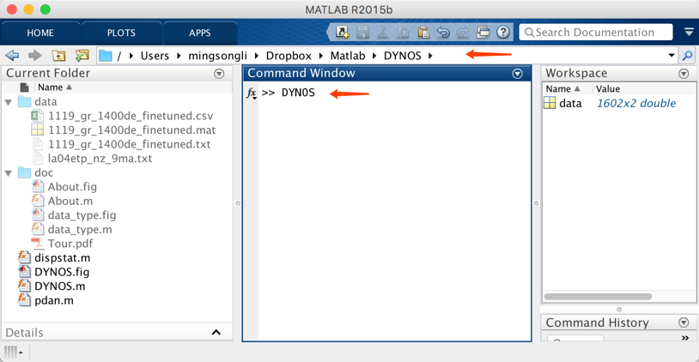

Fig. 1. MatLab workspace for the DYNOS model.

***4.2 Run the DYNOS code***

Type >> DYNOS in the Command Window (Fig. 1).

The DYNOS sea-level model GUI is as follows (Fig. 2):

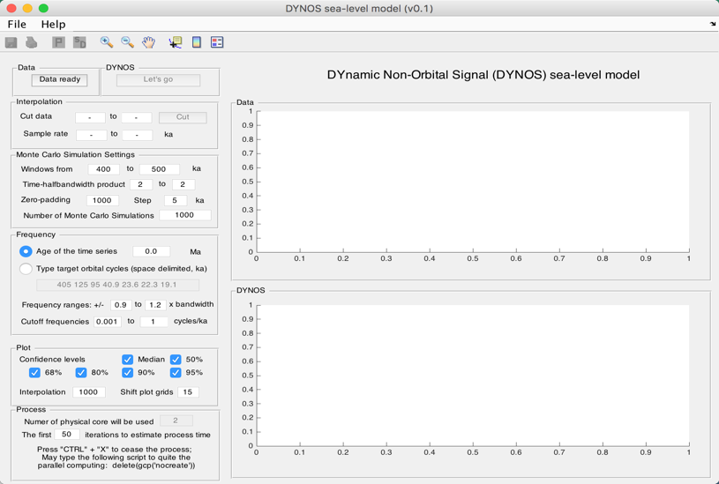

Fig. 2. The DYNOS model

**5. Input Data**

*data for the DYNOS model*

Name: data

Length: m × 2 % must be a 2-column dataset

Column 1: time; % unit must be in ka;

Column 2: value

(See 6. for how to load data.)

**Notes** (see Fig. 3):

**#1:** Proxy data is assumed to be sensitive to water-depth related noise at your section/core.

**#2:** There is no requirement for interpolation, normalization, or removing long-term trend (i.e., pre-whitening) of the dataset.

**#3:** Extreme values should be removed.

**#4:** Both increasing-upward and decreasing-upward time series are valid.

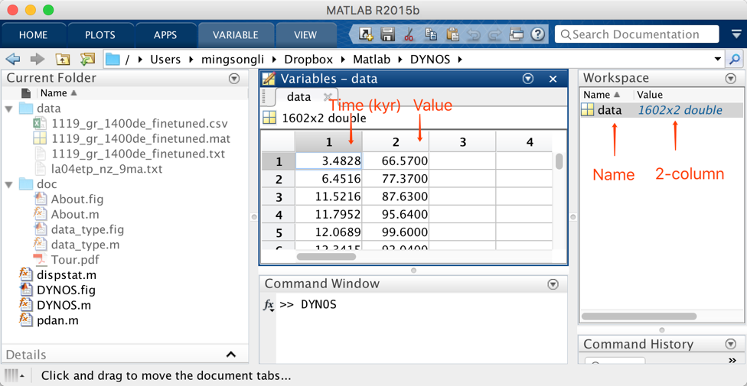

Fig. 3. Load data to DYNOS model.

**6. Load data**

There are three options. ***Read more*** on “MatLab Import Data” here: <https://www.mathworks.com/help/matlab/standard-file-formats.html>

***6.1 from *.mat file***

Double click the MAT-file “*1119_gr_1400de.mat*” in the “Current folder” to load data.

Or in the Command Window, type:

>> cd data

>> load('1119_gr_1400de_finetuned.mat');

>> cd ..

to load data (Fig. 3).

***6.2 from *.txt or *.csv file***

In the DYNOS menu: Select “File” 🡪 “Import Data (*.txt, *.csv) ” 🡪 Select data (chose “1119_gr_1400de_finetuned.txt” or “1119_gr_1400de_finetuned.csv”) 🡪 Click “Open ”

***6.3 copy and paste***

Type >> data=[]; in the Command Window; Double click “data” in the Workspace;

Copy 2-column time-value series from other resources (e.g., Excel file, etc.) and paste to “data” in the Variables tab.

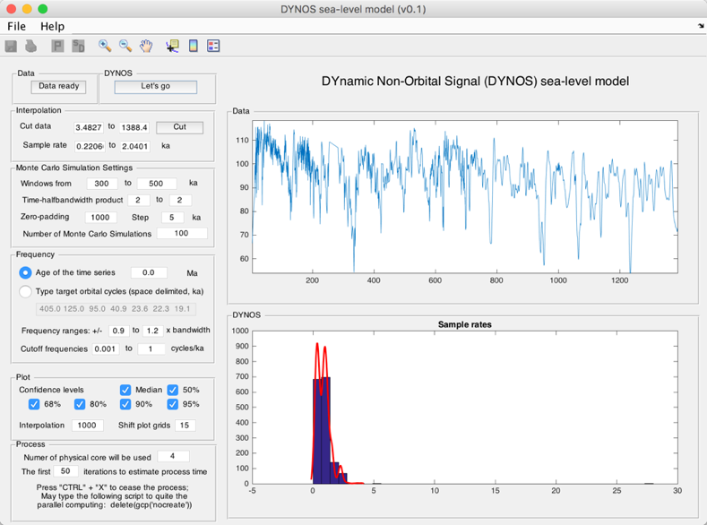

Fig. 4. Run the DYNOS code.

**7. Settings**

7.0. Click on Data ready (button) to load data into the DYNOS model.

7.1. Cut data (*optional*): These settings automatically show the beginning and the end of the time series, i.e., time span of dataset. Unit is ka. If you want to choose a different interval, just type two new ages and click Cut button.

7.2. Sampling rates (*optional*): These show a range of sample rates covering 90% of sample rates (Green Box 20 in Fig. 5). Unit is ka. A Monte Carlo method of hypothesis testing and the multi-taper method (MTM) of power spectral analysis are to be undertaken, and so resampling must be applied. Sampling rates of proxy datasets in time are always greater than zero and so are non-normally distributed. Therefore, the Weibull distribution is used to represent sampling rate distributions for uncertainty analysis in the DYNOS model. To avoid an ultra-low or ultra-high, unrealistic sampling rate created by the Weibull distribution algorithm, we set the 5th and 95th percentiles of sampling rates of of the data as default, lower and upper limits of the generated, Weibull-distributed sampling rates.

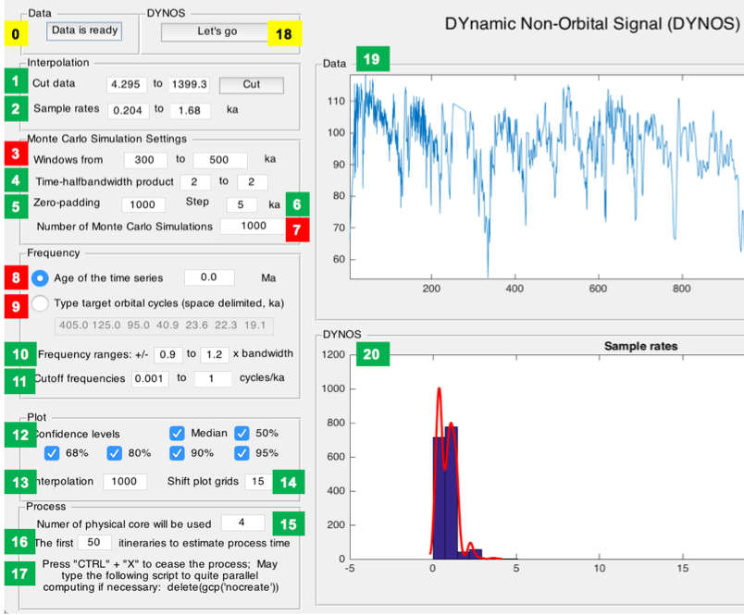

Fig. 5. Settings of the DYNOS model.

*Yellow: load data and run the model.*

*Red: Key settings. Check before running the model.*

*Green: Optional settings. Default values are okay for most running.*

7.3. **Windows**: These values set sliding window range. Moving window length in units of time (<< total data length). Unit is ka.

Different windows in the DYNOS model can affect results in two ways.

(1) The DYNOS model with a large window will shorten DYNOS results, and the model with a small window will generate longer DYNOS results, *Nr* = *Ndata* – *window* + 1, where *Nr* is total number of DYNOS values of each simulation, *Ndata* is total number of interpolated data points, and *window* is the running window employed.

(2) The DYNOS model with a small running window generates higher resolution results, however, the variance of low-frequency cycles and total variance diminish simultaneously, which leads to increased uncertainty in non-orbital signal ratio estimation.

The DYNOS model with a small running window also increases the MTM power spectrum bandwidth (i.e., reduces frequency resolution). The expected sea-level variations of interest in the Early Triassic are 104 to 106 year-scale, i.e., the fifth to third-order sequences, therefore a comparable or shorter time window (e.g., 300-500 kyr, 400 kyr or shorter) should be adopted for DYNOS modeling.

7.4. Time-bandwidth product (*optional*): Time-bandwidth product of discrete prolate spheroidal sequences used for window. Typical choices are 2, 5/2, 3, 7/2, 4.

7.5. Zero-padding (*optional*). zero-padding number, e.g., 1000.

7.6. Step (*optional*). step of calculations; default is 5 ka.

7.7. **Number of Monte Carlo Simulations:** default is 1000. Maybe use 100 or 300 for a trial running. Recommended value for publication is >5000.

7.8. **Age of the time series**: The age in Ma will be used to estimated target orbital cycles in 7.9. You can use either 7.8 or 7.9 to tell the DYNOS model the target cycles.

7.9. **Target orbital cycles** (space delimited, in ka): 6 orbital cycles of long-eccentricity (405), short-eccentricity (125 and 95), obliquity (40.9 or shorter), precession (23.6, 22.3, and 19.1 or shorter). This is age dependent (see 7.8). The 405, 125, and 95 kyr cycles are assumed to be invariant through time. While the obliquity = 41-0.0332*age; precession 1 = 23.75-0.0121*age; precession 2 = 22.43-0.0121*age; precession 3=19.18-0.0079*age. These calculations are from Yao et al. (2015), and are based on the La2004 astronomical model (Laskar et al., 2004).

7.10. Frequency ranges (*optional*): For the definition of the non-orbital signal ratio by Li et al. (in revision), cutoff frequencies and their bandwidths are crucial for estimation of variances of eccentricity, obliquity and precession signals. We vary each cutoff frequency assuming a uniform distribution with cutoff frequency ranges at ± 90% to ± 120% bandwidth. Here the bandwidth (*bw*) equals *nw*/*window*, where *nw* is time-bandwidth product of discrete prolate spheroidal sequences, and *window* is the running window.

7.11. Cutoff frequencies (*optional*): lower cutoff frequency (> 0) for estimation of total variance and upper cutoff frequency (< Nyquist frequency) for estimation of total variance.

7.12. Confidence levels (*optional*): default values show median and confidence levels (e.g., 50%, 68%, 80%, 90%, and 95%) of the DYNOS results.

7.13. Interpolation (*optional*): In 7.3, a smaller *Nr* compared to *Ndata* leads to a “no data” effect at the very beginning and/or very end of the DYNOS results. To avoid this problem and to provide a better constraint for noise estimation, technically, the DYNOS model is interpolated and randomly shifts and plots simulation results of a single iteration at the same time scale of the dataset, although the plots also generate relatively smoothed DYNOS spectra when a gap is shorter than 2 × *window*. Here 1000 is adequate for the DYNOS model.

7.14 Shift plot grids (*optional*): See 7.13 for interpretation. Default is 15. One can also use 15-30 for the better shape of the beginning and the end of the DYNOS spectra.

7.15. Number of physical cores (*optional*): This detects the physical cores of the CPU of the computer.

7.16. Number of itineraries to estimate the process time (*optional*): To estimate process time of the time-consuming DYNOS model, the model will run some itineraries. Default is 50.

7.17. Emergency note: Press “Ctrl” + “C” to cease the DYNOS process before the parallel computing. Press “Ctrl” + “X” to cease the DYNOS process during the parallel computing. You may need to type the following script in the command window to quite parallel computing.

>> delete(gcp(‘nocreate’))

7.18. Click the button to run the model.

7.19. A window shows the dataset.

7.20. A window shows sample rates of the dataset OR the DYNOS spectrum of the dataset.

**8. Running the DYNOS model**

Click the Let’s go button to run the DYNOS code. In the command window, the estimated running time will appear:

16:21:20 Begin the process ...

16:22:54 First 50 iterations suggest: remain >= 0h:7m:27sec

% The model runs the first 50 iterations to estimate that the total running time will last ca. 7 minutes 27 seconds. The real run-time may be 10s seconds to several minutes longer than this estimate.

Starting parallel pool (parpool) using the 'local' profile ... connected to 4 workers.

16:23:07 Current iteration takes 1.11 seconds

16:23:08 Current iteration takes 1.21 seconds

16:23:15 Current iteration takes 1.19 seconds

16:26:26 Current iteration takes 1.38 seconds

% Start parallel computing and show time of each iteration.

Parallel pool using the 'local' profile is shutting down.

>> Done. % Stop parallel computing and display the DYNOS result (Fig. 6).

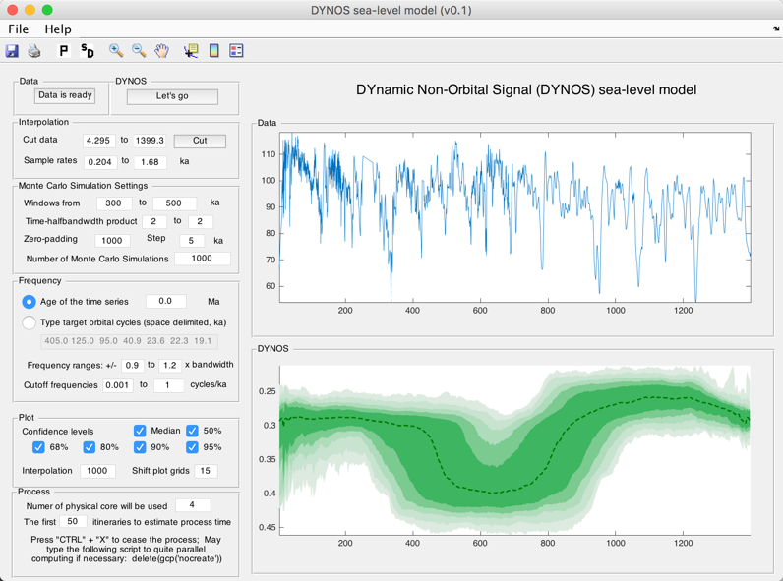

Fig. 6. DYNOS sea-level model of the gamma-ray series at ODP site 1119 from 0 to 1.4 Ma.

**9. Output Files**

After running the DYNOS model, the GUI menu (Fig. 7) can be used to:

#1: save a MatLab-fig in the working directory entitled “plots_.fig”.

#2: save a PDF file of the plots in the working directory entitled “plots_.pdf”

#3: pop-up display the DYNOS spectrum in a new window.

#4: save DYNOS output data in the working directory entitled “result_handles.mat”.

**Caution: Change names of output files, or they will be overwritten by new files.**

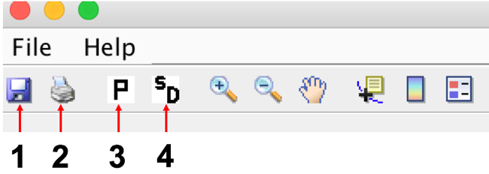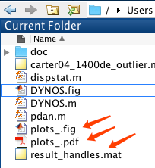

Fig. 7. Output files

**10. References**

1. Laskar J*, et al.* (2004) A long-term numerical solution for the insolation quantities of the Earth. *Astron Astrophys* 428(1):261-285.

2. Li, Mingsong, Hinnov, Linda, Chunju Huang. (in revision), Land-ocean water balance dynamics and sea-level change in the Early Triassic hothouse, *PNAS*.

3. Li, Mingsong, Huang, Chunju, Hinnov, Linda, Ogg, James, Chen, Zhong-Qiang, Zhang, Yang, 2016. Obliquity-forced climate during the Early Triassic hothouse in China. *Geology* 44, 623-626. doi: 10.1130/G37970.1

4. Tasdemir, 2013. Matlab File Exchange: Overwritable message outputs to commandline window. https://www.mathworks.com/matlabcentral/fileexchange/44673-overwritable-message-outputs-to-commandline-window?focused=3804030&tab=function.

5. Yao, Xu, Zhou, Yaoqi, Hinnov, Linda, 2015. Astronomical forcing of Middle Permian chert in the Lower Yangtze area, South China, *Earth Planet Sc Lett* **422**, 206-221.