HW4 Rmarkdown and Litterfall Module Synthesis

Alexia Ford

2/26/2018

# Introduction

The NEON (National Ecological Observatory Network) project provides scientific real time data in hopes of understanding environmental change, informing natural resource decisions, and engaging the next generations of scientists with this data. The project is responsible for measuring the causes and effects of environmental change across the United States within 20 eco-climate domains that all represent different landforms, vegetation, climate, and ecosystem dynamics. The project is constantly collecting data from it’s observatory’s regional domain to provide data and statistically represent ecological, physical, and biological variability across the US.

NEON has four different sites that the project collects data from that will be introduced in this project, these sites include: core terrestrial sites, core aquatic sites, relocatable terrestrial sites, and lastly relocatable aquatic sites (NEON data website).In this analysis we will specifically be looking at: the Barlett Experimental Forest (relocatable terrestrial), Guanica Forest Common Wealth of Puerto Rico (core terrestrial), Harvard University Forest (core terrestrial), Santa Rita Experimental Range University of Arizona (core terrestrial), Steigerwaldt Land Services (relocatable terrestrial), Treehaven University of Wisconsin (relocatable terrestrial), and University of Notre Dame Environmental Research Center (core terrestrial).

The site I will specifically be focused on for this project is the “STEI” site, other wise known as Steigerwaldt Land Services. This site is a relocatable terrestrial site located near the Great Lakes in Tomahawk, Wisconsin. It is approximately located 1 mile North of NEONs other site Treehaven. Steigerwaldt has a specific vegetation consisting of the most abundant tree species with young, even aged stand such as: aspen (Populus tremuloides), red maple (Acer rubrum), and balsam fir (Abies balsamea). The stand was cut in 2005 and was scattered with oak and hemlock and the roads were planted with clover for wildlife food for animals such as deer and ruffed grouse.

In addition to vegetation the area has a distinguishable climate. “STEI” has endured salvage timber projects following ice and hail damage, windstorms, tornadoes, and spruce decline. Steigerwaldt typically faces a humid continental climate and experiences no dry seasons and warm summers from mid-May to mid-September with average temperatures in July around 79 F. Contrastingly the site faces extremely cold winters lasting from November to March with temperatures around 4 F in January. The sites annual average temperature is 41.6 F.

# Methods

The NEON observatory collects from a total of 81 fields sites, 47 of them are terrestrial sites and 34 are aquatic sites. Data is collected using “in situ” measurements, field sampling, and airborne remote censoring. The NEON project follows a protocol for each site in which they set up a 3m X 0.5m rectangular ground trap that collects differing dry masses from flowers to twigs and branches.

R studio has been used in this report to analyze data provided from NEON’s observatory, by specifically sub-setting out the the twigs and branches from the litterfall data and analyzing the differences in the dry mass of trees and branches found at each of the sites being observed using a box plot. Additionally, a scatterplot was used to analyze dry mass of branches and twigs at just one site, The Steigerwaldt Land Services. ANOVA was used in R studio to calculate the p-value from the varying sites and information from the boxplot/the dry mass of branches in order to analyze the significant differences in the sites.

# Results

Read in Litterfall data set:

# read in the literfall data from a csv  
literfall_data <- read.csv("data/ltr_massdata.csv",  
 header = TRUE)

Data Set showing the dry mass of Branches and Twigs at NEON sites:

# just look at twigs and branches dry mass  
branches_data <- subset(literfall_data,   
 functionalGroup == "Twigs/branches")

#just look at the "STEI" neon site  
STEI_branches_data <- subset(branches_data,  
 siteID == "STEI")

Scatter plot of the Branches/Twigs mass at STEI NEON site:

# make a scatterplot of branches and twigs dry mass at the STEI NEON site  
plot(x = as.POSIXct(STEI_branches_data$collectDate),  
 y = STEI_branches_data$dryMass,  
 main = "Dry mass of branches fallen in Steigerwaldt Land Service",  
 xlab = "Date",  
 ylab = "Dry mass of banches in grams",  
 pch = 16)

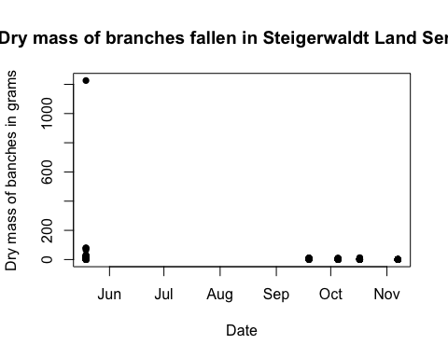

Box plot of the dry mass of Branches and Twigs at varying NEON sites:

# mass of twigs and branches at diffrent sites in the NEON data  
boxplot(dryMass ~ siteID,  
 data = branches_data,  
 main = "Mass of Branches at NEON sites",  
 xlab = "site ID",  
 ylab = "dryMass (grams)")

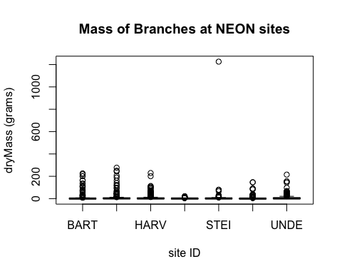

#r statistical test  
anova(lm(dryMass ~ siteID,  
 data = branches_data))

## Analysis of Variance Table  
##   
## Response: dryMass  
## Df Sum Sq Mean Sq F value Pr(>F)   
## siteID 6 19388 3231.3 2.1474 0.04545 *  
## Residuals 1744 2624243 1504.7   
## ---  
## Signif. codes: 0 '***' 0.001 '**' 0.01 '*' 0.05 '.' 0.1 ' ' 1

**Chi-square test** ANOVA p-value: 0.04545 This number shows there are some similarities but not all of the sites have similarities, this is most likely the case as the majority of the dry mass data for the sites is between 0 and 400 grams, but there is one outlier showing a mass of 1200 grams, somewhat skewing the p-value as the majority of the dry mass for each site is extremely similar.

# Discussion

In analyzing the box plot, it shows that the majority of the data is extremely similar as most of the dry mass for each site is somewhere between 300-400 grams of fallen branches and twigs, with no distinguishable higher regions of litter mass. The “SRER” site displays the smallest amount of litter mass of twigs and branches with very few data even above 0 grams. This may be the smallest amount of litter mass as the “SRER” site is at the University of Arizona in which the dominant vegetation is a mix of short trees, shrubs, cacti, and other succulents. With this being the case, the site would have less branches and twigs to fall as the other sites as it is typically shrubs and cacti rather than large trees like some sites. The “STEI” site and the “SRER” site are the only sites that do not have somewhat similar data with smaller amounts of litter mass, under about 300 grams. Where the “STEI” site and “SRER” site differ is in their outliers. The “STEI” site shows one individual outlier at 1200 grams, while all the other sites including “SRER” display no visible outliers let alone any data above 400 grams. The “STEI” site possibly displays an outlier because it is in Wisconsin and it’s climate has cold winters with potential ice and snow storms resulting in more fallen branches/twigs. This site is also a lot newer as the land houses young and even-aged stand where as sites like “SRER” would have little to no outliers with active and longer accurate results.

In analyzing the scatterplot, the results for the dry mass (in grams) of branches and twigs fallen at the Steigerwaldt Land Service shows that the majority of litter mass fallen is typically in the winter months. From mid-September to mid-May the dry mass is about 200 grams of fallen twigs and branches, never reaching above 200, expect for before June in which there is one outlier above 1200 grams. In the months from June to September there is absolutely no visible dry mass this could also be because the site is somewhat newer (accounting for the outlier) and the cold season at the “STEI” site faces extreme storms. The site is known for cold winters and even house rehabilitation projects following ice and hail damage, windstorms, tornadoes, and spruce decline. The cold season for this site is typically from November to March with the coldest temperatures typically in January with an average of about 4 F. The vegetation of the Steigerwaldt Land Service “STEI” site consists of abundant tree species that are young, even aged stand, such as: aspen (Populus tremuloides), red maple (Acer rubrum), and balsam fir (Abies balsamea). As “STEI” mostly houses tree species I would assume that this particular site would have a higher carbon to nitrogen ratio as the abundance in trees would typically increase the carbon levels, and the lack of flowers would decrease nitrogen levels. In comparing the carbon and nitrogen flow at the “STEI” site to the “SRER” Santa Rita Experimental Range site at the University of Arizona we know the dominant vegetation is a mix of short trees, shrubs, cacti, succulents, perennial grasses, and other herbaceous species (florals) one could assume the carbon to nitrogen ratio would be much lower as the carbon levels would be lower due to lack of trees and the nitrogen levels would be somewhat higher as there is an abundance of cacti with flowers, grasses, and herbaceous species with high levels of rubisco (a nitrogen fixing enzyme).