[Computer Graphics ClassAssignment1]

컴퓨터소프트웨어학부 2018007956 김채아

1. Which requirements I implemented

- Orbit

- Panning

- Zooming

- Toggle perspective projection / orthogonal perspective projection

- rectangular grid with lines on xz plane

전부 구현 성공

1. A few screenshot images of my program

Rotate Panning

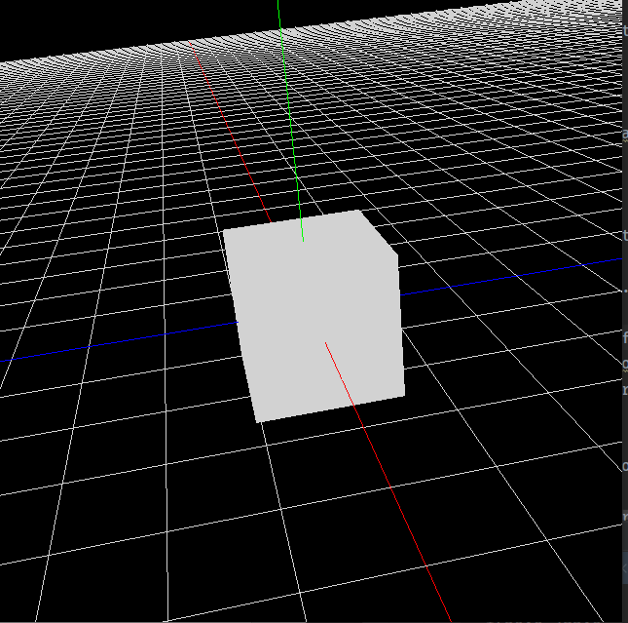 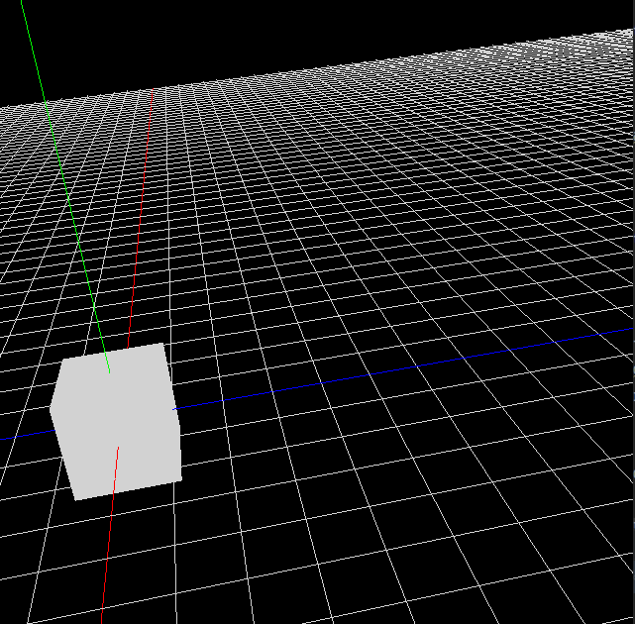 Zooming Orthogonal projection

