姓名：李洁 | 专业：物联网工程 | 班级：20181191班 | 学号：2018119114、
科目：STM32单片机 |  | 实验日期：2020/09/12
实验题目：PC与MCU通信
【实验目的】
1.实验设备
◆ 硬件：PC机一台
◆ STM32L431RCT6
软件：keli 5
2.实验效果
PC1发给MCU1，MCU1发给MCU2，MCU2发给PC2
【实验内容】
主要代码：
#include "main.h"
#include "usart.h"
#include "gpio.h"
void SystemClock_Config(void);
int main(void)
{
char str[12] = "Hello World\n";
char recv_buf[12] = {0};
HAL_Init();
SystemClock_Config();
MX_GPIO_Init();
MX_USART1_UART_Init();
HAL_UART_Transmit(&huart1, (uint8_t*)str, 12, 0xFFFF);
while (1)
{
if(HAL_OK == HAL_UART_Receive(&huart1, (uint8_t*)recv_buf, 12, 0xFFFF))
{

HAL_UART_Transmit(&huart1, (uint8_t*)recv_buf, 12, 0xFFFF);
}
}
}
void SystemClock_Config(void)
{
RCC_OscInitTypeDef RCC_OscInitStruct = {0};
RCC_ClkInitTypeDef RCC_ClkInitStruct = {0};
RCC_PeriphCLKInitTypeDef PeriphClkInit = {0};

RCC_OscInitStruct.OscillatorType = RCC_OSCILLATORTYPE_HSE;
RCC_OscInitStruct.HSEState = RCC_HSE_ON;
RCC_OscInitStruct.PLL.PLLState = RCC_PLL_ON;
RCC_OscInitStruct.PLL.PLLSource = RCC_PLLSOURCE_HSE;
RCC_OscInitStruct.PLL.PLLM = 1;
RCC_OscInitStruct.PLL.PLLN = 8;
RCC_OscInitStruct.PLL.PLLP = RCC_PLLP_DIV7;
RCC_OscInitStruct.PLL.PLLQ = RCC_PLLQ_DIV2;
RCC_OscInitStruct.PLL.PLLR = RCC_PLLR_DIV2;
if (HAL_RCC_OscConfig(&RCC_OscInitStruct) != HAL_OK)
{
Error_Handler();
}
RCC_ClkInitStruct.ClockType = RCC_CLOCKTYPE_HCLK|RCC_CLOCKTYPE_SYSCLK
|RCC_CLOCKTYPE_PCLK1|RCC_CLOCKTYPE_PCLK2;
RCC_ClkInitStruct.SYSCLKSource = RCC_SYSCLKSOURCE_PLLCLK;
RCC_ClkInitStruct.AHBCLKDivider = RCC_SYSCLK_DIV1;
RCC_ClkInitStruct.APB1CLKDivider = RCC_HCLK_DIV1;
RCC_ClkInitStruct.APB2CLKDivider = RCC_HCLK_DIV1;

if (HAL_RCC_ClockConfig(&RCC_ClkInitStruct, FLASH_LATENCY_1) != HAL_OK)
{
Error_Handler();
}
PeriphClkInit.PeriphClockSelection = RCC_PERIPHCLK_USART1;
PeriphClkInit.Usart1ClockSelection = RCC_USART1CLKSOURCE_PCLK2;
if (HAL_RCCEx_PeriphCLKConfig(&PeriphClkInit) != HAL_OK)
{
Error_Handler();
}
if(HAL_PWREx_ControlVoltageScaling(PWR_REGULATOR_VOLTAGE_SCALE1) != HAL_OK)
{
Error_Handler();
}
}

【实验结果】
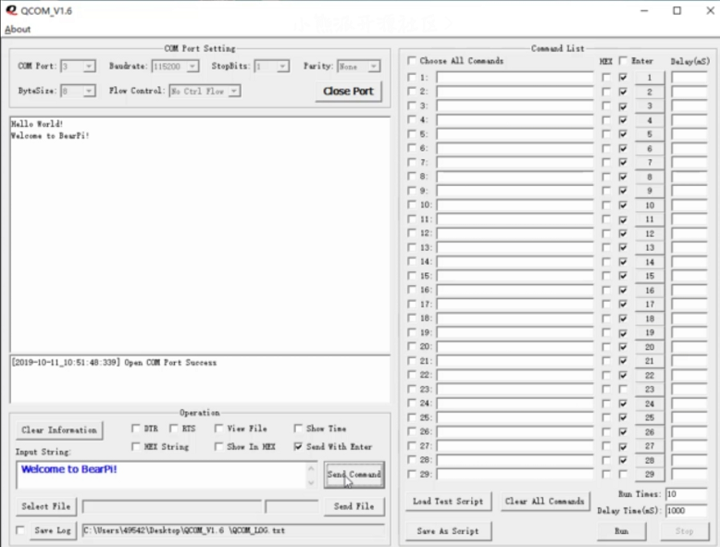

【教师评语和成绩】

成绩： 指导教师： 日期：

