姓名：黄洋燕 | 专业： 物联网工程 | 班级：20181191 | 学号：2018119115
科目：单片机原理与应用 |  | 实验日期：2020.11.26
实验题目：UART与PC互相发送数据
【实验目的】
◆ 使用STM32单片机实现使用UART发送数据给PC
【实验内容】
1.实验设备
硬件：PC机一台
◆ STM32F103C8
软件：keli 5
2.实验效果
UART与PC互相发送数据
【实验结果】
主要代码：
main.c
#include "main.h"
#include "usart.h"
#include "gpio.h"
void SystemClock_Config(void);
int main(void)
{
char str[12] ="Hello World\n";
char recv_buf[12] = {0};
HAL_Init();

SystemClock_Config();
MX_GPIO_Init();
MX_USART1_UART_Init();

HAL_UART_Transmit(&huart1, (uint8_t*)str, 12, 0xFFFF);
while (1)
{
//接收7个字节的数据，不超时
if(HAL_OK == HAL_UART_Receive(&huart1, (uint8_t*)recv_buf, 12, 0xFFFF))
{
//将接收到的数据发送
HAL_UART_Transmit(&huart1, (uint8_t*)recv_buf, 12, 0xFFFF);
}
}
}
void SystemClock_Config(void)
{
RCC_OscInitTypeDef RCC_OscInitStruct = {0};
RCC_ClkInitTypeDef RCC_ClkInitStruct = {0};
RCC_PeriphCLKInitTypeDef PeriphClkInit = {0};

/** Initializes the RCC Oscillators according to the specified parameters
* in the RCC_OscInitTypeDef structure.
*/
RCC_OscInitStruct.OscillatorType = RCC_OSCILLATORTYPE_HSE;
RCC_OscInitStruct.HSEState = RCC_HSE_ON;
RCC_OscInitStruct.PLL.PLLState = RCC_PLL_ON;
RCC_OscInitStruct.PLL.PLLSource = RCC_PLLSOURCE_HSE;
RCC_OscInitStruct.PLL.PLLM = 1;
RCC_OscInitStruct.PLL.PLLN = 20;
RCC_OscInitStruct.PLL.PLLP = RCC_PLLP_DIV7;
RCC_OscInitStruct.PLL.PLLQ = RCC_PLLQ_DIV2;
RCC_OscInitStruct.PLL.PLLR = RCC_PLLR_DIV2;
if (HAL_RCC_OscConfig(&RCC_OscInitStruct) != HAL_OK)
{
Error_Handler();
}
/** Initializes the CPU, AHB and APB buses clocks
*/
RCC_ClkInitStruct.ClockType = RCC_CLOCKTYPE_HCLK|RCC_CLOCKTYPE_SYSCLK
|RCC_CLOCKTYPE_PCLK1|RCC_CLOCKTYPE_PCLK2;
RCC_ClkInitStruct.SYSCLKSource = RCC_SYSCLKSOURCE_PLLCLK;
RCC_ClkInitStruct.AHBCLKDivider = RCC_SYSCLK_DIV1;
RCC_ClkInitStruct.APB1CLKDivider = RCC_HCLK_DIV1;
RCC_ClkInitStruct.APB2CLKDivider = RCC_HCLK_DIV1;

if (HAL_RCC_ClockConfig(&RCC_ClkInitStruct, FLASH_LATENCY_4) != HAL_OK)
{
Error_Handler();
}
PeriphClkInit.PeriphClockSelection = RCC_PERIPHCLK_USART1;
PeriphClkInit.Usart1ClockSelection = RCC_USART1CLKSOURCE_PCLK2;
if (HAL_RCCEx_PeriphCLKConfig(&PeriphClkInit) != HAL_OK)
{
Error_Handler();
}
/** Configure the main internal regulator output voltage
*/
if (HAL_PWREx_ControlVoltageScaling(PWR_REGULATOR_VOLTAGE_SCALE1) != HAL_OK)
{
Error_Handler();
}
}
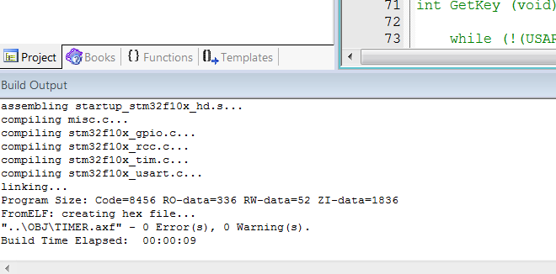
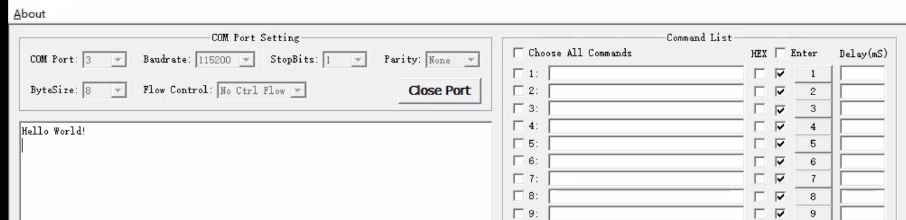
【教师评语和成绩】

成绩： 指导教师： 日期：

