Output File

Q.1-1

accuracy: 75.2669039146%
precision: 100.0%
recall: 0.179533213645%
f1 score: 0.358422939068

Q.1-2

accuracy: 97.2419928826%
precision: 91.5750915751%
recall: 96.8992248062%
f1 score: 0.941619585687

Q.1-3

Entropy:  accuracy: 97.2419928826%  precision: 91.5750915751%  recall: 96.8992248062%  f1 score: 0.941619585687 | Gini Index:  accuracy: 97.1085409253%  precision: 92.6391382406%  recall: 95.5555555556%  f1 score: 0.940747493163 | Misclassification Rate:  accuracy: 97.731316726%  precision: 98.997995992%  recall: 91.4814814815%  f1 score: 0.950914340712

Q.1-4

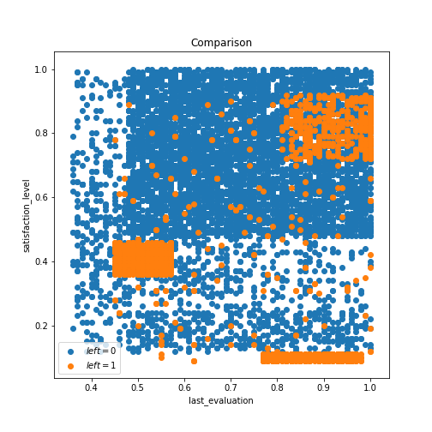

Q.1-5
