PRN : 2018BTECS00103
Practical No : 3

To study web browser and its Developer Tools option

- Problem statement : 1

Step 1 : Click Start, then click the Windows 10 Settings icon (which looks like a wheel).

Step 2 : Click the Apps icon. Then, on the left, choose Default apps. You see the Default Apps dialog box.

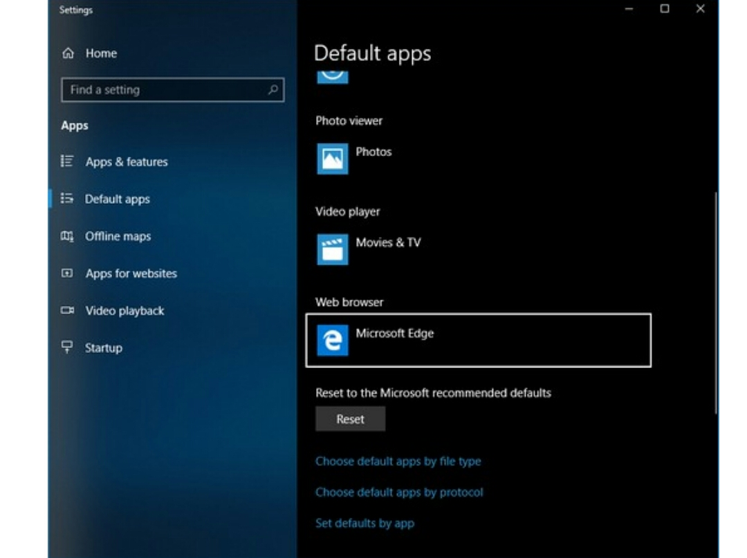
Step 3 : On the right, scroll down to the web browser entry; chances are good it says Microsoft Edge. Click Microsoft Edge. You see a list of all browsers currently installed on your computer.

Step 4 : Choose the browser that you want to turn into your default browser. Then click Switch anyway when Microsoft tries to convince you to continue using Edge.

Step 5 : Don’t trust Microsoft’s re-assigning your browser defaults? Good. Down at the bottom, click the link that says Set Defaults by App.
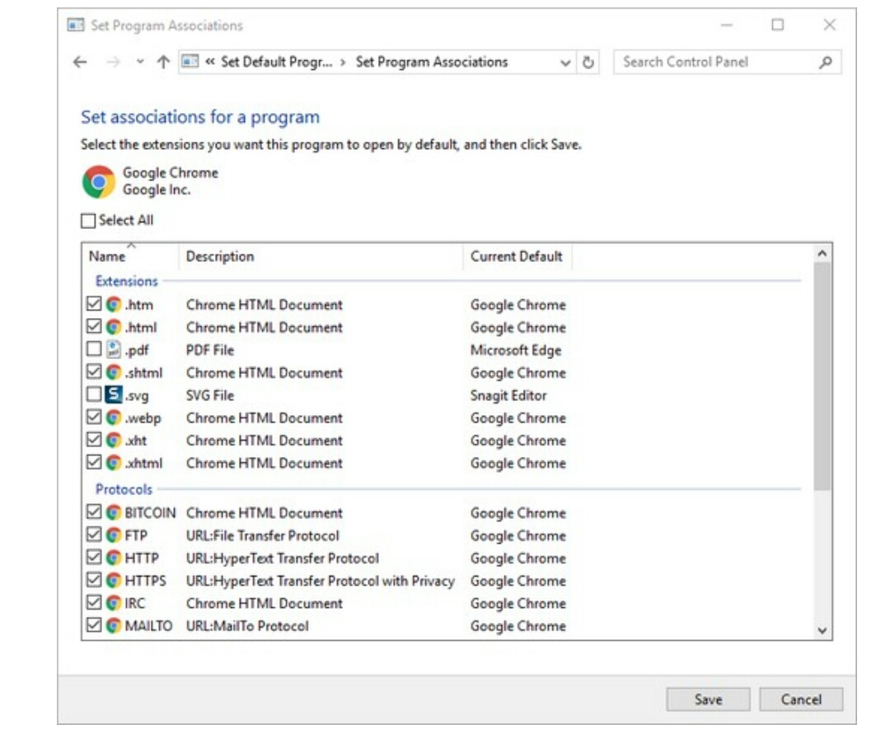
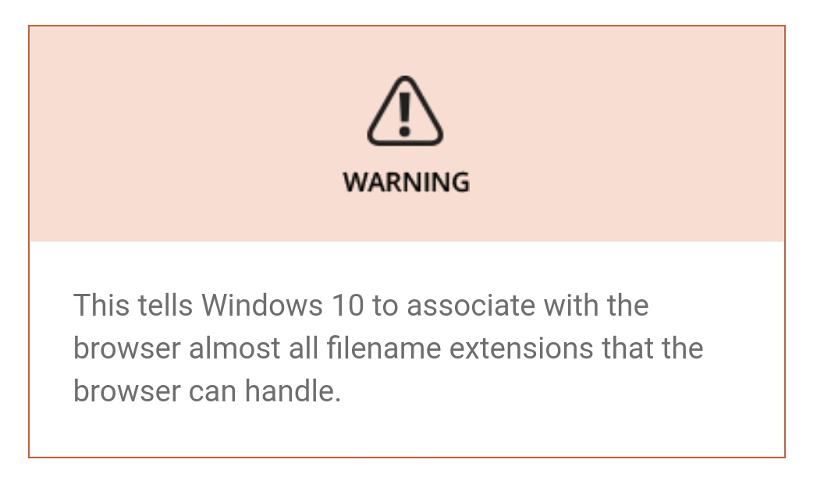
The pick list appears. Whoa! When Windows 10 sets defaults for Google Chrome, it doesn’t shuffle PDF files to Chrome. Instead, it keeps PDF files inside Edge. A little bit of dirty pool here.
Step 6 : Select the boxes next to whichever files you want to open in your new browser, and then click Save.
Your chosen Windows 10 program (in this case, Google) becomes the default for that particular kind of file.

- Problem statement : 2

There are many ways to open Chrome DevTools, because different users want fast access to different parts of the DevTools UI.

- Open the Elements panel to inspect the DOM or CSS :

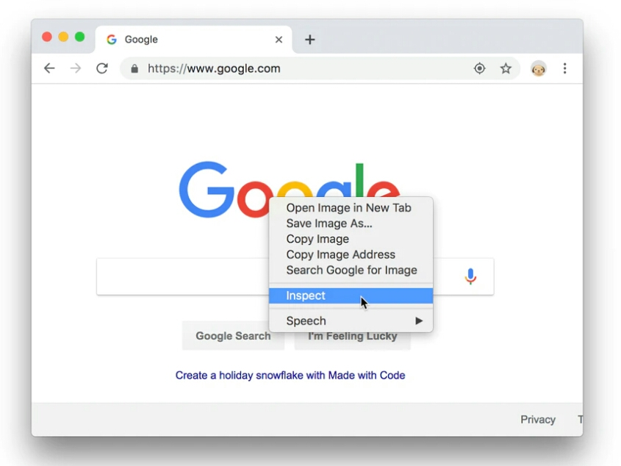
When you want to inspect a DOM node's styles or attributes, right-click the element and select Inspect.
Figure 1. The Inspect option
- Or press Command+Option+C (Mac) or Control+Shift+C (Windows, Linux, Chrome OS).

- Open the Console panel to view logged messages or run JavaScript :
- Press Command+Option+J (Mac) or Control+Shift+J (Windows, Linux, Chrome OS) to jump straight into the Console panel.

- Open the last panel you had open :
- Press Command+Option+I (Mac) or Control+Shift+I.

- Open DevTools from Chrome's main menu :
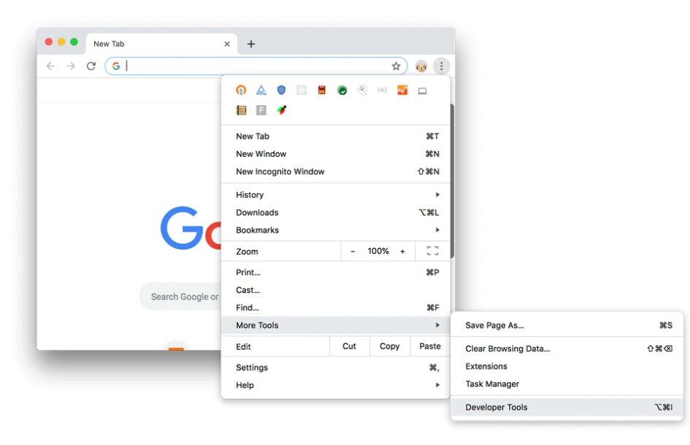
- Click Customize and control Google Chrome Customize and control Google Chrome and then select More Tools > Developer Tools.
Figure 2. Opening DevTools from Chrome's main menu

- Auto-open DevTools on every new tab :
- Open Chrome from the Command line and pass the --auto-open-devtools-for-tabs flag .

- Mac :

- /Applications/Google\Chrome.app/Contents/MacOS/Google\ Chrome --auto-open-devtools-for-tabs

- This will only work if an instance of Chrome is not already running. From then on, every new tab will automatically open DevTools until the user fully quits Chrome.

