PRN : 2018BTECS00103
Practical No : 4
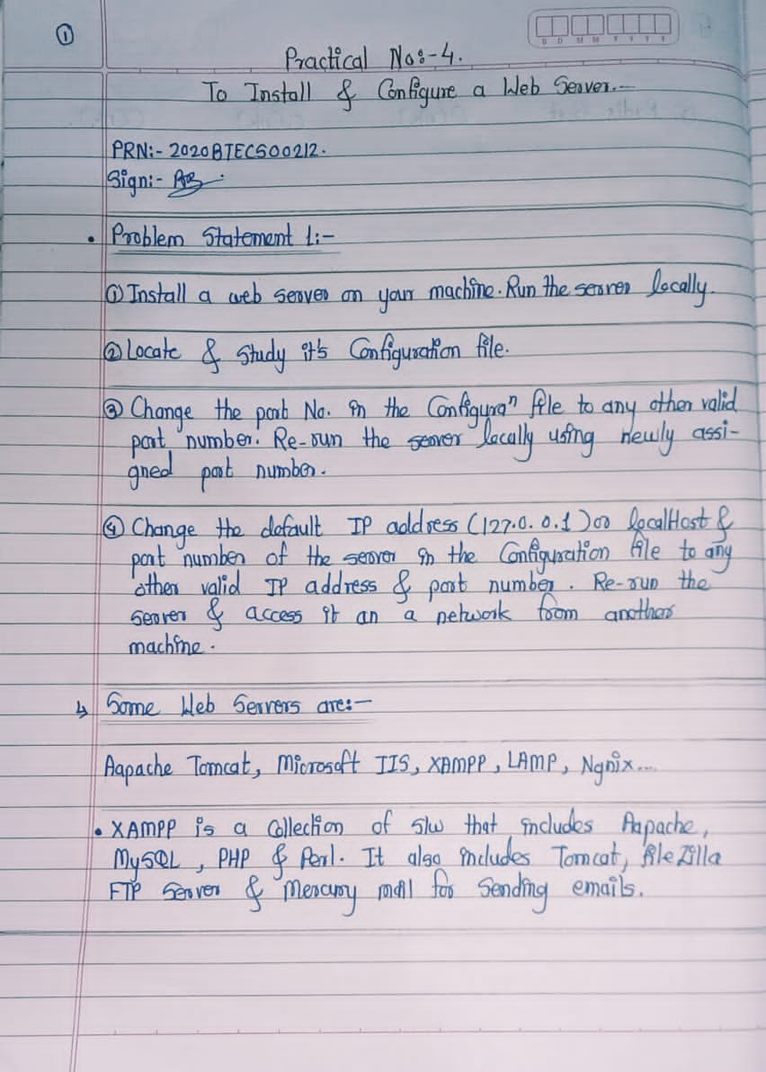
To install and configure a Web Server.

- To install XAMPP, I can Follow Below Steps :

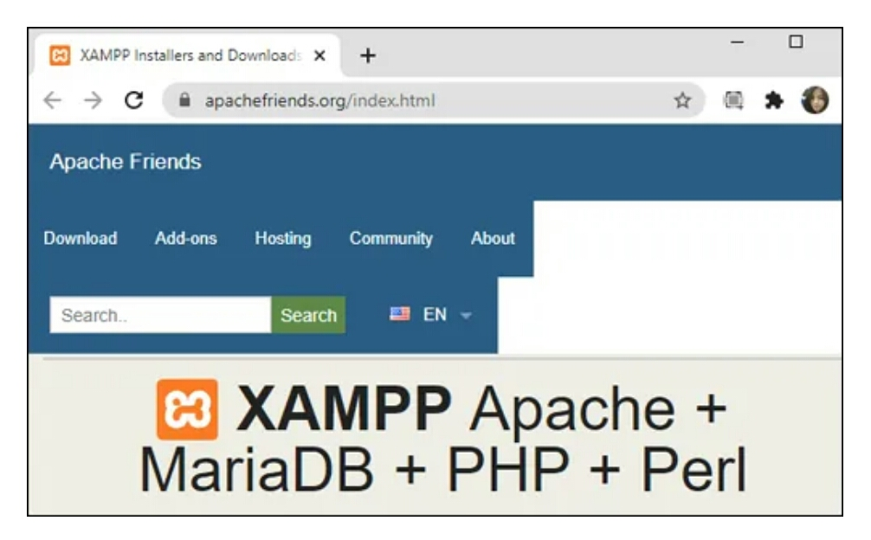
Step 1 : Search to XAMPP and proceed to install the Windows version.

Step 2 : When prompted, execute the installer.
Step 3 : I can Select “Apache” to install a Web Server .
Step 4 : Once the installation is complete click “Finish” to open the XAMPP control panel.

- To confirm successful installation, I enter “127.0.0.1” or “localhost” into my web browser’s address bar. The XAMPP configuration page should display.

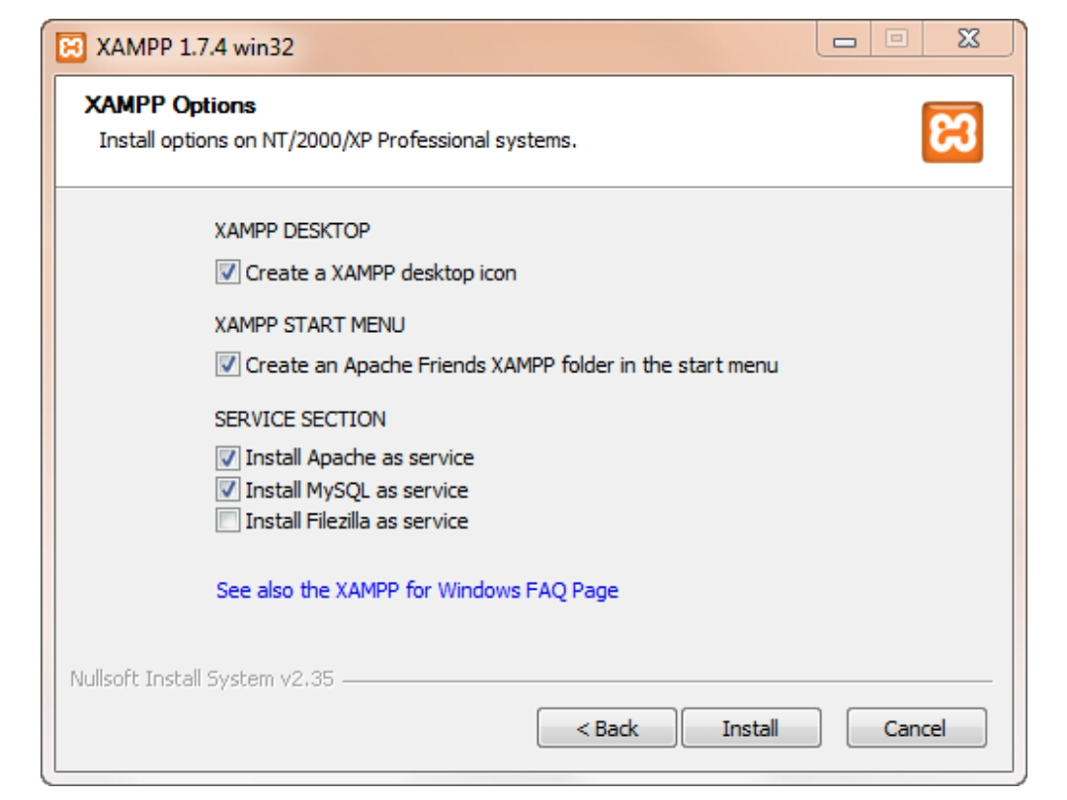
- I would suggest checking off Apache and MySQL as a service as this will allow me to better manage this software later : When finished, click "Yes" to start the control panel.
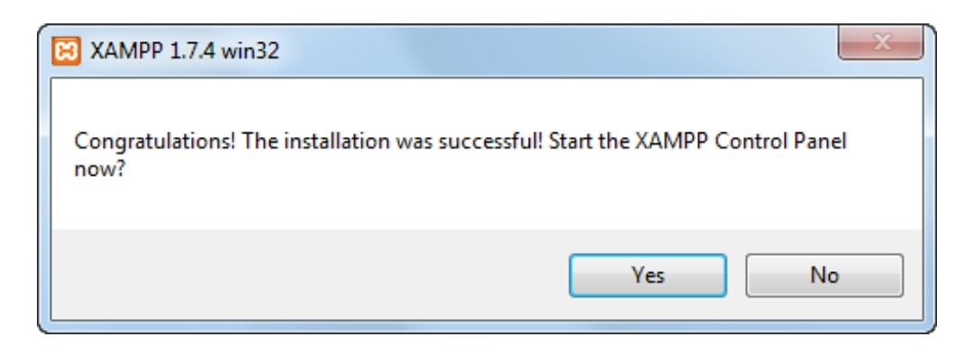
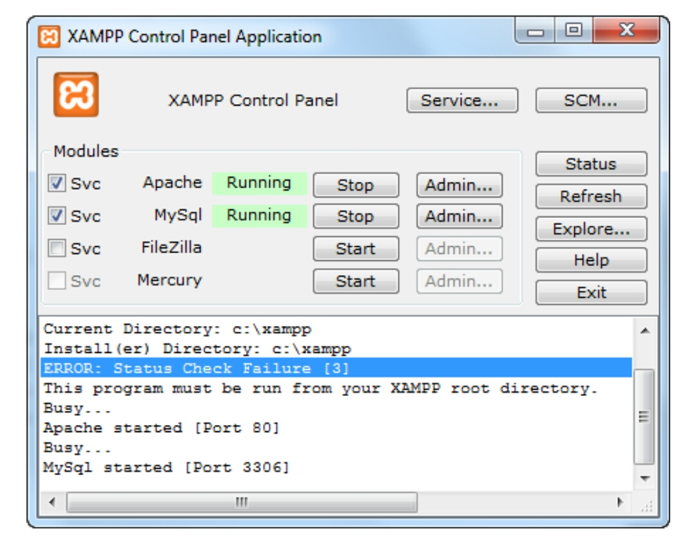
- I also received several popups after installing the software. One was from Microsoft Security Essentials asking to send the FileZilla binary to them for analysis (this software can sometimes be used in backdoors - however this use is legitimate) and also the Firewall will pop up a few boxes asking if you want to allow the port to be used. Leave the checkbox unchecked so that your server will not be available over public wifi and other open networks (for example if you connect at a Starbucks), but to still allow your server to be available from your local PC and other computers in your own private network.

- Once the control panel is up, I click on "Start" Apache and MySQL.
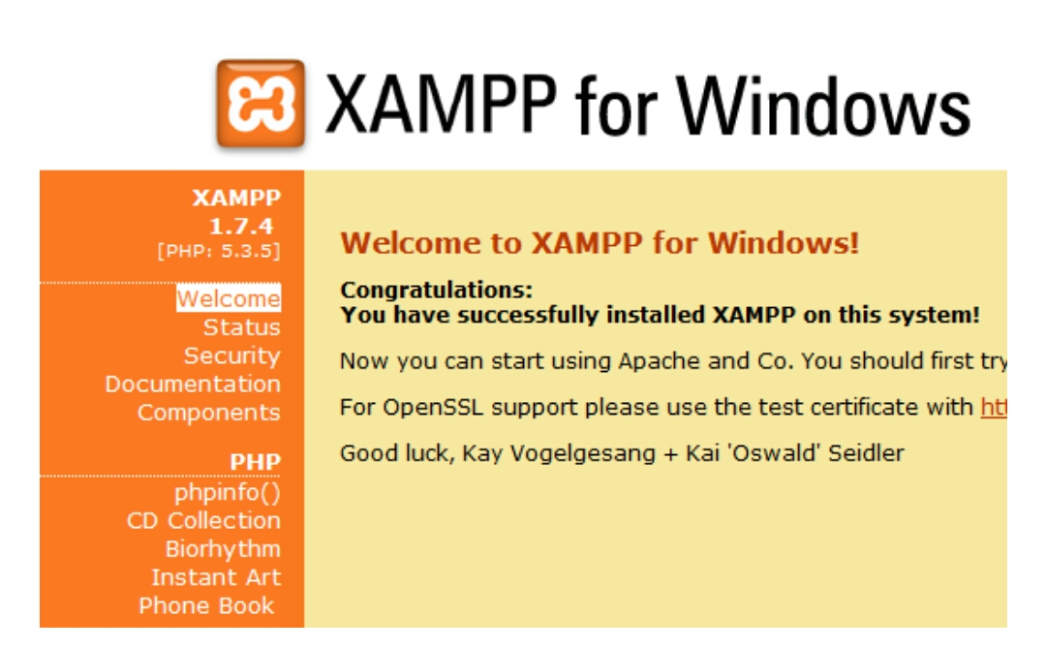
- This will launch my default web browser and send you to the Welcome page.

- The "Status" page will show you which services are currently activated. They should all be green except for FTP, SMTP and Tomcat.
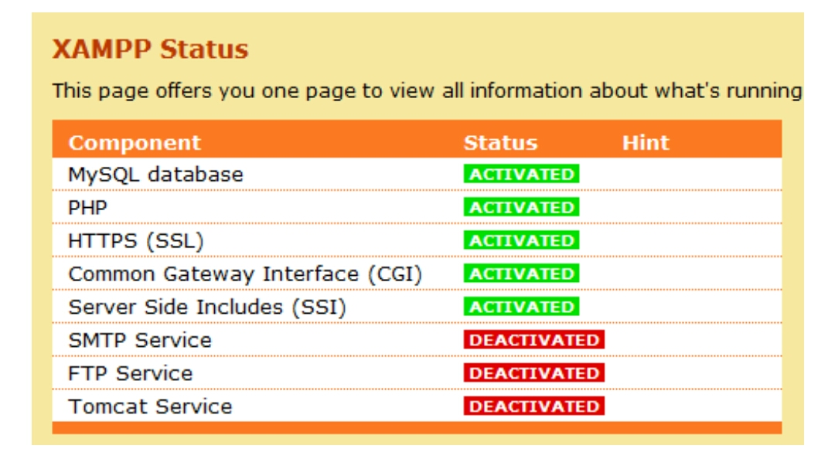
- After Installing Process I can Tried for Run program :
C:\xampp\htdocs\

- This includes the administration program. The default page your web server loads when you visit http://localhost/ is index.php. You can open that file to replace it with your own text or remove it altogether, it is really up to you.
