High-School management system

##### User stories

Major roles are –

* Students
* Parents
* Teachers
* Guests
* Admin

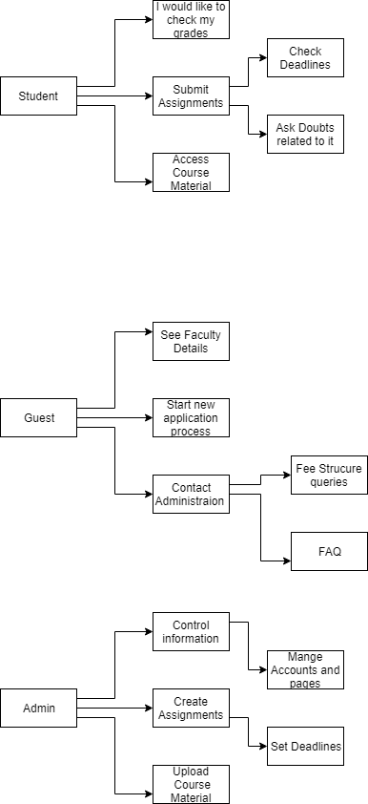

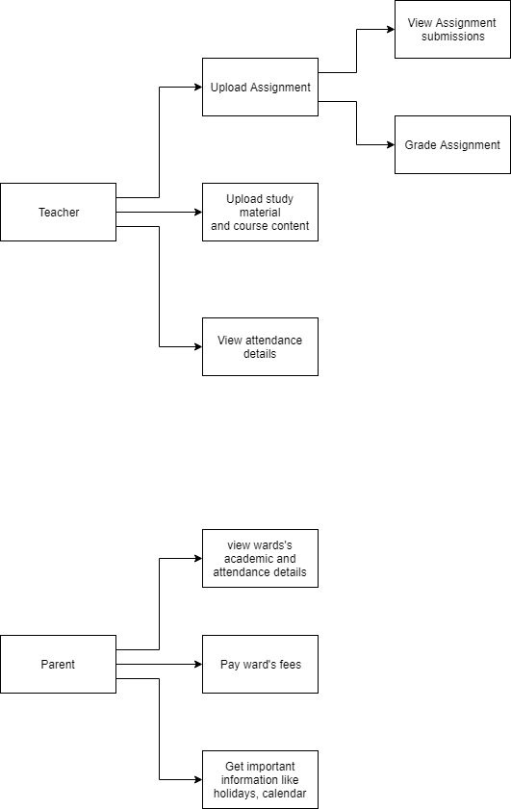

Group members:

1. Raja Rakshit (IMT2016087)
2. Swastik Shrivatsava (IMT2016055)
3. Rishikesh Chaumal (IMT2016131)