PROTOTYPES-

Below are the prototypes for our android application:

Here is the profile picture of our android application:

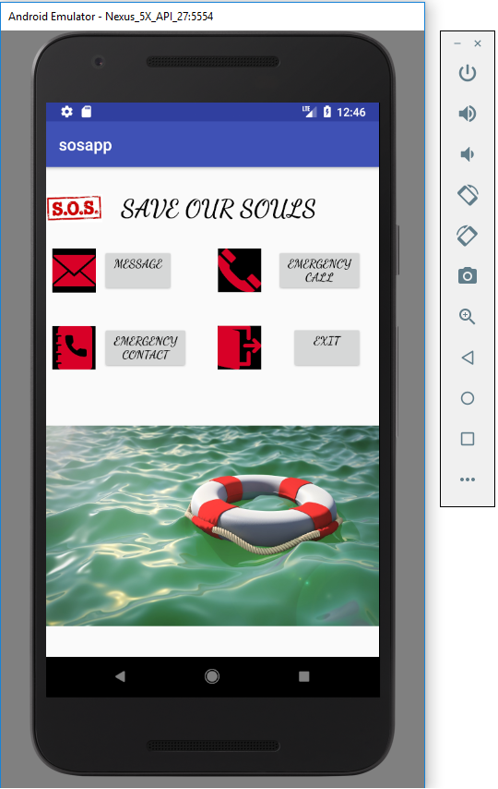

Here is the message page where you have to select or customize the message you want to send the specific person or emergency services:

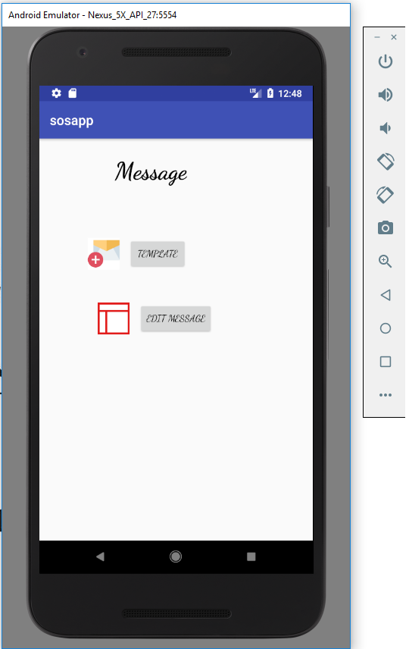

In this page you can select the country you are in so that the emergency services will be provided according to it:

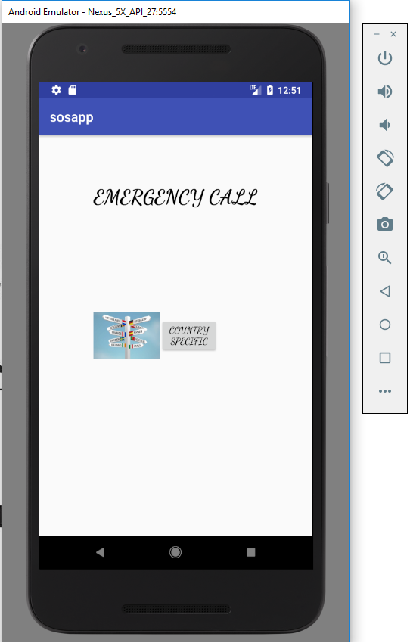

In this message you can add or edit your contact with whom you want to share your information:

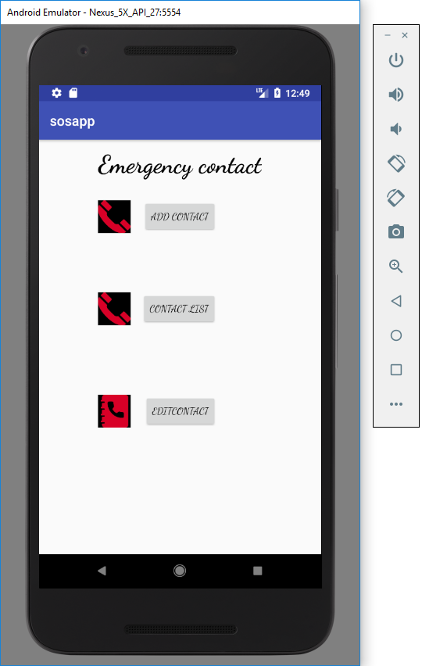

This is the exit page for the application:

