HUNTED

The Board Game

Design by Mateusz Kolodziejczyk and Thomas Farrell

12/12/2019

For your tabletop

Ages: 12 – Up

Ship Date: TBD

**Game Story**: Slaves turned warriors, Demons hunting for blood.

The two converge in a town where things are not always what is expected. A town where the streets shift and change, never the same as the day before.

A battle for artefacts of power, and the fate of humanity in the balance.

**Game Summary**: The game is a 1v2 competitive board game structured around a game of cat and mouse and guesswork. One person plays the demon hunter, who must chase down the enemy demons before they escape and kill them. They must also guess where the correct artifacts are placed, as only the Demons know where they are. To add an element of deception, the Demons place fake artifacts alongside the real artifacts. These objectives represent magical artifacts needed to summon the escape portal. The Demons only advance in their goals by completing the real objectives. Once enough real objectives are completed by the Demons, an exit portal appears and is the final objective for the Demons. If any demons reach it, they win the game.

**Characters**:

**Demon Hunters**

Samuel Clemens

A former demon prisoner, his killing of one of his captors and touching its blood awoke powers within him that would drive anyone mad. Lucky for Samuel, he already was. Now he frees captives and allows those who wish to follow his fight against the demonic invasion to do so. Currently, he defends the town of Noellia due to its high number of magical artefacts, which the demons are interested in.

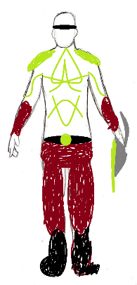

Merisa Highnight

Bio: A former demon prisoner, she was rescued from a hovel of demons thanks to an attack by Samuel and his Demon Hunter followers. More than willing to join the cause for her fellow humans, she hastily drank the demon’s blood and awoke a newfound power inside her.

Currently, she defends the town of Noellia due to its high number of magical artefacts, which the demons are interested in.

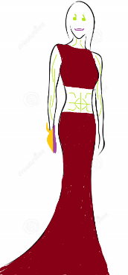

**Demons**

Ga’arth

Bio: A cold, calculating demon that quickly rose through the ranks, sent by someone directly of the higher order to attack the human town of Noellia to retrieve some magical artefacts for a ritual.

Ga’arth’s belief: Sanguinem Ignis!

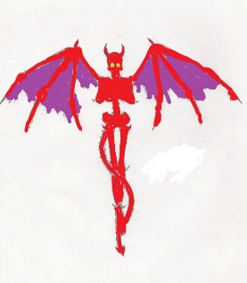

O’ka’dreth

This demon steals its victims’ fingers as a trophy which it hangs from its Armor. Its Armor is thick, heavy, near impenetrable, except for the flames of the Demon hunters.

O’ka’dreth’s belief: Cum debilis pedibus currere multitudinem tuam!

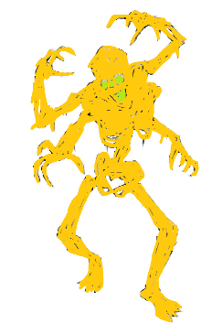

Bograhmah

Boramesh is particularly cruel, feeding off the flesh of not only its victims, but specifically seeking out the flesh of its close family members. It prefers to sneak in the shadows than to be out in the open, but that cowardice was rewarded due to its effectiveness at its job.

Boramesh’s belief: Magister Circa Artem occidendum

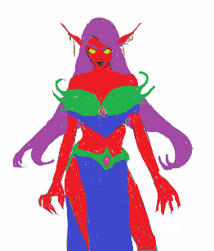

**Gameplay Overview**: Hunted is a co-operative/competitive board game fielding a team of two players playing the demons being chased down by a single player playing the demon hunter. It uses a modular board where buildings and objectives can be placed where the players wish, with some limits to prevent unplayable layouts.

The demons attempt to collect enough artifacts to spawn an escape portal in the middle of the map, while the demon hunter tries to stop them by killing them and preventing them from collecting them.

However, the demons have hidden the true nature of the artifacts and placed dummy artifacts around the board, only they know where the true ones are. The demon hunter needs to guess where the true ones are located by observing the way the demons are moving.

The board is littered with multiple buildings of varying sizes and artifacts can be placed on them. Whether to take a shortcut or take the high ground, you can move onto these buildings which have squares of their own on them.

Movement is unique in this game, the demon hunters use a d10 and demons use a d6 to move but adding to this each player has two pieces in play. The movement points gotten from the rolls can be divided in any way the player wants between their pieces.

However, moving is not the only way to evade or kill in this game. There are also ability cards which each player draws periodically. Each one has a beneficial effect for the player that plays it, for example extra movement points, slowing down the other team, etc. Using these cards at the right time is part of the strategy in this game.

If any demon reaches the escape portal, the demons win. If the demon hunter kills every demon, they win.

**Game World**: The two demon hunters attempt to catch the demons in the town of Noellia. This is a Victorian era town, full of dark greys similar to Bloodbourne. However not everything is dark here, as this city is filled with magical artifacts and this is why the demons have come.

The board itself is dark, each square representing a part of a Victorian district. However, the placeable buildings also fit the theme. With their neo gothic architecture, they set a shadow on all twisting alleys on the board.

If the demons manage to find enough artifacts, they spawn the portal. This is an ominous, demonic portal that allows them to escape. It is one of the truly bright things in this world as it burns with a bright, demonic glow.

**Game Experience**: Before playing the game the board is set up as the players wish, or set up using a quick setup map provided. After setting up the board, the Demon team chooses where the true objectives lie to add a feeling of uncertainty to the Demon Hunter.

The story of the game is told mostly through the instruction manual, but also through the board and gameplay. The demons are locked up in a Victorian city district of labyrinthine buildings and alleys. The demon hunter moves faster than the demons to make the demon team feel being trapped and hunted in this harsh world. However, the demons always feel like there is some hope as there is always a chance to win until the very end.

The demon hunter must kill a large number of demons to win and will feel very hopeless at the beginning as the demons run around. However, as the demon hunter can move faster than the demons, he is more powerful than them. He also starts on the edge of the map, allowing him to encircle the demons who spawn in the middle.

As the game draws to a close, the clock starts ticking and the Demon Hunter only has a certain number of turns left to stop the remaining demons. This gives the game a time constraint that increases tension up to the very last moment, especially with the random elements of the game in the ability cards and movement.

The world and characters of this world are dark, with very little light. It feels similar to games like Bloodbourne where demon hunters try to rid the world of evil. The demon hunters and demons are alike in their looks, as the demon hunters are part demons themselves like in World of Warcraft. However, they remain human, while the demons are hideous monstrosities. The demon hunters are one of the few sources of color in this world, as they are the only hope for humanity, while the demons are of inhumane colors.

**Game Mechanics**:

Modular Board: The objective positions as well as the buildings can be placed wherever the players want, but any layout has to provide a route to each objective and there cannot be too many objectives in each quadrant.

Starting positions: The demons start in the centre of the map, while the demon hunter chooses where he spawns on any of the squares on the edge of the board.

Movement: Each player handles two pieces, but the movement points gotten from dice rolls are split amongst them. Demon hunters roll 1 d10, demons roll 1d6. Players can climb up any building as long as it is only one story higher

Catchup Mechanics: If a demon player drops out of the game by losing both of their pieces, the other player gets the other player’s dice to help them move faster. They get to choose the better of the two dice rolls, or their sum in case of doubles.

Collecting artifacts: 8 artifacts are placed around the board, 3 of them are real artifacts. Only these real artifacts help the demons summon their portal. A demon simply walks onto the artifact to collect it, taking 2 turns to do so. Once 2 out of 3 real artifacts are collected, the portal spawns.

Ability cards: Both demon hunters and demon, alongside their movement, can use ability cards to swing the game in their favour. These include:

* Slow down the demon hunter.
* Create a barricade in a specific spot on the map
* Create a trap on a demon to kill the demon hunter If they kill them.
* Create a trap on a particular square that stops demons from moving out of it.

Buildings: The board is filled with multiple buildings of different shapes and sizes. Each building can be climbed by a player and has its own squares on top to move on. Objectives can be placed in the buildings. The buildings can be used to gain the high ground or simply take a shortcut. You can only move to a building that is 1 story higher than the level you’re currently on.

Killing demons: If the demon hunter moves on top of a demon, they kill them, removing them from the game permanently, if no ability cards have been played to change this. If the demon is on top of an artifact attempting to collect it, the demon hunter destroys the objective permanently as well. However, if the objective is a fake objective it kills the demon hunter as its been booby trapped by the demons. The demon hunter must guess when the demons are laying a trap or collecting a true objective.

**Expansions & Bonus Material**: Like board games such as Cards against Humanity, expansion packs offering additional content will be created and sold in the future. These will include for example additional buildings for the map, new ability cards, new art.

Special themed editions that board games such as Monopoly come out with are also possible. These would retheme the game into for example a 1930s gangster aesthetic where gangsters are being chased down by detectives. These would also include new mechanics. For example a gangster themed edition would give gangsters(demons) a chance to fight back.

Building sets for the original game are also a possibility. These would include new buildings to place on the original board to create more intriguing and novel layouts. They would not be standalone and would require the original game in order to be used.

If the game is successful as boardgame, a digital version could be produced but that is far in the future.

A small booklet detailing the story and world of the game is included as bonus content with the standard edition. A proper book telling the story of the game in detail could happen down the line.

**Monetisaion**: The game’s release date is TBD, however the price of the game will be around €40 retail. This is similar to other board games such as Settlers of Catan. It will be a single purchase with everything needed to play the game included in the box.

Expansions/building sets would range from €10-20 and would require the original game to be used. These would add additional buildings, cards etc.

Special editions would cost the same as the original game, around €40 and be playable straight out of the box.