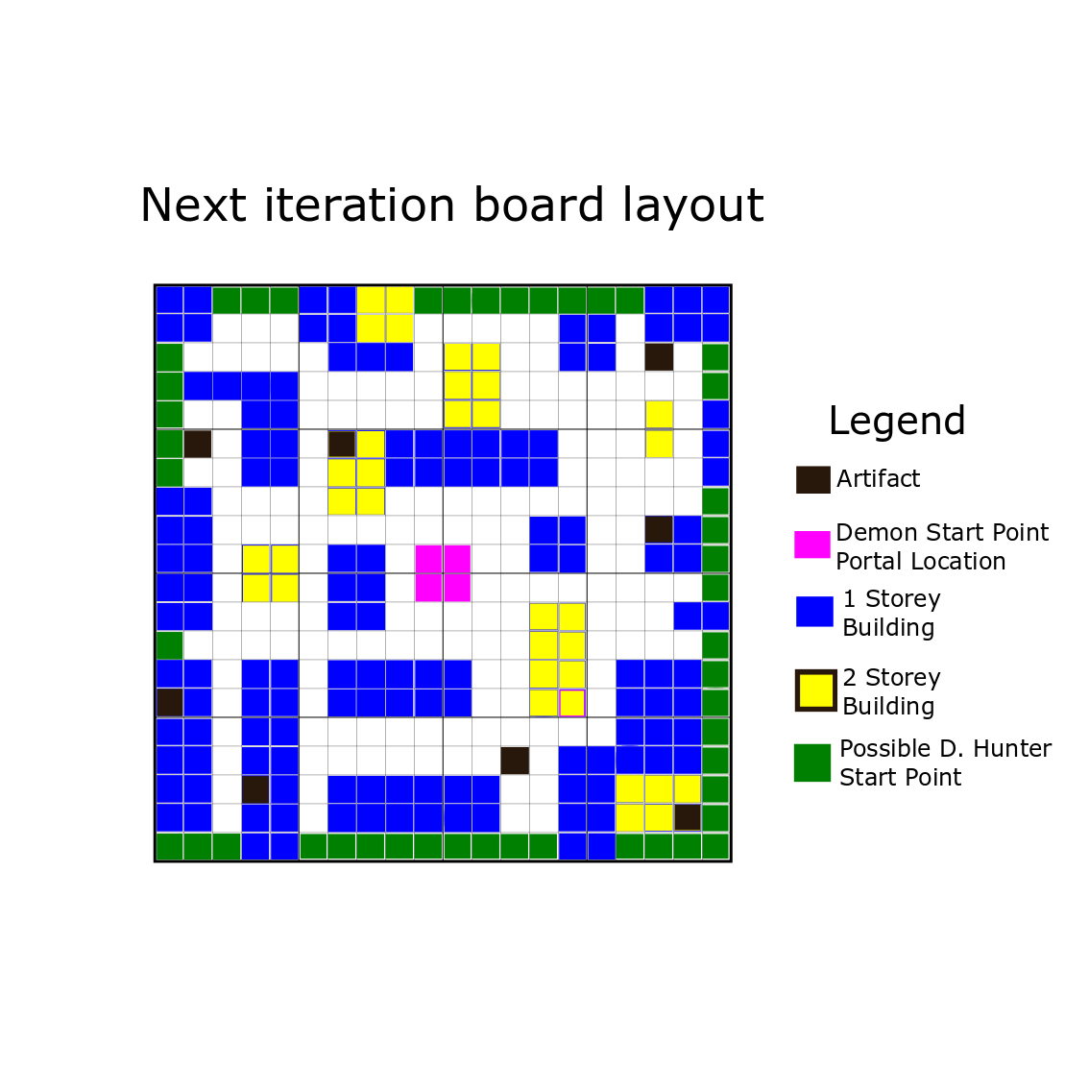

**Changes from initial layout:**

**Squares/ objectives on buildings**

The Next iteration board layout has a few major modifications, the biggest one is the addition of squares and artifacts on top of buildings as well as codifying two story buildings as part of the game. With the addition of artifacts on top of the buildings players are required to interact with the mechanic which teaches them a good way to take shortcuts as well as hide from their opposition. However, ground objectives remain to provide variety to the gameplay.

Not only do these objectives force players to learn the climbing mechanic, they also provide an element of risk/reward especially when it comes to choosing the true artifact placement. Putting the true artifacts on buildings makes you vulnerable and stationary on top of a building however it also forces the demon hunter to climb, wasting a turn.

By using smart strategy you might fool the demon hunter into thinking the true objective isn’t there on the building, giving you an advantage.

**More buildings**

Another difference is the major increase in the number of buildings of various shaped and sizes. This helps create a bigger labyrinthine feeling of being trapped in a labyrinth that was lacking from the first iteration. It also gives the demons some time to plan their moves until the demon hunters can get to the middle using the twisting paths.

**Design decisions that stayed:**

**Demon/D Hunter starting points**

Neither the demon or demon hunter spawn points seem to cause any problems so they stay. Demons starting in the middle allows them to plan a route around the map to collect the most artifacts possible, while the demon hunter gets to choose where to spawn based on the layout of them aswell. As the demon hunter moves faster than the demons, they will be able to catch up to the demons and meet them on the objectives.