Characters:

Name: Samuel Clemens

Age: 38

Occupation: Demon Hunter

Gender: Male

Bio: A former demon prisoner, his killing of one of his captors and touching its blood awoke powers within him that would drive anyone mad. Lucky for Samuel, he already was.

Now he frees captives and allows those who wish to follow his fight against the demonic invasion to do so.

Currently, he defends the town of Noellia due to its high number of magical artefacts, which the demons are interested in.

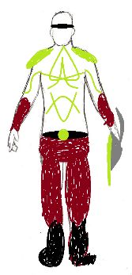

Name: Merisa Highnight

Age: 25

Occupation: Demon Hunter

Gender: Female

Bio: A former demon prisoner, she was rescued from a hovel of demons thanks to an attack by Samuel and his Demon Hunter followers. More than willing to join the cause for her fellow humans, she hastily drank the demon’s blood and awoke a newfound power inside her.

Currently, she defends the town of Noellia due to its high number of magical artefacts, which the demons are interested in.

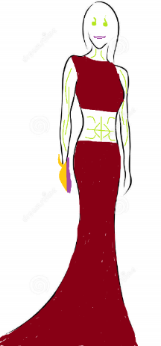

Name: Ga’arth

Age:???

Occupation: Demon General

Gender: Male

Bio: A cold, calculating demon that quickly rose through the ranks, sent by someone directly of the higher order to attack the human town of Noellia to retrieve some magical artefacts for a ritual.

Ga’arth’s belief: Sanguinem Ignis!

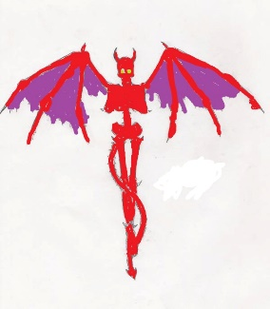

Name: O’ka’dreth

Age:????

Occupation: Demon General

Gender: Male

Bio: This demon steals its victims’ fingers as a trophy which it hangs from its Armor. Its Armor is thick, heavy, near impenetrable, except for the flames of the Demon hunters.

O’ka’dreth’s belief: Cum debilis pedibus currere multitudinem tuam!

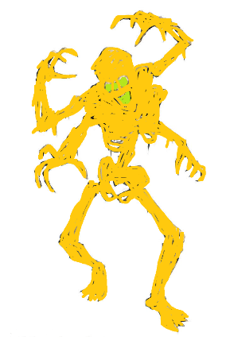

Name: Bograhmah

Age:???

Occupation: Demon General

Gender: Female

Bio: Boramesh is particularly cruel, feeding off the flesh of not only its victims, but specifically seeking out the flesh of its close family members. It prefers to sneak in the shadows than to be out in the open, but that cowardice was rewarded due to its effectiveness at its job.

Boramesh’s belief: Magister Circa Artem occidendum

