Exploring the Microbiome in Native and Non-Native Plants at the University of San Francisco Lone Mountain Campus

Isabella Finney

March 21, 2019

# Introduction

Classifying plants as standalone entities is inaccurate because they host a diverse array of microorganisms that are essential to their major functions (1). Although microbes are fundamental to plant maintenance, little is known about the exact microbial communities inhabiting different plants species around the world and their impact on plants’ ecological function. In addition, the leaf microbiome, or phyllosphere microbiome, is influenced by abiotic and biotic factors that make this dynamic relationship harder to understand (2). Leaves are a huge contributor to a plant’s system and it is estimated that about 6.4 × 108 km2 microbes can colonize a leaf’s surface area (3). Culture-based and molecular techniques have helped biologists examine isolated microbes in greater detail. These techniques can be applied to examining the phyllosphere and its vast array of microbial communities. Thus far, many different genera of bacteria, fungi, yeasts, and algae have been identified through research (4).

The focus on my investigation was to examine differences in the colonies and morphotypes present on two plants growing on the Lone Mountain portion of the University of San Francisco’s Hilltop Campus. The two plants I examined were the ice plant (*Carpobrotus edulis*) and fern-leaf yarrow (*Achillea filipendulina*). I chose these particular plants because of their differing plant structure and environmental status. Fern-leaf yarrows are bright, yellow flowering plants and ice-plant is a succulent with a very low percentage of flowers present. Plant-pollinator relationships are highly important to plant biodiversity and in particular, about 90% of all flowering plants rely on animals for pollination (5). In Northern California, fern-leaf yarrows are naturalized plants and ice plant is considered an invasive species. Plant invasions are known to pose serious threats to native and naturalized plant communities by robbing natural resources and reducing overall biodiversity (6). Due to the structural diversity and environmental impact between these plant species types, I hypothesized that there would be a greater morphotype diversity and higher colony counts present on the leaves of fern-leaf yarrows because of the higher interactions with pollinating insects and its proximity to an invasive plant species requires more microbes to protect and enhance its fitness against the invasive threat. To test this plant-microbiome relationship, I conducted culture-based techniques from samples obtained on the leaves of each plant species. I grew cultures on tryptic soy agar (TSA) plates at three different dilutions. I found both colony and morphotype counts to be larger in fern-leaf yarrow leaves but there was only a statistical significance between the morphotype counts of each plant. Then I obtained pure cultures for 7 different observed morphotypes. I created a crystal violet, gram, and Maneval’s stain slides for each morphotype. After taking microscopic photos, I measured the length, width, and area for each microbe using the ImageJ software and Fiji platform.

# Methods

## Study design

### Field Collection

On January 31st, 2019, I sampled leaves from a fern-leaf yarrow and an ice plant located at the Lone Mountain campus of the University of San Francisco in San Francisco, California (37.776N, 122.4506W). For each plant, I collected samples from 3 different leaves which were located at 3 different elevations from the soil to the tip of the plant. I used a new, sterile cotton swab on each leaf for approximately 10 seconds and then I proceeded to place each swab into a labeled tube filled with 1mL of PBS solution. To obtain the control for my experiment, I used sterile swabs to collect 3 air samples from the area where the plants were located. I exposed each swab to the air for approximately 10 seconds and placed each swab into a labeled tube filled with 1mL of PBS solution. I kept each sample swab in its respective tube for approximately an hour and a half before removing it for culturing.

### Culturing and Dilution Plating

I used 100mm tryptic soy agar (TSA) plates for plating the three sample treatments I collected. I first vortexed each test tube for approximately 10 seconds in order to release remaining microbes from the cotton swab and into the PBS solution. For each tube, I transferred 50 µL into a new sterile tube and added 450 µL of PBS solution to create a 10x dilution sample. I created a 100x dilution sample by transferring 50 µL from the 10x dilution and adding 450 µL of PBS solution. For each sample collected at each plant type and control, I used 27 TSA plates. Each TSA plate was covered with its respective PBS and sample solution mix at a concentration of either 1, 10, or 100. I spread the bacterial liquid onto each TSA plate by swirling approximately 6-8 glass beads until the plate was completely covered. The glass beads were removed and appropriately disposed of. I placed these plates inside an incubator at 37C for a weak to allow colonies to grow. On February 5, 2019, I removed all of the plates from the incubator in order to examine colonial morphology and counts. I distinguished morphotypes based on color, pigmentation, shape, colony margin, and elevation. Any additional features or anomalies such as distinctively emitted smells were noted as well. To count the number of colonies per plate, I used a Sharpie pen to mark each counted colony as to avoid miscounting.

### Streak Plating

For further examination, I obtained pure microbial cultures from morphotypes that I observed to be either in high abundance or very rarely present among all of the TSA dilution plates from my samples. To do this, I used an inoculating loop to scoop the desired morphotype colony from the diluted plate. I transferred the single colony on a sterile TSA plate by streaking the loop across one third the agar surface, inoculating the loop with a bacticinerator, dragging the loop through the 1st streak and streaking another third, and repeating once more. This method should isolate pure cultures of microbes. I completed this method 7 times, once for each morphotype observed. I also used the bacticinerator to sterilize the metal loop between each morphotype streaking. After 5 days of incubating the plates at 37C, I restreaked plates that did not produce single colonies or were contaminated. The restreaked plates were incubated for only two days.

### Staining and Microscopy

In order to visualize and identify the different morphotypes, I created 3 stained slides from the pure cultures I obtained. I made a crystal violet stain, gram stain, and Maneval’s stain. These staining methods were used so that I could observe and identity microbes’ different physical features under a light microscope. Crystal violet staining helps to visualize the basic size, shape, and arrangement of the cells. Gram staining helps distinguish between gram-positive and gram-negative bacteria. Maneval’s stain is a negative stain that shows whether the bacterium contains a capsule. After mounting, fixing, and staining each culture, I placed the slide under a Leica DM500 light microscope and observed each slide at 100x magnification under immersion oil.

## Computational Analysis

## Culturing Analysis

The process to analyze the data gathered was accomplished using a systematic workflow. First, I created and uploaded data onto a Google Sheet. I added data about the number of different colonies and morphotypes counted per TSA plate at each concentration for each sample treatment. This sheet was then converted and exported as a csv file to the raw data project file folder. Using the R language and RStudio, I uploaded my project and added various software packages such as dplyr and ggplot2 to a Rmd file. I used the csv data file and appropriate packages I added to create the figures for my analysis. I also performed ANOVA analyses on both colony and morphology counts.

## Microscopy Analysis

I connected the light microscope to a computer containing the Leica LAS E2 software in order to directly take photos of each slide from the microscope. Photos were standardized and captured at 2048x1536 resolution. After obtaining my images, I used Fiji and ImageJ to measure and analyze each image. Fiji is an image processing package within the ImageJ software that focuses on biological-image processing (7). I uploaded the captured micrograph and then proceeded to calibrate and scale each micrograph to 10 m. I changed each image to an inverted, binary form and recorded the length, width, and area for 5 cells per morphotype. I created a montage with appropriate labels of each micrograph taken for each staining method per morphotype. Using R and R studio, I uploaded these montages to my report with appropriate captions. I also analyzed the mean and standard deviation for length, width, and cell surface area per morphotype.

# Results

## Colony Counts

The first thing I investigated was the number of colonies present for each sample treatment at the original concentration (1x). Looking at each sample, I observed that, qualitatively, the number of colonies found on the leaves of fern-leaf yarrow plants is larger than the number of colonies found on the leaves of ice plants but I found no statistical significance (Figure 1; ANOVA, p = 0. 3372).

## Detecting Morphotypes

Because of the differences I observed in colony counts, I decided to investigate whether the sample treatments differed in the number of morphotypes I detected per sample. The average number of morphotypes detected in fern-leaf yarrow plants were larger than the average number found in ice plants (Figure 2; ANOVA, p = 0.03303). One of the morphotypes I detected at the highest frequencies were white, circular, glistening, and raised. One of the rarest morphotypes obtained from the 1x sampling plates was present in the fern-leaf yarrow sample which was taken from the leaf closest to the soil of the plant.

# load packages as needed  
library("dplyr")

##   
## Attaching package: 'dplyr'

## The following objects are masked from 'package:stats':  
##   
## filter, lag

## The following objects are masked from 'package:base':  
##   
## intersect, setdiff, setequal, union

library("ggplot2")  
library("ggthemes")  
library("RColorBrewer")  
library("broom")  
library("tidyr")  
  
# Read in csv file with data  
colony_data <- read.csv(  
 paste0("data/raw_data/",  
 "2019-02-05_dilution_plating_colony_and_morphotype_counts ",  
 "- Sheet1.csv"))

#make a histogram of colony counts  
colony_data %>%  
 filter(dilution_1_10_100 == 1) %>%  
 filter(student_name == "Isabella_Finney") %>%  
ggplot(aes(x = location_name_or_control,  
 y = number_of_colonies_total,  
 fill = location_name_or_control)) +  
 geom_boxplot() +  
 geom_point() +  
 ggtitle("Count of colonies from different locations, 1x dilution") +  
 xlab("Plant Name") +  
 ylab("Number of colonies")

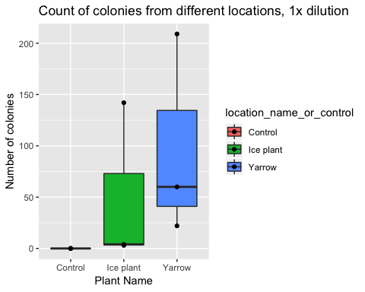

**Figure 1:** Number of colonies per sample treatment and control at 1x dilution.

# Do a statistical test to determine if there are differences  
# in the number of colonies based on plants  
colony_data %>%  
 filter(dilution_1_10_100 == 1) %>%  
 filter(student_name == "Isabella_Finney") %>%  
 lm(number_of_colonies_total ~ location_name_or_control,  
 data = .) %>%  
 anova()

## Analysis of Variance Table  
##   
## Response: number_of_colonies_total  
## Df Sum Sq Mean Sq F value Pr(>F)  
## location_name_or_control 2 14116 7058.1 1.31 0.3372  
## Residuals 6 32327 5387.8

broom::tidy() %>%  
 knitr::kable(digits = 2)

# ANOVA GAVE P=0.3372--> NOT STATISTICALLY SIGNIFICANT

# make a histogram of morphology counts  
colony_data %>%  
 filter(dilution_1_10_100 == 1) %>%  
 filter(student_name == "Isabella_Finney") %>%  
ggplot(aes(x = location_name_or_control,  
 y = number_of_morphotypes_total,  
 fill = location_name_or_control)) +  
 geom_boxplot() +  
 geom_point() +  
 ggtitle("Count of morphotypes from different locations, 1x dilution") +  
 xlab("Plant Name") +  
 ylab("Number of morphotypes")

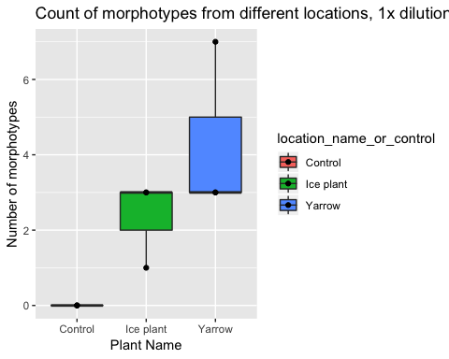

**Figure 2:** Count of different morphotypes present per sample treatment and control at 1x dilution.

# Do a statistical test to determine if there are differences  
# in the number of morphologies based on plants  
colony_data %>%  
 filter(dilution_1_10_100 == 1) %>%  
 filter(student_name == "Isabella_Finney") %>%  
 lm(number_of_morphotypes_total ~ location_name_or_control,  
 data = .) %>%  
 anova()

## Analysis of Variance Table  
##   
## Response: number_of_morphotypes_total  
## Df Sum Sq Mean Sq F value Pr(>F)   
## location_name_or_control 2 28.222 14.1111 6.35 0.03303 *  
## Residuals 6 13.333 2.2222   
## ---  
## Signif. codes: 0 '***' 0.001 '**' 0.01 '*' 0.05 '.' 0.1 ' ' 1

broom::tidy() %>%  
 knitr::kable(digits = 2)

# ANOVA GAVE P = 0.03303, --> STATISTICALLY SIGNIFICANT

microscopy_data <- read.csv(  
 "data/raw_data/2019_Spring_microscopy_data_sheet.csv")

# Create a table of cell length, width, and area  
microscopy_data %>%  
 filter(Student_name == "Isabella_Finney") %>%  
 group_by(MOTU_ID) %>%  
 summarize(mean_length = mean(Cell_length),  
 sd_length = sd(Cell_length),  
 mean_width = mean(Cell_width),  
 mena_area = mean(Cell_area),  
 sd_area = sd(Cell_area)) %>%  
 knitr::kable(digits = 2,  
 col_names = c("MOTU ID",  
 "Mean cell length (µm)",  
 "SD cell length (µm)",  
 "Mean cell width (µm)",  
 "SD cell width (µm)",  
 "Mean cell area (µm^2)",  
 "SD cell area (µm^2)"))

|  |  |  |  |  |  |
| --- | --- | --- | --- | --- | --- |
| MOTU_ID | mean_length | sd_length | mean_width | mena_area | sd_area |
| 1 | 0.92 | 0.15 | 0.92 | 0.16 | 0.24 |
| 2 | 1.66 | 0.15 | 1.83 | 0.51 | 0.56 |
| 3 | 0.69 | 0.34 | 2.86 | 0.15 | 0.05 |
| 4 | 0.71 | 0.09 | 1.74 | 0.11 | 0.02 |
| 5 | 1.03 | 0.06 | 2.47 | 0.15 | 0.02 |
| 6 | 0.90 | 0.14 | 4.87 | 0.30 | 0.03 |
| 7 | 0.74 | 0.03 | 2.71 | 0.17 | 0.03 |

**Table 1:** Mean and standard deviation for the length, width, and cell surface area per morphotype analyzed.

## Microscopy Image Results

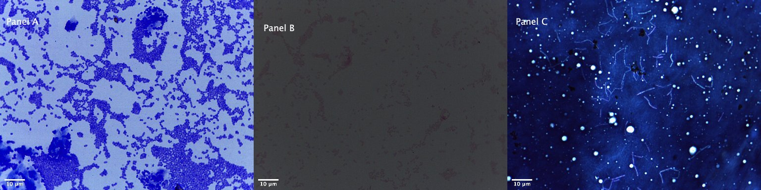

**Figure 1:** Montage imaging of morphotype #1 stained in crystal violet ( Panel A), gram’s stain (Panel B), and Maneval’s stain (Panel C).

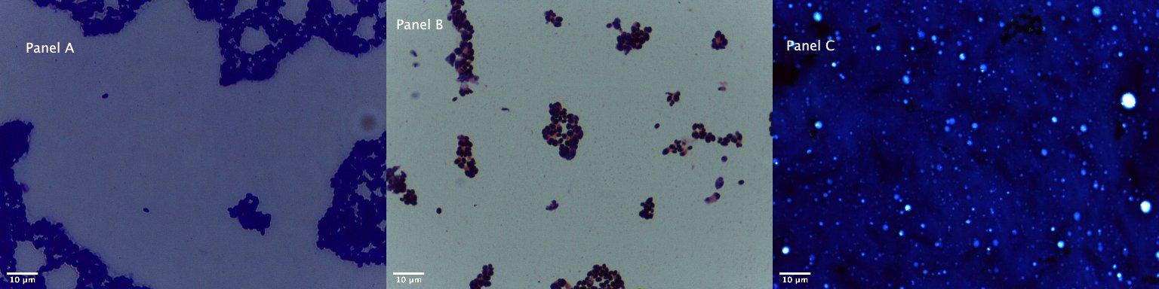

**Figure 2:** Montage imaging of morphotype #2 stained in crystal violet ( Panel A), gram’s stain (Panel B), and Maneval’s stain (Panel C).

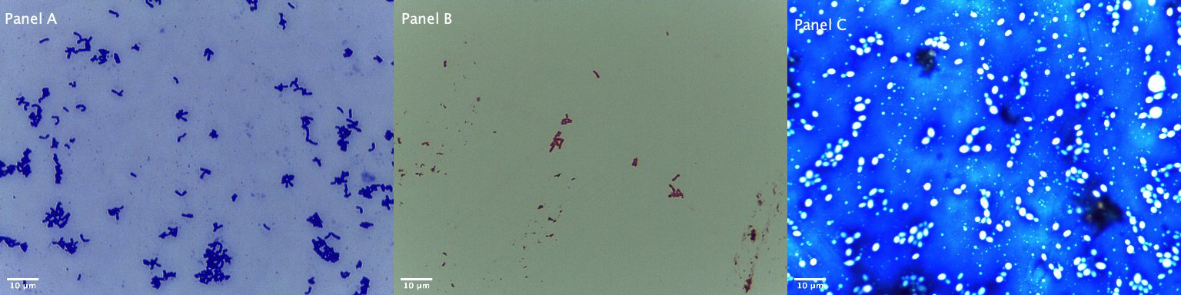

**Figure 3:** Montage imaging of morphotype #3 stained in crystal violet ( Panel A), gram’s stain (Panel B), and Maneval’s stain (Panel C).

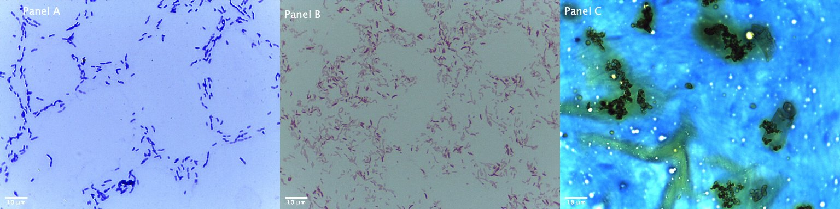

**Figure 4:** Montage imaging of morphotype #4 stained in crystal violet ( Panel A), gram’s stain (Panel B), and Maneval’s stain (Panel C).

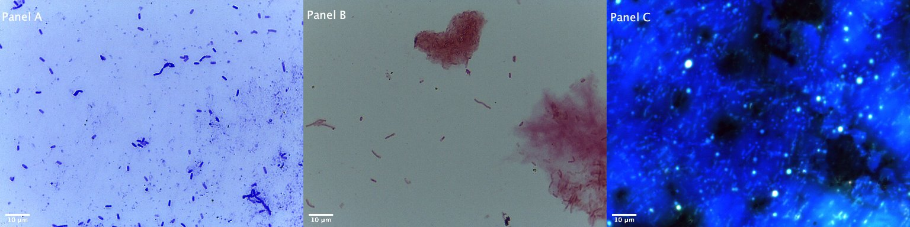

**Figure 5:** Montage imaging of morphotype #5 stained in crystal violet ( Panel A), gram’s stain (Panel B), and Maneval’s stain (Panel C).

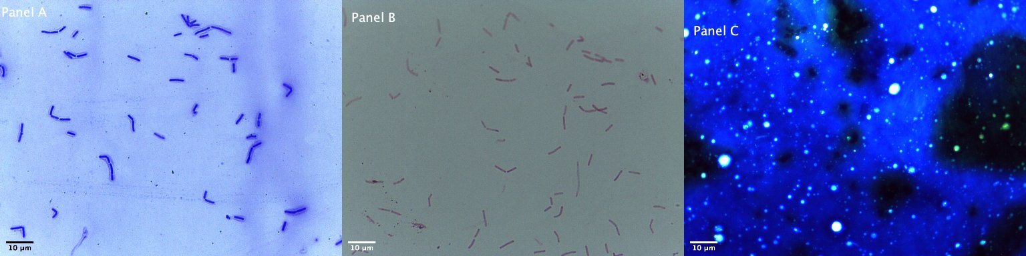

**Figure 6:** Montage imaging of morphotype #6 stained in crystal violet ( Panel A), gram’s stain (Panel B), and Maneval’s stain (Panel C).

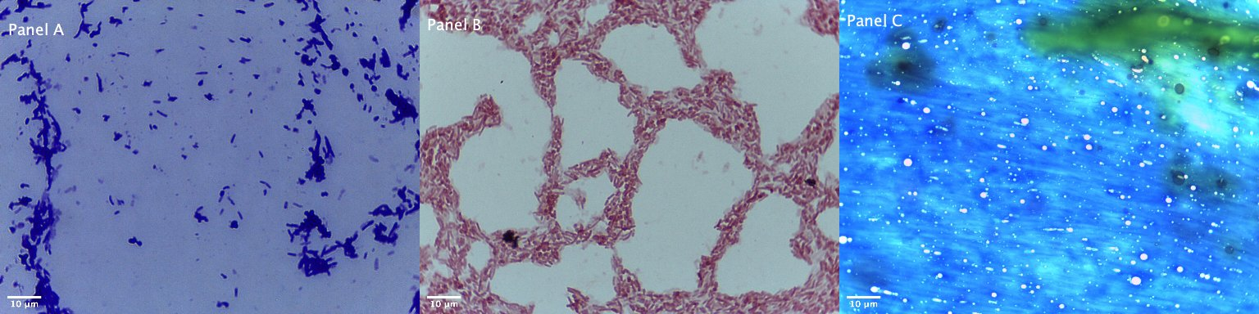

**Figure 7:** Montage imaging of morphotype #7 stained in crystal violet ( Panel A), gram’s stain (Panel B), and Maneval’s stain (Panel C).

# Discussion

## Culturing

The focus of my investigation was to determine whether differences in the colonies and morphotypes present on a fern-leaf yarrow plant and ice plant growing on the Lone Mountain portion of the University of San Francisco’s Hilltop Campus. I hypothesized that the fern-leaf yarrow plant would have higher colony counts and morphotype diversity than the ice plant. The result of this experiment suggests that the plant structure and naturalized status allow fern-leaf yarrows to have greater morphology diversity. Although, qualitatively, fern-leaf yarrows exhibited higher colony counts, there was no statistical difference between the mean counts of the two plants. Some limitations and caveats of the study that are important to mention are the weather on my day of collection and the type of media I used for culturing. There were rain showers the night and morning before I collected my samples which could have potentially added or removed microbes and reduced the amount pollinator visits to each plant type. In addition, I used TSA plates to grow the microbes which may have negatively impacted the morphotypes I observed. My observations may be based on only a subset of microorganisms because tryptic soy agar is an ideal media for bacterial growth, not fungi or plant microbes that are very common in plant species.

Differences in performance among plant species can greatly impact ecosystem function so studying the plant microbiome is important. Invasive plant species, like ice plants, are often able to invade and persist in their environment due to their ability in altering soil chemistry and nutrient cycling through the microbes that accompany them (8). This can lead to the decline in species diversity among native and naturalized plants in their respective environment. To try and combat this depletion in resources, native and naturalized plants such as the fern-leaf yarrow may recruit more beneficial microbes that can aid in tolerance or defense from varying environmental stresses. In addition, scientists argue that invasive plants can be released from attack by natural enemies, like fungal and viral pathogens (9). This may have contributed to the differences I observed in the number of morphotypes present on each plant species. Understanding the microbial impact of invasive species on native and naturalized plants and their ecosystem can be an effective tool in restoring habitats that have been negatively impacted by introduction these invasive plants.

## Microscopy

# Sources Cited

1. Nihorimbere V, Ongena M, Smargiassi M, Thonart P. 2011. Beneficial effect of the rhizosphere microbial community for plant growth and health. Biotechnologie, Agronomie, Société et Environnement 15:327–337.

2. Copeland JK, Yuan L, Layeghifard M, Wang PW, Guttman DS. 2015. Seasonal community succession of the phyllosphere microbiome. Molecular Plant-Microbe Interactions 28:274–285.

3. Morris C. 2002. Fifty years of phyllosphere microbiology: Significant contributions to research in related fields. Phyllosphere microbiology.

4. Andrews JH, Harris RF. 2000. The ecology and biogeography of microorganisms on plant surfaces. Annual review of phytopathology 38:145–180.

5. Ollerton J, Winfree R, Tarrant S. 2011. How many flowering plants are pollinated by animals? Oikos 120:321–326.

6. Foxcroft LC, Pyšek P, Richardson DM, Pergl J, Hulme PE. 2013. The bottom line: Impacts of alien plant invasions in protected areas, pp. 19–41. *In* Plant invasions in protected areas. Springer.

7. Schindelin J, Arganda-Carreras I, Frise E, Kaynig V, Longair M, Pietzsch T, Preibisch S, Rueden C, Saalfeld S, Schmid B, others. 2012. Fiji: An open-source platform for biological-image analysis. Nature methods 9:676.

8. Vilà M, Espinar JL, Hejda M, Hulme PE, Jarošík V, Maron JL, Pergl J, Schaffner U, Sun Y, Pyšek P. 2011. Ecological impacts of invasive alien plants: A meta-analysis of their effects on species, communities and ecosystems. Ecology letters 14:702–708.

9. Mitchell CE, Power AG. 2003. Release of invasive plants from fungal and viral pathogens. Nature 421:625.