The Comparison of Bacteria on Individual versus Communal PC Keyboards

Jacinda Chen

October 16, 2019

# Introduction

Computers have become an essential part of college life as a result of the increased dependency on the internet. Therefore, a growing amount of students are required to buy or have access to computers. Food and drinks are constantly consumed around keyboards, which provide resources for creatures living on top of the keyboard, if there are (Malik and Naeem, 2014). Keyboards are being touched constantly in personal laptops as well as shared computers open to students, faculty and staff (that the university offers). Most people are not aware of the number of microorganisms present on their keyboards (Al-Ghamdi *et al.*, 2011). My primary question was whether or not the keyboards of individual University of San Francisco’s (USF’s) college students’ laptops from the Bioinformatics class have more or less microbacterial species compared to shared computers on campus from the library, the University Center and Toler Hall. Previous research done on this topic has found that shared computers had more microorganisms than individual computers (Anderson and Palombo, 2009). This project will circle around hygiene and aim to figure out if computers should be cleaned more often and if it would be necessary to raise awareness of keyboard hygiene as most people are not that informed about the number of the microorganisms present on keyboards. It is recommended that food and drink should be separated from computers and keyboards should be disinfected regularly (Hamzeh and Na’was, 2011). This is a problem, especially on a school campus where diseases spread quickly. In the interest of people trying to find ways to prevent the spread of these microorganisms, it is important to keep regularly used computers clean, especially in shared public settings. Although the microorganisms found on computers may not be pathogenic or malignant for most people, they can definitely cause harm for people with compromised immune systems (Fraser and Girling, 2009). An example of this could be burn victims, where the issue was raised if computer keyboard contamination was a possible method of transmission of methicillin-resistant *Staphylococcus aurerus* onto patients (Isaacs *et al.*, 1998).

Even though different institutions and people can have various methods of cleaning keyboards, without a regular and frequent keyboard cleaning, bacteria is free to grow. The longer that keyboards are not cleaned, the higher the chance that users of the keyboards will contract diseases from the microorganism or transmit the microorganism elsewhere. The microorganisms with resistances to most antibiotics or disinfectants are growing steadily and exponentially, which allows a growing amount of microorganisms to have longer lifespans on keyboards. Because of this, patients with compromised immune systems, like burn victims, no longer have the assurance of antibiotics fully curing them. Most of the bacteria that plague burn victims or other immunosuppressed patients are gram-negative bacteria, which survive significantly longer on hard surfaces (such as polyurethane, or computer keyboard covers) and humid conditions (Neely, 2000). A longer lifespan gives microorganisms more time to transmit and spread to other places where they have more time to replicate, mutate, and increase survival chances (Eltablawy and Elhifnawi, 2009). Food crumbs, soda residues, and more food residues help millions of bacteria grow. All of the sampled keyboards were positive for microorganism growth (Eltablawy and Elhifnawi, 2009). The environmental surface at which bacteria grow on largely affects their survival times.

My hypothesis is that the keyboards of shared computers have more microbacterial species than individual keyboards because of the increased number of people (students, faculty, staff, etc.) that have access to the keyboard. I collected three bacterial samples from three different individual laptops on the “F” key from students from USF (University of San Francisco) and three other samples from three public spaces on campus, also on the “F” key. These bacteria were diluted then grown in cultures with their dilutions, where DNA was extracted from them. Touchdown PCR was done along with Sanger sequencing, whose results I analyzed with Geneious Prime and R Studio. My primary findings for the culture data was a significant difference in the number of bacterial colonies between Communal and Individual computer keyboards. For the molecular data, it was important that the BLAST table agreed with the Maximum Likelihood Phylogeny and the Bayesian Phylogeny in which samples were more closely related.

# Methods

## Study design

I planned to look at the number of bacteria species on laptop keyboards of individual University of San Francisco students versus the bacteria found on shared computers. I sampled the “F” key for three different individual USF students, as well as the keyboards of three different shared computers on the main campus of USF (Toler Hall, University Center, and Gleeson Library). My primary question was whether or not the keyboards of individual USF college students’ laptops from the Bioinformatics class have more or less microbacterial species compared to shared computers on campus from the library, the UC and Toler Hall.

I collected bacteria, diluted the samples, plated the samples on TSA plates, extracted DNA from the samples, did touchdown PCR, gel electrophoresis, and Sanger sequencing. These results were analyzed with Geneious Prime and R Studio.

## Bacterial Collection

The surface samples were collected during the lab section of the Bioinformatics class on September 3rd, 2019. In total, six tubes were collected. For each location, the “F” key on the keyboard was swabbed. Each sterile swab was dipped in sterile PBS (Phosphate Buffer Saline at pH 7.4) to moisten, then wrung of excess PBS against the side of the tube. I swabbed each surface for 15 seconds. The tip of the swab was broken off into a labelled eppendorf with initials, date,and an unique sample ID. All swab samples were gathered on the “F” key, then put into labelled eppendorfs. I gathered samples on the first floor of Toler Hall (the shared computer at the front desk), the fourth floor of the University Center (in the graphics center on a shared computer), and the first floor of Gleeson Library (on a shared computer). Subsequently, inside the Bioinformatics class, I gathered samples from three different laptops from three different students (Student A, Student B, and Student C) in the same way for the “F” key.

## Dilution Series

The dilution series was done with the “F” key group. In order to prepare the undiluted group, I put 200 µL of PBS into the six eppendorfs with swabs. These six eppendorfs were then vortexed for fifteen seconds. There were another six eppendorfs that were dedicated to 1:10 dilutions of the original six eppendorfs. For these six 1:10 dilution eppendorfs, I added 180 µL of PBS to each of them. Twenty µL of one undiluted eppendorf was then added to its respective 1:10 dilution eppendorf to complete the dilution. This was then repeated another five times to complete the other 1:10 dilutions. I vortexed these six eppendorfs for five seconds. In order to do the 1:100 dilutions, I once again added 180 µL of PBS into each of the six eppendorfs labelled respectively as 1:100 dilutions. Twenty µL of a 1:10 dilution was then added to its respectively labelled 1:100 dilution eppendorf. I repeated this step for the other five 1:100 dilution eppendorfs. The six 1:100 dilution eppendorfs were then vortexed for 5 seconds.

## Plating “F” Key Group

I used 18 100 mm TSA (Tryptic soy agar) plates for plating samples from each of my 2 treatments (n = 3 per group, 6 total). I put 100 µL of an eppendorf from the undiluted series onto a TSA plate and used sterile rattler Plating Beads (5 mm) to spread the medium evenly across the TSA plate. I repeated this step for the other five eppendorfs from the undiluted series, the six eppendorfs from the 1:10 dilution series, as well as six eppendorfs from the 1:100 dilution series. These 18 TSA plates were then incubated at 37o Celsius for a week.

## DNA Extraction

I followed the manufacturer’s protocol from the Sigma REDExtract-N-Amp kit (Weber and Douglas). I labelled a 1.5 mL tube for each sample and added cells from one colony to the tube using a sterile pipette tip to gently scrape off one colony (not pipetting). One colony was chosen each from the TSA plate of the undiluted sample from Toler Hall, the University Center, Gleeson library, and Student B. Two colonies were chosen from the TSA plate of the undiluted sample from Student C. I added 100 µL of extraction solution then vortexed the tube for 60 seconds. This was repeated for the other five 1.5 mL tubes. All six tubes were incubated at 95o Celsius for ten minutes then vortexed for 60 seconds. I added 100 µL of dilution solution to each of the six tubes and vortexed them for five seconds. These six tubes were then centrifuged for five minutes at 14,000 rpm. For the Qubit protocol, I added 198 µL of the Qubit solution to the qubit tube. Two µL of the DNA extraction was added to the 198 µL of Qubit solution. This step was repeated for the other five DNA extractions. I vortexed all six Qubit tubes for five seconds then incubated them for five minutes in the dark. The Qubit machine was used to measure the concentration of DNA.

## Touchdown PCR for Cultured “F” key series

I labelled a tube for the master mix. Inside, I put 77 µL of Amp, 6.2 µL of 27f primer, 6.2 µL of 1492r primer, 7.7 µL BSA, and 49.5 µL of water. These volumes of the reagents were calculated according to (n+1) + 10%(n+1) where n is the number of samples to amplify with PCR. The master mix was vortexed for three seconds and centrifuged at low speed. I aliquoted 19 µL of the master mix to each 250 µL sample tube, six in total, and one other 250 µL tube for the negative control. One µL of the sample was added to each of the six sample tubes. One µL of water was added for the negative control. The seven 250 µL PCR strip tubes were put in specific PCR cycles and conditions. The PCR strip tubes were put in the machine for 95o C for 5 minutes. Then, they were put in the machine for 94o C for 30 seconds, 65o C for 30 seconds, 72o C for 1 minute. These last three times were repeated for ten cycles, but the temperature was decreased by one degree per cycle. The next three temperatures and times were 94o C for 30 seconds, 55o C for 30 seconds, 72o C 1 minute. These last three times were repeated for 25 cycles. Lastly, the PCR sample tubes went through 72o C for 10 minutes and held at 4o C. The electrophoresis gel was made with 2% agarose gel, SYBR safe dye, 1x TAE buffer and put through 140 V for 30 minutes. An Ez load 1 kb Molecular Ruler (already has glycerol, dye, and DNA set fragments), or a ladder, was added to the first and last wells of both lines of wells in the gel. One µL of each of my seven PCR tubes was pipetted into seven wells of the gel. After checking for successful amplification using gel electrophoresis, PCR products were cleaned with ExoSAP (Invitrogen) and sent for unidirectional Sanger sequencing at MCLAB (South San Francisco, CA) using the 27f primer.

## Analysis

### Geneious Prime

My first task in Geneious Prime was to assess whether or not the sequences were usable. Then, I had to trim or correct usable sequences. This was done by trimming off a large part of the beginning and ending of the sequences (since they were filled with low quality or unusable bases) and going through the low quality bases in the middle of the sequence to decide whether or not they should be deleted, changed, or an ambiguity code needed to be added from the IUPAC Ambiguity Codes. I used MAFFT to create an appropriate multiple sequence alignment with all five of my usable and corrected sequences with the default settings and an offset value of 0.123. A Maximum Likelihood Phylogeny and a Bayesian Phylogeny were created using *Thermus aquaticus* as an outgroup by downloading the sequence from GenBank. For the Maximum Likelihood Phylogeny, a substitution model of General Time Reversible (GTR) was used with 100 bootstrap replicates with defaults for all other settings. For the Bayesian Phylogeny, I used a substitution model of GTR, a rate variation of Gamma plus Invariants model, as well as a Burn-in Length of 100,000 with all other settings set to default. I used Nucleotide BLAST (Basic Local Alignment Search Tool) by comparing my nucleotide sequences to the sequence databases, where it also calculated the statistical significance of the match (Johnson *et al.*, 2008).

### R Studio

I used the packages dplyr and ggplot in order to visualize the data with boxplots. I also tested between different sampling groups using Wilcox statistical tests in order to get the p values.

# Results

## Culture Data

### Colony Abundance

The colony abundances from the Communal computers had larger number of colonies compared to the Individual computers, which is shown by the maximum number of colonies observed in the Individual computers remaining smaller than the minimum of the colony abundances from the Communal computers (Figure 1; boxplot of colony abundance). I also observed a bigger range of larger values for the colony abundances of Communal computers where the minimum and maximum number of colony abundances had a difference of around eight, whereas the differences between the minimum and maximum number of colony abundances for Individual computers was about one. The colony abundance for Individual computers had a singular abnormally abundant colony depicted by the outlier, just under the 2.5 number of colonies mark.

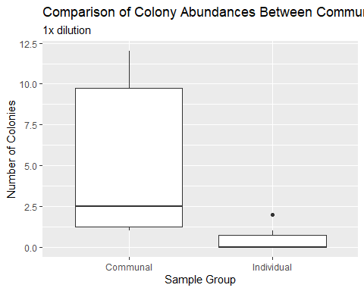

**Figure 1:** Boxplot of colony abundances at Communal versus Individual computers, 1x dilution. There was a higher median number of colonies from Communal Computer samples, and the mean number of colonies were significantly different between the two sites (Wilcox p = 0.02104).

### Statistical (Wilcox) test for above Colony Abundance

A statistical (Wilcox) test was run to compare the number of colony abundances of Communal versus Individual computers at 1x dilution. The mean number of colonies between Communal and Individual computers were significantly different, with a p-value of 0.02 (Table 1; Statistical test for Colony Abundance).

|  |  |  |  |
| --- | --- | --- | --- |
| statistic | p.value | method | alternative |
| 32.5 | 0.0210402 | Wilcoxon rank sum test with continuity correction | two.sided |

**Table 1:** The statistical (Wilcox) test to compare the number of colony abundances between Communal and Individual computer keyboards, 1x dilution.

### Boxplot showing the number of morphotypes in each of your two treatments (1x Dilution)

I made a boxplot showing the number of morphotypes in Communal versus Individual computer keyboards for 1x dilution (Figure 2). Both Communal and Individual computer keyboards had an outlier of two morphotypes. The Communal computer keyboards had a median, minimum, and maximum of one morphotype. Individual computer keyboards had a median and minimum of 0 morphotypes and a maximum of 0.75 morphotypes.

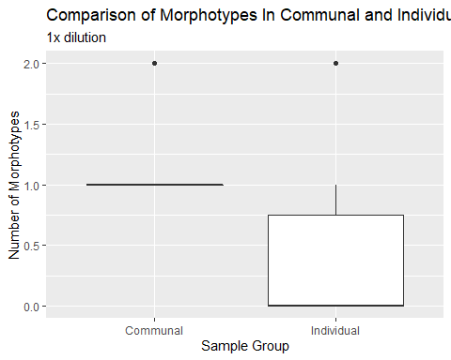

**Figure 2:** Boxplot showing the number of morphotypes between Communal and Individual computers, 1x dilution. The mean number of morphotypes were not significantly different between the communal and individual computers (Wilcox p = 0.09679).

### Wilcox test for the number of morphotypes

The mean number of morphotypes between Communal and Individual computer keyboards were not significant with a p-value of 0.10 (Table 2; Statistical test on the number of morphotypes). This was the result of a statistical test to compare the number of morphotypes in Communal versus Individual computer.

|  |  |  |  |
| --- | --- | --- | --- |
| statistic | p.value | method | alternative |
| 28 | 0.096791 | Wilcoxon rank sum test with continuity correction | two.sided |

**Table 2:** The statistical (Wilcox) test to compare the number of morphotypes between Communal and Individual computers, 1x dilution.

### Grown Cultures

Two colonies were used from 6F (Figure 3). 3F and 5F both had a single colony growing significantly larger than other colonies. 6F had two different morphotypes, while every other culture had the same morphotype: circular with pale coloring. 2F had many small culture growing.

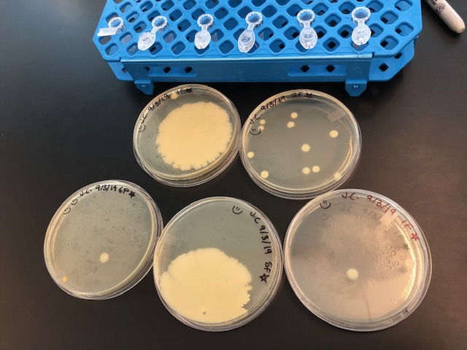

**Figure 3:** A picture showing the usable colonies from culturing with 1F, 2F, 3F, 5F, and 6F sample TSA plates.

## Molecular Data

### Table of Qubit DNA extraction samples of Key “F” series (cultured)

The Qubit numbers of the DNA extractions from the “F” key culture samples were larger than zero. The 1F sample had a Qubit number of 5.40 ng/µL, 2F had 6.10 ng/µL, 3F had 8.76 ng/µL, 5F had 7.51 ng/µL, 6Fo had 5.66 ng/µL, and 6Fp had 9.05 ng/µL (Table 3; Qubit Table).

|  |  |
| --- | --- |
| Sample | Qubit Number Range (ng/µL) |
| 1F | 5.40 |
| 2F | 6.10 |
| 3F | 8.76 |
| 5F | 7.51 |
| 6Fo | 5.66 |
| 6Fp | 9.05 |

**Table 3:** Table of Qubit DNA extraction samples of Key “F” series (cultured)

### Gel Electrophoresis

Bright bands, or higher concentrations, were shown for the 1F, 2F, 3F, 5F, and 6Fp samples, while the 6Fo sample showed a faint band, or a lower concentration (Figure 4; Gel electrophoresis). The bands all showed up at a similar place, using to the ladder. There were no bands at all in the negative control.

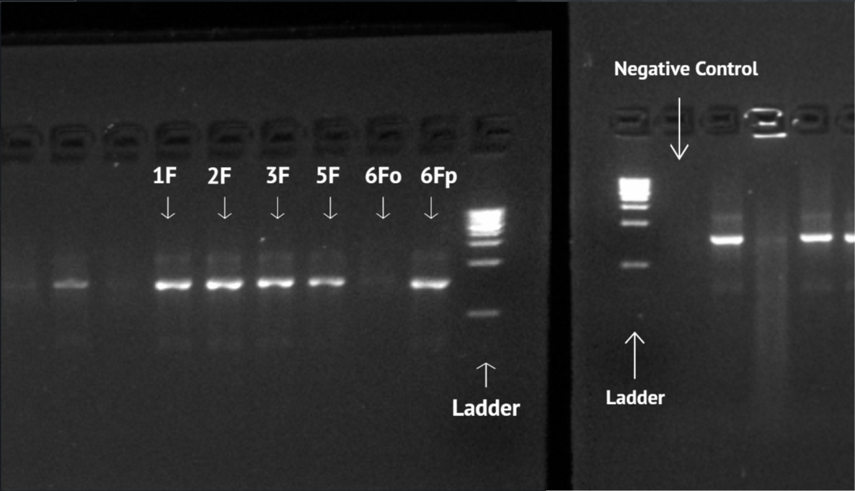

**Figure 4:** Gel electrophoresis image of samples 1F, 2F, 3F, 5F, 6Fo, 6Fp, ladder, and negative control.

### Sequence Usability Table

The original filename of my sequences came from the Sanger sequencing. The unusable ends were trimmed off and four bases out of the remaining 426 bases for the 1F trimmed sequence were changed (Table 4). For the 2F trimmed sequence, four bases out of 658 bases were changed (Table 4). Three bases out of 634 bases for the 3F trimmed sequence were edited with ambiguity codes (Table 4). For 5F trimmed sequence, seven bases out of 593 bases were changed to ambiguity codes (Table 4). For the 6Fp trimmed sequence, three bases out of 559 bases were changed (Table 4).

|  |  |  |  |  |  |
| --- | --- | --- | --- | --- | --- |
| Sequence Locus | Original Sequence Filename | Corrected Sequence Filename | Usability | Length after trimming | Manually corrected/adjusted bases |
| 16S | JC_1F_27f_A07.ab1 | JC_1F_27f_A07_JC_cleaned_mixed.ab1 | Usable | 426 bases | 4 |
| 16S | JC_2F_27f_B07.ab1 | JC_2F_27f_B07_JC_cleaned_mixed.ab1 | Usable | 658 bases | 4 |
| 16S | JC_3F_27f_C07.ab1 | JC_3F_27f_C07_JC_cleaned.ab1 | Usable | 634 bases | 3 |
| 16S | JC_5F_27f_D07.ab1 | JC_5F_27f_D07_JC_cleaned.ab1 | Usable | 593 bases | 7 |
| 16S | JC_6Fo_27f_E07.ab1 | JC_6Fo_27f_E07_JC_failed.ab1 | Unusable | N/A | N/A |
| 16S | JC_6Fp_27f_F07.ab1 | JC_6Fp_27f_F07_JC_cleaned.ab1 | Usable | 559 bases | 3 |
| 16S | JC_Neg_27f_G07.ab1 | JC_Neg_27f_G07_JC_failed.ab1 | Unusable | N/A | N/A |

**Table 4:** Table depicting the original filenames, usable trimmed sequences that were corrected and renamed, and details surrounding the latter.

### BLAST Table

For the trimmed sequence of 1F, Staphylococcus epidermidis was found to be the closest match using BLAST; the percent identification is 99.53%, the query cover is 100%, and the E-value is 0.0. The same goes for the following trimmed sequences: Staphylococcus hominis subsp. novobiosepticus was matched with 2F; the percent identification is 99.39%,the query cover is 100%, and the e-value is 0.0. Bacillus subtilis was matched with 3F; the percent identification is 99.53%, the query cover is 100%, and the e-value is 0.0. Bacillus subtilis was matched with 5F; the percent identification is 98.82%, the query cover is 100%, and the e-value is 0.0. Staphylococcus epidermidis was matched with 6Fp; the percent identification is 99.82%, the query cover is 100%, and the e-value is 0.0 (Table 5; Used BLAST to calculate the statistical significance between matched sequences).

|  |  |  |  |  |  |
| --- | --- | --- | --- | --- | --- |
| BLAST filenames | Description | Percent Identity | Query cover | Accession | E-Value |
| JC_1F_27f_A07_JC_cleaned_mixed.ab1 | *Staphylococcus epidermidis* strain IBK-11 16S ribosomal RNA gene, partial sequence | 99.53% | 100% | MN428237.1 | 0.0 |
| JC_2F_27f_B07_JC_cleaned_mixed.ab1 | *Staphylococcus hominis* subsp. novobiosepticus strain IBK-7 16S ribosomal RNA gene, partial sequence | 99.39% | 100% | MN428234.1 | 0.0 |
| JC_3F_27f_C07_JC_cleaned.ab1 | *Bacillus subtilis* strain SR3-30 16S ribosomal RNA gene, partial sequence | 99.53% | 100% | MN421487.1 | 0.0 |
| JC_5F_27f_D07_JC_cleaned.ab1 | *Bacillus subtilis* strain SR3-30 16S ribosomal RNA gene, partial sequence | 98.82% | 100% | MN421487.1 | 0.0 |
| JC_6Fp_27f_F07_JC_cleaned.ab1 | *Staphylococcus epidermidis* strain LY-2 16S ribosomal RNA gene, partial sequence | 99.82% | 100% | MH930441.1 | 0.0 |

**Table 5:** Table of nucleotide BLAST results of edited sequences.

### Maximum Likelihood Phylogeny with PhyML

For the Maximum Likelihood Phylogeny, *Thermus aquaticus* was used as the outgroup. I found that sequences 6Fp and 2F are grouped together in a monophyletic clade with 85 bootstrap support value, while sequences 3F and 5F are grouped together in a monophyletic clade with 100 bootstrap support (Figure 5). This was also supported by the Bayesian Phylogeny (Figure 6; Bayesian posterior probability > 95).

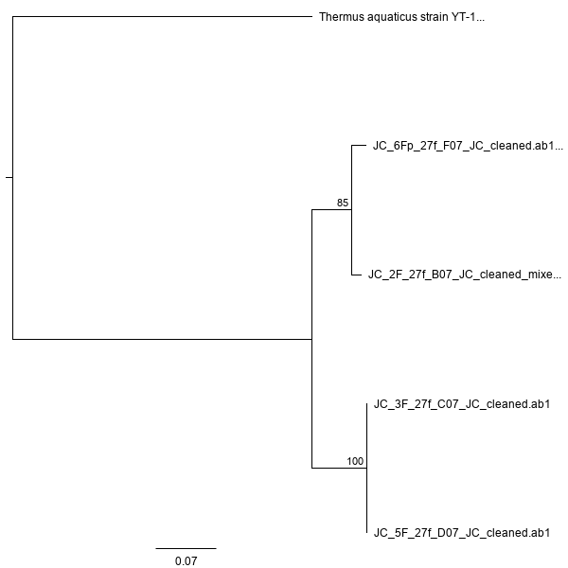

**Figure 5:** Maximum Likelihood Phylogeny with PhyML using *Thermus aquaticus* as an outgroup.

### Bayesian Phylogeny with Mr. Bayes

For the Bayesian Phylogeny, *Thermus aquaticus* was used as the outgroup. I found that sequences 6Fp and 2F are grouped together in a monophyletic clade, while sequences 3F and 5F are grouped together in a monophyletic clade (Figure 6). This was also supported with the Maximum Likelihood Phylogeny (Figure 5; ML bootstrap > 80).

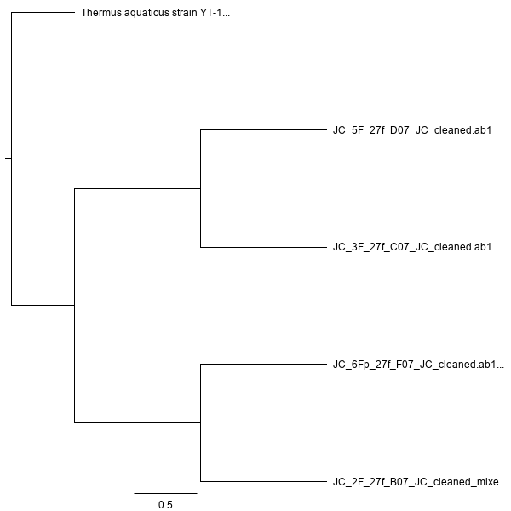

**Figure 6:** Bayesian Phylogeny with Mr. Bayes using *Thermus aquaticus* as an outgroup.

# Discussion

My primary question was whether or not the keyboards of individual USF college students’ laptops from the Bioinformatics class have more or less microbacterial species compared to shared computers on campus from the library, the UC and Toler Hall. I hypothesized that the keyboards of shared computers have more microbacterial species than individual keyboards because of the increased number of people (students, faculty, staff, etc.) that have access to the keyboard. My primary findings for the culture data was a significant difference in the number of colonies between Communal and Individual computer keyboards. For the molecular data, it was important that the BLAST table agreed with the Maximum Likelihood Phylogeny and the Bayesian Phylogeny in which samples were more closely related.

## Grown Cultures

For each location, the “F” key on the keyboard was swabbed and bacteria was collected and diluted. Since the type of bacteria was unknown nor how it would grow, it was necessary to dilute the samples in order to maximize the number of environments that the bacteria could possibly grow in. The undiluted series were vortexed for 15 seconds in order to get the bacteria off the swabs and into the PBS. I found that the 1x dilution cultures worked the best because all of the Communal computer samples had at least one colony and a majority of the Individual computers samples had at least one colony. There was a higher number of colonies that was present on Communal computer keyboards. The median number of colonies from the Communal samples was around 2.5 colonies larger than the median number of around 0 for Individual samples (Figure 1; Boxplot of the comparison of colony abundances). In order to prove if this difference was statistically significant, a statistical (Wilcox) test was performed. My null hypothesis was that there was no difference between the sample groups. The p-value I attained was 0.02 (Table 1; Wilcox test for Colony Abundance boxplot). Since it was less than 0.05, I rejected the null hypothesis, meaning that there was significant difference between the number of colony abundances between sample groups. Both the Communal and Individual samples had a very small range of the number of morphotypes, with an outlier of two morphotypes (Figure 2; boxplot of the comparison of morphotypes between the two samples). My null hypothesis was that there was no difference between the sample groups. The p-value from the statistical (Wilcox) test was 0.10, which is larger than 0.05. I failed to reject the null, meaning that the number of morphotypes between the sample groups were not significantly different (Table 2; statistical test for the comparison of morphotypes between the sample groups). Statistical tests were performed in order to remove human subjectivity with finding statistically significant patterns. Each of the two boxplots are supported with a statistical test for a difference in group means. The easiest approach was to use a Wilcox test (a nonparametric alternative to the t-test).

The only TSA plate group of 1x, 10x, and 100x that did not have any culture growing at all was 4F, or the personal laptop from Student A. This was similar to previous research since a majority of the samples contained bacterial contamination and for my small sample size of six different bacterial swabs, five out of six showing bacterial contamination is congruent with previous findings since a majority of samples contained bacterial contamination (Al-Ghamdi *et al.*, 2011). Two colonies were chosen from the TSA plate of the undiluted sample from Student C, or sample 6F, for this reason (Figure 3; showing chosen plates and colonies). During DNA extraction, the caustic extraction solution broke down cell walls and the incubation at 95o Celsius was to break membranes. Dilution solution was added to stop the extraction solution from digesting DNA too. The dilution solution was added in 16 minutes from when the extraction solution was first added, which was under twenty minute mark when the extraction solution would have started to break down the DNA as well. The last vortex for five seconds was to mix the extraction and dilution solutions. Qubit samples were incubated in the dark because the Qubit machine is sensitive to the light. It was important to measure the concentration of DNA in order to ensure that we had enough DNA to amplify in PCR, a later step. All of my samples showed that they had a sufficient amount of DNA from the Qubit numbers, which were all above 5 ng/µL (Table 3; Qubit DNA extraction numbers).

## Touchdown PCR for “F” key series

The PCR strip tubes were put in the machine for 95o C for 5 minutes. Then, they were put in the machine for 94o C for 30 seconds, 65o C for 30 seconds, and 72o C for 1 minute. These last three cycles were repeated for ten additional cycles, where the temperature was decreased by one degree per cycle. Touchdown PCR was used in order to increase selectivity so that higher quality attractions would click together in the beginning (Korbie and Mattick, 2008). The purpose of starting at a higher temperature was to be more selective at the first round of 65o C with the copies of the best match. As the temperature decreased by one degree, it created matches and copies preferentially of the already selective primer rather than the original strand. Also, if I had accidentally put two colonies instead of one, one colony would most likely be a better match to the primer, then the primer would preferentially amplify that one.

## Gel Electrophoresis

For the gel electrophoresis, buffer was used instead of water because nothing would happen with water while buffer is able to conduct a high level of current. Agarose gel was used rather than polyacrylamide because agarose is less dense and gives DNA more space to stretch out. The master mix contained glycerol, which made my sample more dense than water, causing it to sink at the bottom of the well in the gel instead of mixing with water in the gel. There were ladders in the first and last wells of each of the two lines of wells in order for them to act as standards (a bunch of fragments of DNA at known lengths). The ladders act as the positive control from the cyber working. If the electrophoresis and the cyber works, then the known lengths of DNA fragments should be seen. The ladder looks more grouped together above 3 kb because the gel only ran for 30 minutes. There were bright bands shown for 1F, 2F, 3F, 5F, and 6Fp at 1-2 kb, a faint band for 6Fo at 1-2 kb, and no band for the negative control (Figure 4; Gel electrophoresis image). There were no bands for the negative control because there is no DNA in there. There was a strange brightness above the bright band possibly because tandem repeats of the ribosome were made due to their importance. In order to fix this problem in future projects, I could change the restriction enzyme, drop the number of cycles (however faint bands would most likely not show at all), or shorten the extension time (to give taq polymerase less time to copy). The fluorescence around 30 kb was due to the gel having auto-fluorescence and was not due to the DNA.

## Geneious Prime

The sequence 6Fo was not usable possibly either because there the DNA was low quality, an incorrect amount of DNA template was used, mixed templates were sequenced, or I used the wrong the primer. For future follow-up experiments, I could use an agarose gel to check the DNA template concentration prior to sequencing or to make my own primer. Knowing that I was sequencing bacteria, some of the ambiguous peaks I observed in the 1F and 2F trimmed sequences were probably because I might have sampled two colonies instead of one (Table 4; Sequence Usability Table). Another reason why this may have occurred was because the colony sampled is an entire population, which consists of millions of cells that have divided and might have had mutations. I had over 400 bases for a majority of my sequences after trimming, and five usable sequence (Table 4; Sequence Usability Table). This was an acceptable amount of bases to be used for the alignments and phylogenies. All of my usable sequences were mostly high quality 16S sequences that required less than eight bases that needed to be manually corrected (Table 4; Sequence Usability Table).

## Sequence Relationships

The high 100% Query Covers for 1F, 2F, 3F, 5F, and 6Fp sequences meant a large percentage of the target sequence covered the query sequence (Table 5; BLAST Table). The 5F trimmed sequence had a percent identity of over 98%, showing that the matched BLAST sequence was very similar to my trimmed sequences (Table 5; BLAST Table). My trimmed sequence of 1F, 2F, 3F, and 6Fp had a percent identity over 99%, which means the matched BLAST sequences were even more similar. The accession number is an unique tag for a sequence that allows me to track different versions of the sequence over time. The E-value (expect value) was 0.0 for all of my usable sequences (Table 5; BLAST Table). Since the number of hits that the result received were by chance was 0.0, I am confident that the matched BLAST sequences were not due to chance 1F was matched with *Staphylococcus epidermidis*, 2F was *Staphylococcus hominis*, 3F was *Bacillus subtilis*, 5F was *Bacillus subtilis*, and 6Fp was *Staphylococcus epidermidis* (Table 5; BLAST Table). This was similar to previously identified bacteria in preceding research set up in the same university conditions (Anderson and Palombo, 2009). The trimmed sequence of 1F was not included in the phylogenies because it was too low quality for an accurate phylogeny. The phylogenetic results using the trimmed sequences of 2F, 3F, 5F, and 6Fp matched with my BLAST results. In both phylogenies, *Thermus aquaticus* was used as the outgroup, from the domain Archaea. Since the bacteria I cultured were unknown, I needed to use the domain Archaea as the outgroup, which had the closest relation to the domain Bacteria. In the Maximum Likelihood Phylogeny, sequences 6Fp and 2F were grouped together in a monophyletic clade with a 85 bootstrap support value, while sequences 3F and 5F were grouped together in another monophyletic clade with a 100 bootstrap support value, which agreed with the separation of genera *Staphylococcus* and *Bacillus* from the BLAST table (Figure 5; Maximum Likelihood Phylogeny and Table 5; BLAST table). The Bayesian Phylogeny agreed with the Maximum Likelihood Phylogeny and the BLAST table, resulting with the same groupings (Figure 6; Bayesian Phylogeny). I did not find support for my hypothesis as there was no difference between the number of bacterial species between Communal or Individual computer keyboards. Sequences 6Fp and 2F were from the genus *Staphylococcus*, yet 6Fp was from an Individual Student’s computer keyboard while 2F was from a shared computer keyboard (Table 5, Figure 5, Figure 6). Sequences 3F and 5F were from the genus *Bacillus*, yet 3F was from a shared computer keyboard while 5F was from an Individual Student’s computer keyboard (Table 5, Figure 5, Figure 6).

# Sources Cited

Al-Ghamdi,A. *et al.* (2011) Bacterial contamination of computer keyboards and mice, elevator buttons and shopping carts. *African Journal of Microbiology Research*, **5**, 3998–4003.

Anderson,G. and Palombo,E.A. (2009) Microbial contamination of computer keyboards in a university setting. *American journal of infection control*, **37**, 507–509.

Eltablawy,S. and Elhifnawi,H. (2009) Microbial contamination of some computer keyboards and mice in national center for radiation research and technology (ncrrt). *World Applied Sciences Journal*, **6**, 162–167.

Fraser,M. and Girling,S. (2009) Bacterial carriage of computer keyboards in veterinary practices in scotland.

Hamzeh,F. and Na’was,T. (2011) Computer mice in public centers: A source of pathogenic bacteria.

Isaacs,D. *et al.* (1998) Swabbing computers in search of nosocomial bacteria. *The Pediatric infectious disease journal*, **17**, 533.

Johnson,M. *et al.* (2008) NCBI blast: A better web interface. *Nucleic acids research*, **36**, W5–W9.

Korbie,D.J. and Mattick,J.S. (2008) Touchdown pcr for increased specificity and sensitivity in pcr amplification. *Nature protocols*, **3**, 1452.

Malik,K. and Naeem,N. (2014) Study of bacteria on computer’s mice and keyboards. *Int J Curr Microbiol App Sci*, **3**, 813–23.

Neely,A.N. (2000) A survey of gram-negative bacteria survival on hospital fabrics and plastics. *The Journal of burn care & rehabilitation*, **21**, 523–527.

Weber,S. and Douglas,D. Extract-n-amp™ tissue pcr kit: Rapid genomic dna extraction from tissue coupled with pcr.