Your Title Here

Jacqueline Imperial

October 16, 2019

# Introduction

# Methods

## Study design

## Analysis

# Results

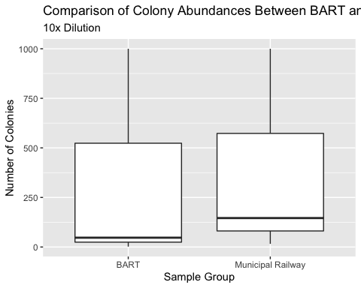

**Figure 1:** Boxplot of colony abundances at different sites, 10x dilution. Despite a higher median number of colonies from the Municipal Railway samples, the mean values of colonies were not significantly different between the two sites (Wilcox p = 0.82)

|  |  |  |  |
| --- | --- | --- | --- |
| statistic | p.value | method | alternative |
| 3.5 | 0.8247781 | Wilcoxon rank sum test with continuity correction | two.sided |

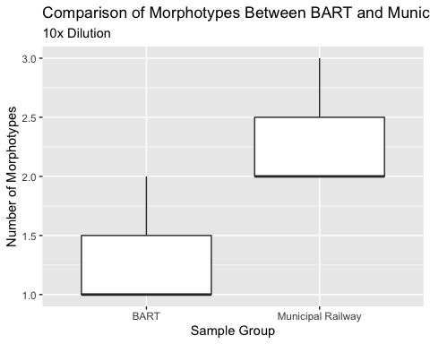

**Figure 2:** Boxplot showing the number of morphotypes from the two different sites. There was a difference in the mean number of morphotypes, W = 1 and p = 0.16

|  |  |  |  |
| --- | --- | --- | --- |
| statistic | p.value | method | alternative |
| 1 | 0.1572992 | Wilcoxon rank sum test with continuity correction | two.sided |

## Culture Data

## Subsections are ok in the results section too

# Discussion

# Sources Cited