Your Title Here

Kris Choi

October 16, 2019

# Introduction

# Methods

## Study design

The model of the experiment was ground beef and they were replicated by purchasing 3 different brands: Teva kosher foods from Trader Joe’s, Lucky California from Lucky Supermarkets, and Butcher shop from Trader Joe’s. The first treatment group remained refrigerated while the second treatment group was stored at room temperature. For both treatment groups, they were stored for 80 hours before subsampled.

## Subsampling

I dipped a sterile cotton swab in PBS buffer first and swabbed each sample on the surface for at least 10 seconds. Then, I broke off the tip of the cotton swab into the labeled tube and closed the cap. In order to conduct culturing and culture-free experiment for each sample in later steps, I collected total of 18 samples (n = 3 per group, 6 total).

## 1:10/1:100 Dilution and Microbial Culture

I prepared 3 dilutions for each sample: the original stock, 1:10, and 1:100 using PBS buffer (total volume of 200µL each). For culturing process, I transferred 100µL of each diluted sample to 100mm TSA plate and spread the solution with the beads for 10 seconds. The petri dishes were stored in incubator for growth of microbes.

## DNA Extraction and Quantification of DNA concentration

I chose 6 different bacterial morphotypes across the cultured sample and added the cell from colony to a tube using a sterile pipette tip. I performed DNA extraction by following the manufacturer’s protocol from the Sigma REDExtract-N-Amp kit. After the extraction, I measured DNA concentration using Qubit Fluorometer.

## Touchdown PCR

I prepared the master mix for PCR using following ingredients: Amp reagent, 27f primer, 1492r primer, BSA, and water. After aliquoting the master mix and adding DNA to each tube, PCR started with denaturing at 95⁰C for 5 minutes, another denaturing at 94⁰C for 30 seconds, annealing at 65⁰C for 30 seconds, and extending at 72⁰C for 1 minute. The temperature for annealing stepped down 1⁰C per cycle and the second denaturing, annealing,and extending steps were repeated for 10 cycles. Subsequently, additional 25 cycles were started at 94⁰C for 30 seconds, 55⁰C for 30 seconds, and 72⁰C for 1 minute. The cycle stayed at 72⁰C for 10 minutes and went down to 4⁰C for hold.

## Gel Electrophoresis and PCR cleanups

I loaded 6 PCR products and a negative control for 4µL each on 2% agarose gel containing SYBR safe dye and ran the electrophoresis at 140V for 30 minutes. After inspecting the fluorescent bands under UV light, PCR cleanups were performed using Invitrogen Exo-SAP and sent for unidirectional Sanger sequencing using 27f primer at MCLAB in South San Francisco, CA.

## Sanger sequencing and Analysis

I used the software called Geneious Prime to analyze the integrity of the sequencing data delivered from MCLAB. After reviewing the quality of the samples, I determined 3 usable raw sequences with long stretches of high-quality reads. I trimmed the sequences by removing poor quality reads near the primer site and at the end and manually adjusting bases with IUPAC ambiguity codes. After cleaning the sequences, I aligned the trimmed sequences along with *Thermus aquaticus* as an outgroup. In addition, I used two phylogeny programs, PhyML and MrBayes, within Geneious Prime to construct phylogenetic trees of the aligned sequences. Lastly, I loaded the 3 cleaned sequences and 1 failed sequence into BLAST to identify its gene families.

# Results

## Culture Qubit DNA concentration and Gel Image

To demonstrate successful DNA extraction, I measured DNA concentration values for each sample using Qubit Fluorometer (Figure 1). The data validated that all samples contain DNA in it and the values were within 2-30ng/µL range. However, I found no bands in lane 6 and 7, sample #5 and 6 respectively, indicating no DNA separated from the sample (Figure 2). Sample #1, 2, and 4 showed bright bands while sample #3 produced a faded band. All the visible bands are appeared to be about 1.5kb in fragment size according to EZ Load 1 kb Molecular Ruler (Figure 2a).

|  |  |
| --- | --- |
| Sample ID | DNA Conc. (ng/µL) |
| 1 | 10.50 |
| 2 | 25.50 |
| 3 | 7.56 |
| 4 | 15.10 |
| 5 | 12.40 |
| 6 | 14.30 |

**Figure 1:** DNA concentration values for culture samples. Sample ID 1 was extracted from the original stock of refrigerated Teva kosher foods from Trader Joe’s, 2 was extracted from 1:100 dilution of refrigerated Teva kosher foods from Trader Joe’s, 3 and 4 were extracted from the original stock of refrigerated Lucky California from Lucky Supermarkets, and 5 and 6 were extracted from the original stock of refrigerated Butcher shop from Trader Joe’s.

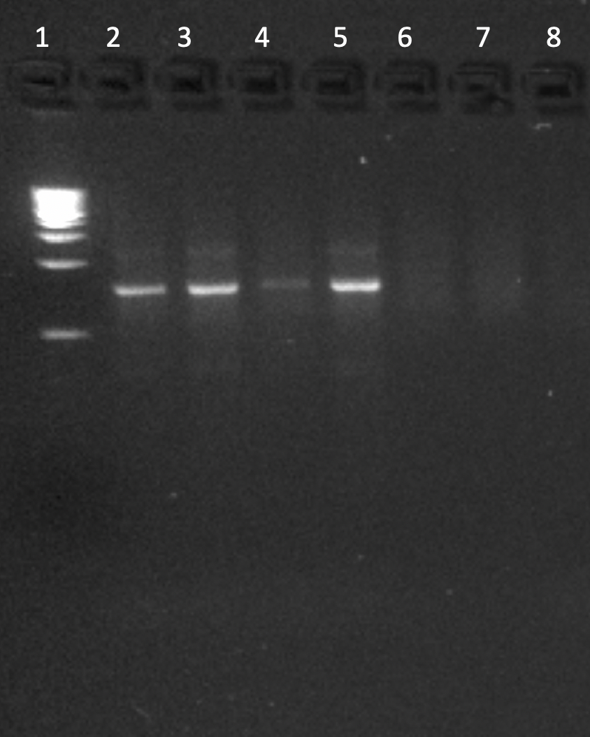 **Figure 2:** Gel image of culture samples. Ladder is shown in lane 1, and the samples from 1 to 6 are located in lane 2-7. Negative control is located in lane 8.

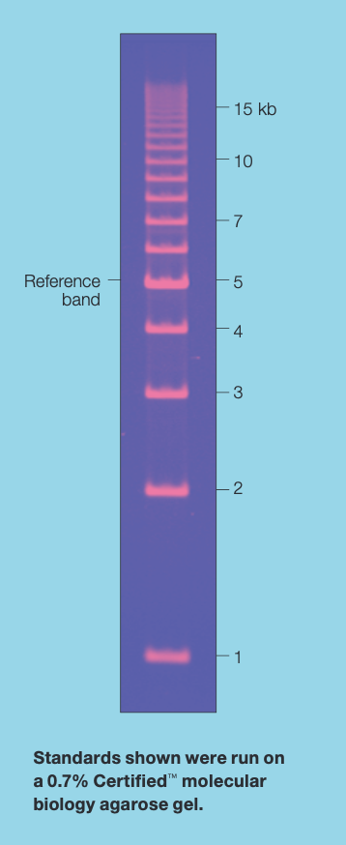

**Figure 2a:** Ladder used in lane 1 (EZ Load 1 kb Molecular Ruler #1708355).

## Comparison of colony abundances and morphotypes

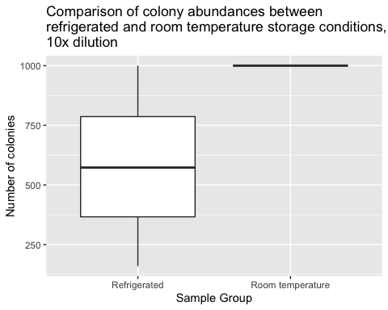

**Figure 3:** Boxplot of colony abundances at different storage conditions, 10x dilution. Despite a higher median number of colonies from room temperature samples, the mean numbers of colonies were not significantly different between the two storage conditions (Wilcox p = 0.20).

|  |  |  |  |
| --- | --- | --- | --- |
| statistic | p.value | method | alternative |
| 1.5 | 0.1967056 | Wilcoxon rank sum test with continuity correction | two.sided |

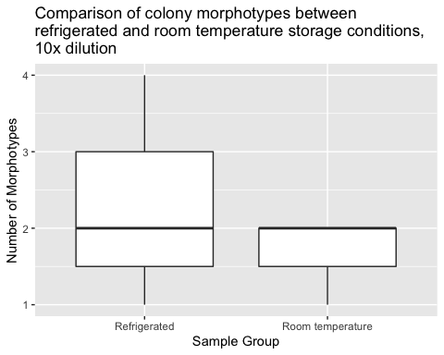

**Figure 4:** Boxplot showing the number of morphotypes from the two different storage conditions. There was no difference in the mean number of morphotypes (Wilcox p=0.81).

|  |  |  |  |
| --- | --- | --- | --- |
| statistic | p.value | method | alternative |
| 5.5 | 0.8136637 | Wilcoxon rank sum test with continuity correction | two.sided |

## Sanger Sequencing and Phylogenetic Trees

|  |  |  |  |  |  |
| --- | --- | --- | --- | --- | --- |
| ID | Original File Name | File name after Correction | Usable? | length after trimming | Manually adjusted bases |
| 1 | 1-KC_27f_A01.ab1 | 1-KC_27f_A01_KC_cleaned.ab1 | Yes | 611 | 16 |
| 2 | 2-KC_27f_B01.ab1 | 2-KC_27f_B01_KC_cleaned.ab1 | Yes | 713 | 36 |
| 3 | 3-KC_27f_C01.ab1 | 3-KC_27f_C01_KC_failed_blast.ab1 | No | N/A | N/A |
| 4 | 4-KC_27f_D01.ab1 | 4-KC_27f_D01_KC_cleaned.ab1 | Yes | 552 | 8 |
| 5 | 5-KC_27f_E01.ab1 | 5-KC_27f_E01_KC_failed.ab1 | No | N/A | N/A |
| 6 | 6-KC_27f_F01.ab1 | 6-KC_27f_F01_KC_failed.ab1 | No | N/A | N/A |
| 7 | 7-KC Neg Control | 7-KC Neg Control_KC_failed | No | N/A | N/A |

**Figure 5:** Sanger sequencing data for each sample.

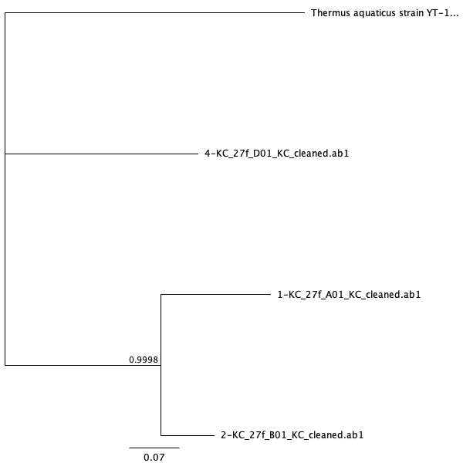

**Figure 6:** Bayesian phylogenetic tree

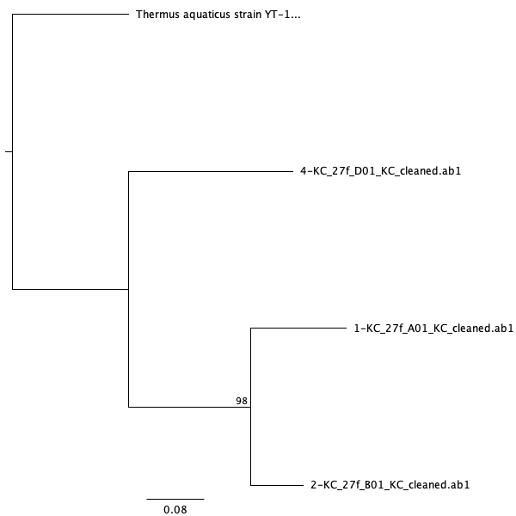

**Figure 7:** Maximum Likelihood phylogeny

## Identification of Samples using BLAST

|  |  |  |  |  |  |
| --- | --- | --- | --- | --- | --- |
| ID | Description | % Identity | Query cover | Accession | E-value |
| 1 | *Acinetobacter baumannii* | 97.38 | 100% | CP044356.1 | 0 |
| 2 | *Hafnia paralvei* | 96.36 | 96% | MK995600.1 | 0 |
| 3 | *Kocuria rhizophila* | 90.46 | 77% | KY522908.1 | 5e-136 |
| 4 | *Staphylococcus saprophyticus* | 98.55 | 100% | MH930439.1 | 0 |

**Figure 8:** Identification of each sample using BLAST

# Discussion

# Sources Cited