2 . 1. **introduction**

Smart mobile device usage is increasing rapidly among young children due to the novel characteristics of these devices and the rapid development of apps targeting these age groups.

Many researchers have pointed out that mobile devices are the preferred learning technological tool for young children, due to the advantages of this technology relative to other older ways of learning, These include a user-friendly touchable interface and interactive displays that stimulate multiple sensory systems and provide instant responses to input [4].

Unlike traditional learning ways such as school which demand fine skills and self-study to get the most benefit, which often proves difficult for young children.

We found that the most effective way to learn a child is by gaming because gaming lets children practice what they know, and also what they don't. It allows them to experiment through trial and error, find solutions to problems, work out the best strategies, and build new confidence and skills, specific games will be designed for each age range [5].

This chapter will give a brief on our project and show the games that we choose and the categories we'll be including in the app. It will also go through the rationale behind our choice of this teaching strategy.

**2.2. body**

**2.2.1. why education for children?**

Firstly, before we start this chapter we have to know why education for children is one of the rights that every child should have, and how we are obliged to upgrade the educational process all over the time to fit the new children's minds and also make the educational process it keeps up with the now times.

A good education process for children brings their self-esteem, better career prospects, improved health, and a better understanding of the surrounding world and the people that live in it, it's a significant resource to end the cycle of poverty and to bring brilliant minds to light in order to change and develop people's livelihood in this world in which we live [6].

Receiving education through the traditional method has become a thing of the past nowadays. All countries put children’s education as the priority for them because they know the importance of having a future generation aware and aware of the development in which we live [7], so they are now competing to develop the method of education and make it easier, better, and more developed.

So, we have to adapt to this new era and participate in it and make our own mark.

**2.2.2. The mobile educational apps**

Learning in its wider perspective could be seen as a continuous process of enriching human knowledge, of which focus has now completely shifted to eLearning. Due to mobile phones and the various feature-oriented applications, students can learn at their pace and take their time at understanding things, as everything is just a click away [8].

mobile learning is the fastest-evolving learning technology and has ample opportunities in the global learning technology industry. If the app is designed very well [9], it will definitely fulfill the purpose of learning and discovery.

In accordance with this context, we have aimed to design an educational app named Bubble. The proposed app aims at teaching and self-learning for children in preschool and in school, even any child who does not even have any previous knowledge.

**2.2.3. The important role of using mobile apps in education**

mobile applications have gradually brought about some crucial changes in the education industry, as most individual educators are getting in touch with the app stores, to get mobile apps for imparting knowledge, and this is because the educational apps offer a lot of benefits.

Thus, mobile apps have progressively become the most interactive and constructive way to attract students to study and enhance their productivity.

Therefore, some of the key benefits of adopting mobile educational apps include the following:

**Interactive learning:**

Gone are the days, when the only option for the students to read books, was by visiting the library (the traditional setting). On the other hand, the innovative gadgets of today make it easy for students to practice their lessons in an effective and interactive way. These become readily possible through the use of apps on mobile gadgets and are available for all types of skill levels and aid learning using various teaching methods, such as video tutorials, and even educational games [9].

These apps ensure interactive and effective learning, by transforming boring lessons and helping the students to visualize each and everything.

**Availability:**

Unlike schools, mobile apps are available round the clock. Therefore, learning via apps is not time-bound learning; rather it is relaxed learning. Consequently, time-bound learning is not much effective, as children get distracted very easily and are not able to concentrate continuously for a long time.

Thus, educational apps work the best regarding this issue, as they are always available, and the students can study at their convenience [9].

**Portability:**

Mobile devices could be said to be an important part of our everyday lives since they enable us to access a large variety of ubiquitous services, a reason why most persons will not leave their mobile phones at home while going somewhere [9].

Thus, using apps have become a part of the daily routine, whether one is watching a video on the way to work or playing games at lunch, one’s phone is always with him/her. Therefore, the apps can be the constant companions for the students, that is, with the help of educational apps, learning will not be confined to the classroom alone, as the apps allow pupils to take their learning into their own hands and they can study and test themselves at any point in the day.

**2.2.4. Design and its effects on the mobile educational apps**

There are many people living in our country. Most individuals in today's economic and technical progress own cellphones. In my nation, smartphone development has increased since around 2010. With the help of 3G and 4G networks, there are more than 900 million smartphone users worldwide, and the penetration rate of the Internet is close to 70%. About 99% of these 900 million netizens use their mobile phones to access the internet, which essentially means that every household in our nation owns a smartphone. As a result, there are always more smartphone applications available, with education apps serving as an example. The key issue at hand right now is how to satisfy entirely various sorts of netizens through interface design what we called in (UI/UX) [10].

Designing for UI and UX is closely tied to the academic field of Human-Computer Interaction (HCI). For HCI research, practice, and teaching, user interface design is essential. Don Norman I initially coined the phrase "user experience" (UX) [14], which aims to address the human experience from an emotional, affective, experiential, hedonic, and artistic perspective. The UX research and design processes respond, focusing on well-established work environments in the public and private spheres and elevating the user's element of emotion and experience. Based on this, the designers can cope with a complex, networked world of information and computer-mediated interactions and grasp the dynamics of socio-behavioral settings of HCI [13].

Interfaces (UI/UX) are the means through which consumers and digital products communicate. The layer of the UX that is visible is referred to as the UI. The user is encouraged to "share" her personal information with the service provider through the UI. The most important factors when discussing user interface and privacy are clearly telling users about the kind and volume of data that is gathered when they use the service [11].

The user requirements for educational APPs are more complex, and the APP interface must enable users to feel the exquisite product experience in terms of vision; otherwise, users won't have a favorable initial impression of the APP. The user's desire for engagement is quite strong in addition to their visual requirements. Users prefer to actively participate in learning and do not want to passively consume app content. User experience and emotional needs can only be met in this way [10].

Due to the relative range of educational aims and the dispersed nature of user wants, the education APP interface must be explicit about both its product goals and user needs. The effectiveness of educational APP products can only be ascertained when they are used by younger, older, mature, and adult populations. The user's demands are obviously to increase their professional level or learn material for fundamental education [10].

The design goals define which features are necessary for the interface interaction design of educational APPs. The interface interaction design components must incorporate video material if the APP is built around the teaching style of live and recorded viewpoint. [10] The APP, however, is primarily built around a question bank, therefore the interface interaction design components should concentrate on the exercises and aid users in improving their learning outcomes through interactive design features like the in-depth justifications of incorrect questions.

The user experience significantly influences whether a user is likely to use a product again, and this influence is favorably connected with learning results; User willingness is significantly impacted by user-friendliness and entertainment; the User experience is greatly influenced by the way that content is presented, the interaction manner, and the design of the interface. We can easily understand how numerous aspects interact when we organize their connection into a map. The learning results are strongly influenced by user experience and user willingness, and user experience enhancement can also lead to greater user willingness. According to research, the user experience design of ICH craft education applications has a strong emphasis on appearance and interaction, in contrast to other types of apps. The aesthetics of color and graphics, which are frequently valued, are not that significant. The major strategies to stimulate user interest in using educational applications again include designs that are fun and helpful to the user. The desire of users to use craft education applications may also be increased by improving the user experience. [12] Enhancements in these areas can be employed in practical design to raise learning effectiveness and interest

**2.2.5. Why the games?**

A special type of computer software that is both entertaining and instructive is called educational games. In addition to efficiently promoting student learning and problem-solving skills development, it may deftly blend knowledge with games, create authentic problem situations for learners, and drive learning motivation [5].

Several advantages of educational games that led us to pick this way of learning include:

* Increases A Child’s Memory Capacity:

Games often revolve around the utilization of memorization, children have to remember aspects in order to solve the game,

* Helps With Fast Strategic Thinking & Problem-Solving:

Most games require children to think quickly. Moreover, they have to utilize their logic in order to think three steps ahead in order to solve problems and complete levels. This is great because it is something that helps children in later life as they develop their logic, their accuracy, and their ability to think on their feet and outside of the box.

* Skill-Building:

A lot of games contain new skills that child didn't know before. For example, learn the concepts of programming, and how to make software like games, Also learn the concepts of electric circuits.

**2.2.6. Using a reward system // Badri**

Rewarding is one of the factors that influence student learning outcomes so it is crucial to available of it, it’s tough to create an effective and efficient learning environment for young learners, they feel bored so quickly and get distracted all the time easily. At this young age, most of those children just want to play physical or digital games they are not interested in getting knowledge in a direct way or in the traditional way of studying so, it is essential to make the students feel comfortable and enjoy learning [1] by using a reward system to maximize the understanding for the learning content [3][4].

According to [2], in this article, A group of teachers did an experiment on some of their students about giving rewards to the students and determining the effectiveness of it in the quality of learning, they got at the end of the experiment that is important that continuously give rewards to the students due to the positive effect on students’ learning, the rewards can make the students study harder or it can make the students feel fun during studying, its encourage students and motivate them, also they note that not all students interested with the verbal rewards given they prefer to get a tangible thing as a reward.

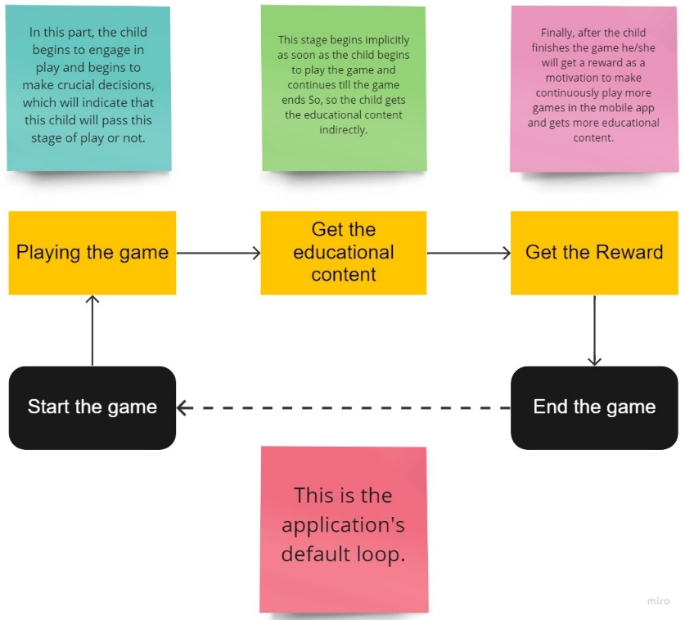The research methods section of this article [3] contains a straightforward architecture that illustrates and discusses the general structure of the game reward model.

**2.2.7. choosing frameworks // Saif**

2.3. conclusion

Reff

[1] Ketut Sintia Kesuma Dewi, Padmadewi, N. N., & Dewi, K. S. (2022). An Analysis Analysis of Reward System Used in Blended Learning Strategy to Develop Students’ Learning Motivation at North Bali Bilingual School. *Innovative Education Journal*, *1*(1), 58–63.

[2] Journal of Educational Research and EvaluationVolume 4, Number 3,Tahun 2020, pp. 307-314P-ISSN: 2597-422x E-ISSN: 2549-2675

[3] Haryanto, Hanny, Ardiawan Bagus Harisa, and Indra Gamayanto. "Appreciative Learning for Immersive Reward System in Education Game Development." *Journal of Games, Game Art, and Gamification* 6.2 (2021): 32-38.

[4] M. Morsidi, S. Tajuddin, R. K. Patchmuthu and S. H. S. Newaz, "Blockchain-based Reward System: a Means for Providing Incentive to Students for Teaching Feedback," 2021 International Conference on Electronics, Communications and Information Technology (ICECIT), 2021, pp. 1-5, doi: