**Use case diagram:**

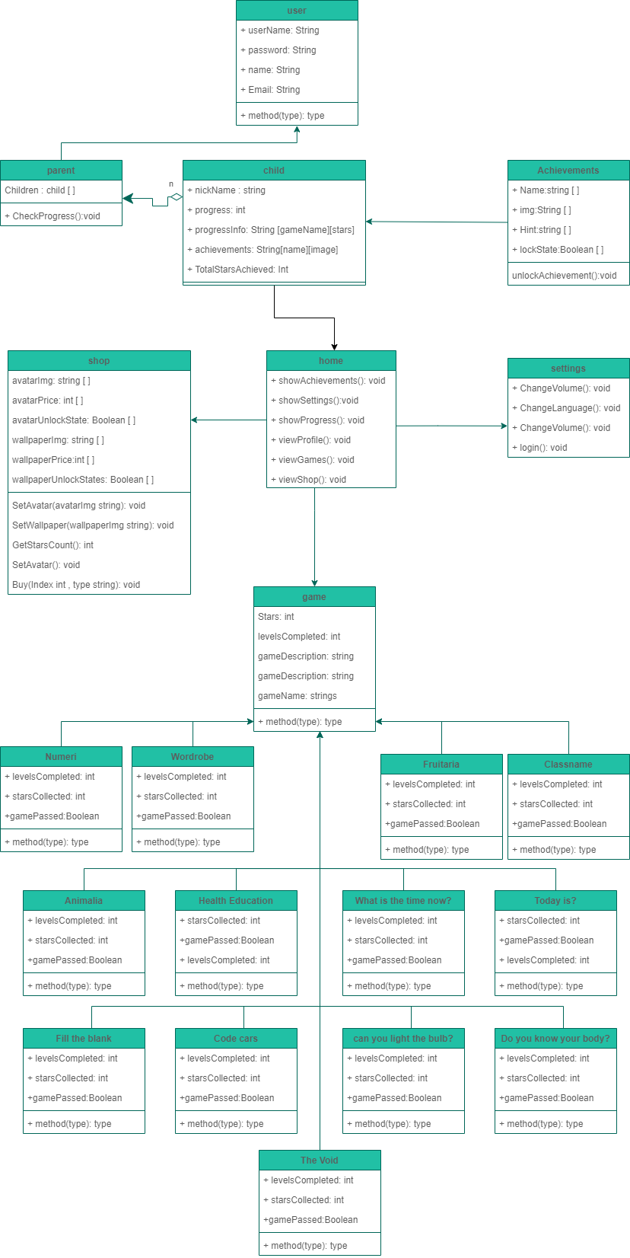**Class diagram:**

**ERD**

**Activity diagram:**

**Package diagram:**

**Sequence diagram:**