Our software will be divided into three sections:

* preschool:
  + Educational Games for Kids
  + ABC Kids
  + Math Kids
  + Baby Games

this section will teach the kids the letters, shape of animals and their sound, and concept of math.

* beginning of school:

this section will teach the children the concept of Algorithm, and concept of problem solving.

* midschool:

this section will teach the children the concept of programing, and concept of logic gates.

**Educational Games for Kids :**

The alphabet, numbers, colors, forms, days of the week, months of the year, planets in our solar system, space, and much more will all be taught to your children.

Our educational game teaches kids to recognize letters as they appear while introducing them to the alphabet. As a result, preschoolers pick up on letter sounds considerably more quickly.

The free days of the week for kids, educational quotations, the solar system for kids (planets, sun, space, universe), and kindergarten educational games are some of the features of our "flashcards for learning words." Kids, teenagers, and adults may all use ABC flashcards.

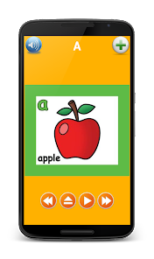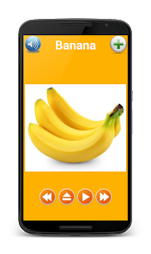Additional features include spoken alphabet, animal noises for infants, shapes for babies apps, numbers for kid's games, and amusement games and apps for preschoolers.

**ABC Kids :**

is one of the better (and free) educational Android games for kids. It’s a simple game that teaches things like the ABCs, how to read, and the difference between upper case and lower-case letters. The games are super simple and reward kids with in-game stickers for completing the various tasks. This one is obviously for younger kids around kindergarten age.Graphical user interface
**Math Kids :**

Preschoolers may learn addition, subtraction, counting, and arithmetic in a fun-free way!

You should never start your child's education too early. Toddlers, preschoolers, kindergarteners, older children, and others are eager to learn the alphabet, numbers, addition, subtraction, and other skills. Sharing clever, well-made educational applications and games with children frequently is the greatest way to support that.

The ideal way to learn the fundamentals of counting, addition, and subtraction is with Math Kids. Your toddler, kindergartener, and first grader will study early arithmetic along with sorting and reasoning abilities, laying the groundwork for a lifetime of learning.

A free educational game is intended to teach basic math concepts to young children. It has a variety of mini games that preschoolers and toddlers will enjoy playing, and the more they play, the more their arithmetic abilities will advance. Preschoolers, kindergarteners, and first graders can use Math Kids to learn how to recognize numbers and begin practicing addition and subtraction problems. They'll love completing games and collecting stickers, and you'll love seeing them develop and learn.

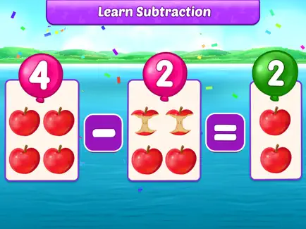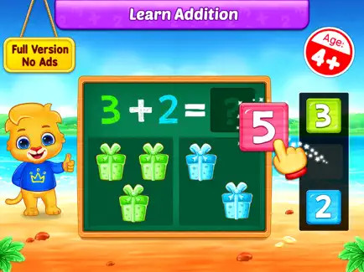

**Baby Games :**

With 15 different educational baby games, you can keep your toddlers active as they learn and develop their abilities. They will also have a lot of fun. Preschool games provide our infants a ton of interactive learning time so they may learn, build skills, and have fun all at once.

Children will learn colors, shapes, and how to follow basic, themed stories. like tending to attractive creatures or categorizing objects based on their size, color, and form.

Children will study shapes and colors while following along with straightforward theme tales. Taking care of adorable creatures, or arranging objects according to their size, color, and form.

A simple UI and gameplay with timely suggestions, designed and evaluated by child development specialists for kindergarten-aged children, will guarantee that your child never gets lost or confused in the game.

In addition, all settings and external links are secured and unavailable to children.