**Final Year B. Tech., Sem VII 2022-23**

**Cryptography And Network Security Lab**

**Assignment submission**

**PRN No: 2019BTECS00022**

**Full name: Prachi R. Chobhare**

**Batch: B6**

**Assignment: 14**

**Title of assignment: Create Digital Certificate**

**Title:**

Creating Digital Certificate using keytool.

**Aim:**

To get a Digital certificate for localhost.

**Theory:**

A [Digital Certificate](https://www.digicert.com/tls-ssl/digital-certificates) is an electronic file that is tied to a cryptographic key pair and authenticates the identity of a website, individual, organization, user, device or server. It is also known as a public key certificate or identity certificate. The certificate contains the subject, which is the identity piece, as well as a digital signature.

Digital certificates ensure both the identity and secure encryption of a website, individual, organization, device, user or server. They are the foundation to implementing [Public Key Infrastructure (PKI)](https://www.digicert.com/pki/enterprise-pki-manager) security.

Digital Certificates can be used to [secure websites](https://www.digicert.com/tls-ssl/tls-ssl-certificates), devices, web servers, signatures, code, software, email and more. In addition, digital certificates can help encrypt data, activate HTTPS in the URL bar, prove legitimacy of a website, comply with PCI standards, improve SEO rankings for websites and strengthen a brand’s identity.

**Code:**

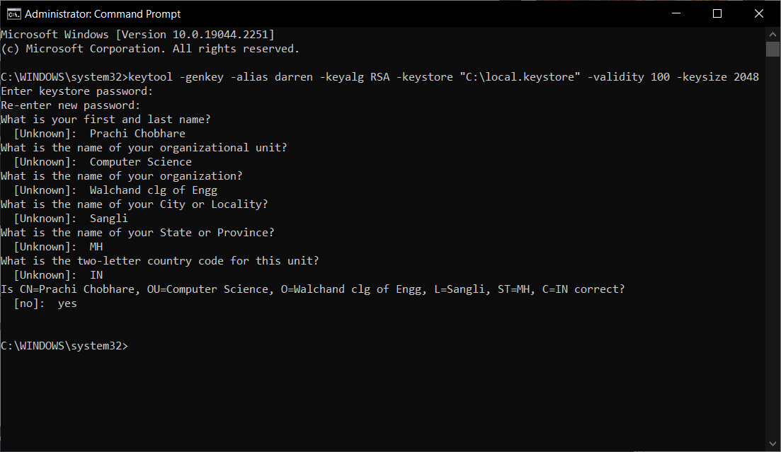

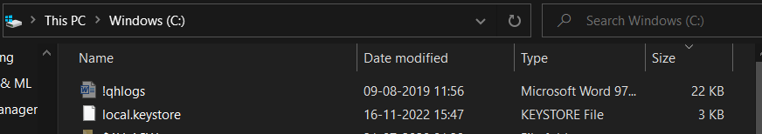

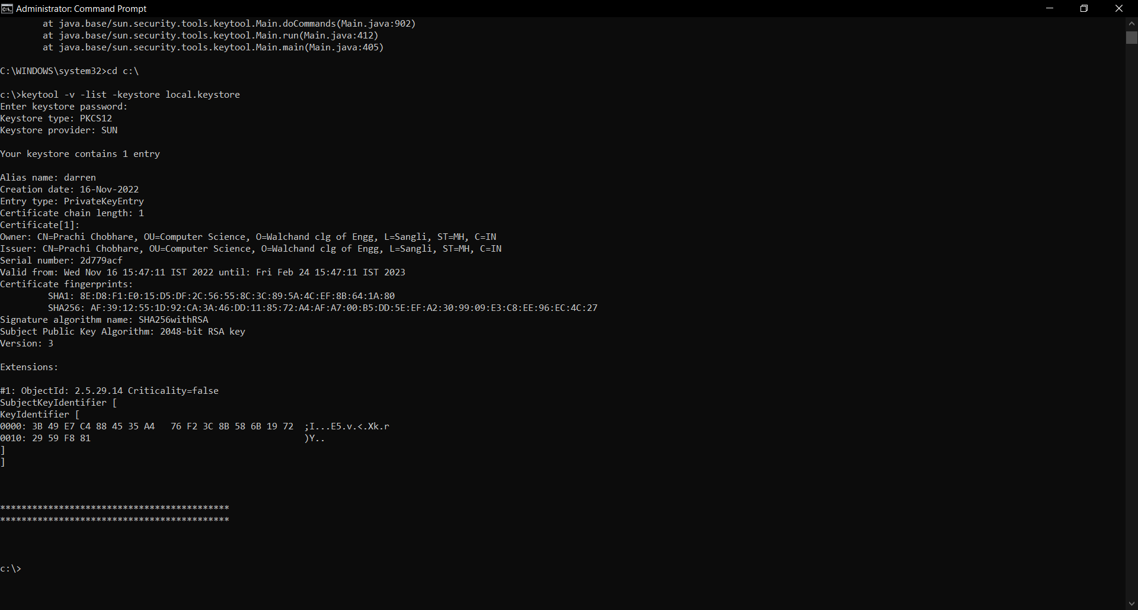**Output:**

**Conclusion:**

Performed the experiment successfully.