**Internship Project System Hacking:**

**By- Mayank Singh Tomar (tomarm698@gmail.com)**

1. HYDRA

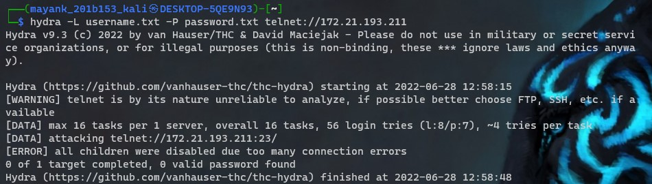

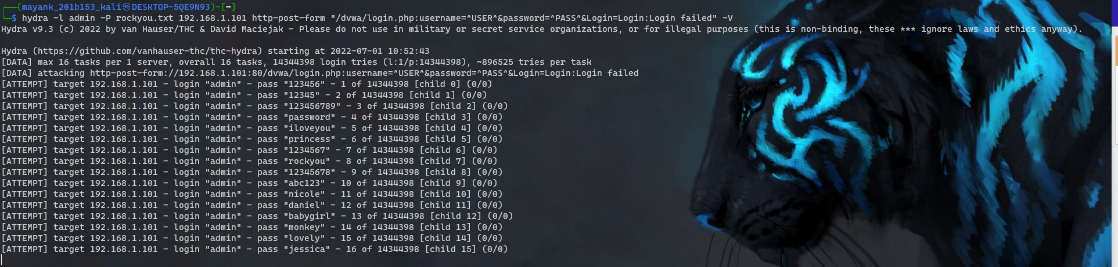

1. Auxiliary Module

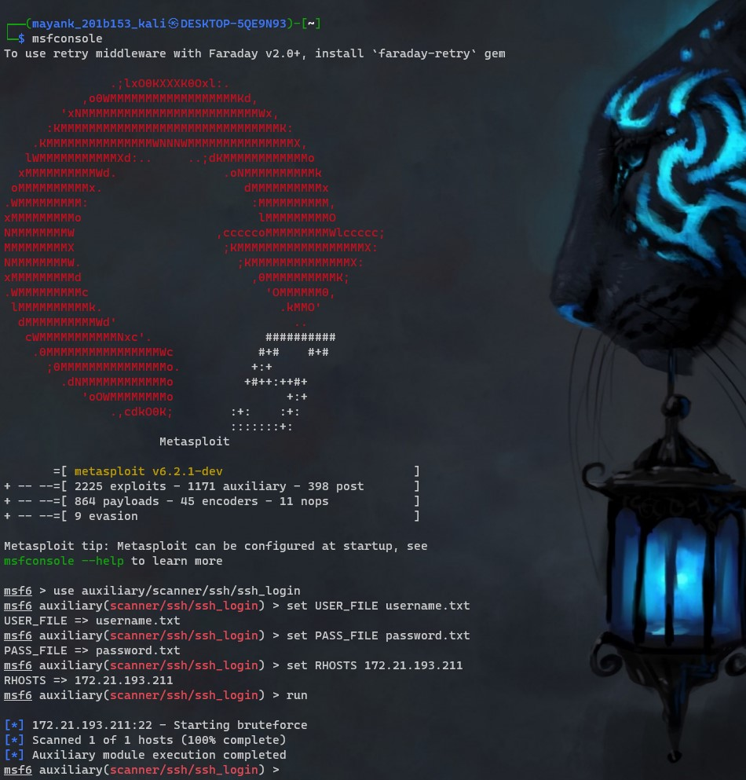

1. NSE scripts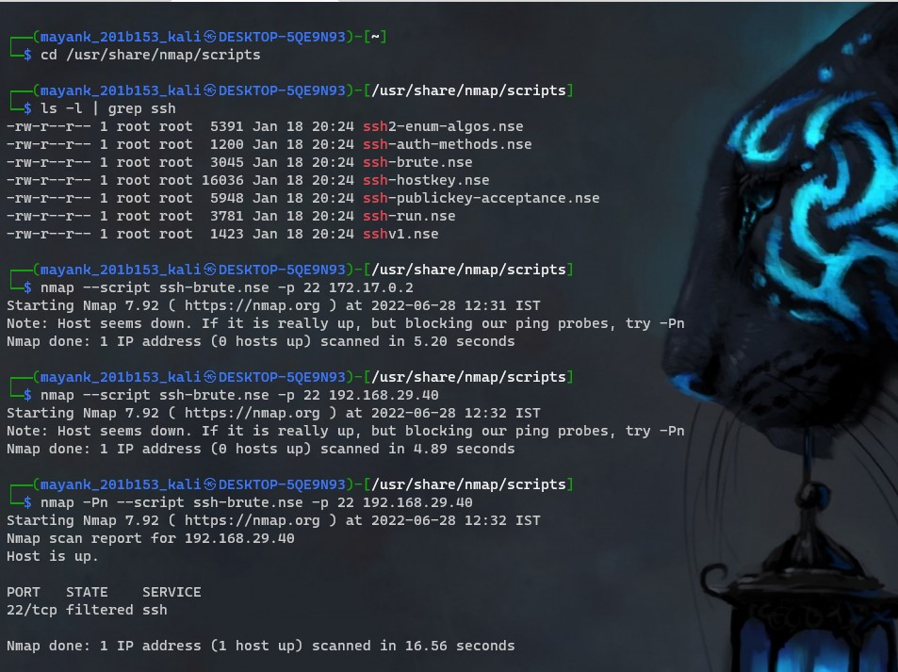

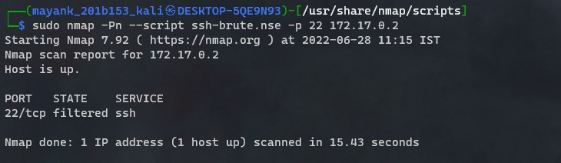

1. John the ripper

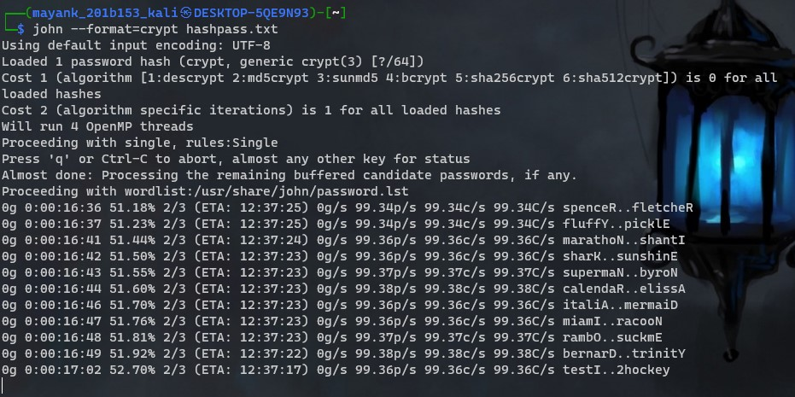

1. Password generating using CRUNCH

