**Unit Micro-service**

1. **Usage**

The unit micro-service can manage all transactions that need to be done with a hospital room.

In our app, unit micro service will be used when creating a new patient admission, so user can select type, class and the unit chosen to be reserved for the client

1. **Functionalities**

* Structure hospital, blocs, floors, units based on their type, class
* Reserve room with specific criteria (type, class)
* Free unit after admission end
* Check room equipment depending on type

1. **Access to micro-service:**

After running Eureka server (registry server, used for port mapping of services) on <http://localhost:8761>, unit microservice can be accessed on localhost port 8081: <http://localhost:8081>/room/

1. **Code:**

Find microservice source code on GitHub:

<https://github.com/2020-10505f-c2-EidLea/C2-hospital-covid19/tree/master/unit-service>

1. **Architecture**

* **Schema**

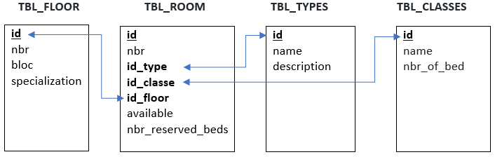

* **Folders Structure**

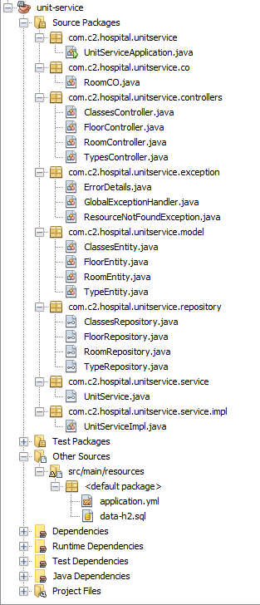

**Source Packages**

**🡪 unitservice**

**🡪 unitservice.co:** Container Object is a class that exposes all needed attributes of entities to be used inremote calls, making the DB structure hidden for third parties.

**🡪 unitservice.controllers:** functions routing

**🡪 unitservice.exception:** Error handling

**🡪 unitservice.model:** Entity related table and Fields Model

**🡪 unitservice.repository:** interface with built-in CRUD operation (JPA repo extended) + other customed queries

**🡪 unitservice.service:**  Service Interface, list of all functions

**🡪 unitservice.service.impl:** Functions (listed in service interface) implementation

**Other Sources 🡪 src/main/resources:** configuration + data queries