**Using Slack for Communication during the 2020 Coriell Bioinformatics Research Experience**

We’ve set up a workspace on the chat application Slack in order to facilitate communication during the 2020 Coriell Bioinformatics Research Experience. Slack allows you to create multiple project rooms where members can collaborate and discuss ideas. We ask that each student join the Slack workspace. We want to provide some instructions as to how to join our workspace to those new to Slack, and to those who are already using Slack.

Whether you’re new to Slack or you are a Slack veteran, you’ll need to register on the Bioinformatics Summer Experience Workspace. Please click on the following link: [Coriell Bioinformatics Research Experience](https://join.slack.com/t/coriellbioinf-se37156/shared_invite/zt-fnl20d7k-li03bC9OEIDklcFJ0CPoPw)

You’ll then enter a valid email address that you will use as your username in the field shown below:



Click Verify email. Slack will send an email to the account you’ve specified. The email should come from Slack. If you can’t find the email, please check your spam folder.

Once you’ve clicked the Confirm Email button, you’ll be taken back to finish filling out your account information.

Please enter your Full Name along with a Password according to the guidelines below the password field.

Finally, Click create account.

You should now be a member of the Coriell Bioinformatics Research Experience workspace.

---

Slack has a client program that you can download to your computer, if you wish to do so. You’ll just need to visit <http://slack.com/downloads> This link will take you to the correct application to download for your computer. Once you download and install Slack, you will sign in with your email address and the password that you created.

Slack also offers apps for your phone which can be found by searching “Slack” in your iOS or Google Play store. Again, you will authenticate using the email address and password that you provided upon the setup of your account.

If you’d rather not download the client program or mobile app, you can access the workspace via a browser by visiting the following link: <https://coriellbioinf-se37156.slack.com> and logging in with your email address and password.

If you’ve been using Slack and wish to add the Workspace to your client, you’ll need to do the following:

Click the “down” arrow under your workspace name in the top-right corner of the application to expand your options:

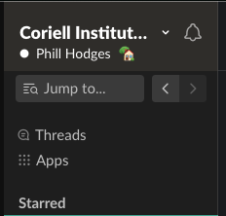

Next, Click “Sign into another workspace” at the bottom:

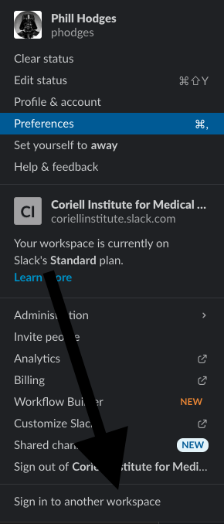

This should open a browser window that requests your Slack Workspace URL. Please enter the following: coriellbioinf-se37156

Next, click continue.

You will then be prompted to enter your username and password that you created for the Coriell Bioinformatic Research Experience Workspace.