**DBMS - MINI PROJECT**

**Fitness Management System**

Submitted By:

Name : Ghanashyam Mahesh Bhat

SRN : PES1UG20CS153

V Semester Section C

**ABSTRACT**

Fitness is an important part of the life, and the Fitness management system helps the user maintain the fitness and good health with the structured information on healthy diet and exercise routine.

The user can subscribe to membership which gives the access to personal trainer. The personal trainer can assign the routine and diet plan; when user follows the assigned routine, he will be awarded with streaks and level ups.

The streaks and levels helps the user to keep the motivation and work towards better health.

With the help of this tool user can get access to personalized diet plan and workout plan. Daily workout logs will be stored by the database which can further be used to do some analytics to obatin useful insights

The project servers as a platform for the user to get certified directions in the fitness journey and serve as tracker for maintaing the fitness and health.

.

**ER Diagram**

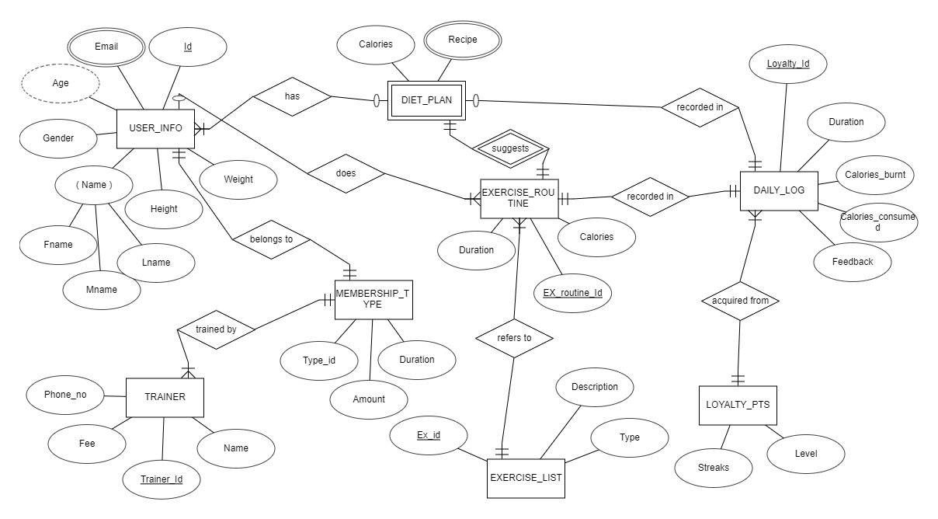

The ER diagram shows the 8 entities and their interrelations. Each entity has different kind of attributes defining the charecteristics of the entity.

**Relational Schema**

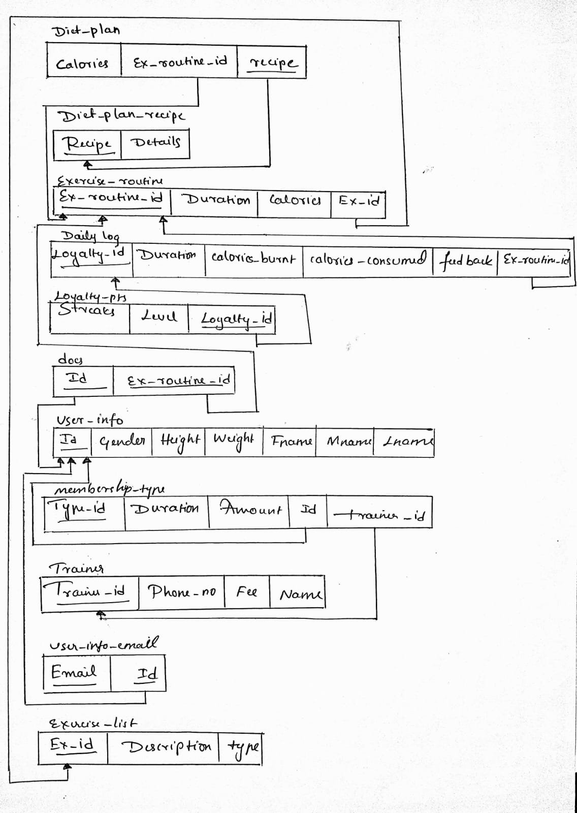

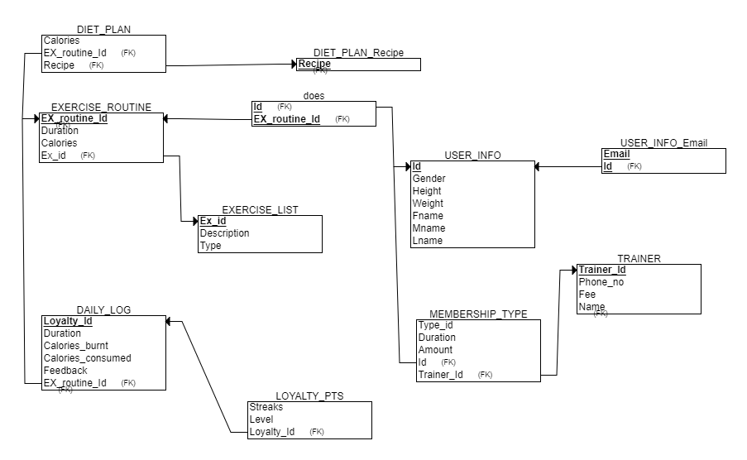**DDL statements - Building the database**

CREATE DATABASE fitnessmanagement;

USE fitnessmanagement;

CREATE TABLE diet_plan (

  ex_id varchar(20) NOT NULL ,

  recipe varchar(30) DEFAULT NULL,

  calories int(10) DEFAULT NULL

);

CREATE TABLE exercise_routine (

  ex_routine_id varchar(20) NOT NULL,

  duration int NOT NULL,

  calories int(10) DEFAULT NULL,

  ex_id varchar(20) NOT NULL

);

CREATE TABLE daily_log (

  loyalty_id varchar(20) NOT NULL,

  duration int NOT NULL,

  calories_burnt int(10) DEFAULT NULL,

  calories_consumed int(10) DEFAULT NULL,

  feedback varchar(20) DEFAULT NULL,

  ex_routine_id varchar(20) NOT NULL

);

CREATE TABLE diet_plan_recipe (

  recipe varchar(30) DEFAULT NULL

);

CREATE TABLE does (

  id varchar(20) NOT NULL,

  ex_routine_id varchar(20) NOT NULL

);

CREATE TABLE exercise_list (

  ex_id varchar(20) NOT NULL ,

  description varchar(30) DEFAULT NULL,

  type varchar(10) DEFAULT NULL

) ENGINE=InnoDB DEFAULT CHARSET=utf8mb4;

CREATE TABLE loyalty_pts (

  loyalty_id varchar(20) NOT NULL ,

  level int(3) NOT NULL,

  streaks int(10) NOT NULL DEFAULT 0

);

CREATE TABLE user_info(

  id varchar(20) NOT NULL,

  PRIMARY KEY(id),

  gender int(2) NOT NULL,

  height int NOT NULL,

  weight int NOT NULL,

  fname varchar(20) NOT NULL,

  mname varchar(20) DEFAULT NULL,

  lname varchar(20) DEFAULT NULL

);

CREATE TABLE membership_type (

  type_id varchar(20) NOT NULL,

  duration int NOT NULL,

  amount decimal(10,2) NOT NULL,

  id varchar(20) NOT NULL ,

  trainer_id varchar(20) NOT NULL

);

CREATE TABLE user_info_email (

  id varchar(20) NOT NULL ,

  email varchar(30) NOT NULL

);

CREATE TABLE trainer (

  trainer_id varchar(20) NOT NULL,

  PRIMARY KEY (trainer_id),

  phoneno int(10) NOT NULL,

  amount decimal(10,2) NOT NULL,

  name varchar(20) NOT NULL

);

ALTER TABLE diet_plan

  ADD KEY ex_id (ex_id),

  ADD KEY recipe (recipe);

ALTER TABLE exercise_routine

  ADD PRIMARY KEY (ex_routine_id),

  ADD KEY ex_id (ex_id);

ALTER TABLE daily_log

  ADD PRIMARY KEY (loyalty_id),

  ADD KEY ex_routine_id (ex_routine_id);

ALTER TABLE diet_plan_recipe

  ADD KEY recipe (recipe);

ALTER TABLE does

  ADD PRIMARY KEY (id,ex_routine_id),

  ADD KEY id (id),

  ADD KEY ex_routine_id (ex_routine_id);

ALTER TABLE exercise_list

  ADD PRIMARY KEY (ex_id);

ALTER TABLE loyalty_pts

  ADD KEY (loyalty_id);

ALTER TABLE membership_type

  ADD PRIMARY KEY (type_id),

  ADD KEY id (id),

  ADD KEY trainer_id (trainer_id);

ALTER TABLE user_info_email

  ADD PRIMARY KEY (id,email),

  ADD KEY id (id);

ALTER TABLE diet_plan

  ADD CONSTRAINT diet_plan_ibfk_1 FOREIGN KEY (ex_id) REFERENCES exercise_routine (ex_routine_id);

ALTER TABLE diet_plan

  ADD CONSTRAINT diet_plan_ibfk_2 FOREIGN KEY (recipe) REFERENCES diet_plan_recipe (recipe);

ALTER TABLE exercise_routine

  ADD CONSTRAINT exercise_routine_ibfk_1 FOREIGN KEY (ex_id) REFERENCES exercise_list (ex_id);

ALTER TABLE does

  ADD CONSTRAINT does_ibfk_1 FOREIGN KEY (ex_routine_id) REFERENCES exercise_routine (ex_routine_id);

ALTER TABLE daily_log

  ADD CONSTRAINT daily_log_ibfk_1 FOREIGN KEY (ex_routine_id) REFERENCES exercise_routine (ex_routine_id);

ALTER TABLE loyalty_pts

  ADD CONSTRAINT loyalty_pts_ibfk_1 FOREIGN KEY (loyalty_id) REFERENCES daily_log (loyalty_id);

ALTER TABLE does

  ADD CONSTRAINT does_ibfk_2 FOREIGN KEY (id) REFERENCES user_info (id);

ALTER TABLE user_info_email

  ADD CONSTRAINT user_info_email_ibfk_1 FOREIGN KEY (id) REFERENCES user_info (id);

ALTER TABLE membership_type

  ADD CONSTRAINT membership_type_ibfk_1 FOREIGN KEY (id) REFERENCES user_info (id);

ALTER TABLE membership_type

  ADD CONSTRAINT membership_type_ibfk_2 FOREIGN KEY (trainer_id) REFERENCES trainer (trainer_id);

The table list and their description after the execution of DDL commands.

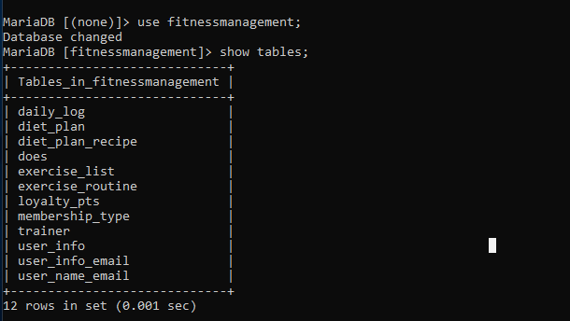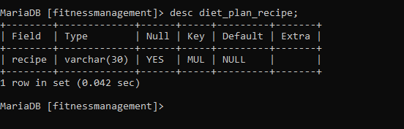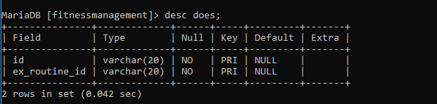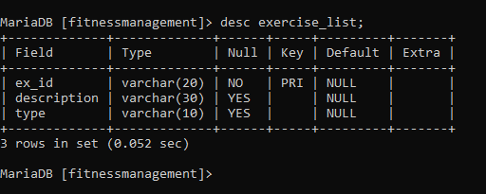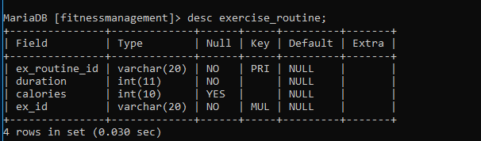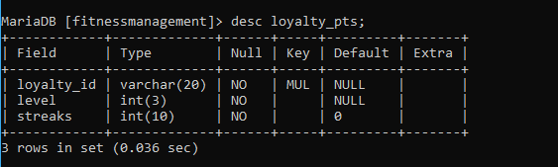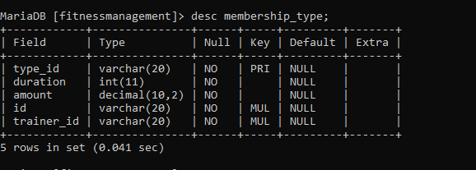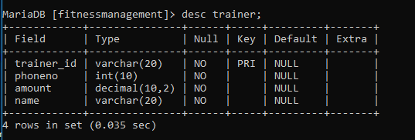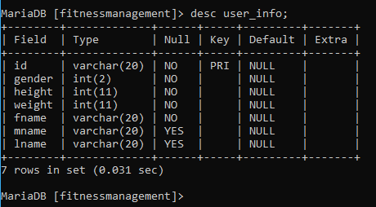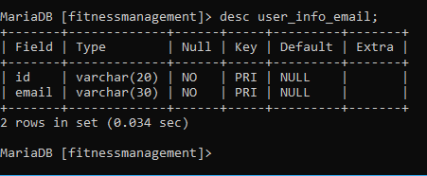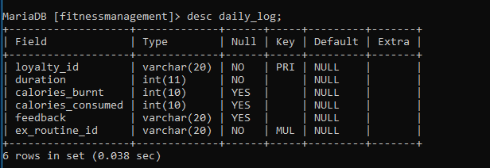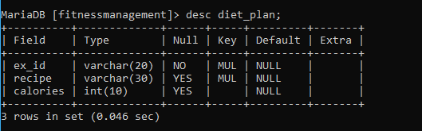

**Populating the Database**

The population of data is done by the below python code which exports CSV files with data for all the tables.

These CSV files are imported into tables using phpmyadmin.

import csv

from random import randint as r

class dataGeneration:

    def __init__(self):

        self.l1 = ['Calories','EX_Id',"Recipe"]

        self.l2 = ["Ex_routine_Id",'Duration',"Calories","Ex_id"]

        self.l3 = ['Loyalty_Id',"Duration","Calories_burnt","Calories_consumed","Feedback","Ex_routine_Id"]

        self.l4 = ["Recipe"]

        self.l5 = ["Id","Ex_routine_Id"]

        self.l6 = ["Ex_id","Description","Type"]

        self.l7 = ["Streaks","Level" , "Loyalty_Id"]

        self.l8 = ["Id","Gender","Height","Weight","Fname","Mname","Lname"]

        self.l9 = ["Type_id","Duration","Amount","Id","Trainer_Id"]

        self.l10 = ["Email","Id"]

        self.l11 = ["Trainer_Id","Phoneno","amount","Name"]

    def diet_plan(self,count,ex_routine_min,ex_routine_max,cal_min,cal_max,recipe_min,recipe_max):

        #f1

        result = []

        for i in range(count):

            result.append([r(cal_min,cal_max),'EX_routine'+str(r(ex_routine_min,ex_routine_max)),"Recipe"+str(r(recipe_min,recipe_max))])

        return result

    def exercise_routine(self,count,duration_min,duration_max,cal_min,cal_max,ex_id_min,ex_id_max):

        #f2

        result = []

        for i in range(count):

            result.append(['EX_routine'+str(i),r(duration_min,duration_max),r(cal_min,cal_max),"EX_ID"+str(r(ex_id_min,ex_id_max))])

        return result

    def daily_log(self,count,duration_min,duration_max,cal_min,cal_max,cal_consume_min,cal_consume_max,feedback_min,feedback_max,ex_routine_min,ex_routine_max):

        #f3

        result = []

        for i in range(count):

            result.append(["LYL"+str(i),r(duration_min,duration_max),r(cal_min,cal_max),r(cal_consume_min,cal_consume_max),"Feedback"+str(r(feedback_min,feedback_max),),'EX_routine'+str(r(ex_routine_min,ex_routine_max))])

        return result

    def diet_plan_recipe(self,count):

        #f4

        result = []

        for i in range(count):

            result.append(["Recipe"+str(i)])

        return result

    def does(self,count,user_id_min,user_id_max,ex_routine_min,ex_routine_max):

        #f5

        result = []

        check = []

        for i in range(count):

            id = "USR"+str(r(user_id_min,user_id_max))

            ex_r_id = 'EX_routine'+str(r(ex_routine_min,ex_routine_max))

            if (id,ex_r_id) in check:

                pass

            else:

                result.append([id,ex_r_id])

                check.append((id,ex_r_id))

        return result

    def exercise_list(self,count,description_min,description_max,type_min,type_max):

        #f6

        result = []

        for i in range(count):

            result.append(["EX_ID"+str(i),"Description"+str(r(description_min,description_max)),"Type"+str(r(type_min,type_max))])

        return result

    def loyalty_pts(self,count,streaks_min,streaks_max,Level_min,Level_max,loyalty_min,loyalty_max):

        #f7

        result = []

        for i in range(count):

            result.append([r(streaks_min,streaks_max),r(Level_min,Level_max),"LYL"+str(r(loyalty_min,loyalty_max))])

        return result

    def user_info(self,count,height_min,height_max,weight_min,weight_max,Fname_min,Fname_max,Mname_min,Mname_max,Lname_min,Lname_max):

        #f8

        gender_min = 0

        gender_max = 2

        result = []

        for i in range(count):

            result.append(["USR"+str(i),r(gender_min,gender_max),r(height_min,height_max),r(weight_min,weight_max),"Fname"+str(r(Fname_min,Fname_max)),"Mname"+str(r(Mname_min,Mname_max)),"Lname"+str(r(Lname_min,Lname_max))])

        return result

    def membership_type(self,count,period_min,period_max,amount_min,amount_max,user_id_min,user_id_max,trainer_id_min,trainer_id_max):

        #f9

        result = []

        for i in range(count):

            result.append(["MEM"+str(i),r(period_min,period_max),r(amount_min,amount_max),"USR"+str(r(user_id_min,user_id_max)),"TRAINER"+str(r(trainer_id_min,trainer_id_max))])

        return result

    def user_info_email(self,count,email_min,email_max,user_id_min,user_id_max):

        #f10

        result = []

        check = list()

        for i in range(count):

            email = "email.id."+str(r(email_min,email_max))+"@email.com"

            id = "USR"+str(r(user_id_min,user_id_max))

            if (email,id) in check:

                pass

            else:

                result.append([email,id])

                check.append((email,id))

        return result

    def trainer(self,count,fee_min,fee_max,name_min,name_max,ph_min=1000000000,ph_max=9999999999):

        #f11

        result = []

        for i in range(count):

            result.append(["TRAINER"+str(i),r(ph_min,ph_max),r(fee_min,fee_max),"TrainerName"+str(r(name_min,name_max))])

        return result

if __name__=='__main__':

    dataGen = dataGeneration()

    filename = "diet_plan.csv"

    with open(filename,'w',newline='') as csvfile:

        csvwriter = csv.writer(csvfile)

        csvwriter.writerow(dataGen.l1)

        csvwriter.writerows(dataGen.diet_plan(count=100,ex_routine_min=20,ex_routine_max=60,cal_min=100,cal_max=350,recipe_min=5,recipe_max=25))

    filename = "exercise_routine.csv"

    with open(filename,'w',newline='') as csvfile:

        csvwriter = csv.writer(csvfile)

        csvwriter.writerow(dataGen.l2)

        csvwriter.writerows(dataGen.exercise_routine(count=200,duration_min=30,duration_max=120,cal_min=50,cal_max=400,ex_id_min=0,ex_id_max=120))

    filename = "daily_log.csv"

    with open(filename,'w',newline='') as csvfile:

        csvwriter = csv.writer(csvfile)

        csvwriter.writerow(dataGen.l3)

        csvwriter.writerows(dataGen.daily_log(count=400,duration_min=40,duration_max=90,cal_min=90,cal_max=320,cal_consume_min=1000,cal_consume_max=2500,feedback_min=0,feedback_max=100,ex_routine_min=20,ex_routine_max=80))

    filename = "diet_plan_recipe.csv"

    with open(filename,'w',newline='') as csvfile:

        csvwriter = csv.writer(csvfile)

        csvwriter.writerow(dataGen.l4)

        csvwriter.writerows(dataGen.diet_plan_recipe(count=80))

    filename = "does.csv"

    with open(filename,'w',newline='') as csvfile:

        csvwriter = csv.writer(csvfile)

        csvwriter.writerow(dataGen.l5)

        csvwriter.writerows(dataGen.does(count=70,user_id_min=15,user_id_max=100,ex_routine_min=11,ex_routine_max=95))

    filename = "exercise_list.csv"

    with open(filename,'w',newline='') as csvfile:

        csvwriter = csv.writer(csvfile)

        csvwriter.writerow(dataGen.l6)

        csvwriter.writerows(dataGen.exercise_list(count=150,description_min=20,description_max=300,type_min=5,type_max=300))

    filename = "loyalty_pts.csv"

    with open(filename,'w',newline='') as csvfile:

        csvwriter = csv.writer(csvfile)

        csvwriter.writerow(dataGen.l7)

        csvwriter.writerows(dataGen.loyalty_pts(count=50,streaks_min=0,streaks_max=20,Level_min=1,Level_max=5,loyalty_min=30,loyalty_max=300))

    filename = "user_info.csv"

    with open(filename,'w',newline='') as csvfile:

        csvwriter = csv.writer(csvfile)

        csvwriter.writerow(dataGen.l8)

        csvwriter.writerows(dataGen.user_info(count=90,height_min=150,height_max=195,weight_min=45,weight_max=95,Fname_min=1,Fname_max=200,Mname_min=5,Mname_max=250,Lname_min=5,Lname_max=250))

    filename = "membership_type.csv"

    with open(filename,'w',newline='') as csvfile:

        csvwriter = csv.writer(csvfile)

        csvwriter.writerow(dataGen.l9)

        csvwriter.writerows(dataGen.membership_type(count=5,period_min=2,period_max=12,amount_min=1000,amount_max=10000,user_id_min=1,user_id_max=75,trainer_id_min=1,trainer_id_max=20))

    filename = "user_info_email.csv"

    with open(filename,'w',newline='') as csvfile:

        csvwriter = csv.writer(csvfile)

        csvwriter.writerow(dataGen.l10)

        csvwriter.writerows(dataGen.user_info_email(count=60,email_min=1,email_max=50,user_id_min=1,user_id_max=50))

    filename = "trainer.csv"

    with open(filename,'w',newline='') as csvfile:

        csvwriter = csv.writer(csvfile)

        csvwriter.writerow(dataGen.l11)

        csvwriter.writerows(dataGen.trainer(count=30,fee_min=1000,fee_max=10000,name_min=1,name_max=50,ph_min=1000000000,ph_max=9999999999))

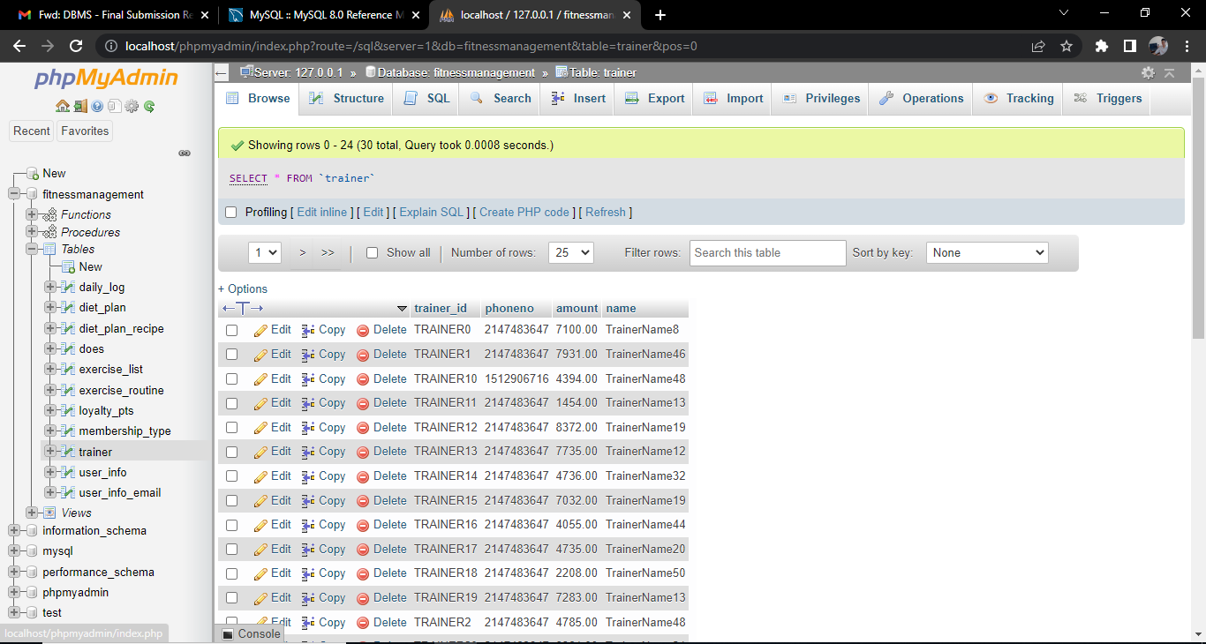

Sample data of every table after population of database

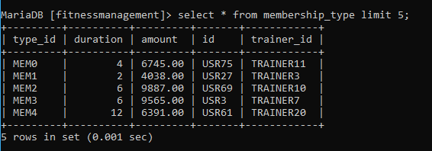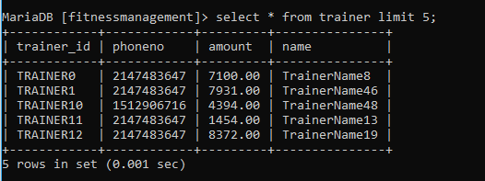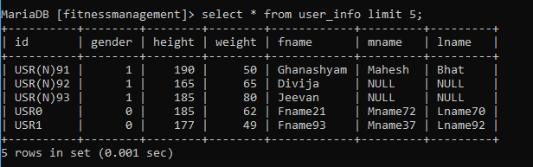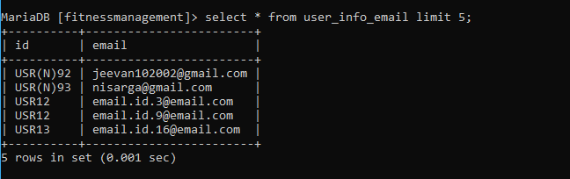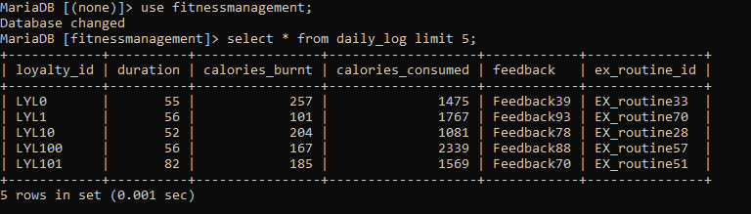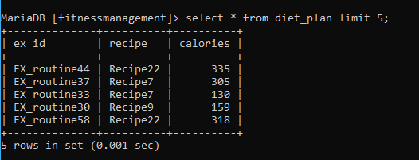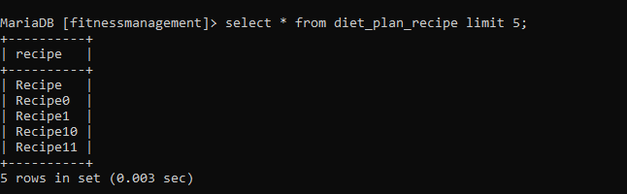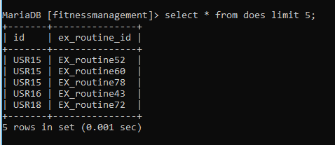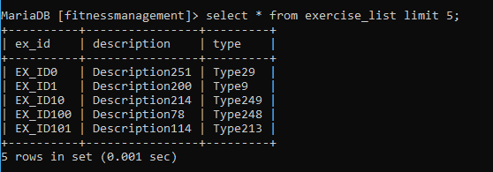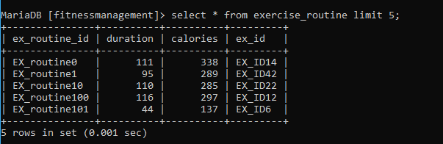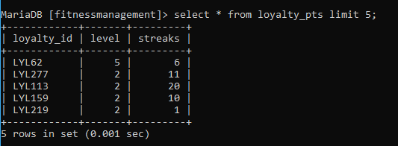

**Tool Used**

The below are the tools used for the project development

|  |  |
| --- | --- |
| Frontend | Backend |
| Flask | mysql |
| HTML | Sql sqlalchemy |
| Bootstrap | Python3.x |
| Jinja | javascript |

**Queries**

**Join queries (at least 6)**

**Regualar Join (2 queries):**

1. To display the user information along with the user email ID by combining user_info and user_info_email table.

select * from user_info ui natural join user_info_email;

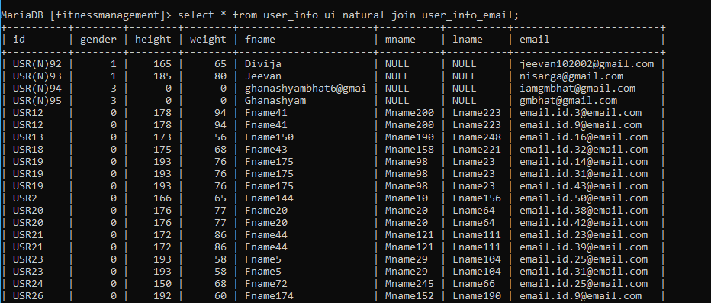

2. Display each exercise routine id along with the exercise description by combining excercise list and exercise routine table

SELECT r.ex_routine_id,e.description

FROM exercise_routine as r, exercise_list as e

WHERE r.ex_id=e.ex_id;

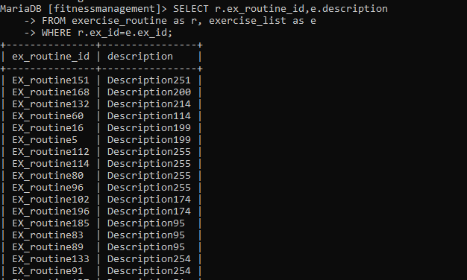

**Co-related Join (2 Queries)**

1. Display name of the trainer and the amount if the amount charged by the trainer is less than the average amount

SELECT t.name,m.amount

FROM membership_type m,trainer t

WHERE m.trainer_id=t.trainer_id

AND m.amount< (

    SELECT avg(amount)

    FROM membership_type

);

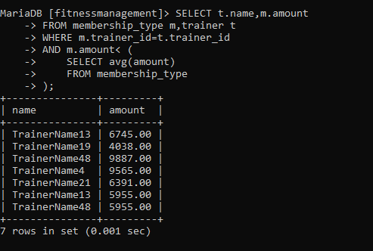

2. Display the ID and name of the user if he burns more than 30% of the calories consumed.

SELECT u.id,u.fname

FROM user_info u

WHERE EXISTS (

    select * from does d,exercise_routine r,daily_log dl

    WHERE d.id = u.id and d.ex_routine_id=r.ex_routine_id and r.ex_routine_id=dl.ex_routine_id

    AND ((dl.calories_burnt/dl.calories_consumed) > 0.3)

);

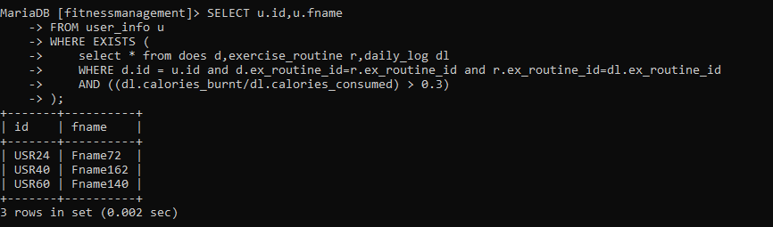

**Nested Join (2 Queries)**

1. Display exercise routine and recipe with calories consumed and calories burned.

SELECT d.calories,r.calories,d.recipe

FROM exercise_routine as r, (

    SELECT dp.calories,dpr.recipe,dp.ex_id

    FROM diet_plan as dp,diet_plan_recipe as dpr

    WHERE dp.recipe=dpr.recipe

) as d

WHERE r.ex_routine_id = d.ex_id;

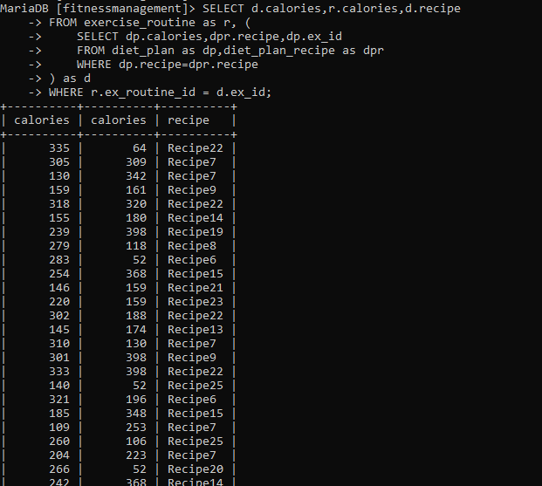

2. List user info, subscription purchased and trainer info for the user who has subscribed to a membership

SELECT u.id,u.fname,t.trainer_id,t.name,t.duration,t.type_id

FROM user_info as u

JOIN (

    SELECT m.id,m.duration,m.type_id,t.trainer_id,t.name

    FROM trainer as t

    JOIN

    membership_type as m

    WHERE

    t.trainer_id=m.trainer_id

) as t

WHERE u.id=t.id ;

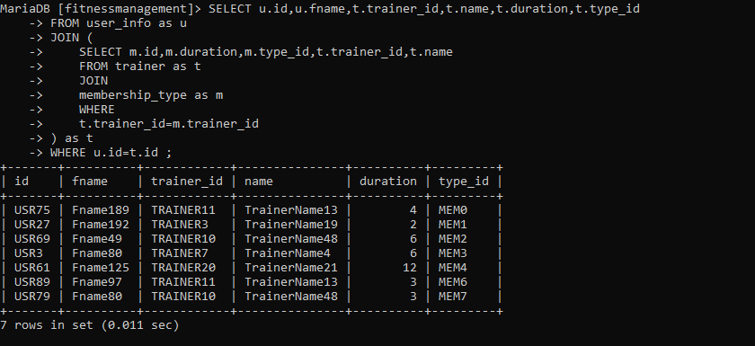

**Aggregate Functions (at least 2)**

1.Display the average calories consumed, average calories burned and duration of exercise by all the users.

select avg(calories_burnt),avg(calories_consumed),avg(duration) from daily_log;

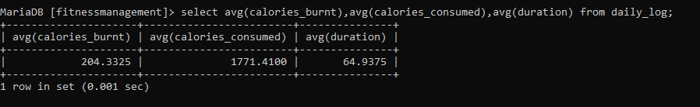

2. Display number of users per trainer as per the membership purchased

select count(u.id),t.trainer_id from user_info u,membership_type m,trainer t where u.id=m.id and t.trainer_id=m.trainer_id group by t.trainer_id;

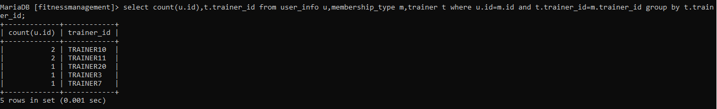

**Set Operations (at least 2)**

**1.** Display users who have subscribed to Trainer3 or Trainer7

select id from membership_type where trainer_id = "TRAINER3" union select id from membership_type where trainer_id = "TRAINER7";

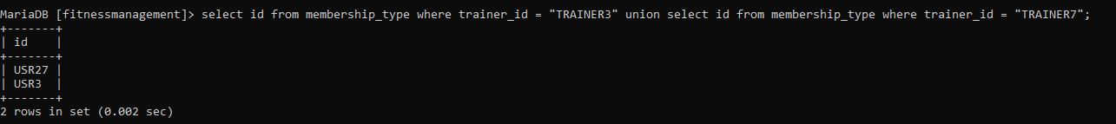

**2.** Display all the trainers who are not assigned to any user

SELECT  trainer_id from trainer

EXCEPT (SELECT trainer_id from membership_type);

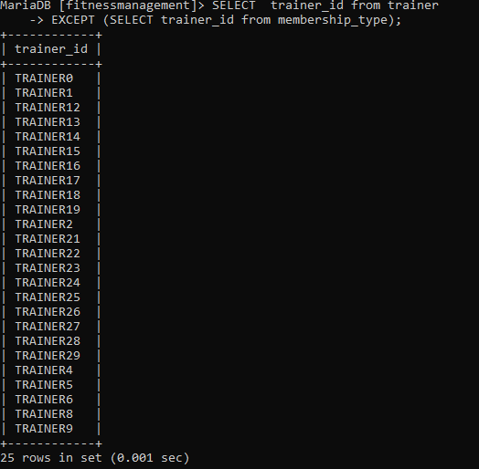

**View (atleast 1)**

The view is created for easier access of Streak and Level information of every user based on their daily log.

CREATE view user_level as

SELECT u.fname,l.streaks,l.level

FROM user_info u,does d,exercise_routine r,daily_log dl,loyalty_pts l

WHERE d.id = u.id and d.ex_routine_id=r.ex_routine_id and r.ex_routine_id=dl.ex_routine_id and dl.loyalty_id=l.loyalty_id;

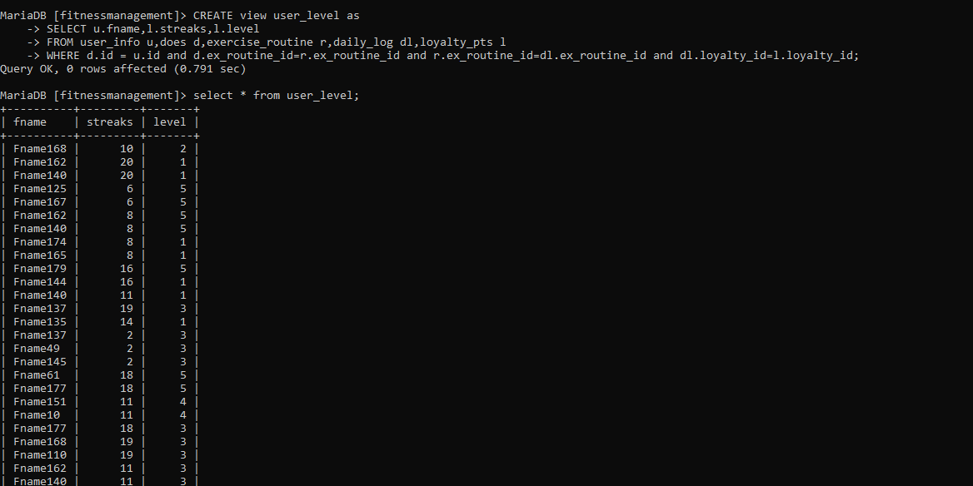

**Function and Procedure**

The function takes gender value (INT) as input and returns 1, if the value is greater than 0, otherewise returns 0.

The procedure has been created with this function to make the gender as binary value in the database.

DELIMITER $$ ;

CREATE FUNCTION correcting_gender(GENDER1 INT)

RETURNS INT

DETERMINISTIC

BEGIN

   DECLARE gender INT;

   SET gender = GENDER1 ;

   IF gender > 0 THEN

   SET gender = 1;

   ELSE

   SET gender = 0;

   END IF;

   RETURN gender;

END; $$

DELIMITER ;

DELIMITER $$

CREATE procedure gender_updation()

BEGIN

UPDATE user_info

SET gender = correcting_gender(gender);

END;$$

DELIMITER ;

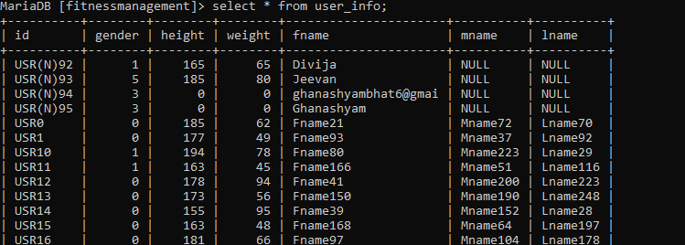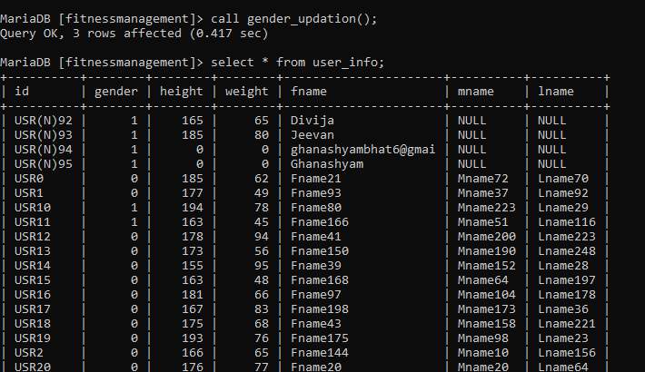

**Trigger**

The trigger here prevent the Trainer from having more than 3 subscribers.

When a new user takes membership, he cannot choose the trainer with already 3 subscribers.

DELIMITER $$

CREATE TRIGGER total_no_of_user_per_trainer_exceed_check

BEFORE INSERT

ON membership_type FOR EACH ROW

BEGIN

    DECLARE error_msg VARCHAR(255);

    SET error_msg = (' total number of users per trainer exceeds more than 3');

    IF (select count(*) from membership_type where trainer_id=new.trainer_id group by trainer_id) > 2 THEN

    SIGNAL SQLSTATE '45000'

    SET MESSAGE_TEXT = error_msg;

    END IF;

END $$

DELIMITER ;

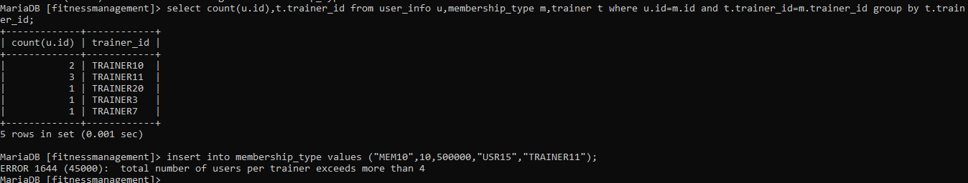

**Developing a Frontend**

The frontend should support

1. Addition, Modification and Deletion of records from any chosen table

Addition of data

When the user signs up, new user will be added to the database. The data like Name, password, email will be stored in the database. New user ID will be allocated to each user on creation of new account.

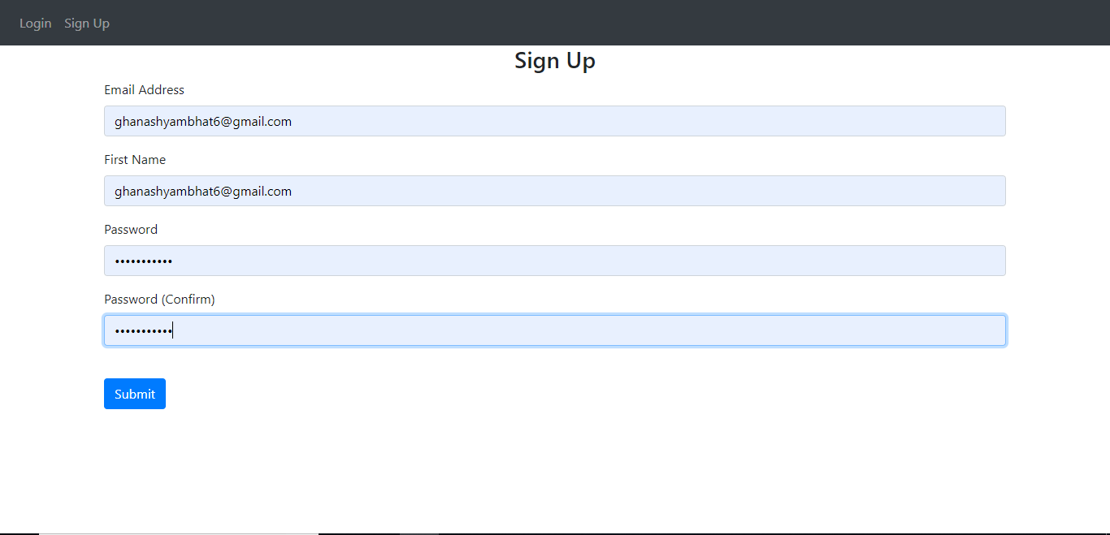

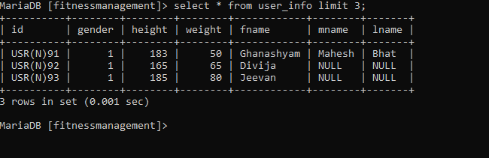

Fetch Data

The user who already has an account can log in to the account and access all his data by providing the correct password.

The password will be checked with the stored hash in the database and the user will be logged in if it matches.

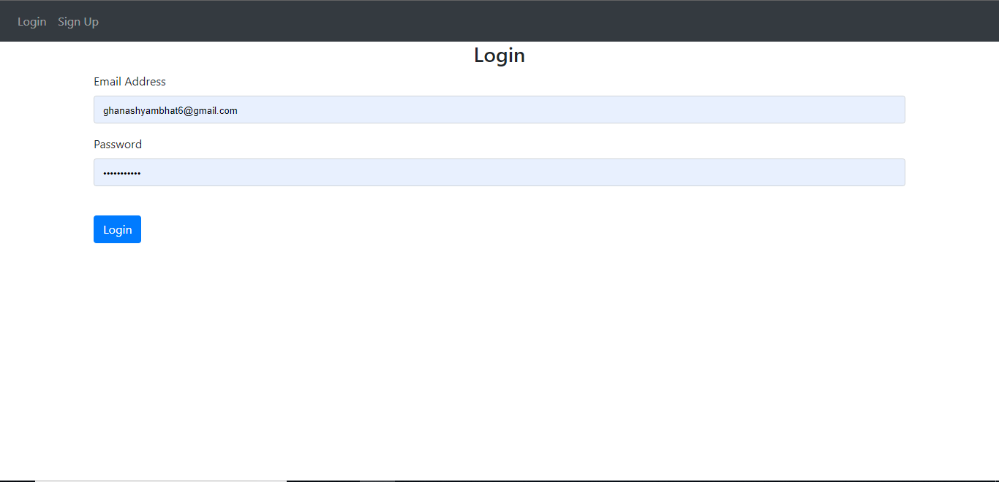

Data Modification

The user can modify his name,height and weight data. On clicking the submit button, the data gets updated.

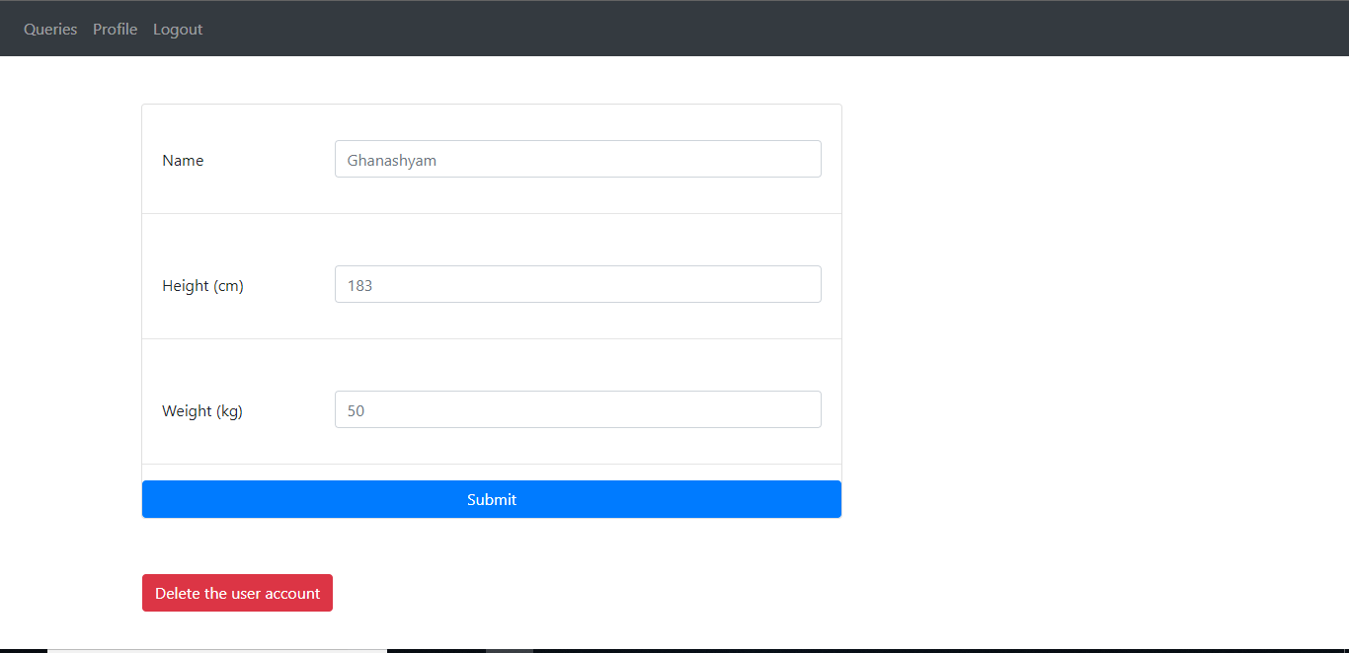

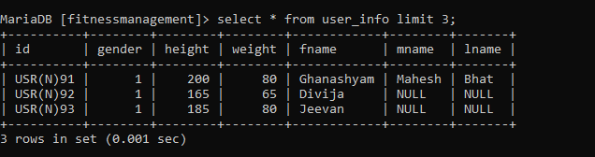

Delete Data

On pressing delete account button, the user account will be deleted from the database and the user cannot login using same account in future.

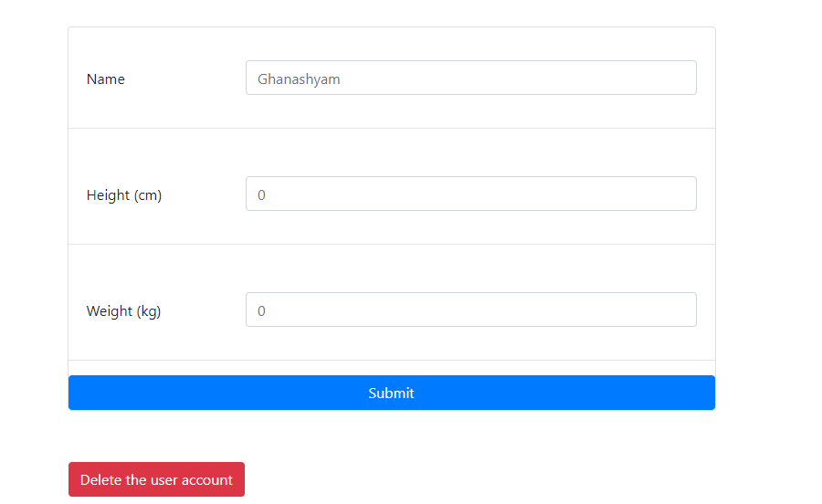

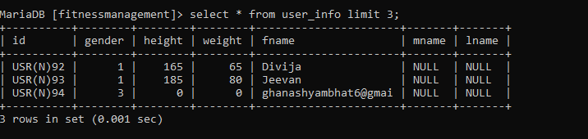

1. There should be a window to accept and run any SQL statement and display the result

