DBMS Mini Project
Fitness Management System

Submitted By:
NISARGA BHASKAR
PES1UG20CS268
V Semester Section E

Short Description and Scope of the Project

This project aims to automate gym and fitness admission process as the admission process in gyms and selecting a trainer is difficult.
Being healthy is the first thing to be kept in mind because most of the time our attitude depends on how we feel. Being healthy gives us the energy to work and do things.
This fitness management system will help to overcome such problems by booking the deciding the exercise routine online and pay fees by electronic money transfer.
In this fitness management system, there is 3 entity namely, Admin, Member, and Trainer. Admin can login using credentials. Admin can manage packages by adding cost, discount and deleting old membership types. Admin can manage member details by adding, updating and deleting. Admin can view the membership details of an individual member. Admin can also view the member’s attendance taken by the trainer. Members can login using credentials. They can view their profile and list of trainers. They can also view the package and payment details. Members can give feedback on their trainers. They can make payments via card details. A trainer can log in using credentials. A trainer can set their profile. A trainer can take member’s attendance daily, suggest the exercise routine for the given day.

ER Diagram

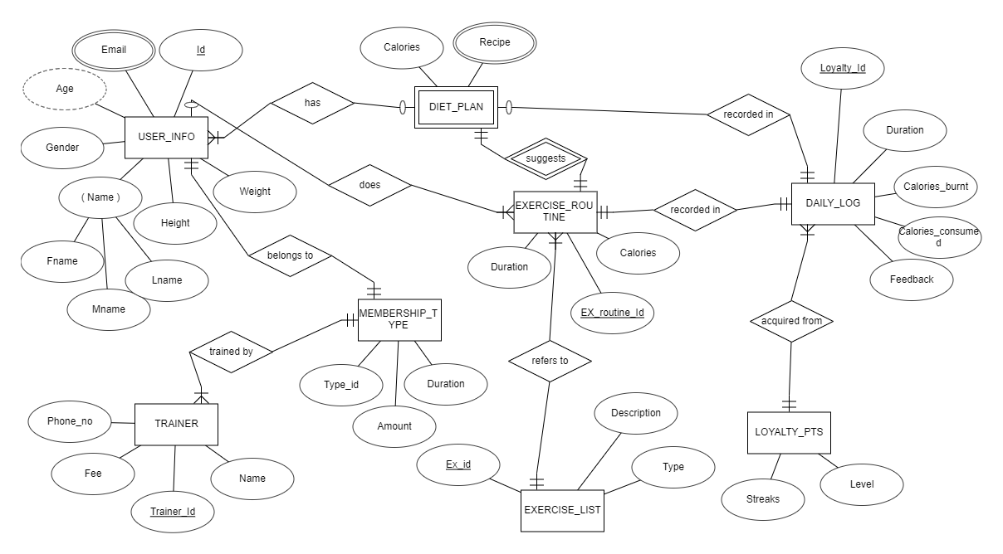Figure 1: ER Diagram for the database System

Schema Diagram

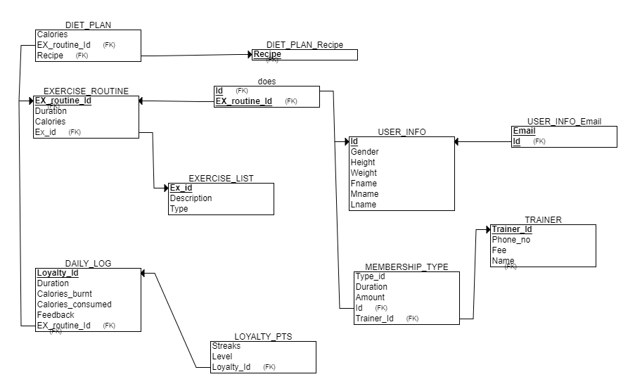Figure 2: Relational Schema for the database
DDL statements – Building the database

CREATE DATABASE fitnessmanagement;
USE fitnessmanagement;

CREATE TABLE diet_plan (
ex_id varchar(20) NOT NULL ,
recipe varchar(30) DEFAULT NULL,
calories int(10) DEFAULT NULL
);

CREATE TABLE exercise_routine (
ex_routine_id varchar(20) NOT NULL,
duration int NOT NULL,
calories int(10) DEFAULT NULL,
ex_id varchar(20) NOT NULL
);

CREATE TABLE daily_log (
loyalty_id varchar(20) NOT NULL,
duration int NOT NULL,
calories_burnt int(10) DEFAULT NULL,
calories_consumed int(10) DEFAULT NULL,
feedback varchar(20) DEFAULT NULL,
ex_routine_id varchar(20) NOT NULL
);

CREATE TABLE diet_plan_recipe (
recipe varchar(30) DEFAULT NULL
);

CREATE TABLE does (
id varchar(20) NOT NULL,
ex_routine_id varchar(20) NOT NULL
);

CREATE TABLE exercise_list (
ex_id varchar(20) NOT NULL ,
description varchar(30) DEFAULT NULL,
type varchar(10) DEFAULT NULL
) ENGINE=InnoDB DEFAULT CHARSET=utf8mb4;

CREATE TABLE loyalty_pts (
loyalty_id varchar(20) NOT NULL ,
level int(3) NOT NULL,
streaks int(10) NOT NULL DEFAULT 0
);

CREATE TABLE user_info(
id varchar(20) NOT NULL,
PRIMARY KEY(id),
gender int(2) NOT NULL,
height int NOT NULL,
weight int NOT NULL,
fname varchar(20) NOT NULL,
mname varchar(20) DEFAULT NULL,
lname varchar(20) DEFAULT NULL
);

CREATE TABLE membership_type (
type_id varchar(20) NOT NULL,
duration int NOT NULL,
amount decimal(10,2) NOT NULL,
id varchar(20) NOT NULL ,
trainer_id varchar(20) NOT NULL
);

CREATE TABLE user_info_email (
id varchar(20) NOT NULL ,
email varchar(30) NOT NULL
);

CREATE TABLE trainer (
trainer_id varchar(20) NOT NULL,
PRIMARY KEY (trainer_id),
phoneno int(10) NOT NULL,
amount decimal(10,2) NOT NULL,
name varchar(20) NOT NULL
);

ALTER TABLE diet_plan
ADD KEY ex_id (ex_id),
ADD KEY recipe (recipe);

ALTER TABLE exercise_routine
ADD PRIMARY KEY (ex_routine_id),
ADD KEY ex_id (ex_id);

ALTER TABLE daily_log
ADD PRIMARY KEY (loyalty_id),
ADD KEY ex_routine_id (ex_routine_id);

ALTER TABLE diet_plan_recipe
ADD KEY recipe (recipe);

ALTER TABLE does
ADD PRIMARY KEY (id,ex_routine_id),
ADD KEY id (id),
ADD KEY ex_routine_id (ex_routine_id);

ALTER TABLE exercise_list
ADD PRIMARY KEY (ex_id);

ALTER TABLE loyalty_pts
ADD KEY (loyalty_id);

ALTER TABLE membership_type
ADD PRIMARY KEY (type_id),
ADD KEY id (id),
ADD KEY trainer_id (trainer_id);

ALTER TABLE user_info_email
ADD PRIMARY KEY (id,email),
ADD KEY id (id);

ALTER TABLE diet_plan
ADD CONSTRAINT diet_plan_ibfk_1 FOREIGN KEY (ex_id) REFERENCES exercise_routine (ex_routine_id);

ALTER TABLE diet_plan
ADD CONSTRAINT diet_plan_ibfk_2 FOREIGN KEY (recipe) REFERENCES diet_plan_recipe (recipe);

ALTER TABLE exercise_routine
ADD CONSTRAINT exercise_routine_ibfk_1 FOREIGN KEY (ex_id) REFERENCES exercise_list (ex_id);

ALTER TABLE does
ADD CONSTRAINT does_ibfk_1 FOREIGN KEY (ex_routine_id) REFERENCES exercise_routine (ex_routine_id);

ALTER TABLE daily_log
ADD CONSTRAINT daily_log_ibfk_1 FOREIGN KEY (ex_routine_id) REFERENCES exercise_routine (ex_routine_id);

ALTER TABLE loyalty_pts
ADD CONSTRAINT loyalty_pts_ibfk_1 FOREIGN KEY (loyalty_id) REFERENCES daily_log (loyalty_id);

ALTER TABLE does
ADD CONSTRAINT does_ibfk_2 FOREIGN KEY (id) REFERENCES user_info (id);

ALTER TABLE user_info_email
ADD CONSTRAINT user_info_email_ibfk_1 FOREIGN KEY (id) REFERENCES user_info (id);

ALTER TABLE membership_type
ADD CONSTRAINT membership_type_ibfk_1 FOREIGN KEY (id) REFERENCES user_info (id);

ALTER TABLE membership_type
ADD CONSTRAINT membership_type_ibfk_2 FOREIGN KEY (trainer_id) REFERENCES trainer (trainer_id);
Populating the Database

The database is populated by two methods
- Using the insert command
- Importing the CSV file in the PHP admin
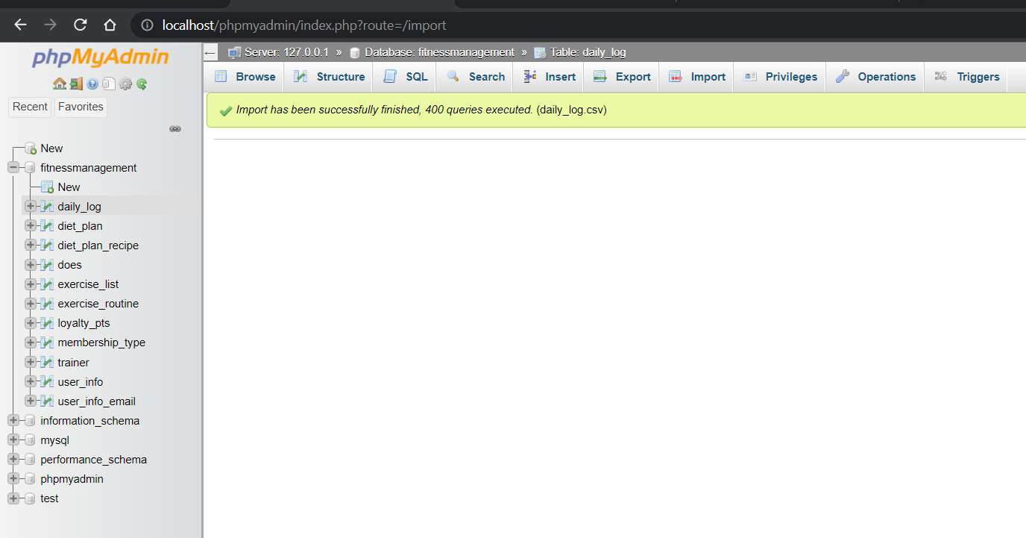

Join Queries
- Display the complete information of the user
create view complete user info as select * from user_info ui natural join user_info_email;
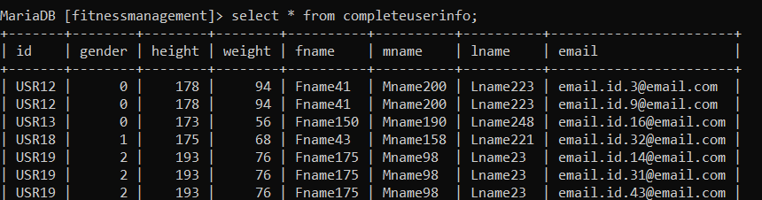
- Display the feedback for the session for each loyalty_id
create view loyalty_pts_feedback as select dl.loyalty_id,feedback from daily_log dl join loyalty_pts lp on dl.loyalty_id = lp.loyalty_id;
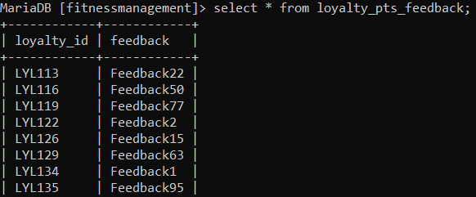
- Display the exercise routine followed for a given day
create view exercise_routine_dailylog as select * from exercise_routine natural join daily_log;
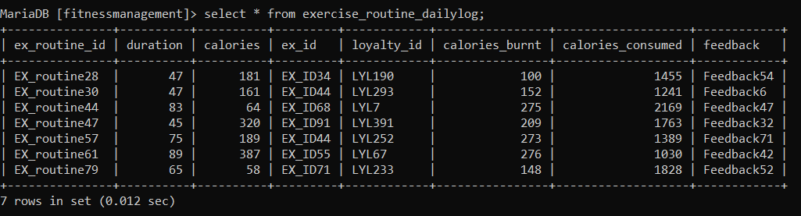

- Display the exercise routine followed by a each user
create view exercise_routine_fname as select d.ex_routine_id,ui.fname from user_info ui join does d on d.id = ui.id;

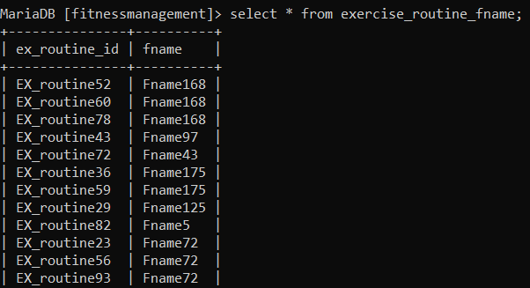

Aggregate Functions

- Display the no of users a trainer is currently training
create view no_of_user_per_trainer as select trainer_id,count(*) as no_of_user_per_trainer from membership_type group by trainer_id;
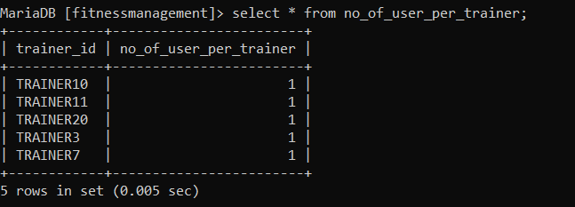
- Display the maximum calories burnt
select max(calories_burnt) from exercise_routine_dailylog;
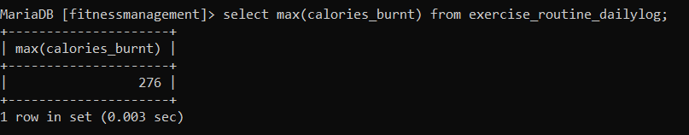
- Display the minimum calories consumed
select min(calories_consumed) from exercise_routine_dailylog;
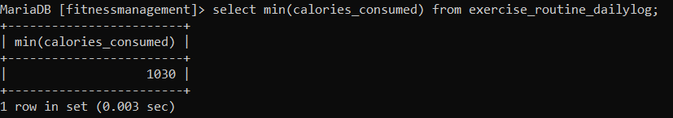
- Display the average calories burnt for a given duration
select avg(calories_burnt) as calories_burnt,duration from exercise_routine_dailylog group by duration;
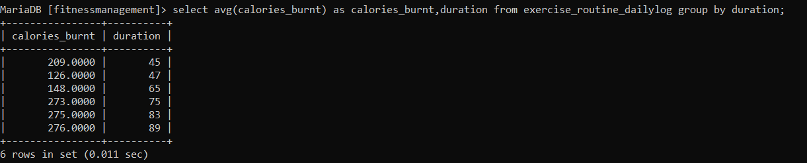

Set Operations
- Display userid of the users under trainer 3 or trainer 7
create view userid_of_trainer_3and7 as select id from membership_type where trainer_id = "TRAINER3" union select id from membership_type where trainer_id = "TRAINER7";
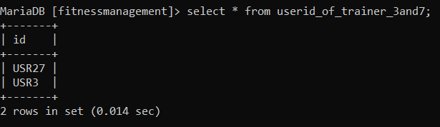
- Display the userid who have done exercise routine 52 and 93
select fname from exercise_routine_fname where ex_routine_id="EX_routine52"and exists (select fname from exercise_routine_fname where ex_routine_id="EX_routine93");
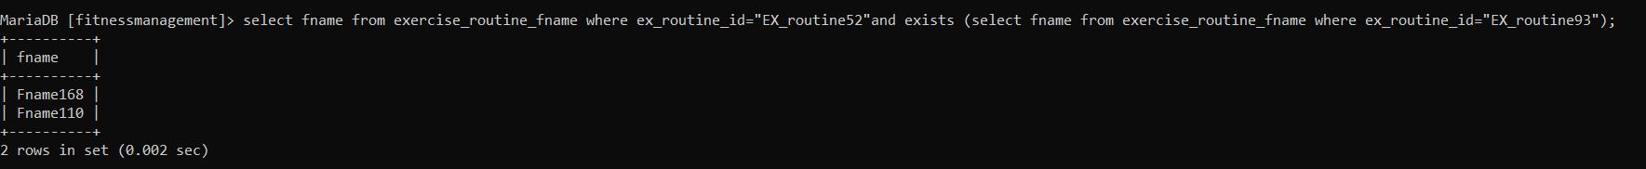
- Display the userid who have done exercise routine 29 and exercise routine 39
select fname from exercise_routine_fname where ex_routine_id="EX_routine39"and exists (select fname from exercise_routine_fname where ex_routine_id="EX_routine29");
- Display exercise id which belong to exercise routine 52 or exercise routine 93
select ex_id from exercise_routine where ex_routine_id="EX_routine52" union (select ex_id from exercise_routine where ex_routine_id="EX_routine93");
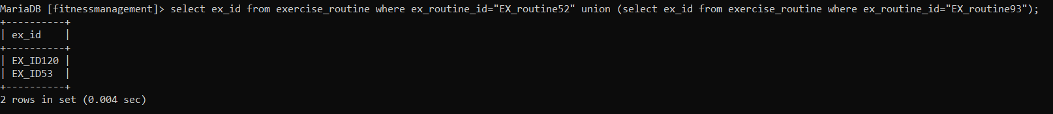

Functions and Procedures
A function to correct the gender as some of the gender values where not acceptable
A procedure to call the above function
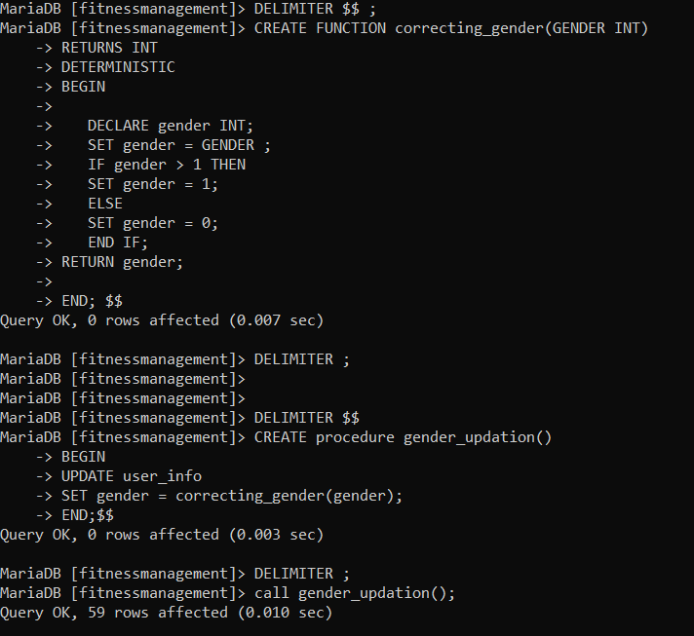

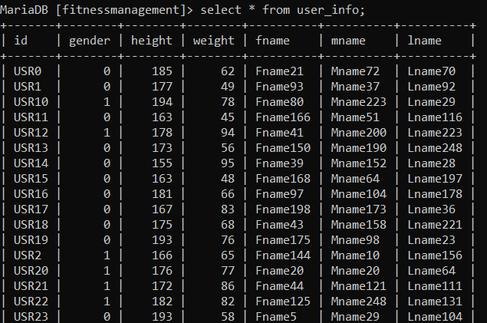

Triggers and Cursors
A trigger is created if a trainer has more than 4 users under him

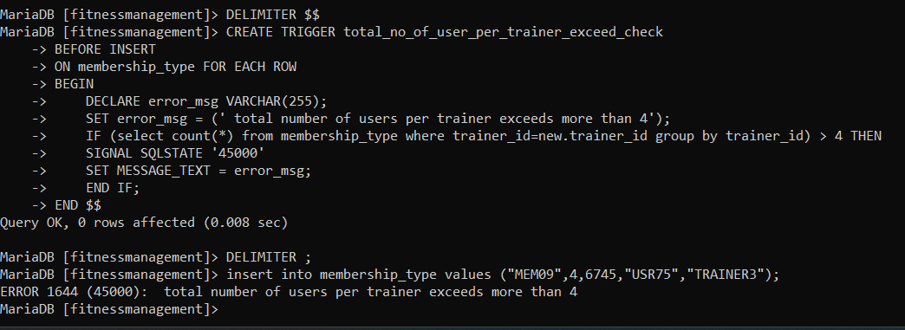
A cursor for displaying the emailing list


Developing a Frontend

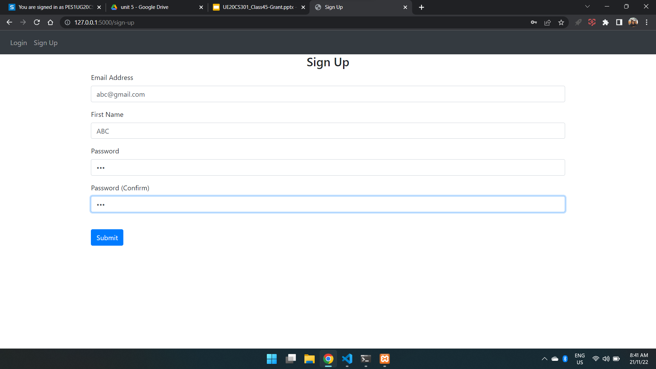Figure 3: Sign up page

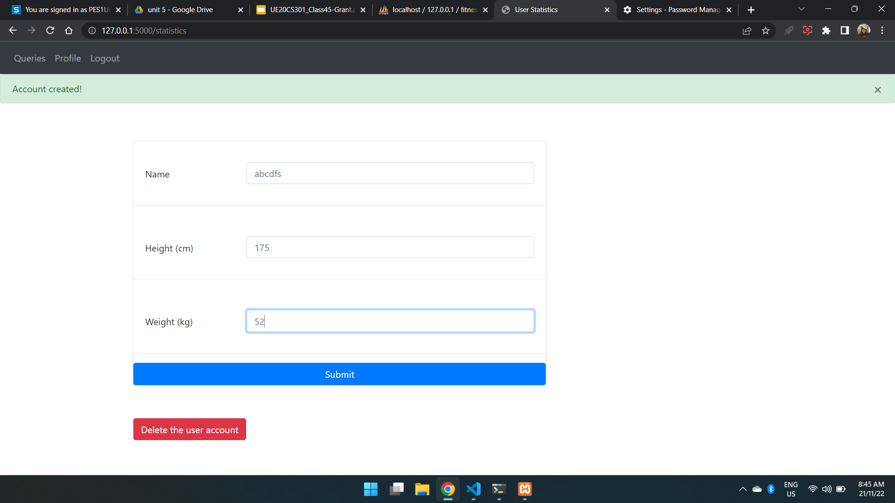Figure 4: Creation of an account
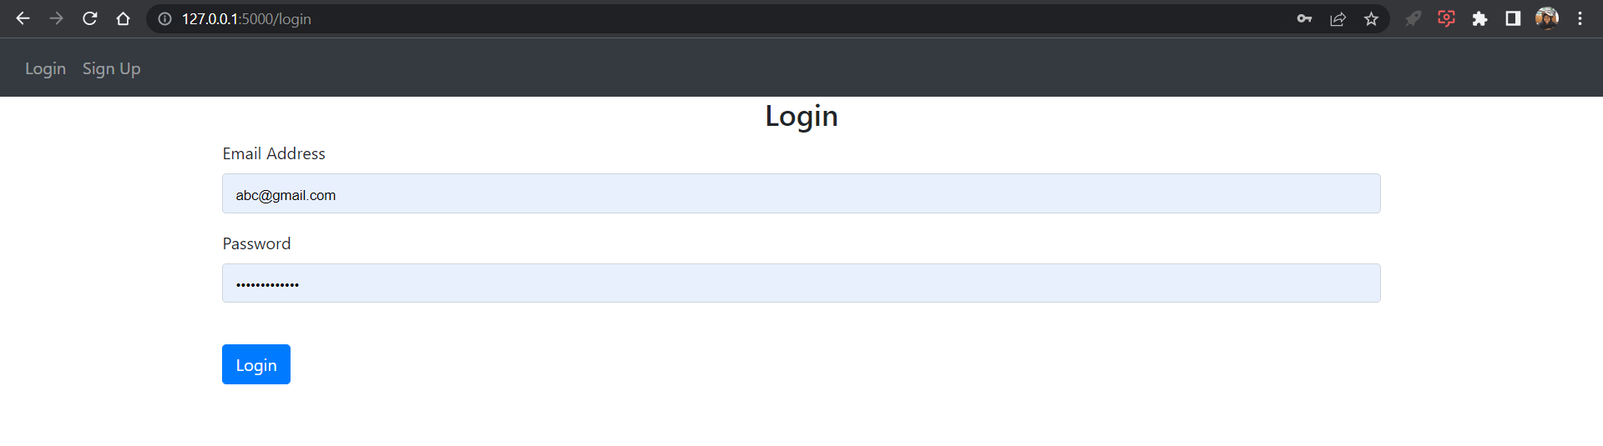Figure 5: Login page for existing account

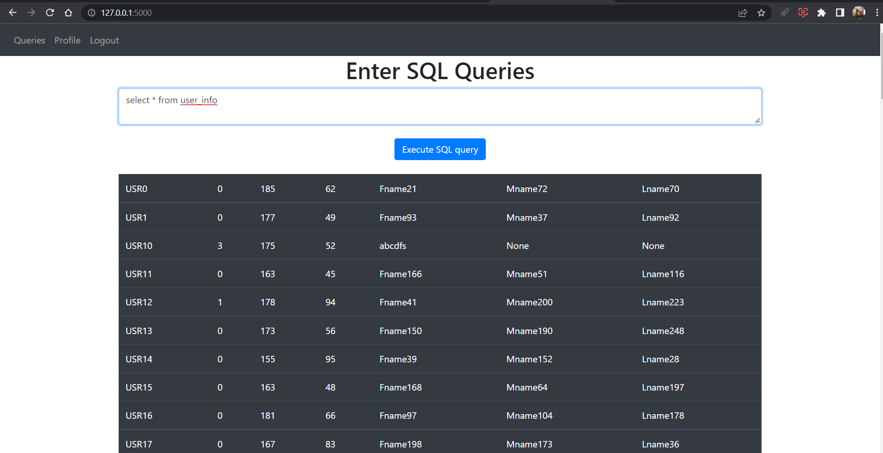Figure 6: A window to accept and run any SQL statement

