**Part 1: Understanding SQL (30 minutes)**

**Question 1.1: Research**

* **Summary of Findings:**
  + SQL (Structured Query Language) is a standard language used to interact with databases. It allows for the creation, manipulation, and retrieval of data from relational databases. SQL is essential for managing data in web applications, ensuring that data can be efficiently stored, updated, and queried as needed.

**Question 1.2: Role of SQL in Web Applications**

* **Explanation:**
  + SQL plays a crucial role in web applications by managing the underlying data. For example, in an online store, SQL is used to handle product information, user accounts, and order details. It allows the application to retrieve product listings, verify user credentials, and process transactions efficiently.

**Question 1.3: Benefits of Using SQL for Web Applications**

* **List of Benefits:**
  1. **Efficiency:**
     + SQL enables quick and efficient querying and updating of large datasets, ensuring web applications run smoothly.
  2. **Data Organization:**
     + SQL helps in structuring data in a well-organized manner using tables, which makes data management easier.
  3. **Data Retrieval:**
     + SQL provides powerful tools for retrieving specific data through queries, which is essential for dynamic content generation in web applications.

**Question 1.5: Database Management Systems**

* **List:**
  1. MySQL
  2. PostgreSQL
  3. SQLite

**Part 2: Database Fundamentals (45 minutes)**

**Question 2.1: Tables**

* **Definition:**
  + A database table is a collection of data organized in rows and columns, similar to a spreadsheet. Each row represents a unique record, and each column represents a specific attribute of the data.

**Question 2.2: Columns**

* **Definition:**
  + Columns in a database table represent the attributes or fields of the data. Each column holds a specific type of data, such as text, numbers, or dates.
  + **Example:**
    - Column Name: expense_amount
    - Data Type: DECIMAL
    - Explanation: This column would store the amount of each expense as a decimal number.

**Question 2.3: Data Types**

* **Importance:**
  + Data types are crucial in databases as they ensure data integrity and efficient storage. They define the kind of data that can be stored in each column, preventing errors and optimizing storage space.
  + **Common Data Types:**
    1. **Text (VARCHAR):**
       - Used for storing text strings.
    2. **Number (INT, DECIMAL):**
       - Used for storing integer and decimal numbers.
    3. **Date (DATE):**
       - Used for storing dates.

**Part 3: Expense Tracker Database Design (45 minutes)**

**Question 3.1: Planning**

* **Data Points:**
  1. Expense ID
  2. Expense Amount
  3. Date
  4. Category
  5. Description

**Question 3.2: Tables**

* **Table Structure:**
  + **Table Name: Expenses**
  + **Columns:**
    1. expense_id (INT, Primary Key)
    2. expense_amount (DECIMAL)
    3. date (DATE)
    4. category (VARCHAR)
    5. description (VARCHAR)

**Table Structure in Document:**

|  |  |  |
| --- | --- | --- |
| Column Name | Data Type | Description |
| expense_id | INT | Unique identifier for each expense |
| expense_amount | DECIMAL | Amount of the expense |
| date | DATE | Date of the expense |
| category | VARCHAR | Category of the expense |
| description | VARCHAR | Description of the expense |
|  |  |  |

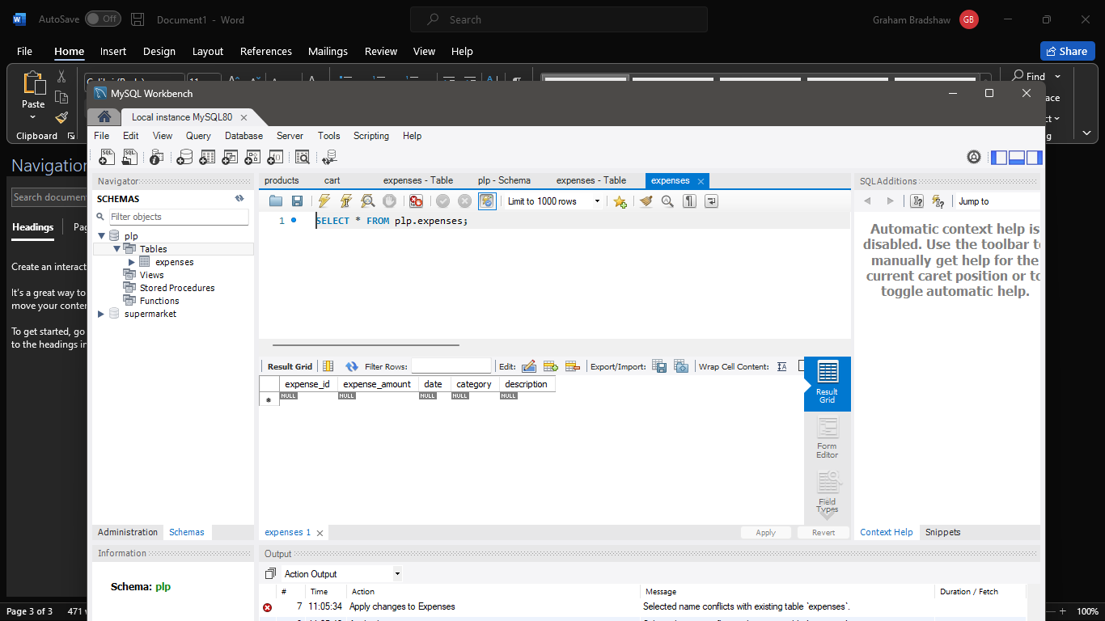

Bonus: Entity Relationship Diagram (ERD)

