COSC360

UBCO

Feb 27, 2023

Client-Side Proposal

Client-Side Demo

URL: <https://boisterous-duckanoo-39a298.netlify.app/page/index.html>

Github: <https://github.com/COSC360/project-2020-byte>

Demo Video: <https://youtu.be/8FsKOUNbwyw>

Page List:

/page/index.html

/page/login.html

/page/signup.html

/page/lost.html

/page/profile.html

/page/users.html

/page/productSearch.html

/page/product.html

/page/opinion.html

Client-Side Validation

Responsive Design

/page/index.html

Home page

When “LET’S DIVE IN!” or Search button clicked, site brings user to /page/productSearch.html

Clicking the human-shaped button on the upper right will give user a link to the sign-in or sign-up page.

/page/login.html

Sign in page

When user sign in, site brings user /page/productSearch.html.

User can go to sign-up page clicking “Register” and go to /page/lost.html clicking “Forgot Password”.

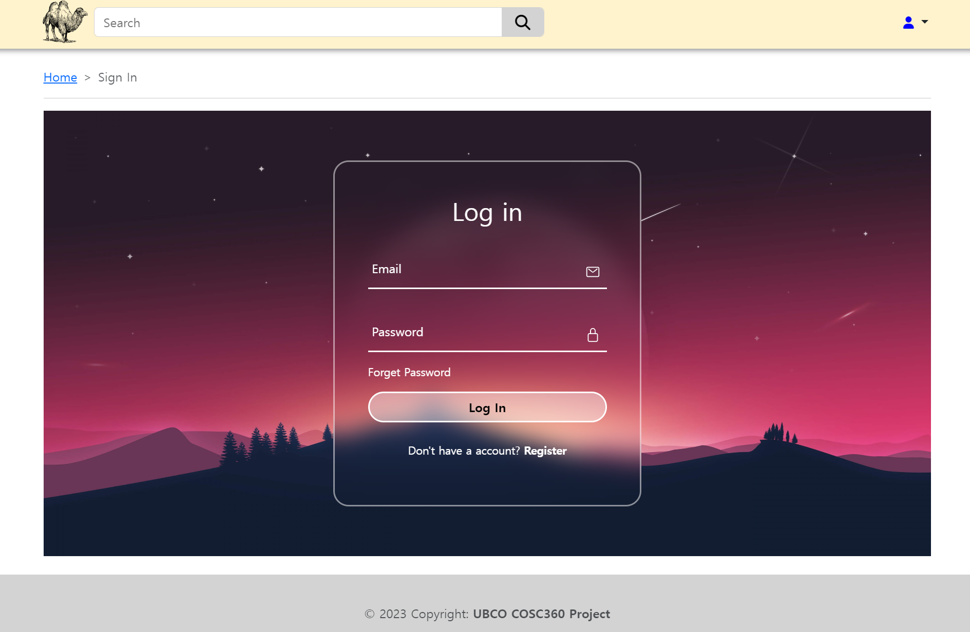

/page/singup.html

Sign up page

Clicking “Sign In” will bring user to sign-in page

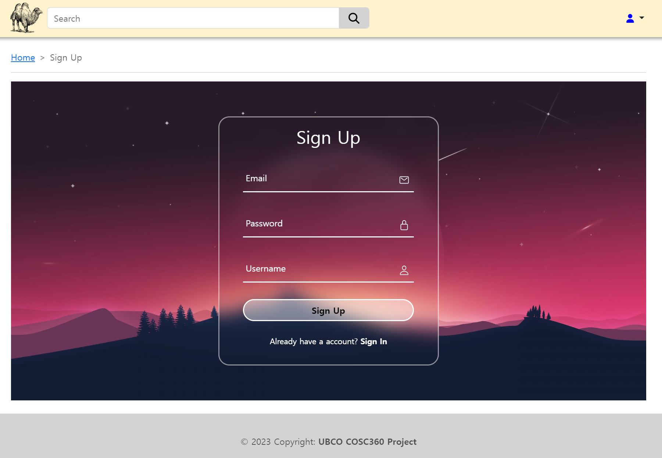

/page/lost.html

Page for when user lost password

If user input valid email, it will send code to user and when user type that code, it will make user be able to sign in. Then, user can update password at profile page.

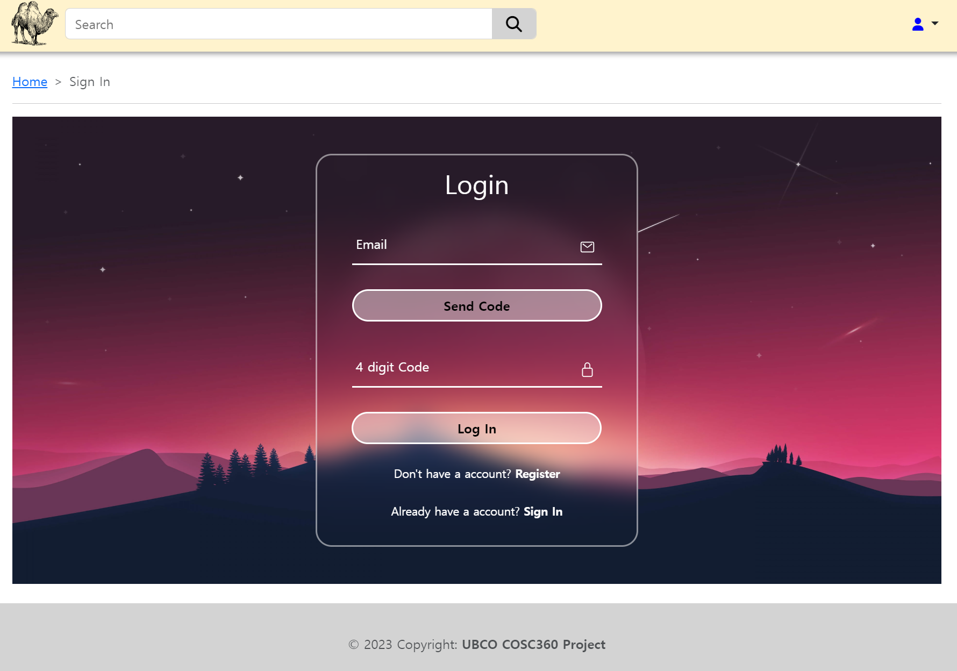

/page/profile.html

Profile page

Users can see their current username and email and change their username, email and password. Clicking the human-shaped button on the upper right will give profile page link once user signed in. (This should implement with server side)

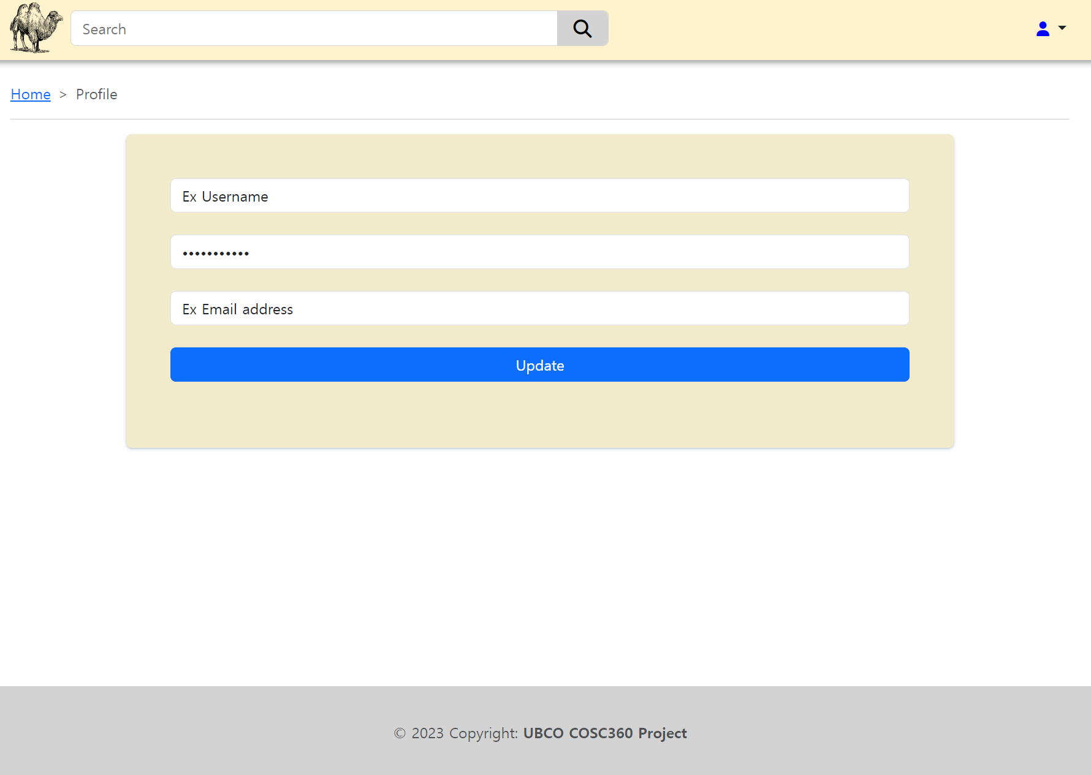

/page/users.html

Page for administer to manage users. Will be made to be updated status by click. Clicking the human-shaped button on the upper right will give profile page link once administer signed in. (This should implement with server side)

/page/productSearch.html

Page for searching product. Clicking more-opinion button will bring user /page/product.html where there is details of product and opinions about it.

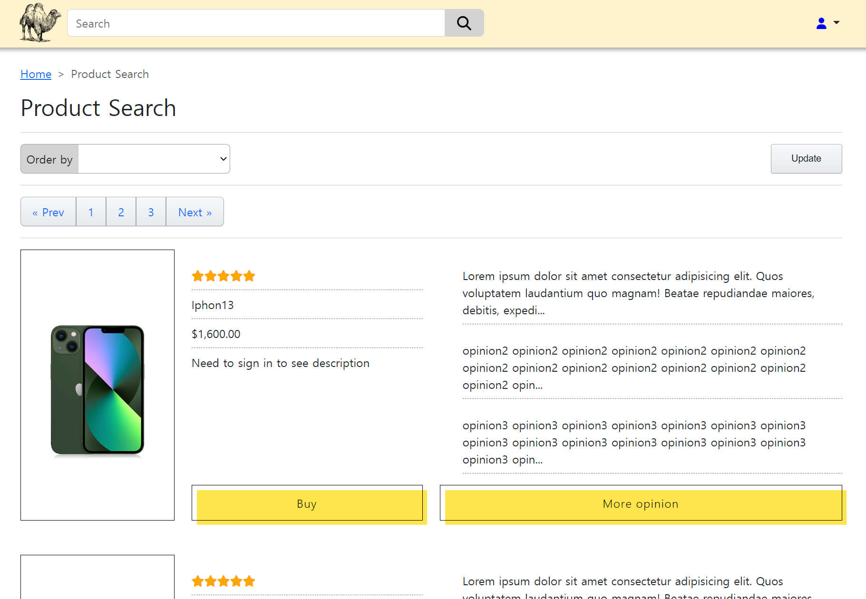

/page/product.html

Page for details of product and opinions of user. Clicking review posted by user themselves will bring user to page where user can edit or delete that post.

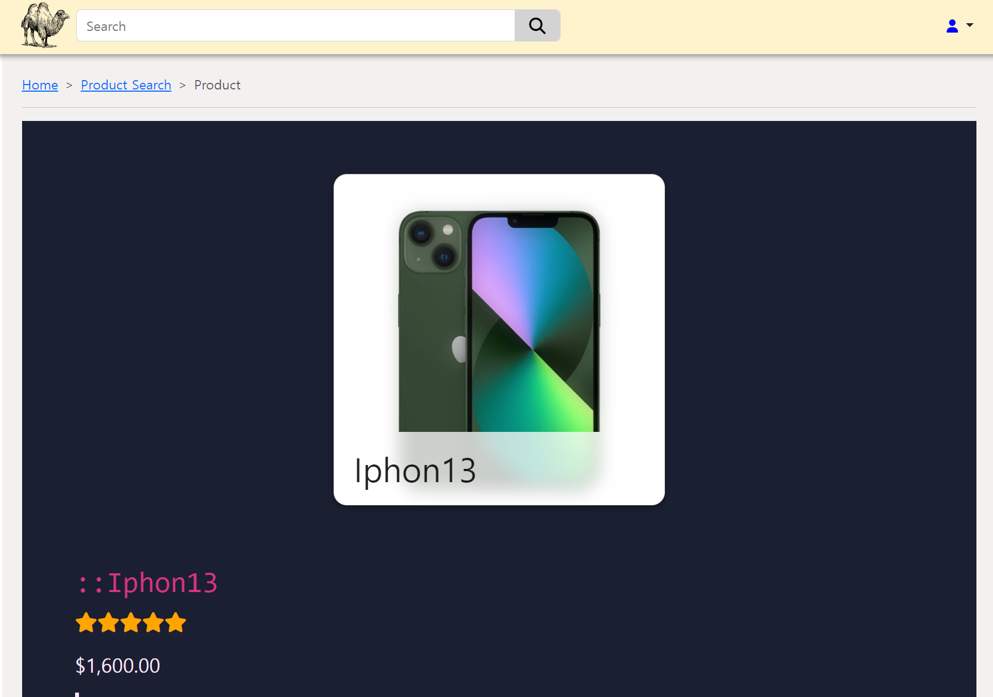

/page/opinion.html

Page for editing or deleting opinion

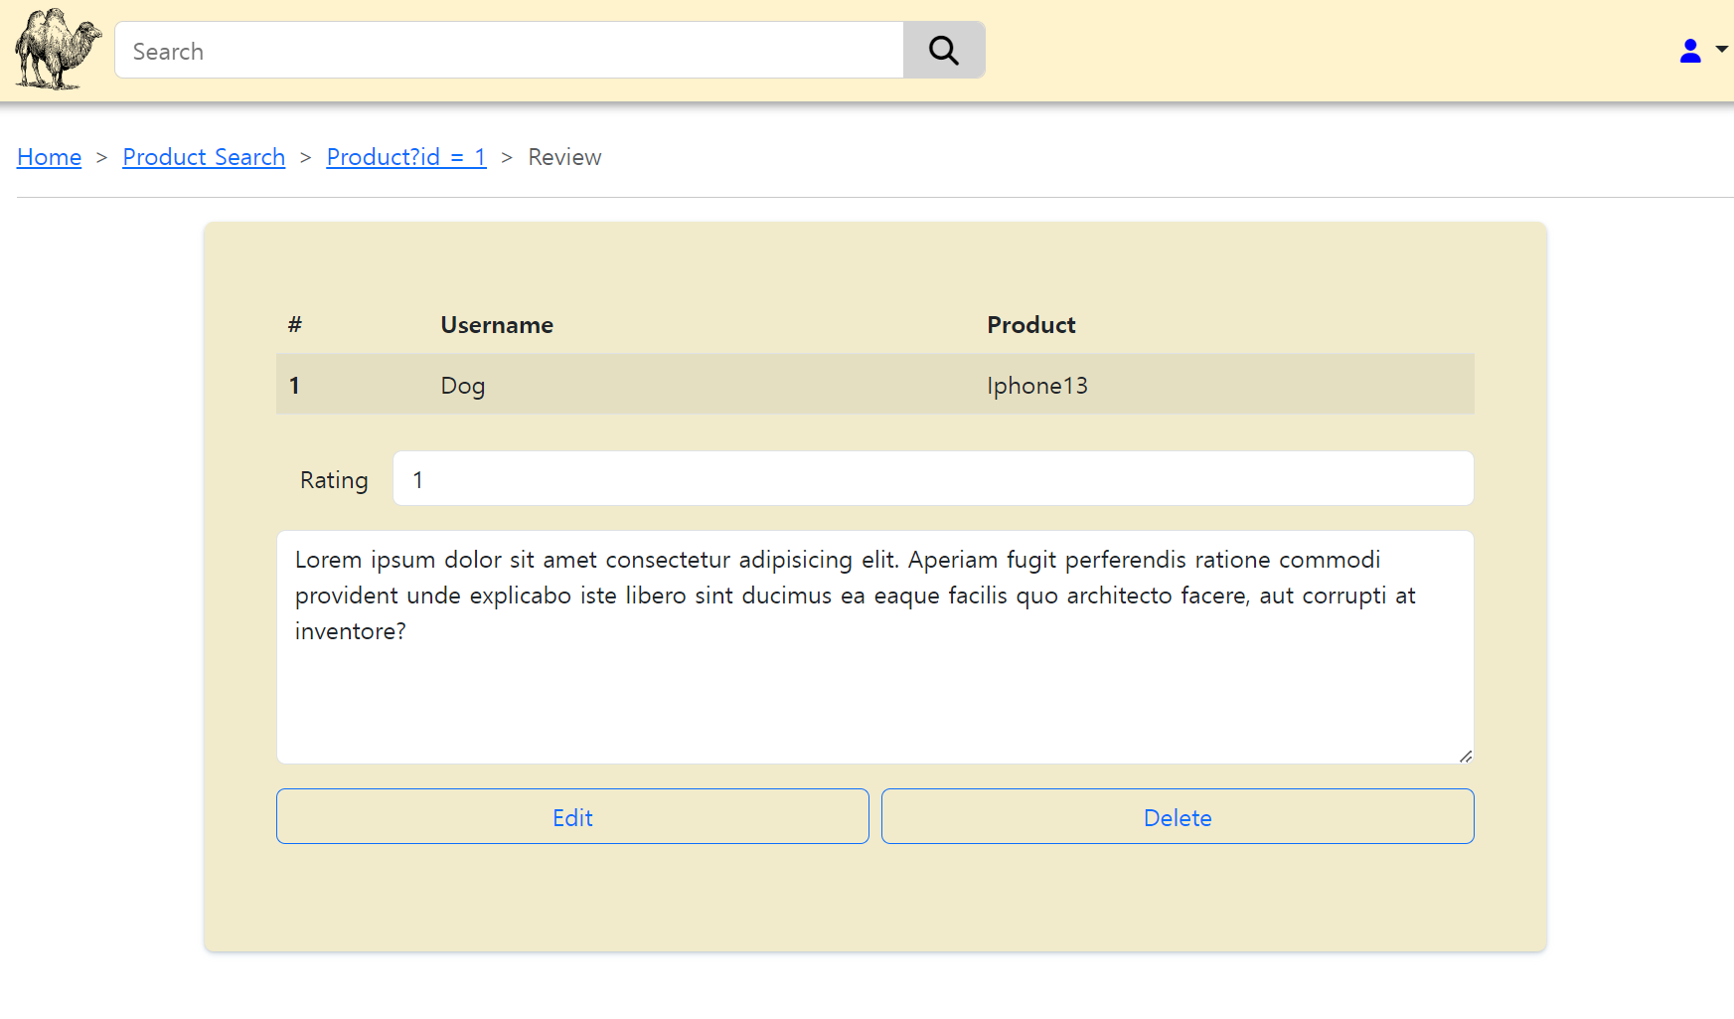

Client-side validation

When submit form with invalid value or empty value, it warns user and shows the valid format.

There is same feature for Sign up page.

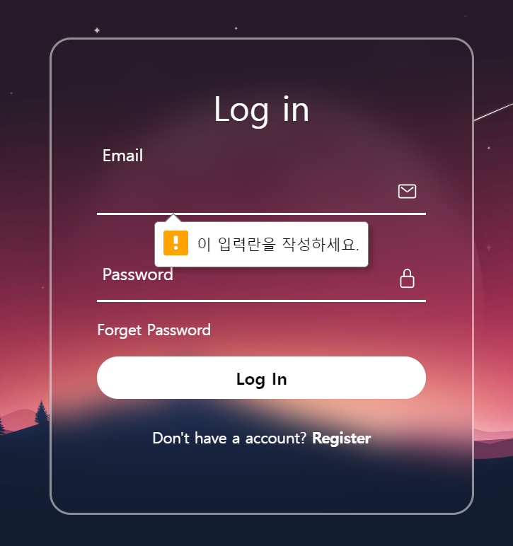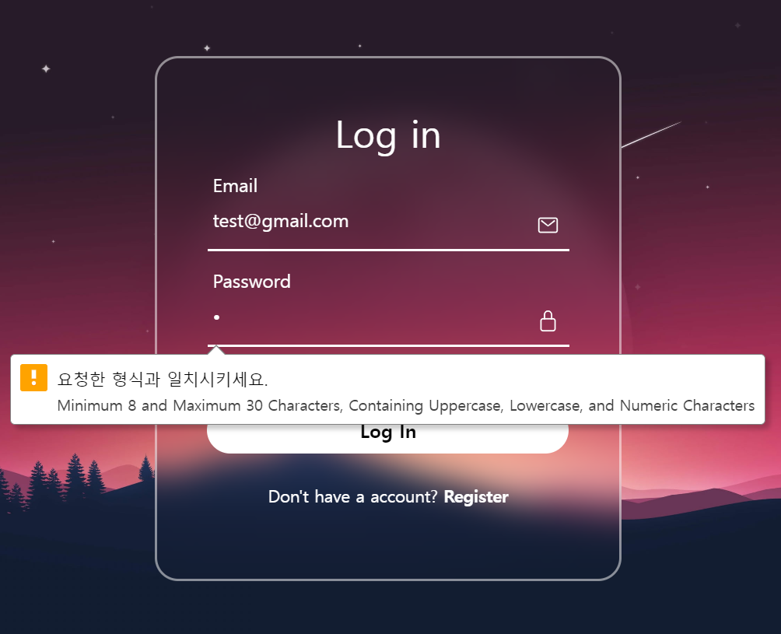

Responsive Design

Wide Screen Mode

Narrow Screen Mode

Wide Screen Mode

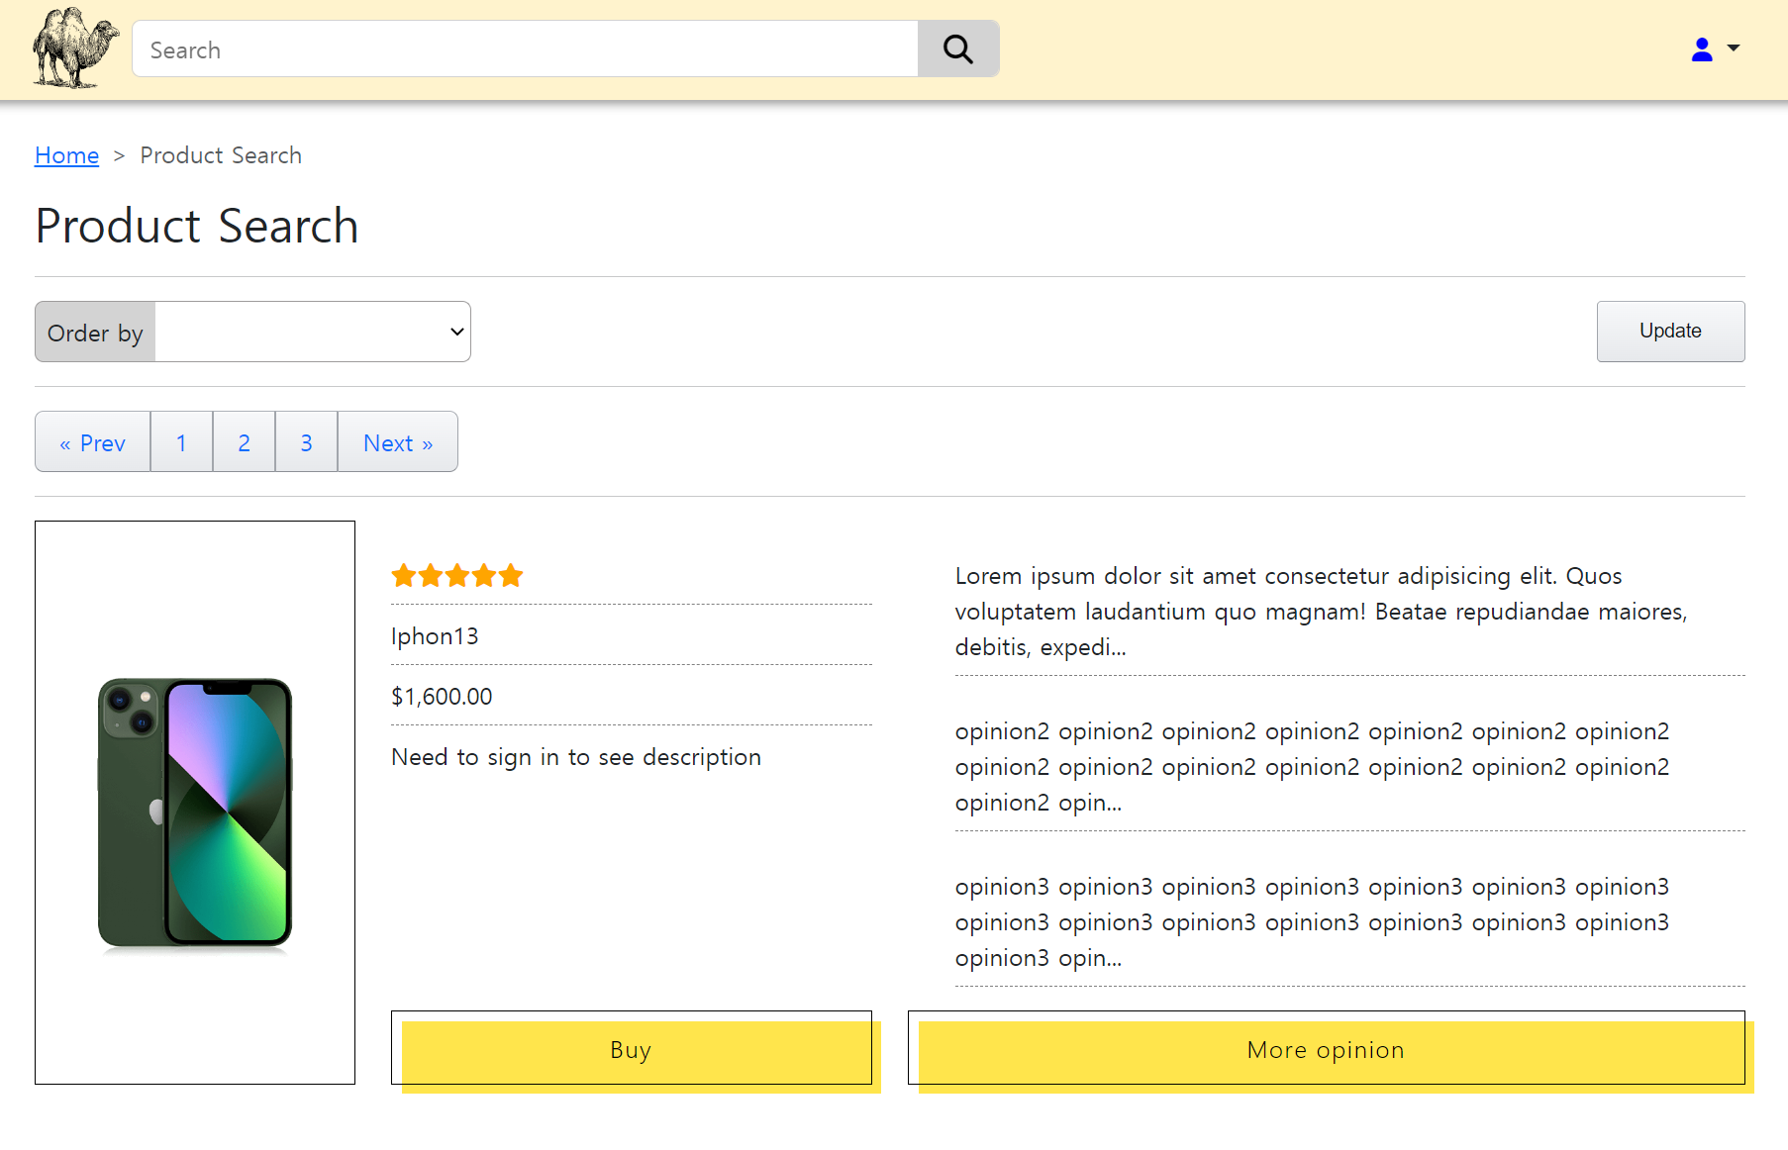

Narrow Screen Mode

