The Unfortunate Circumstances of Poverty

Jacinda Chen

May 15, 2020

# Introduction

Air is vital for the majority of living organisms on Earth. As such, the quality of the air should be of paramount importance to us. However, past and current ignorance has led to multiple occurrences that contributed to air pollution. Some of the anthropological events are the creation of many industries and human-built buildings such as health care buildings that contribute to air pollution. Some of the events that contribute to air pollution that are out of human control are excessive wildfires. According to Moore et al., “increases in physician visits for respiratory diseases of between 46 and 78% above 10-year mean rates were observed for three weeks during the forest fire period” (Moore et al. 2006). The only thing we can do is decrease air pollution output from humans. One way that we can do that is by using lower sulfur marine fuel oil on main engines on ships at sea as opposed to high-sulfur heavy fuel oil, which has been found to result in a large reduction in the fine particle concentration of markers for heavy fuel oil combustion (Tao et al. 2013). These reductions in sulfate particulates can really help the environment, and many people do not know about small changes they can make to do that. Another human-caused event that contributes to air pollution is vehicle traffic. Especially in San Francisco, overcrowding and traffic is a big issue. As a result from this, most people in San Francisco lean towards using public transport such as BART or Muni, which is a good alternative to car emissions. A lot of people also tend to walk or bike more, which increases foot traffic leading to less vehicle pollution. This is only a problem when there is bad weather, leading to conditions where people can no longer walk. Bad weather can increase the number of cars used, which in turn, increases traffic and then pollution. Air pollution as a result of traffic has also been found to create respiratory issues in surrounding residents. In the San Francisco Bay Area, traffic pollution has caused respiratory problems including bronchitis symptoms and asthma in children (Kim et al. 2004).

The decreased quality of air does not only affect humans, it can affect other organisms such as birds and plants. Birds are also a good model to monitor as a measure of air pollutants compared to invertebrates as they are higher up in the food chain and more representative of human health threats (Furness et al. 1993). It has been found that the presence of highways had decreased the population size of birds for an entire area of study (Reijnen and Foppen 1994). In addition to air pollution as a result of traffic, noise pollution is also a point of concern. It was found that if the environmental noise was louder at a certain location, free-ranging nightingales would sing louder compared to quieter environmental locations (Brumm 2004). This is significant because it is an example of a bird’s change in behavior as a result of noise pollution. Their change in song might compromise mating interactions because of decreased quality of sound. Acoustic-dependent communication suffers greatly in environments with a lot of noise pollution. It was also found that different species of birds react differently to air pollution. While one species of birds reacted negatively to air pollution at the egg stage, another reacted very negatively at the nesting stage (Eeva 1996). In addition, these birds were also found to have a reduced number of breeding occurrences as a result of air pollution (Eeva 1996). In addition, mining and crushing stones are very common industrial practice in some places that produce a dust, adding to the air pollution. It added so much noise and air pollution in India that they found evidence of forest degradation and a lesser density of birds (Saha and Padhy 2011).

As a result of the large importance of good air quality, people in power have assigned themselves to areas with better air quality while they assign lower air quality areas to others. The poorer you are, the more susceptible you are to living in areas with more air pollution, however these areas are also more prone to increased pollution (Lipfert 2004). It is a hard loop to get out of. There is a three-way relationship between socioeconomic status, air quality, and health. People with low socioeconomic statuses lead to residential areas with worse air quality, resulting in overall less health. Environmental justice issues have been raised continuously over the uneven distribution of environmental impacts inside a city that leads to further discrimination. Although areas with worse air quality leads to more health issues, these people often have less accessibility financially to health care. These low socioeconomic neighborhoods have also been found to contain high traffic densities which contribute hazardous pollutants like diesel exhaust to respiratory illnesses and mortality rates. It has been found that children in California that come from low-income or minority families disproportionately live in over two times the level of high-traffic compared to the rest of Southern California (Houston et al. 2004). In Canada, there has been a lack of research linking the environment to child poverty. With such little precedence on environmental justice in such a large country, it is no surprise when there seems to be a lack of environmental justice awareness in the world overall. Children with low socioeconomic status are more likely to live in unkept residencies where the buildings themselves contain high levels of toxic contaminants. In addition, they are more prone to risk factors such as cigarette smoke and little nutrition while growing up, which leads to additional health concerns as they get older (Chaudhuri 1998).

One way to track air pollution is by measuring their PM 2.5 concentration levels. Particulate Matter 2.5 (PM 2.5) are fine particles in the air that can affect the respiratory and cardiovascular systems depending on the amount of time and exposure an individual has to PM 2.5 (Health n.d.). Elevated amounts of PM 2.5 in the air will lead to hazy appearances that limit visibility as well as an increase in illness, especially to those with previous respiratory concerns (such as asthma). The factors that contribute to PM 2.5 are from vehicles, grass or forest fires, power plants, heating coal, cooking, smoking, and more. PM 2.5 are also able to travel across large distances from their source by wind.

With all of these health concerns, it begs the question of how they would receive treatment. Many children who come from low-income families cannot afford to have health insurance. DeNavas-Walt writes that an “estimated 21.9 percent of Hispanic children did not have any health insurance in 2005, compared with 7.2 percent for non-Hispanic White children, 12.5 percent for Black children, and 12.2 percent for Asian children” (DeNavas-Walt 2010). From that, it is apparent that a strikingly high amount of low-income families that cannot afford health insurance for their children come from non-White families. Since the likelihood of health insurance coverage increases with income, a large percentage of non-White families are low-income compared to non-Hispanic White children. These families are in no position to be able to pay for out-of-pocket health visits. This means that if these families were able to afford health insurance, it would enhance their utilization of the health care system and protect low-income families (Asfaw and Jütting 2007). “Universal health coverage” is still a far-fetched dream for many countries, however studies show that this would help with poverty reduction (Asfaw and Jütting 2007). Low-income families have little to no access to life-saving drugs, surgeries, or interventions with drug and alcohol addiction. Studies in Ghana in 2004 with the implementation of the National Health Insurance Scheme proved that health insurance protected low-income families financially from catastrophic out-of-pocket expenditure and reduced poverty (Aryeetey et al. 2016).

But how did they become low-income families? Many low-income families do not have a choice between education and working in or just out of high school as their families cannot afford to keep them in school. Less education means they are not able to easily obtain the qualifications that many jobs with higher pay require. However, money is not the cure-all option. There are many other variables that go into being in poverty that may affect children in poverty regarding school, such as an unstable home condition. A study showed that far less low-income students graduated from free college than expected (Burney and Beilke 2008). This has no relationship to their view on higher education. Another interview of 76 students from a high-poverty area showed a cohesive positive view of higher education that leads to more opportunities, however attending college would involve multiple risks (Cilesiz and Drotos 2016). Many first-generation families carry the dreams of their ancestors on their shoulders along with their own dreams and aspirations. A majority of these involve getting a higher education since higher education is usually linked with more income and having a better life. Another study showed that socioeconomic status increased the probability of learning disabilities and the impact that learning disabilities has on high school completion. It found that efforts to help students face poverty and their learning disabilities was effective in keeping them in school (Ingrum 2006). Other studies have found a link between establishing good reading skills by third grade and dropping out of high school. Students who do not reach that milestone usually struggle more in later grades and end up dropping out before high school graduation (Hernandez 2011). Many of these low-income families, especially children, need a stable support system in order to help them get the resources they need for free.

My primary question was what is the correlation between poverty and detrimental environmental factors or available resources. My hypothesis was that there is a correlation between increasing percentages of poverty and decreasing amount of resources (worse air quality, less health insurance coverage, little to no high school education) related to being non-white. Increased PM 2.5 concentrations lead to more health issues, less health insurance coverage means these issues will not be addressed, and no higher education generally means lower job income. Bad air quality leads to lung and cardiovascular issues that would lower the number of species of birds per area. Less health insurance means that most families cannot afford even going up for a checkup at a hospital, nevermind an actual injury or condition that requires a hospital bed or drugs for treatment. Only completing high school means that there is less opportunity for jobs of higher pay, which gives them less of an opportunity to afford better living arrangements and such.

# Methods

## Data Download and Processing

I downloaded a dataset from DataSF called Community Resiliency Indicator System (SFDPH 2015). Another dataset that I used was from the United States Census Bureau, from the “Income and Poverty in the United States: 2019” page, was “Table B-1. People in Poverty by Selected Characteristics: 2017 and 2018” (Bureau 2018). As the dataset was not able to be directly used in RStudio, I had to un-merge cells from the original Excel file without the use of empty cells. The third dataset that I used was also from the United States Census Bureau, from the “Health Insurance: Tables 2018-forward” page, was “H-02. Health Insurance Coverage Status and Type of Coverage by Selected Characteristics: 2019” (Bureau 2019). As the dataset was not able to be directly used in RStudio, I had to un-merge cells from the original Excel file without the use of empty cells.

## Data Analysis and Statistics

In order to analyze the data from the datasets, I used the libraries: dplyr, tidyr, ggplot2, readr, citr, broom, knitr. The package dplyr is used for data manipulation by rearranging existing variables, picking cases and variables based on their values and names, and summarizing values. Often used with dyplyr, tidyr is for “tidying” your data by organizing it in a way that is easy to use with other packages to visualize (ggplot2) and more. The package ggplot2 is able to create graphics based on the provided data. In order to read the datasets in csv format, the package readr is necessary. I cited my sources using the package citr. Broom organizes messy outputs into tidy data frames. In order to turn my report into a Word document, I use knitr for the report generation.

I found the p-value and the R^2 value using linear regression. Linear regression explores the relationship between a dependent variable and an independent variable using a linear approach. A p-value of less than 0.05 was statistically significant as there was less than a 5% chance that the relationship occurred due to chance. R^2 determines the predictable proportion of variance of the dependent variable on the independent variable. A R^2 close to one means that the dependent variable is entirely predictable from solely the independent variable.

# Results

## Air Quality (PM 2.5 levels) and Poverty

In San Francisco, as the percent poverty rate increased, the harmful PM 2.5 levels also increased (Figure 1). This positive linear relationship (p < 0.01) explains 23.96% of the variation of relationship between PM 2.5 levels and poverty (Table 1). There is also a link between the percent cover of trees in a given neighborhood in San Francisco and the amount of PM 2.5 concentration from all sources. As the percent cover of trees increased, the PM 2.5 concentration decreased (Figure 2). This negative linear relationship (p <0.01) explains 19.35% of the variation of relationship between the percent cover of trees and PM 2.5 concentration (Table 2).

## High School Graduation and Poverty

In San Francisco, as the percent poverty rate increased, the percent of people over 25 with a high school degree decreased (Figure 3). This negative linear relationship (p < 0.01) explains 45.16% of the variation of relationship between percent poverty rate and percent of high school degrees (Table 3). In the United States of America in 2017, 10% of the 219,821 people aged 25 and older were below poverty (Table 4). Out of that 10%, 24.5% did not have a high school diploma while only 4.3% had a bachelor’s degree or higher (Table 4). In 2018, the percent below poverty went down by 0.1% (Table 4). However, out of the 9.9%, 25.9% did not have a high school diploma while 4.4% had a bachelor’s degree or higher (Table 4).

## Poverty Demographics

Looking at the non-white percentages in five neighborhoods with the highest poverty rates and five neighborhoods with the lowest poverty rates in San Francisco in 2019, it becomes apparent that the richest five neighborhoods have lower non-white percentages (Figure 4). The lowest non-white percentage in the richest five neighborhoods was below 20% while the highest lowest non-white percentage in the poorest five neighborhoods was around 50% (Figure 4).

## Household Income and Health Insurance Coverage

As the household income in the United States increased in 2019, the percent of people not currently coveraged with health insurance decreased (Figure 5). Households that received an income of less than $25,000 had almost 15% not currently coveraged with health insurance while households with an income of $150,000 or more had less than 5% without health insurance (Figure 5). The more financially secure the household, the more they sought health coverage. Zooming into particularly the people in poverty, a similar relationship was discovered. As the income-to-poverty ratio of percentages below poverty increased, the percent not currently coveraged with health insurance decreased (Figure 6). The people below 100 percent of poverty had over 15% without health insurance while less than 5% of people at or above 400 percent of poverty did not have health insurance (Figure 6). As people in the United States earned more income, the more health coverage they had.

# Discussion

My primary question was what is the correlation between poverty and detrimental environmental factors or available resources. My hypothesis was that there is a correlation between increasing percentages of poverty and decreasing amount of resources (worse air quality, less health insurance coverage, little to no high school education) related to being non-white. My primary findings were that there was a significant positive linear relationship between increased poverty rate and increased PM 2.5 concentration. There were also significant negative linear relationships between increased percent tree coverage and decreased PM 2.5 concentration as well as increased percent poverty rate and decreased percent high school degree. Richer neighborhoods in San Francisco were also found to have smaller non-white percentages compared to poorer neighborhoods. In addition, households with larger incomes showed a greater percentage of health coverage in San Francisco.

## Air Quality (PM 2.5 levels) and Poverty

PM 2.5 levels elevated as poverty rate increased and tree coverage increased as PM 2.5 levels decreased (Figure 1; Figure 2). It may be probable, then, that neighborhoods with high poverty rates will show less tree coverage compared with richer neighborhoods. If this is true, then there could be projects implemented in neighborhood with high poverty rates to plant more trees to manage the PM 2.5 levels. This is necessary as other places with high PM 2.5 levels found related health concerns. For example, air samples collected in 2011-2012 in Zhengzhou, China showed five times the standard PM 2.5 levels (Wang et al. 2014). These areas were found to have an increased carcinogenic risk associated with increased PM 2.5 levels (Wang et al. 2014). Another example in Targoviste City, Romania, showed that an increased concentration of PM 2.5 directly influenced the number of asthma attacks and wheezing symptoms in a group of 72 children (Dunea et al. 2016). These examples show the detrimental effects that elevated PM 2.5 levels can take on humans. In San Francisco, decreasing PM 2.5 levels will lower the respiratory and cardiovascular risk of illness, especially in neighborhoods with high poverty. PM 2.5 levels can be decreased by growing more trees around these high poverty neighborhoods.

## High School Graduation and Poverty

In San Francisco, the percent of people over 25 with a high school degree decreased as the percent poverty rate increased (Figure 3). In the United States in 2018, out of 9.9% people over 25 below poverty, 25.9% did not have a high school diploma and 4.4% had a bachelor’s degree or higher (Table 4). This data shows that the lack of higher education for people in high levels of poverty in San Francisco is not limited to only San Francisco. The lack of high education with people in high poverty is seen in the United States as a whole. More education is often linked to better job access with higher incomes, however the children of parents in low income jobs often do not have the financial capability to continue higher education or even complete high school. Just to have enough money to pay rent and have food on the table, some of these low income families see more use in having their child work full-time in high school rather then complete their high school education. It was found that current income affects whether or not the child will pursue higher education as a result of financial constraints (Chevalier et al. 2013). To counteract this, policymakers should put greater impact into advertising the advantages of educational participation and have money transferred to lower income families to increase participation on the contingency that these students perform well or show improvements. These policies should be put in place from a younger age since poor educational achievement from a younger age affects motivation and self-worth in later education.

## Poverty Demographics

In San Francisco, the richest five neighborhoods have lower non-white percentages (Figure 4). This shows the starting advantage of wealth that white people have over colored people. These people have less worries about living in areas with higher PM 2.5 concentrations or not being able to afford higher education. A study found that educational outcomes do not depend on race, but rather a teacher’s curriculum quality (Darling-Hammond 1998). It also found that “2/3 of minority students still attend schools that are predominately minority, most of them located in central cities and funded well below those in neighboring suburban districts” (Darling-Hammond 1998). Once again, I arrive at the unfortunate conclusion that better educational outcome is largely affected by larger incomes which gives, usually, white students better resources to succeed. One of these resources is teacher expertise. While minority students receive a large variety of teachers with different qualifications, schools in more expensive neighborhoods put more effort in finding high quality teachers. Teachers, also, generally do not look to work in poor neighborhoods where crime rates are increased and students often have more problems at home.

## Household Income

Households that received an income of less than $25,000 had almost 15% not currently coveraged with health insurance while households with an income of $150,000 or more had less than 5% without health insurance (Figure 5). The people below 100 percent of poverty had over 15% without health insurance while less than 5% of people at or above 400 percent of poverty did not have health insurance (Figure 6). The less money an individual earns, the less likely they will have the means or the opportunity to get health insurance. A study found a correlation between inadequate health care and poor health status (Braveman et al. 1988).

## Big Picture

To conclude, my hypothesis was correct: poverty is correlated with less available resources. Households with low incomes are generally non-white and begin at a disadvantage compared to white people. People with low incomes live in areas with high PM 2.5 concentrations that can lead to additional respiratory and cardiovascular problems, especially if exposed to PM 2.5 for extended periods of time. Although people with low incomes are more prone to illness, they also have less access to health care because they cannot afford to have it. Children in these homes, who are more susceptible to the harms of elevated PM 2.5 levels, often do not have the financial resources to allow them to further their education. These children might also have more health issues, which might detain them from being able to study or learn properly. On top of that, teachers in neighborhoods with low income have a range of qualifications, which means their curriculum may not always be good quality. This sets up a cycle for low income families to stay low income. No further education generally means that these low income students will not be able to qualify for jobs with better incomes, thus keeping them in this loop. Some ways to counteract this are teachers with good backgrounds going to these neighborhoods to teach and being there for their students. There have been many examples of what a good teacher can do for their students. The government can also look into including more households with low income that cannot afford health insurance so that their health concerns can be attended to. The areas around low income families should be studied further to ascertain what is the leading contributor to PM 2.5 concentration levels to counteract it. Although high poverty rates set people up for less available resources, eventually this uneven distribution of resources will be more balanced.

# Figures

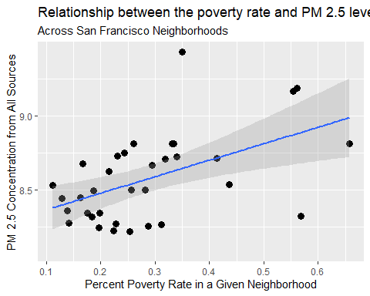

**Figure 1:** There is a positive linear relationship (p < 0.01) between the percent cover of trees in a given neighborhood in San Francisco in 2019 and the PM 2.5 particulates from all sources.

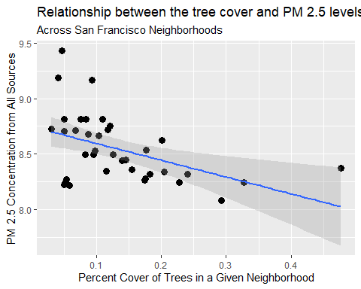

**Figure 2:** There is a negative linear relationship (p < 0.01) between the percent cover of trees in a given neighborhood in San Francisco in 2019 and the PM 2.5 particulates from all sources.

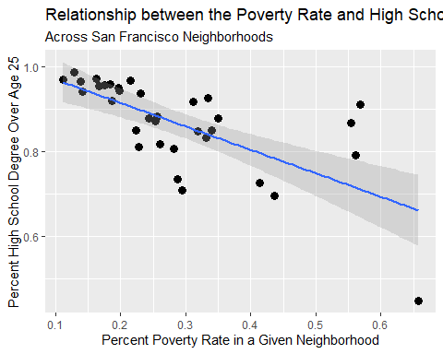

**Figure 3:** There is a negative linear relationship (p < 0.01) between the percent cover of trees in a given neighborhood in San Francisco in 2019 and the PM 2.5 particulates from all sources.

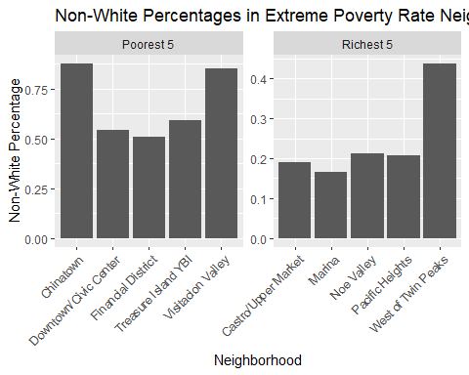

**Figure 4:** There is a higher Non-White Percentage (50-above 75%) in the poorest 5 neighborhoods compared to the Non-White Percentage (10% with an outlier of slightly below 45%) in the richest 5 neighborhoods in San Francisco in 2019.

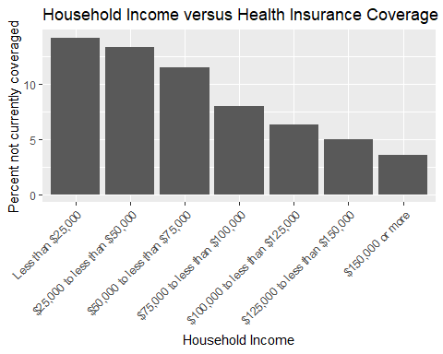

**Figure 5:** There is a negative relationship between household income in the United States in 2019 and the percentage of people not currently coveraged by health insurance.

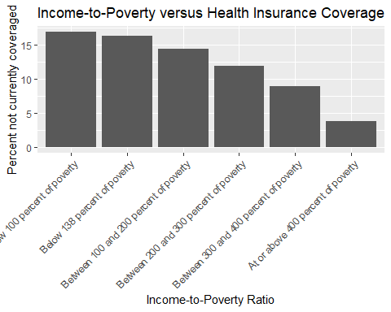

**Figure 6:** There is a negative relationship between the income-to-poverty ratio in the United States in 2019 and the percentage of people not currently coveraged by health insurance.

# Tables

|  |  |  |  |  |
| --- | --- | --- | --- | --- |
| term | estimate | std.error | statistic | p.value |
| (Intercept) | 8.2533 | 0.1044 | 79.0187 | 0.0000 |
| Pov_Per | 1.1148 | 0.3302 | 3.3763 | 0.0019 |

**Table 1:** Statistical table showing results from the linear model depicted in Figure 1 (R^2 = 0.2396).

|  |  |  |  |  |
| --- | --- | --- | --- | --- |
| term | estimate | std.error | statistic | p.value |
| (Intercept) | 8.7464 | 0.0786 | 111.2144 | 0.0000 |
| Tree_Per | -1.5137 | 0.4876 | -3.1046 | 0.0038 |

**Table 2:** Statistical table showing results from the linear model depicted in Figure 2 (R^2 = 0.1935).

|  |  |  |  |  |
| --- | --- | --- | --- | --- |
| term | estimate | std.error | statistic | p.value |
| (Intercept) | 1.0253 | 0.0330 | 31.1008 | 0 |
| Pov_Per | -0.5533 | 0.1042 | -5.3083 | 0 |

**Table 3:** Statistical table showing results from the linear model depicted in Figure 3 (R^2 = 0.4516).

|  |  |  |  |  |  |  |
| --- | --- | --- | --- | --- | --- | --- |
| Characteristics | Total in 2017 | Number Below Poverty in 2017 | Percent Below Poverty in 2017 | Total in 2018 | Number Below Poverty in 2018 | Percent Below Poverty in 2018 |
| Total, aged 25 and older | 219821 | 22007 | 10.0 | 221478 | 21916 | 9.9 |
| No high school diploma | 22404 | 5488 | 24.5 | 21975 | 5693 | 25.9 |
| High school, no college | 62669 | 8054 | 12.9 | 62259 | 7925 | 12.7 |
| Some college | 57828 | 5178 | 9.0 | 57428 | 4812 | 8.4 |
| Bachelor’s degree or higher | 76920 | 3286 | 4.3 | 79816 | 3486 | 4.4 |

**Table 4:** Table showing the educational attainment of everyone in the United States in 2017-2018 compared to poverty.

# Sources Cited

Aryeetey, G. C., J. Westeneng, E. Spaan, C. Jehu-Appiah, I. A. Agyepong, and R. Baltussen. 2016. Can health insurance protect against out-of-pocket and catastrophic expenditures and also support poverty reduction? Evidence from ghana’s national health insurance scheme. International journal for equity in health 15:116.

Asfaw, A., and J. P. Jütting. 2007. The role of health insurance in poverty reduction: Empirical evidence from senegal. International Journal of Public Administration 30:835–858.

Braveman, P., G. Oliva, M. G. Miller, V. Schaaf, and R. Reiter. 1988. Women without health insurance. Links between access, poverty, ethnicity, and health. Western Journal of Medicine 149:708.

Brumm, H. 2004. The impact of environmental noise on song amplitude in a territorial bird. Journal of animal ecology 73:434–440.

Bureau, U. S. C. 2018. People in poverty by selected characteristics: 2017 and 2018.

Bureau, U. S. C. 2019. Health insurance current coverage status and type of coverage by selected characteristics: 2019.

Burney, V. H., and J. R. Beilke. 2008. The constraints of poverty on high achievement. Journal for the Education of the Gifted 31:295–321.

Chaudhuri, N. 1998. Child health, poverty and the environment: The canadian context. Canadian journal of public health= Revue canadienne de sante publique 89:S26–30.

Chevalier, A., C. Harmon, V. O’Sullivan, and I. Walker. 2013. The impact of parental income and education on the schooling of their children. IZA Journal of Labor Economics 2:8.

Cilesiz, S., and S. M. Drotos. 2016. High-poverty urban high school students’ plans for higher education: Weaving their own safety nets. Urban Education 51:3–31.

Darling-Hammond, L. 1998. Unequal opportunity: Race and education. The Brookings Review 16:28.

DeNavas-Walt, C. 2010. Income, poverty, and health insurance coverage in the united states (2005). Diane Publishing.

Dunea, D., S. Iordache, H.-Y. Liu, T. Bøhler, A. Pohoata, and C. Radulescu. 2016. Quantifying the impact of pm 2.5 and associated heavy metals on respiratory health of children near metallurgical facilities. Environmental Science and Pollution Research 23:15395–15406.

Eeva, T. 1996. Direct and indirect effects of air pollution on two hole-nesting bird species. Zoology 72:624–635.

Furness, R., J. Greenwood, and P. Jarvis. 1993. Can birds be used to monitor the environment? Pages 1–41 *in* Birds as monitors of environmental change. Springer.

Health, D. of. (n.d.). Fine particles (pm 2.5) questions and answers.

Hernandez, D. J. 2011. Double jeopardy: How third-grade reading skills and poverty influence high school graduation. Annie E. Casey Foundation.

Houston, D., J. Wu, P. Ong, and A. Winer. 2004. Structural disparities of urban traffic in southern california: Implications for vehicle-related air pollution exposure in minority and high-poverty neighborhoods. Journal of Urban Affairs 26:565–592.

Ingrum, A. 2006. High school dropout determinants: The effect of poverty and learning disabilities. The Park Place Economist 14:72–79.

Kim, J. J., S. Smorodinsky, M. Lipsett, B. C. Singer, A. T. Hodgson, and B. Ostro. 2004. Traffic-related air pollution near busy roads: The east bay children’s respiratory health study. American journal of respiratory and critical care medicine 170:520–526.

Lipfert, F. 2004. Air pollution and poverty: Does the sword cut both ways? BMJ Publishing Group Ltd.

Moore, D., R. Copes, R. Fisk, R. Joy, K. Chan, and M. Brauer. 2006. Population health effects of air quality changes due to forest fires in british columbia in 2003. Canadian journal of public health 97:105–108.

Reijnen, R., and R. Foppen. 1994. The effects of car traffic on breeding bird populations in woodland. I. Evidence of reduced habitat quality for willow warblers (phylloscopus trochilus) breeding close to a highway. Journal of Applied ecology:85–94.

Saha, D. C., and P. K. Padhy. 2011. Effect of air and noise pollution on species diversity and population density of forest birds at lalpahari, west bengal, india. Science of the total environment 409:5328–5336.

SFDPH. 2015. Community resiliency indicator system.

Tao, L., D. Fairley, M. J. Kleeman, and R. A. Harley. 2013. Effects of switching to lower sulfur marine fuel oil on air quality in the san francisco bay area. Environmental science & technology 47:10171–10178.

Wang, J., N. B. Geng, Y. F. Xu, W. D. Zhang, X. Y. Tang, and R. Q. Zhang. 2014. PAHs in pm 2.5 in zhengzhou: Concentration, carcinogenic risk analysis, and source apportionment. Environmental monitoring and assessment 186:7461–7473.