Lab 1 - – Introdução ao SQL Server 2019

Nome: Nuno Reis Número: [202000753](https://portal.ips.pt/ests/pt/fest_geral.cursos_list?pv_num_unico=202000753)

Etapa 1

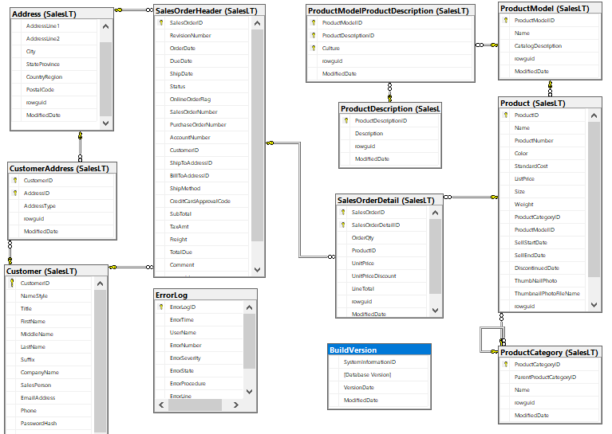

Etapa 2

a)

select concat(FirstName, ' ', MiddleName, ' ', LastName) as 'Nome Completo', EmailAddress

from SalesLT.Customer

b)

select concat(FirstName, ' ', MiddleName, ' ', LastName) as 'Nome Completo', EmailAddress

from SalesLT.Customer

order by LastName desc

c)

select Customer.CustomerID, FirstName

from SalesLT.Customer left join SalesLT.SalesOrderHeader

on Customer.CustomerID = SalesOrderHeader.CustomerID

where SalesOrderNumber is null

Etapa 3

a)

select ProductID, sum(OrderQty*UnitPrice) as 'Total de Vendas'

from SalesLT.SalesOrderDetail

group by ProductID

order by ProductID

b)

select top 1 ProductID, sum(OrderQty*UnitPrice) as 'Total de Vendas'

from SalesLT.SalesOrderDetail

group by ProductID

order by 2 DESC

c)

select p.Name, (tabela.Vendas/(select sum(OrderQty*(UnitPrice-UnitPriceDiscount)) from SalesLT.SalesOrderDetail))*100 as '%Vendas'

from SalesLT.Product p

join (select ProductID, sum(OrderQty*(UnitPrice-UnitPriceDiscount)) as Vendas

from SalesLT.SalesOrderDetail

group by ProductID) Tabela

on p.ProductID=Tabela.ProductID

where Vendas is not null

order by Vendas DESC

d)

select [Name], [Description]

from [SalesLT].[vProductAndDescription]

e)

select Product.Name, [ProductCategoryName], [ParentProductCategoryName]

from SalesLT.Product

join [SalesLT].[vGetAllCategories]

on Product.ProductCategoryID=[vGetAllCategories].[ProductCategoryID]

f)

select Product.Name, Product.ListPrice

from SalesLT.Product

join [SalesLT].[vGetAllCategories]

on Product.ProductCategoryID=[vGetAllCategories].[ProductCategoryID]

where [vGetAllCategories].[ParentProductCategoryName] = 'Bikes'

g)

select [vGetAllCategories].[ProductCategoryName], Tabela.Number

from [SalesLT].[vGetAllCategories]

left join (select ProductCategoryID, count(*) as Number

from SalesLT.Product

group by Product.ProductCategoryID) as Tabela

on [vGetAllCategories].[ProductCategoryID]=Tabela.ProductCategoryID

where Tabela.Number IS NOT NULL

order by Number;

h)

select [vGetAllCategories].[ProductCategoryName], Tabela.Number

from [SalesLT].[vGetAllCategories]

left join (select ProductCategoryID, count(*) as Number

from SalesLT.Product

group by Product.ProductCategoryID) as Tabela

on [vGetAllCategories].[ProductCategoryID]=Tabela.ProductCategoryID

where Tabela.Number>20

order by Number;

Etapa 4

Criar a tabela:

CREATE TABLE Estatisticas (

NomeTabela varchar(50),

NumRegistos int

);

Query que calcula o número de registos criado por cada ano da tabela Customer:

select Year(ModifiedDate), count(*)

from SalesLT.Customer

group by Year(ModifiedDate)

order by Year(ModifiedDate)

Insert com base no comando select:

INSERT INTO Estatisticas(NomeTabela, NumRegistos)

VALUES ('Customer', (select count(*)

from SalesLT.Customer));